Transport. Means of transport.

Ергалиева Мадина Юрьевна
учитель английского языка
КГУ «Средняя общеобразовательная школа № 13» г. Уральск
Learning objectives |  | 5.L3 understand an increasing range of unsupported basic questions on general and curricular topics  5.W3 write with support factual descriptions at text level which describe people, places and objects  5.UE3 use a growing variety of adjectives and regular and irregular comparative and superlative adjectives on a limited range of familiar general and curricular topics
Lesson objectives |  | - Recognize and name the transports;  - Answer the questions on specific information according to the theme;  - Identify and distinguish the names of the transports;  - Describe transport and hypothesize why transport are important
Assessment criteria |  | - answer the questions using topical vocabulary  - match the words using topical vocabulary  - make up story describing transports using adjectives
Value links |  | To develop of industrial and innovative clusters.  Economic growth based on innovations  (“Mangilik Yel”,4)
Cross curricular links |  | Geography
ICT skills |  | Smart board for showing a presentation
Previous learning |  | Students know the names of the transports
Plan
Planned timings  Start | Planned activities  Greeting  Teacher greets the grade and explains lesson objectives in a simplified form.  Warm-up. “ Stop cadre”  Students watch a video and guess the topic of the lesson  Brainstorming  Students match the photos below with the words in the box  a bus a truck a train a boat a bicycle  a plane a taxi |  | Resources
Middle | 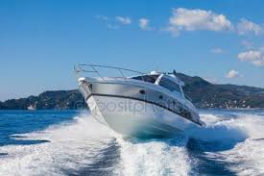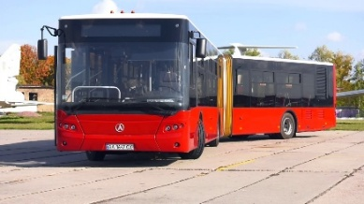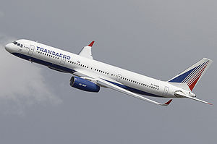  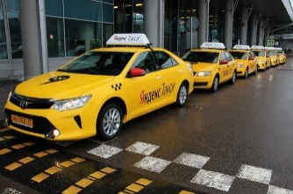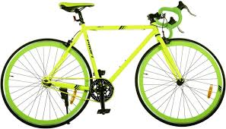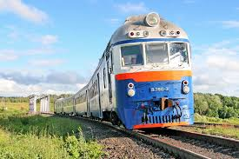  Activity “Puzzle”  Students are divided into three groups using pictures  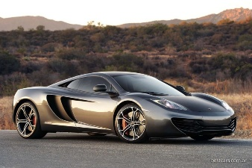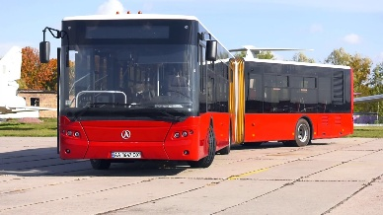  e.g. car, bus, plane  Pre-reading  1. What transport do you like?  2. What type of transport do you know?  3. How do you get to school?  While-reading  Students reads the text  There are as many means of transport as you can only imagine. They are a bus, a bicycle, a car, a ship, a train, a plane and so on. And today I want to discuss all of them. The most popular means of transport is a car. Nowadays there are so many car producers and brands that a car becomes the most popular and comfortable type of transport. You can travel by car everywhere. The only thing that can stop you is your driving license and the foreign country rules. А dream of many people is to buy a car and for most of them it comes true. Another popular transport is a bus. Not everyone can drive or many people just want to enjoy the view and concentrate on their thoughts while travelling. And the bus allows all these. The cost of travelling by bus is much lower than that of a car. Bicycle is popular among young people. They use it during the warm seasons to travel around the city or the nearby places. It’s healthy and affordable for most of people. Train is popular for its low cost and cozy atmosphere. You can make a long travel on the train and don’t need to pay a lot for it. Planе is popular for its speed but the cost is quite high. It is thought to be the safest means of transport among all. The most luxurious means of transport is a ship. I mean not those small ordinary ships, but the ones that travel across the oceans with thousands of tourists. They are often called liners. So we just need to pick up the one we like and completely enjoy it. |  | https://goo.gl/YCSX0w  Flashcards
End | Post-reading  Are the sentences “TRUE” or “FALSE”. Correct the false sentences  - The most popular means of transport is a bicycle  - Everyone can drive or many people just want to enjoy the view and concentrate on their thoughts while travelling  - Bicycle is popular among old people  - The most luxurious means of transport is a car  - Planе is not popular for its speed but the cost is quite high  Writing. Differentiation by tasks  (by support of teacher , by support of friend and by support of group)  Group A. Writes the advantages and disadvantages of Transport  Group B. Think about means of transport in our country and answer a question:  What is the most commonly used means of transport in our country and why?  Write a couple of sentences in your exercise books, please.  Group C. Make a poster about types of a transport and answer why each type of a transport is important  Descriptor:  A learner  - discuss in group  - communicate using the appropriate topical vocabulary  - makes poster and hypothesize it  (FA) “ AIRPLANE”  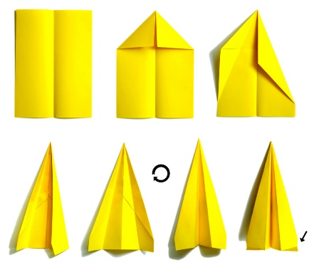  Before completing the assignment, the teacher shows a video where the children following the instructions perform the airplane from paper, then they write they name, and answer the questions of the teacher asked by the topic of the lesson, they write about what they have learnt during the lesson, and run their airplane, after that learners check up each other.  Descriptor:  A learner  - makes a plane according to the instruction  - listens instruction clearly  - answers the questions correctly  Feedback “ Draw your brain ”  Learners draw outlines of brain, then they fill it own feeling the  The lesson is over. Good bye. |  | student’s book  workbook  workbook  Worksheet 1  Card 1

