Short term plan

Unit: 3. People I love. |  | Lesson 17

School:

Teacher’s name:

Date:
Grade: 3 |  | Number present: | absent:
Lesson title | Family and friends.
Learning objectives | 3.1.2.1 recognise familiar words with visual support  3.3.2.1 identify some familiar words and signs on illustrations /pictures in common everyday situations
Lesson objectives  (assessment criteria) | Learners will be able to:  - name and describe family members in English.
Values ​​and its purpose: | Justice and Responsibility  Human rights and responsibilities in society  having a first view about

Stages/  Time | Teachers actions | Students actions | Assessment | Resources
Beginning of the lesson  5 min | Organization moment :  1.Greeting. . (Whale class, Individually)  Warm-up  Ask children to name all the people they have met in the story so far. Write the names in a list on the board (Rosy, Billy, Tim, Miss Jones). Establish that with the exception of Miss Jones, all the characters are from the same family (Rosy and Billy are brother and sister, Tim is their cousin).  Lead – In  Hold up flashcards 60-65, 1, and 3 and say the words for children to repeat. Model words that children don't know.  Hold up each flashcard for children to say the words  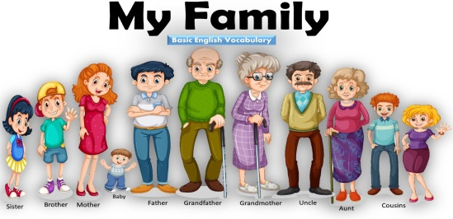 | Greet the teacher and classmates.  Introduce themselves in pairs.  Learners watch the video and remember and recognize the main vocabulary.  Human Rights and Responsibility List  1 Right to life  2 Right to freedom of expression  3 Right to education  4 Right to equality | Teacher controles the process, gives feedback and asks additional questions if it’s nessasery.  Teacher evaluate pupils with phrases like:  “Good job!  Well done!”  Formative Assessment | 
Middle of the lesson  Presentation part.  35 min | Task. I  Ex:1 P:18  Ask children to look at the family members. Play the first part of the recording for children to listen and point to the pictures. ДЛЯ  Play the second part for children to repeat the words.  Play the recording all the way through again for children to listen and point and then repeat the words. Put the flashcards on the board. Point to the family members for individual children to say the words aloud. | Learners listen attentively and match descriptions to pictures. Repeat family member words in the recording.  Transcript  dad, grandpa, sister, mum, grandma, brother Listen and repeat. НЕ  Listen and point.  mum, dad, sister, brother, grandma, grandpa  mum, dad, sister, brother, grandma, grandpa | T’s feedback  Descriptor:  - look at the family members  - match descriptions to pictures  Point 2 | Family flashcards  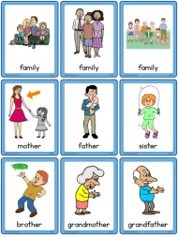
 | Task. II  Ex: 2 P: 4  Play the recording for children to listen to the chant.  Play the chant a second time for children to say the words. Repeat. This time they can point to the correct flashcards as they hear the words. | Learners listen, repeat the chant, and add actions for each family member.  Transcript  Listen and chant.  mum, mum, mum  dad, dad, dad  sister, sister, sister  brother, brother, brother  grandma, grandma, grandma  grandpa, grandpa, grandpa | Self -assessment  Descriptor:  - listen to the chant.  - add actions for each family  Point 2   | 
 | Task. III  Ex: 3 P: 4  Use Story poster 3 to present the story. Point to the different people and ask Who's this? Ask children to name as many things in the picture as they can. Check the meaning of teddy, umbrella and ice cream.  Talk about each frame. Ask What's happening in the story? Encourage predictions from the class. Ask children to look at the poster while you play the recording. Point to each picture as you hear the text. Ask comprehension questions, e.g. Where are Tim and? What do they find? What has Mum got? | Learners engage with the story poster, identifying characters, objects, and making predictions. Listen to the recording, follow along in their books, and answer comprehension questions. | Descriptor:  - listen to the recording  - answer the question   | Worksheet  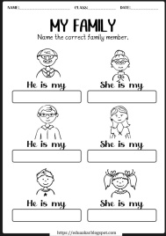
End of the lesson  5 min | Briefly ask students what they learned today (greetings, names of characters, introducing themselves).  Ex: P:  Home task: | Repeat family member words chorally.  Share key takeaways about families from the lesson. |  | Poster Success  

