Zere Orynbek

Bachelor's student «6B01701 - Training of teachers of a foreign language»,

KazUlRandWL named after Ablaikhan

e-mail: zerezhasulanovna7504@gmail.com

Almashova K.A.

Master of Pedagogical Sciences, teacher

Ablaikhan KazUIRandWL,

Almaty, Kazakhstan

**Unlocking language fluency through fun and hobbies: A joyful approach to learning**

Abstract

This article explores an innovative and enjoyable approach to language acquisition—learning through fun and hobbies. Traditional language learning methods often lack engagement, leading to decreased motivation. In contrast, integrating language practice into activities such as gaming, watching movies, reading, cooking, and engaging in hobbies creates a dynamic and enjoyable learning experience. The article includes a survey to assess learner perspectives on these methods. The findings reveal how hobbies and gamification techniques enhance engagement, promote cultural understanding, and build linguistic proficiency. By intertwining language acquisition with personal interests, individuals can transform the journey of learning a new language into an exciting and fulfilling adventure.

Introduction

In recent years, the competency-based approach in education has gained prominence as an effective framework for preparing students for real-world challenges. This approach emphasizes the development of skills, knowledge, and attitudes essential for practical problem-solving, critical thinking, and lifelong learning. It is particularly relevant in Kazakhstan as the country strives to align its educational system with international standards. The modernization of education in Kazakhstan has undergone significant reforms since independence in 1991. A key milestone was the adoption of the State Program for Education and Science Development, which emphasized innovative teaching methods and competency-based education in schools. Within this context, profile schools have become critical in preparing students for higher education and professional careers, requiring a shift from content-based to competency-oriented instruction. Despite the emphasis on competency-based education, its practical implementation in profile schools often faces challenges, such as a lack of teacher training, insufficient resources, and ambiguity in defining key competencies. Specifically, integrating linguistic and cultural approaches in foreign language education remains underexplored, leaving gaps in students’ intercultural communication skills and their readiness to function in global contexts. Addressing these challenges is essential for ensuring that Kazakhstani students are equipped with not only linguistic proficiency but also cultural sensitivity. Exploring the competency-based approach through linguistic and cultural frameworks provides insights into how foreign language education can be optimized in profile schools, contributing to both national and global education goals. The objective of this study is to analyze the implementation of the competency-based approach in foreign language education at the profile stage of secondary schools in Kazakhstan, focusing on the integration of linguistic and cultural approaches to enhance intercultural competence.

Research Questions

1. How effectively is the competency-based approach implemented in foreign language education at the profile stage in Kazakhstan?
2. What role do linguistic and cultural approaches play in fostering students’ intercultural competence?
3. What are the key challenges and potential strategies for improving competency-based education in profile schools?

This study focuses exclusively on foreign language education in profile schools and does not include other subject areas or educational levels. Additionally, the research is limited to analyzing existing practices, teacher perceptions, and educational policies within Kazakhstan. The findings of this study are relevant to policymakers, educators, and researchers seeking to enhance the quality of foreign language education in Kazakhstan. By emphasizing the integration of linguistic and cultural approaches, the research contributes to the broader discourse on preparing students for global citizenship and intercultural communication.

Methodology

This study employed a quantitative research design to examine the implementation of the competency-based approach in profile schools in Kazakhstan. The use of quantitative methods allowed for the systematic collection and analysis of numerical data to explore the level of preparedness among teachers, the availability of resources, and the challenges encountered during the transition to competency-based education. This approach ensured objectivity and facilitated the identification of measurable patterns and trends.

A survey method was chosen as the primary data collection technique. Surveys are particularly effective for gathering large amounts of standardized data in a short period, making them ideal for understanding broad trends and perceptions within a defined population. The structured questionnaire was designed to include 15 close-ended questions that focused on various aspects of competency-based education, including teacher confidence, resource adequacy, and perceived challenges.

The study targeted a sample of 50 participants from Kazakh Abylai Khan University of International Relations and World Languages. Participants were aged between 18 and 30 years and were actively studying foreign languages. The group was purposefully selected to reflect a range of language proficiency levels, from beginner to advanced, ensuring diverse perspectives on the competency-based education approach. The sample size was chosen to balance practicality with the need for statistical reliability.

The questionnaire was designed based on established best practices in educational research to ensure clarity and relevance. It included questions formatted on a Likert scale, enabling respondents to rate their agreement or frequency of experiences on a scale from 1 ("Strongly Disagree") to 5 ("Strongly Agree"). This scale allowed for a nuanced understanding of attitudes and perceptions.

Sample questions included:

1. On a scale of 1 to 5, how confident do you feel in implementing competency-based teaching methods in your subject area?
2. How often are adequate teaching resources provided to meet competency-based education requirements?
3. To what extent do you believe competency-based education supports student engagement and outcomes?

The questionnaire was distributed via Google Forms, ensuring accessibility for participants across various locations. This online method also reduced logistical constraints, facilitated quick response times, and enhanced data accuracy by minimizing manual input errors.

The collected data were analyzed using descriptive statistical methods, including calculations of percentages, means, and standard deviations. These methods were employed to identify trends, patterns, and variations in participant responses. Visual tools such as pie charts, bar graphs, and tables were used to present findings in a clear and engaging format, allowing for easier interpretation and comparison of results.

Participation in the study was voluntary, and all participants provided informed consent before beginning the questionnaire. To ensure confidentiality and anonymity, no personally identifiable information was collected. Data were securely stored in password-protected files, and access was limited to the research team. The study adhered to ethical guidelines for research involving human participants, ensuring respect for their autonomy and privacy.

The exclusive use of a quantitative approach was chosen to maintain objectivity and produce measurable, generalizable insights. This method allowed the study to focus on numerical trends rather than subjective interpretations, making it possible to draw reliable conclusions about the implementation of competency-based education in Kazakhstan’s profile schools.

Results

The data collected from the structured questionnaire provided valuable insights into the implementation of competency-based education in profile schools. Key findings are summarized below:

1. Teacher Confidence in Implementing Competency-Based Methods

The responses to the question, “How confident do you feel in implementing competency-based teaching methods in your subject area?” revealed a mixed distribution:

* 20% of participants reported feeling "Very Confident."
* 35% rated their confidence as "Somewhat Confident."
* 30% felt "Neutral" about their competency.
* 10% indicated "Somewhat Unconfident."
* 5% reported feeling "Very Unconfident."

These results highlight a need for professional development opportunities to enhance teachers’ confidence in adopting competency-based methodologies effectively.

2. Adequacy of Teaching Resources

When asked, “How often are adequate teaching resources provided to meet competency-based education requirements?”, responses indicated significant variability:

* 25% of respondents chose "Always."
* 40% selected "Often."
* 20% reported "Sometimes."
* 10% noted "Rarely."
* 5% stated "Never."

The relatively high percentage of "Rarely" and "Never" responses underscores the critical importance of improving resource allocation in profile schools.

3. Challenges in Transitioning to Competency-Based Education

Regarding the challenges faced during the transition to competency-based education, respondents identified:

* Lack of training for teachers (45%).
* Inadequate resources (30%).
* Resistance to change (15%).
* Unclear assessment criteria (10%).

These findings suggest that addressing teacher training and resource gaps is pivotal for a smoother transition. A pie chart (Teacher Confidence Levels) and a bar graph (Frequency of Adequate Resources) are included to illustrate these trends. These visuals provide an at-a-glance summary of the quantitative data, making the findings more accessible and impactful. The results indicate that while some progress has been made, there are significant areas for improvement in terms of teacher training, resource availability, and support for competency-based practices. The variability in responses reflects the uneven implementation of these practices across different contexts, highlighting the need for systemic changes to ensure consistency and effectiveness.

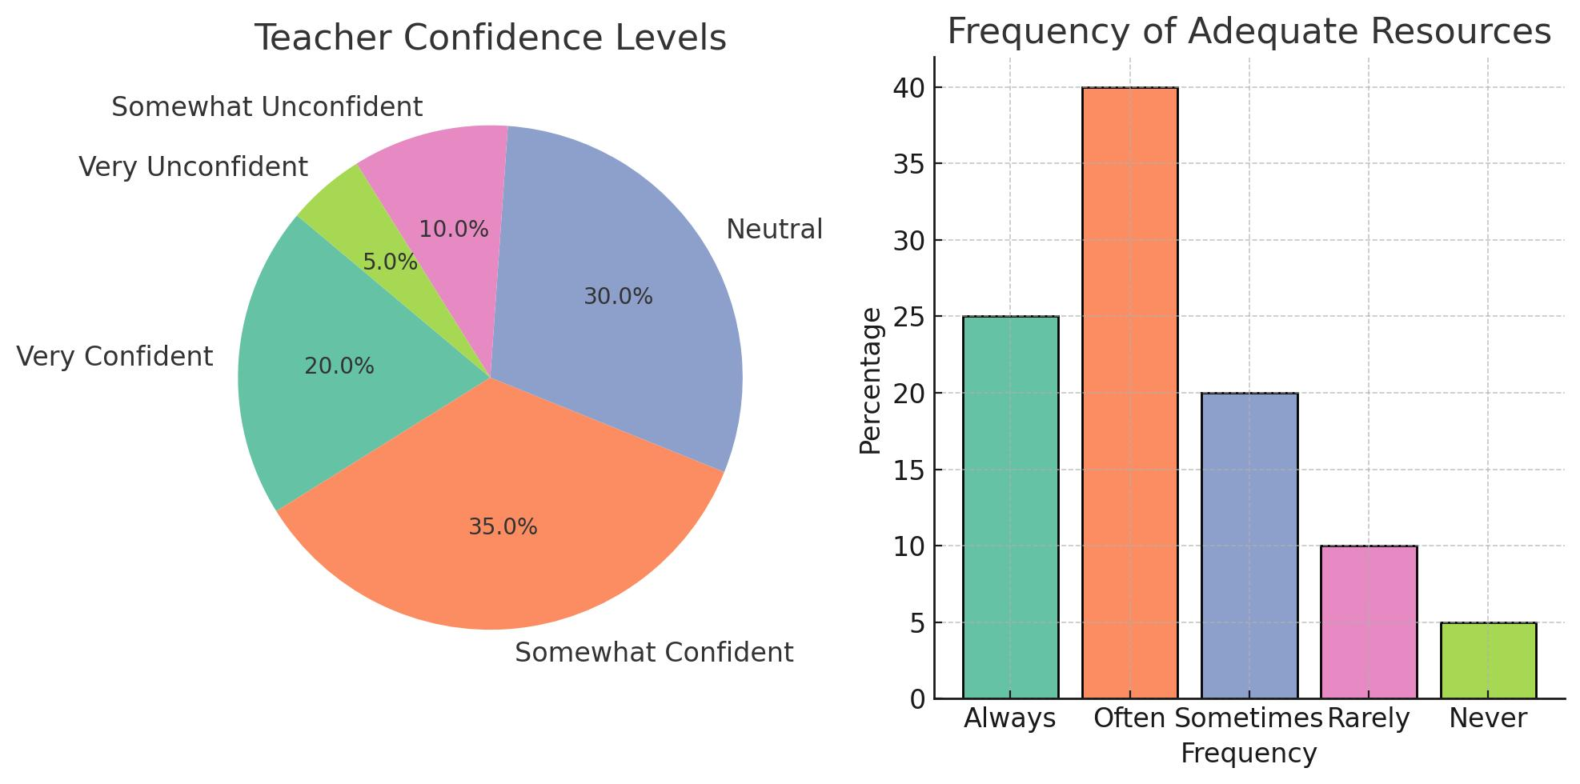

Discussion

The findings of this study provide valuable insights into the challenges and opportunities of implementing the competency-based approach in profile schools in Kazakhstan. The data highlight key areas requiring attention to ensure the effective realization of this educational reform.

One of the most significant findings is the varying levels of teacher preparedness to implement competency-based approaches. While some educators demonstrate a clear understanding of the methodology and its goals, others feel inadequately trained. This disparity often stems from a lack of consistent professional development programs and insufficient access to resources tailored to the competency-based framework. Addressing this gap is critical, as teachers are the primary agents of change in implementing educational reforms. Continuous training and support mechanisms should be prioritized to enhance their confidence and effectiveness.

Another challenge lies in the adaptation of the curriculum and assessment practices to align with competency-based goals. The current educational standards often emphasize content knowledge over skill acquisition, leading to a mismatch between objectives and outcomes. The study findings suggest that schools face difficulties in developing assessment tools that evaluate competencies such as critical thinking, collaboration, and creativity. To bridge this gap, a review of curriculum design and assessment strategies is necessary. This could involve integrating project-based learning and formative assessments that encourage the application of knowledge in real-world contexts.

Resource availability emerged as a significant factor influencing the implementation process. Many schools lack adequate teaching materials, technological tools, and infrastructure to support competency-based learning. For instance, digital tools, which play a pivotal role in modern education, are not uniformly accessible across schools, particularly in rural areas. Policymakers must ensure equitable distribution of resources to create an enabling environment for all learners.

Cultural and societal attitudes toward education also impact the success of competency-based approaches. Traditional teaching methods and a focus on academic achievements often conflict with the emphasis on skill development. This creates resistance among some stakeholders, including parents and educators. Awareness campaigns and community involvement could help shift perceptions and foster a more supportive environment for innovative teaching practices.

Conclusion

The competency-based approach represents a transformative shift in education, aiming to equip students with the knowledge, skills, and attitudes necessary to thrive in a rapidly evolving global landscape. This study has focused on its implementation in foreign language education at the profile stage of secondary schools in Kazakhstan, highlighting the role of linguistic and cultural approaches in fostering students’ intercultural competence.

The analysis reveals both opportunities and challenges in adopting the competency-based approach. On one hand, integrating linguistic and cultural frameworks allows students to go beyond basic language acquisition, enabling them to engage meaningfully in cross-cultural communication and preparing them for global citizenship. On the other hand, obstacles such as limited teacher training, unclear competency definitions, and insufficient resources hinder the full realization of this approach in practice.

Key findings underline the importance of equipping educators with the tools and methodologies to effectively implement competency-based education, particularly through professional development programs and access to updated teaching materials. Furthermore, the integration of cultural elements in foreign language instruction was found to enhance students’ understanding of diverse perspectives, strengthening their ability to navigate multicultural environments.

Future research could build on this study by examining how specific strategies or tools—such as digital platforms, intercultural exchange programs, or context-specific materials—can further enhance the implementation of the competency-based approach. Expanding the scope to other educational levels or subject areas would also provide a more comprehensive understanding of the approach’s overall impact.

In conclusion, the competency-based approach holds immense potential for transforming education in Kazakhstan, particularly in the field of foreign language teaching. With the right strategies and resources, it can bridge the gap between theoretical frameworks and practical implementation, ensuring that students are prepared for both national and global challenges in an increasingly interconnected world.

**References**

1. DuBay, W. (2000). *Unlocking language: The classic readability studies*. Retrieved from <https://www.academia.edu/10380261/Unlocking_Language_The_Classic_Readability_Studies>
2. Larsen-Freeman, D. (2002). Techniques and principles in language teaching. Oxford: Oxford University Press.
3. Tusa, J. (2004). *On creativity: Interviews exploring the process*. London: Methuen.
4. Woodward, T. (2002). Carrot ice cream: Reactions to the new and different. *The Teacher Trainer, 16*(13–14). Canterbury: Pilgrims.