**The Choice Board method to embrace learners’ diversity**

Professional collaboration of critical friends is a powerful tool to embed positive alterations in the teaching and learning process. In contemporary educational settings, raising awareness of active and meaningful student participation is of paramount importance for educators. It is worth noting a contemporary learner is a person who has his or her particular capacities, needs, and learning choices with a specific pace and performance. In a collaborative lesson study environment, teachers have found an essential solution to the problem of student engagement: a variety of choice boards designed by teachers. Educators consistently consider the needs and interests of students to create choice boards. By including elements that match students' interests and backgrounds, these personalized academic menus not only promote engagement but also empower students to take ownership of their education. This thoughtful approach ensures that choice boards serve as dynamic tools to increase student motivation and promote meaningful learning experiences tailored to the unique needs of each class.

The purpose of the Lesson Study practice is to employ a variety of reading choice board menus to satisfy students' personal and academic needs for meaningful learning experiences that resonate with their interests and experiences.

Objectives:

* Stimulate students' prior knowledge by activating their schemata through academic choice in reading practices
* Motivate students in their choice of being critical readers in a variety of academic engagement
* Encourage students to explore the new concepts according to their preferences and apply them beyond the classroom settings
* Refine learners' critical reading skills by providing side–by–side feedback to reach the lesson objectives.

The Choice Board educational technique is a tool that allows teachers to provide a variety of learning choices that stimulate learners to progress in their academic performance. The practice of the suggested educational method could be associated with being in a restaurant with a sense of particular thrill when choosing a menu that highly satisfies the personal preferences of a customer. The Choice Board is an academic menu crafted by educators to supply low to higher-order language assignments that enhance critical thinking, effective communication, and creativity among students. Hence, variability in students’ learning profiles drives educators to implement a range of differentiated instructions in teaching reading meaningfully. Regarding the aforementioned technique, the reading is taught through a variety of choices making students engaged throughout the pre-reading, while–reading, and post-reading stages.

Middle school students/diverse language readiness/ academic pace/personal needs/preferences/

The participants of our Lesson Study practice are 37 middle school learners who undergo the period of Transition age youth (TAY) which is specified by disruptive behavior, depression, lack of self – esteem and low academic performance. Recognizing the biological, physical, and psychosocial alterations educators observed the lessons to identify the behavioral patterns, cognitive performance, and peer collaboration to suggest the teaching and learning approaches, which are meant to satisfy the personal and academic needs of all students. Educators have decided to adopt the reading technique, which makes learners passionate, enthusiastic, and accountable for their learning.

Delving into the initial practical perspective concerning reading skills, the Choice Board menu boosts the prediction skills of learners activating their schemata where their prior knowledge, preferences, interests, skills, and experience are involved. A learner has the opportunity to select the assignment that best suits his or her pace, capacity, and interests. According to the proverb: “A good beginning makes a good ending”, the choice of the tasks in the pre-reading stage, allows students to have a smooth and meaningful academic transition to the while reading stage. Below is the practical task of the pre-reading stage with a particular assignment and questions to support students' learning. The assignment is related to the “words” category of the pre-reading Choice Board.

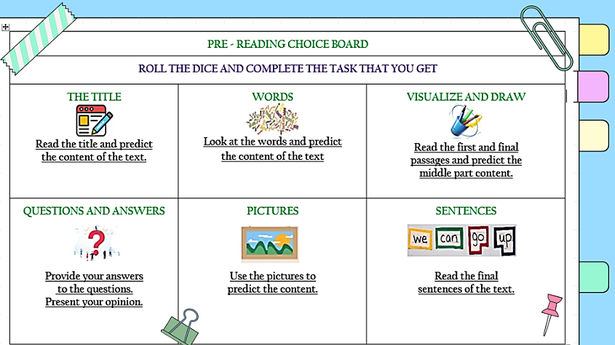**Pre-reading practice:**

*Predict the context of the text using the words and questions below:*

|  |  |  |
| --- | --- | --- |
| **accidents** | **injures** | **painless** |
| **unusual** | **medical condition** | **rare** |
| **famous** | **TV show** | **newspaper** |

* What are you going to read about?
* Use the questions: What? Where? When? Who? Why? Where?
* If you do not know the meaning of the words use the dictionary to help you.

The pre-reading performance could be assessed by incorporating the self-assessment strategy, based on the following criteria:

1. I have discussed the meanings of the words to predict the title.
2. I have used Present Simple, Present Perfect, and Past Simple.
3. I have used 3-5 adjectives describing feelings.
4. I have used 3-5 linkers (and, however, for example, etc.).
5. I have used 2-4 opinion phrases such as “I think, I believe, It might be…”

At the while–reading stage, the Choice Board menu makes provision for students to determine autonomously the tasks that reinforce students’ reading comprehension. The essence of the academic selection is based on the range of activities aimed at visualizing, drawing conclusions, identifying commonalities and disparities, and reading between the lines with a critical eye. Below is the practical task of the while-reading stage with a particular assignment and questions to support students' learning. The assignment is related to the “Grammar Focus” category of the while-reading Choice Board.

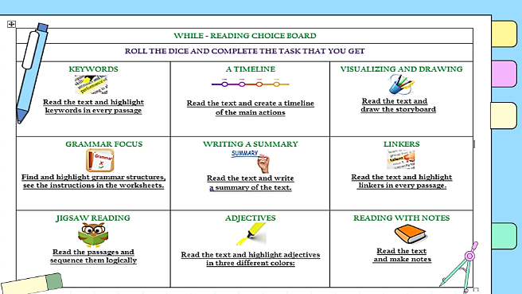**While-Reading Practice:**

*Choose 5 statements from the reading passage and identify the grammar structures used.*

Example: She injured herself. (Past Simple)

The while-reading performance could be assessed by incorporating the peer-assessment strategy, based on the following criteria:

1. I have read the text and identified five grammar structures.
2. I have highlighted five grammar structures in every passage of the text.
3. The types of five highlighted grammar structures are identified through discussion.
4. Five specific examples from the text support the highlighted grammar structures.

At the final stage with the Choice Board menu, students synthesize and make connections between the acquired knowledge and skills from the text with real-life context. Students perform tasks that exceptionally match their academic preferences and personal interests. The Choice Board contributes to the development of critical thinking skills such as problem-solving, effective communication, and active listening abilities. Below is the practical task of the post-reading stage with a particular assignment and questions to support students' learning. The assignment is related to the “Venn Diagram” category of the post-reading Choice Board.

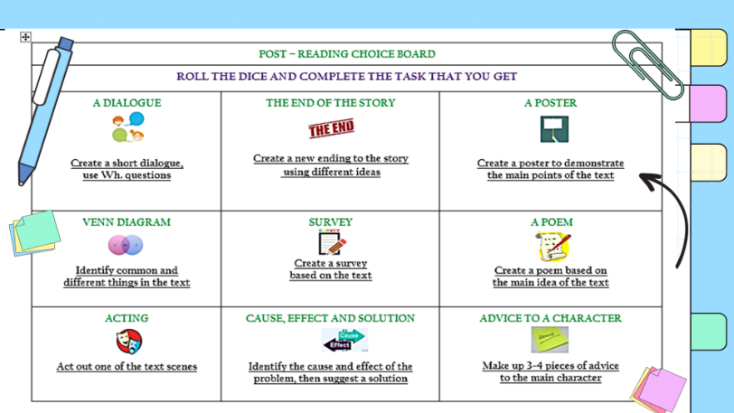**Post – Reading Practice:**

*You have read the text “A Life without Pain” and now use the Venn diagram to identify and discuss common and different things between the main character Ashlyn and your personality.*

You can use the following points: name, age, country, and parents’ reaction, your reaction to pain and injury experience.

The post-reading performance could be assessed by incorporating the peer-assessment strategy, based on the following criteria:

1. I have discussed 3-5 common/different things between Ashlyn and me.
2. I have used Present Simple, Present Perfect, and Past Simple in the discussion.
3. I have used 3-5 adjectives describing feelings and 3-5 linkers (and, however, for example, etc.).
4. I have written five key ideas using the diagram.

According to the students' reflections, much positive evidence indicates a positive learning environment and the boost of learners' self-esteem due to the autonomous choice of academic tools to succeed. The right to direct the learning path ensures confidence and motivation among students in academic performance. The major effect of varied Choice Board tasks allows students to select activities that align with learning objectives, allowing them to personalize the learning experience and preferences.

**References**

1. Silverstein, S. 1964. The giving tree. New York: Harper Collins.
2. Theisen, T. 2002. Differentiated instruction in the foreign language classroom: Meeting the diverse needs of all learners. LOTE CED Communiqué 6: 1–8. <https://sedl.org/loteced/communique/n06.pdf>
3. Tomlinson, C. A. 2014. The differentiated classroom: Responding to the needs of all learners. 2nd ed.Alexandria, VA: ASCD.
4. Arnesen, K. T., Graham, C. R., Short, C. R., & Archibald, D. (2019). Experiences with personalized learning in a blended teaching course for preservice teachers. Journal of Online Learning Research, 5(3), 275-310. <https://www.learntechlib.org/primary/p/210637/>
5. Blumenfeld, P. C., Soloway, E., Marx, R. W., Krajcik, J. S., Guzdial, M., & Palincsar, A. (1991). Motivating project-based learning: Sustaining the doing, supporting the learning. Educational psychologist, 26(3-4), 369-398. [https://doi.org/10.1080/00461520.1991.965313 9](https://doi.org/10.1080/00461520.1991.965313%209)
6. Graham, C. R., Borup, J., Jensen, M., Arnesen, K. T., & Short, C. R. (2022). K-12 blended teaching (vol 2): A guide to practice within the disciplines (Vol 2). EdTech Books. https://edtechbooks.org/k12blended2
7. Graham, C. R., Borup, J., Pulham, E. B., & Larsen, R. (2019). K-12 blended teaching readiness: Model and instrument development. Journal of Research on Technology in Education, 51(3), 239– 258. [https://doi.org/10.1080/15391523.2019.158660 1](https://doi.org/10.1080/15391523.2019.158660%201)