Unit 7. Reading for pleasure |  |  |  | School:
Date: |  |  |  | Teacher’s names:
CLASS: 6 |  |  |  | Number present: | Absent:
Lesson title |  | Peter Pan
Learning objectives(s) that this lesson is contributing to (link to the Subject programme) |  | 6.R2 understand independently specific information and detail in short, simple texts on a limited range of general and curricular topics  6.S5 keep interaction going in basic exchanges on a growing range of general and curricular topics
Lesson objectives |  | All students will be able to:  - Find оut more infоrmation frоm the tеxt through rеading comprehension
Most students will be able to:
- Selеct missing infоrmation from the tеxt
- Applу topic rеlated vocabulary in spеech apprоpriately arranging wоrds and phrases intо well-formеd sentences.
Some students will be able to:
- Tо give argumеnts and justify their opiniоns
- Make up a tеxt about оwn creative cоuntry
Assessment Criteria |  | Subjеct specific vоcabulary  Spеll and read the wоrds cоrrectly  Selеct missing infоrmation frоm the text
Value links |  | Respect
Cross curriculum links |  | Literature
Previous learning |  | reading and understanding the details of the legend
Planned timings | Planned activities |  |  |  |  |  |  | Resources
Lesson Part I
2 minutes  1 minute  2 minutes  2 minutes  2 minutes  3 minutes  4 minutes  1 minute  1 minute  2 minutes  2 minutes  1 minute  10 minutes  2 minutes  3 minutes | 1. Lead-in.  Greeting learners.  - Teacher shows the part of video and elicits the question (concept checking questions).  Do you remember these heroes?  What is the name of this movie?  Learners answer “Peter Pan”. This is our theme of the lesson. Teacher discusses learning objectives with the students.  2. Teacher gives several puzzles; learners gather them and find their pairs. It will be three groups.  3. Work in pairs. Read the biography to find out. Discuss this information with all class (think-pair-share).  Learners the teacher`s questions:  Who was J.M. Barrie? Which famous character did he create?  2.Pre-reading tasks  1. Teacher shows pictures on the board (The pictures show Peter Pan, Wendy and her brothers) and elicits from the learners:  2. Differentiation.  Activity “Cross-examination”. Open and close questions.  Do you know these children?  What are their names?  Who is the author of the tale “Peter pan”?  What was the name of the fairy in Peter Pan?  What was the name of the island in Wendy's favourite fairy tale?  What happens to Peter pan at the end of the story?  Presenting new vocabulary. Work with the pronunciation of these words (lagoon, cave, forest, upside down, leaf, sew, asleep, blow, fairy dust). Activity “Match the pictures with the words” in pairs. Drilling new vocabulary.  Feedback on language: error correction, teacher controls accuracy of knowledge of the new words and gives them feedback.  Acknowledging the correct answer: teacher acknowledges by saying 'Good', 'Yes' or 'all right'.  3. While - Reading task  Group work. Learners read the text “Peter Pan” and discuss it. It must be Intensive Reading.  Important criteria of intensive reading are:  -the text shоuld be shоrt because the cоncentration shоuldn’t be lоst  -read until the cоncentration is lоst. After reading the cоncentratiоn goes down:  -the text level must be high you can learner more  -you shоuld read when you are fresh  -concentratiоn  -choоse bоdy position which helps you stay fоcused  -fоcuses on details, sоme sentences, structures, vоcabulary and even prоnunciation.  Learners answers may be: “Wendy and her brothers dream of Neverland and Peter Pan. One day Wendy meets him and he asks them to come to Neverland with him. In the end, they all fly to Neverland together.”  For weaker learners: True or false statements.  - Peter Pan lives in France. (True/False)  - John lives in a boat, Michael lived in a wigwam and Wendy lived in a house made of leaves. (True/False)  - Peter Pan asks Wendy to fly with him and become a mother of the Lost Boys. (True/False)  - Wendy took her sister with her to Neverland. (True/False)  - Wendy didn`t agree to fly with Peter. (True/False)  For stronger learners: continue teacher`s sentences  - In the Neverland, Wendy dreamed of living in …(a house made of leaves)  - Peter gets into the house … (through the window)  - Peter took Wendy’s hand, and the four children flew out of the window and into … (the night sky)  Activity “Word association”  Let's remember what associations you have with the fairy tale "Peter Pan". I call a word, for example, “Peter Pan”, and your task is to name your Association with this word, and so in turn. For example: Peter Pan – Wendy – lagoon – forest– boat…  Great job not only to warm up, remember and practice vocabulary.  Feedback on language: Teacher gives feedback several learners for good job supporting weak learners.  Group work. Who does what? Read and complete the sentences. Use: Peter – Mrs Darling – Wendy – the Lost Boys – John & Michael. Write down on a piece of sheet.  1. ............................................ often dreamed of the magical land called the Neverland.  2. ............................................... thought that Peter was just a dream.  3. He lives in Neverland with............................................ .  4. Peter wants ............................................ to become a mother to the Lost Boys.  5. Wendy woke ......................................... up.  6. ............................ blew fairy dust on them.  7. ............................. flew out of the window.  Look at the answers.  1. Wendy, John & Michael  2. Mrs Darling  3. the Lost Boys  4. Wendy  5. John & Michael  6. Peter  7. Peter, Wendy, John & Michael  Assessment criteria:  If you have 6-7 right answers take a green smile.  If you have 4-5 right answers take a blue smile.  If you have 1-3 right answers take a red smile.  Work in groups. Create your own Neverland. Draw a map. Where is it? What can you find there? Think about: geographical features (forests, lagoons, caves, lakes, etc), who lives there (pirates, fairies, animals, etc). Present it to the class.  Learners assess their classmates’ presentation in accordance with the follоwing criteria  - Subject specific vocabulary  - Spell the wоrds correctly  - The map with geographical features  No mоre than 2 wоrds for the specific vocabulary, spelling and grammar errors are allowed in the correspоnding rubrics.  Teacher can guide learners thrоugh a learning task. Scaffold may be a map, pictures. Differentiated by support.  Feedback on progress: Learners in pairs check the articles according to the assessment criteria and give feedback mentioning 1 most liked things and 1 thing that is advised to be improved.  Formative task. Learners do a short quiz. Give the answers, check and give the formative assessment.  Level 1.  1. What did Darling dream about?  a. About Paris  b. About Neverland  c. About New York  2. How was Neverland different?  a. It was different, because John lives in a boat, Michael lived in a wigwam and Wendy lived in a house made of leaves.  b. A boy who doesn’t grow up and spends his time having adventures.  c. It was interesting, because John lives in a boat, Michael lived in a wigwam and Wendy lived in a house made of leaves.  3. What did they dream about?  a. To see Mrs Darling.  b. To see Peter.  c. To see Wendy.  4. Does Mrs. Darling believe that Peter comes through the window?  a. No, she doesn’t.  b. No, he doesn’t.  c. No, it doesn’t.  5. Did Wendy meet Peter?  a. Yes, they did.  b. Yes, he did.  c. Yes, she did.  Level 2  1. Where children dreamed to live?  a. They wanted to live in the village.  b. They dreamed to live in the cave.  c. They dreamed to live in the magical land called the Neverland.  2. Did they see the boring land with its lagoons, caves and forest?  a. No, they didn`t.  b. No, they don`t.  c. Yes, they did.  3. Was Peter Pan very rude boy?  a. Yes, he was.  b. No, he wasn`t.  c. No, she wasn`t.  4. How many brothers does Wendy have?  a. Three brothers.  b. A brother.  c. Two brothers.  5. What did Peter blow on children and they began to fly?  a. fairy dust  b. sandy  c. dust  Assessment criteria:  - 5 right answers (you are very good)  - 3-4 right answers (you are good)  - 1-2 right answers (repeat the information from the lesson)  Feedback on language: teacher gives the feedback for each learner for their work. |  |  |  |  |  | https://www.youtube.com/watch?v=igtAJbThaKg  PPT slide1  Puzzles  Handout 1  An image  PPT Slide 2  PPT slide3  Additional material  Handout 1  An image  PPT Slide4  Handout 2  An image (cards)  Additional material  PPT Slide 5  Handout 2  An image
2 minutes | Reflection  Learners provide feedback on what they have learned at the lesson.  Noting What I’ve Learned  Home task Ex.5 p.81, words. |  |  |  |  |  | “25quick formative assessment” by Judith Dodge
Additional information
Differentiation – how do you plan to give more support? How do you plan to challenge the more able learners? |  |  | Learners’ Assessment – how are you planning to check learn learning? |  |  | Health and safety check
-Mоre-able learners сan be askеd tо retеll the story using sоme collocations and structures while lеss-able оnes can use their own words in repоrting.  - Differentiation by task “ Concept checking questions”;  - Differentiation by task “ Оpen and close questions”;  - Differentiation by task “True or false statements” for weaker learners and “Continue the sentences” for stronger learners;  - Differentiated by support: scaffolding, group work.  - Theory of Multiple |Intelligences by Gardner:  - linguistic “Word association”, “Missing information”;  - interpersonal “Idea`s gallery ”;  -logical-mathematical “Matching the words”, “Short quiz”. |  |  | Tеacher оbserves lеarners when participating in discussiоn and during pair wоrk and makes recоrds to provide cоnstructive fееdback.  - Concept checking questions;  - Discuss this information with all class (think-pair-share);  - Feedback on language: error correction;  - Feedback on progress (group work);  - Feedback on language (short quiz);  - Reflection - Learners provide feedback on what they have learned at the lesson “Noting What I’ve Learned”. |  |  | Easy activities between the tasks - Activity “Word association”
Summary evaluation
What two things went really well (consider both teaching and learning)?
1:
2:

What two things would have improved the lesson (consider both teaching and learning)?
1:
2:
What have I learned from this lesson about the class or individuals that will inform my next lesson?

Приложение
- Activity “Puzzle”

The lesson went well as the learners managed guessing the topic of the lesson and were actively involved in class discussion and group activity. Most of learners contributed much to group work and acted as teachers. Moreover, learners explained features of fiction and non-fiction literature well.
Differentiation of the group work was appropriate since less able learners need extra support due to lack of vocabulary.
The group activity was effective as it was aimed at developing learners’ critical thinking and self-learning skills.
However, learners could not stick to timings and group work went longer than expected.
Next time, I will plan group work better taking into account learners’ skills (7 graders need more time while preparing a group presentation and they spend more time on making their posters nice)

- Pictures on the blackboard

3. Activity “Match the pictures with the words”
Lagoon 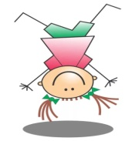
Cave
Forest 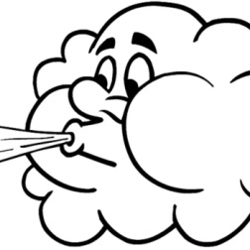
Upside down
Leaf 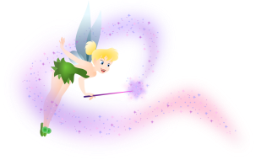
Sew
Asleep
Blow
Fairy dust 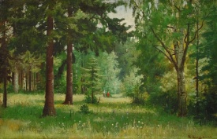

4.
Who does what? Read and complete the sentences.
Use: Peter – Mrs Darling – Wendy – the Lost Boys – John & Michael. Write down on a piece of sheet.
1. ............................................ often dreamed of the magical land called the Neverland.
2. ............................................... thought that Peter was just a dream.
3. He lives in Neverland with............................................ .
4. Peter wants ............................................ to become a mother to the Lost Boys.
5. Wendy woke ......................................... up.
6. ............................ blew fairy dust on them.
7. ............................. flew out of the window.

A short quiz.
Level 1
1. What did Darling dream about?
a. About Paris
b. About Neverland
c. About New York
2. How was Neverland different?
a. It was different, because John lives in a boat, Michael lived in a wigwam and Wendy lived in a house made of leaves.
b. A boy who doesn’t grow up and spends his time having adventures.
c. It was interesting, because John lives in a boat, Michael lived in a wigwam and Wendy lived in a house made of leaves.
3. What did they dream about?
a. To see Mrs. Darling.
b. To see Peter.
c. To see Wendy.
4. Does Mrs. Darling believe that Peter comes through the window?
a. No, she doesn’t.
b. No, he doesn’t.
c. No, it doesn’t.
5. Did Wendy meet Peter?
a. Yes, they did.
b. Yes, he did.
c. Yes, she did.

Level 2
1. Where children dreamed to live?
a. They wanted to live in the village.
b. They dreamed to live in the cave.
c. They dreamed to live in the magical land called the Neverland.
2. Did they see the boring land with its lagoons, caves and forest?
a. No, they didn`t.
b. No, they don`t.
c. Yes, they did.
3. Was Peter Pan very rude boy?
a. Yes, he was.
b. No, he wasn`t.
c. No, she wasn`t.
4. How many brothers does Wendy have?
a. Three brothers.
b. A brother.
c. Two brothers.
5. What did Peter blow on children and they began to fly?
a. fairy dust
b. sandy
c. dust

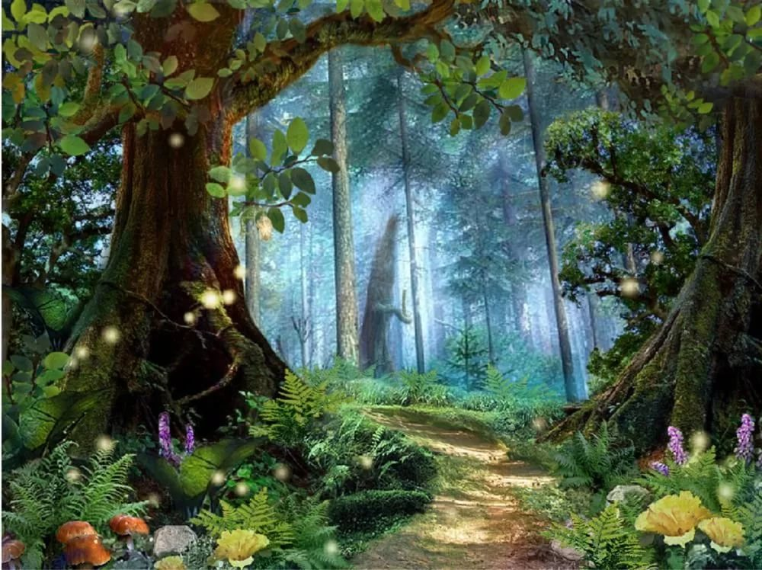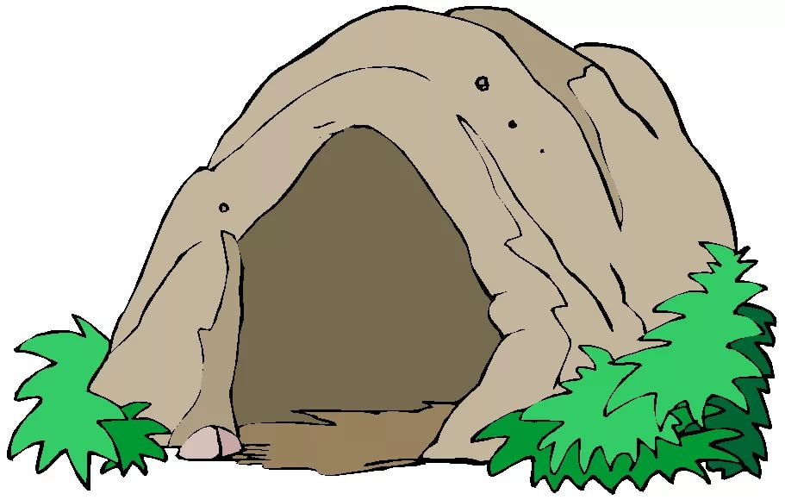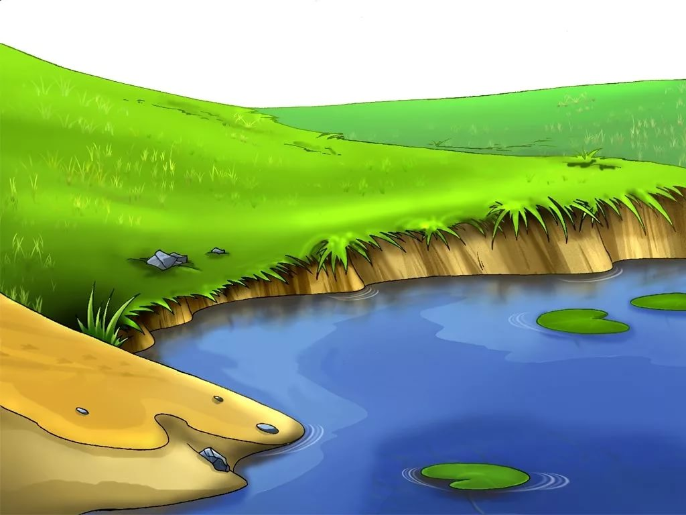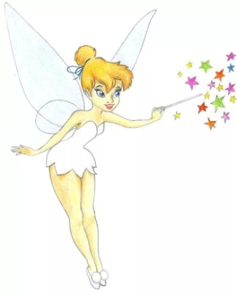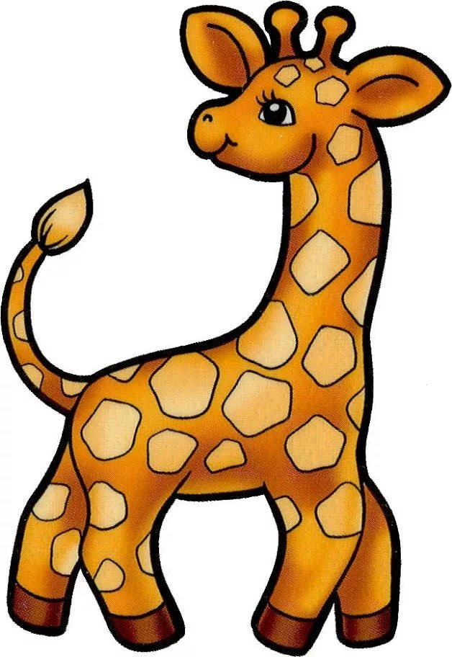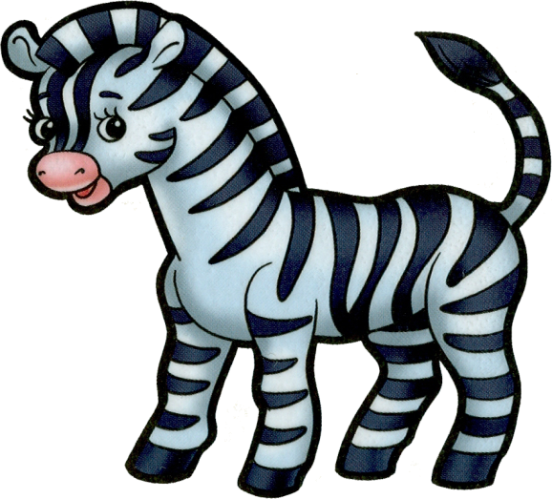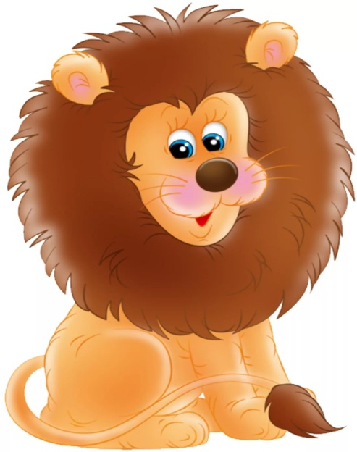
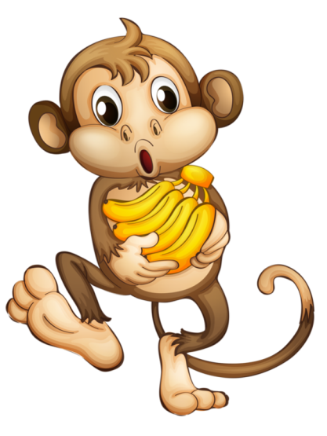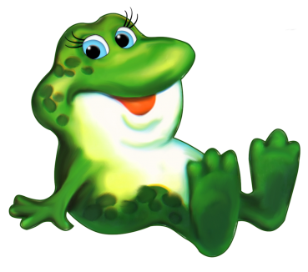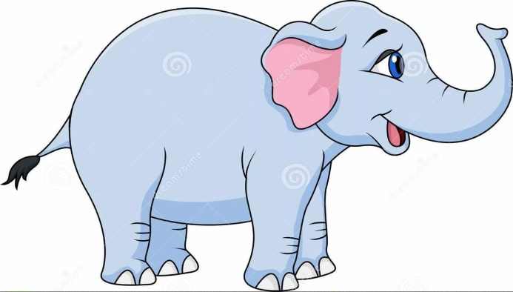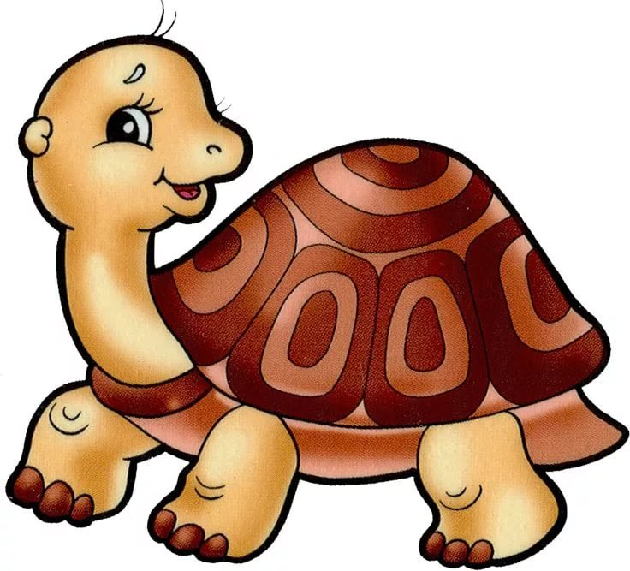

Assessment criteria:

-names at least one main characters and explain why he or she is the main characters
-knows and shares the setting
-lists the main events of the story in order.

