Short term plan

Unit: The world of work |  | School: 29 secondary school
Date: |  | Teacher name: Umiraliyeva M.
Grade: 5 |  | Number present: | absent:
Lesson title | Job qualities
Learning objectives | 5.4.4.1 read with some support a limited range of short fiction and non-fiction texts;  5.5.3.1 write with support factual descriptions at text level which describe people, places and objects;  5.1.4.1 evaluate and respond constructively to feedback from others;
Lesson objectives | - comprehend with little support specific information and details;  -write a short text with factual descriptions;  - evaluate and respond constructively to feedback from others
Level of thinking skills | Knowledge and comprehension
Assessment criteria | - Identify details in a text with little support  - Use the information to write sentences which describe people, places and objects  - Analyze given feedback and give constructive answers to feedback
Functional literacy | - Information handling – locate information. Identifying specific information, using information to write a short text.  - Students learn to describe job qualities.

Stages / Time | Teachers actions | Students actions | Assessment | Resources
Organization:  5 min | Teacher greets students and divides them into three small groups. Before the starting lesson teacher must left stickers with jobs on the desk.  Brainstorming  1.Students are suggested to guess the theme of the lesson due to the stickers.  2.Teacher says the theme  And introduce with the lesson objectives.  Checking-up homework  Checks learned words through the WHEEL OF LUCK | Students respond to greeting. Who have same stickers will be in one group.  1. Students should put the letters under the stickers in right order and will get a word. Write the word and identify the lesson theme.  2.Discuss the lesson objective with teachers support  Spin the WHEEL of Luck and has to name the profession in picture. | Teacher evaluates each learner | PPT 1  PPT 2  https://choice-helper.com/wheelOfFortune/index?lang=ru
Presentation | 1. Teacher sets a purpose for students while watching the video to ask the question and complete the chart.  2.Listens to students answer then hangs the pictures on the board.  Handout 1.  Find the right order of activities from 1 to 8 according to the video.  Introduce adjectives which describes job qualities | 1.Watch the video and answer the question “What jobs did you watch?” and complete the chart.  2. find the right order of activities  3. Check answers.  Repeat and translate them in native language | - Identify jobs  - Complete the chart | Video https://www.linguahouse.com/ru/esl-lesson-plans/general-english/on-holiday  Pictures  Handout 1
Practice | Differentiation by tasks  Task1. Complete the sentences with given adjectives.  Teacher gives students worksheet and identify each students task by their abilities.  Task2. Running dictation  Teacher gives to each groups text.  Clarify the task.  Warm up  Teacher gives instruction how to play this game.  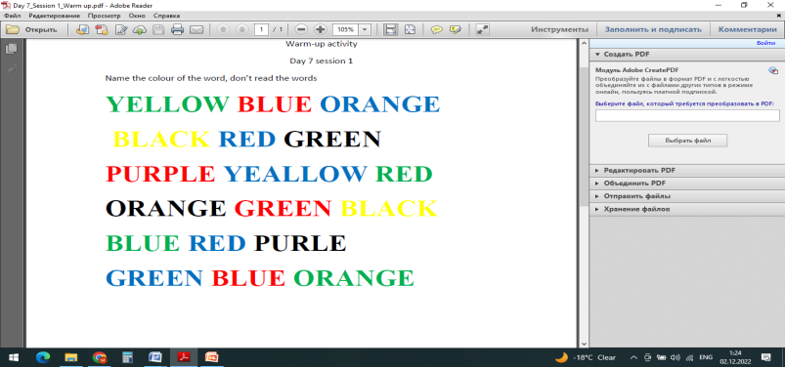 | 1. reads the sentences  2. comprehend the meaning  3. complete the sentences  4. gives correct answer  Reads the text. The leader of group will start the dictation. Other members write remembered information to continue the text.  Students have to call the colour of word, do not read the word. | Peer assessment. Check the right answers.  Self assessment. Tick (V) for each done criteria.  -comprehend the text and find details  -write sentences in affirmative, negative and interrogative form  -make and write sentence correctly. | PPT3  Handout 2  Handout 3  Handout 4
Produce | Writing.  Differentiation by learning outcomes.  1. Gives instruction for writing task. | 1. C students write a topic about the jobs of their family members and describe their qualities.  2. B students put in correct order to make sentences  3. C students underline jobs and adjectives. Use learned vocabulary. | C student:  -write at least 6-7 sentences  - use Present Simple  B student:  -Put the words in correct order  -write sentences correctly  A student:  - underline words correctly  -can use vocabulary | Handout 5  Handout 6  Handout 7
End  5min | Reflection  Teacher share the link answer garden where they should write what they have learned during this lesson. | Write their opinion clearly |  | https://answergarden.ch/

