Lesson plan

Unit of a long term plan : Our Health |  |  |  |  | School: North-Kazakhstan Taiynsha district Podolskaya basic school
Date: |  |  |  |  | Teacher name:Timorskaya Alexandra Petrovna
CLASS: 6 grade |  |  |  |  | Number present: |  | absent:
Lesson title |  |  |  | Physical Education: Rules of a game
Learning objectives(s) that this lesson is contributing to (link to the Subject programme) |  |  |  | 6.L4- understand the main points of supported extended talk on a range of general and curricular topics;  6.R5- deduce meaning from context in short texts on a limited range of familiar general and curricular topics;  6. W1- plan, write, edit and proofread work at text level with support on a limited range of general and curricular topics.
Lesson objectives |  |  |  | All learners will be able to elicit the information in extended talk in 3-4 sentences with active vocabulary on the topic “Physical Education: Rules of a game” with support ;  Most learners will be able to identify the main points of supported extended talk with active vocabulary in 4-5 sentences on the topic “Physical Education: Rules of a game” with support;  Some learners will be able to recognize information on the topic “Physical Education: Rules of a game” with active vocabulary in 6-7 sentences without support.
Assessment criteria |  |  |  | Learner can recognize the information about the topic “Physical Education: Rules of a game”, using active vocabulary.
Values links |  |  |  | Health care, sport is important in our life, communication, support, respect, cooperation
Cross-curricular links |  |  |  | Physical education
Previous learning |  |  |  | Kind of sports
Plan
Planned timings | Planned activities (replace the notes below with your planned activities) |  |  |  |  |  |  | Resources
Start 6min  1 min  3 min  2 min | Activity 1: Greeting “Compliments”.  Learners make a circle in the middle of the class, turn to each other and say compliments.  Hi. You are pretty/beautiful/attractive ….today.  Activity 2: Prediction of the theme of the lesson and lesson objectives. Video «Sport».  Learners guess the theme of the lesson and are given the lesson outcomes according to lesson objectives.  Activity 3: Input in to the theme. Game “What do you know about SPORT?”  Task:  - Make a circle in the middle of the class  - Take a ball one of you in your hands  - Catch a ball and answer the questions  What kind of sport do you know? |  |  |  |  |  |  | https://www.youtube.com/watch?v=tgUSHk6JaTY  PPT Slide 1
Middle 31min  1 min  6min  3 min  2min  6 min  1 min  2 min  10 min | Activity 1. Divission into groups . Puzzle Technology.  Learners take pictures with different kind of sport and form four groups according to the choose.  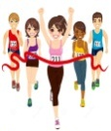  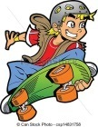  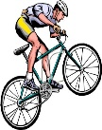  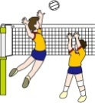  Activity 1:Listening . “Drawing a picture”  Task:  - Count from 1 to 6  - Remember your number  - Find your partner with the same number  - Work in pairs  - Count in pairs from 1 to 2  - Come to the teacher’s table and take a picture if you are number 1  - Don’t show it to anyone  - Return to your partner  - Describe the picture to your partner  - Draw what is described if you are student number 2  Change duties of partner and do the same  Peer-assessment card “Tick”  It was easy for me to do the task I had difficulties doing the task I did not do the task  Learners take a cards on the table and make a tick.  Activity 2:Writing .Matching Strategy“Word Bank”.  Task : Work in a group. Match words with their translation on the card with the help of dictionary and then check a result with keys.  Formative assessment by card  Groups Quantity Quality  1  2  3  4  Activity 3: Practice vocabulary “Completing ”.  Task:  Work in a group. Take worksheets. Complete the sentences with the new words on the left column.Change your worksheets in groups.Take keys .Check answers of the groups  Peer Assessment “Two Stars and one Wish”.  Activity 4: Dynamic pause. “Skeleton dance”.  Learners repeat at the moment in the video.  Formative assesment “ Plus and minus”  Task:  - Sit one by one  - Take a recourse on your table  - Read the text;  - Select an appropriate answer;  - Complete sentences with appropriate words from the box;  - Mark sentences True and False  - Check your result with keys  Learners are given the sheets of paper with the text. Learners read this text, complete sentences with appropriate words from the box and mark sentences True and False.  Learners assess each other’s work using plus and minus. |  |  |  |  |  |  | Handout 1  https://uroky.kz/fo-angliskij-yazyk-5-klass-a-collection-of-tasks-for-formative-assessment-english-grade-5  https://obnovlenka.kz/a-collection-of-tasks-for-formative-assessment-english-grade-6/  Handout 2 https://uroky.kz/fo-angliskij-yazyk-5-klass-a-collection-of-tasks-for-formative-assessment-english-grade-5  https://obnovlenka.kz/a-collection-of-tasks-for-formative-assessment-english-grade-6/  Handout 3  Handout 4  https://www.allthingstopics.com/uploads/2/3/2/9/23290220/wordbank_exercisesports.pdf  Handout 5  Handout 6  https://wordassociations.net/ru/pictures?id=Rocket000-emblem-star  https://www.youtube.com/watch?v=Jpvuqj5nv6U  Handout 7  https://obnovlenka.kz/a-collection-of-tasks-for-formative-assessment-english-grade-6/  PPT Slide 2  Handout 8
End  3min | Reflection “Finish the sentences”.  Task:  - take cards on the table  - complete 2-3 sentences  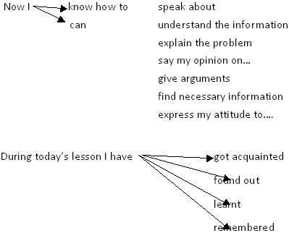  Learners take cards on the table and complete 2-3 sentences.  Teacher’s feedback  Teacher gives oral feedback to students. |  |  |  |  |  |  | Handout 9  http://xn--i1abbnckbmcl9fb.xn--p1ai/%D1%81%D1%82%D0%B0%D1%82%D1%8C%D0%B8/611193/
Additional information
Differentiation – how do you plan to give more support? How do you plan to challenge the more able learners? |  |  | Assessment – how are you planning to check learners’ learning? |  |  | Health and safety check
- By lesson outcomes  - By learning abilities  - By task  - Though support |  |  | Instruments of formative assessment  Criteria  - Self-assessment  - Peer-assessment ”Two stars and one wish”  - Feedback “Finish the sentences”. |  |  | -Dynamic pause “Skeleton dance”.  -using ICT technologies no more than 15 minutes  -division into groups  -rules of sitting on the desks
Reflection |  | Use the space below to reflect on your lesson. Answer the most relevant questions from the box on the left about your lesson.
Summary evaluation

What two things went really well (consider both teaching and learning)?

1:

2:

What two things would have improved the lesson (consider both teaching and learning)?

1:

2:

What have I learned from this lesson about the class or individuals that will inform my next lesson?

Handout 1

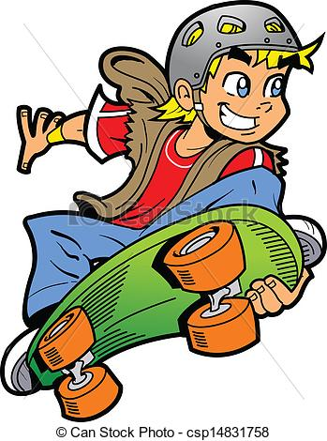
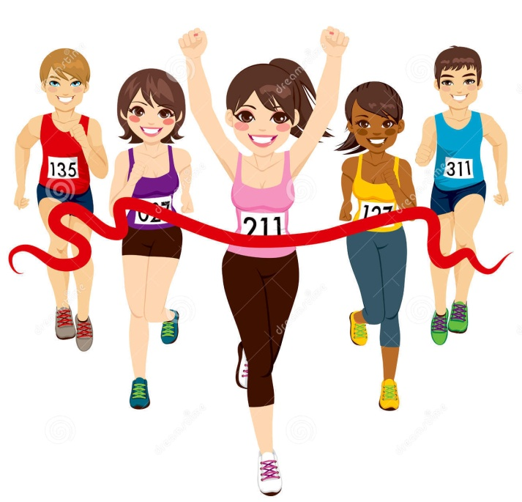
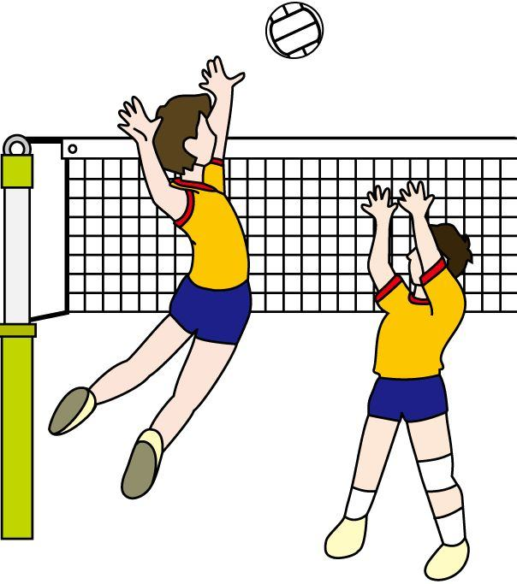
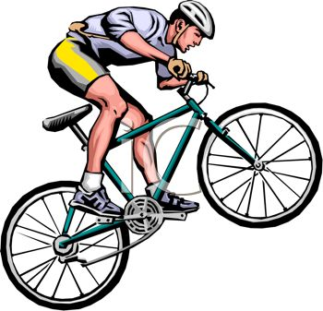

Handout 2

Picture 1  Volleyball | Picture 2  Cycling | Picture 3  First place | Picture 4  Skateboarding

Handout 3

Peer-assessment card

It was easy for me to do the task | I had difficulties doing the task | I did not do the task

Handout 4

Words | Translate
weights | стадион
coach | финиш
Olympics | команда
stadium | старт
finish line | бассейн
race | скорость
swimming pool | гонка
team | золотая медаль
first place | спортсмен
starting line | тренер
score | вес
gold medals | трофей
athlete | волейбол
trophies | олимпийские игры
volleyball | первое место

Handout 5
Groups | Quantity | Quality
1

2
3
4
Handout 6
Worksheets
EXERCISE & SP ORTS
Complete the 15 sentences with the words on the left.
- Many athletes lift heavy __________________ to make themselves become stronger.
- A __________________ is a person who can help an athlete become better at his or her sport.
- The Summer __________________ is an international sporting event that is held every four years.
- Fifty thousand people sat in the __________________.
- I was the last person to cross the _________________.
- My son ran really fast and won the ________________.
- Some people prefer to swim inside in an indoor__________________.
- Football is an example of a __________________sport where you play with several other people.
- Third place, and second place are okay, but I want to win __________________!
- My daughter was the first person to leave the __________________ in the 100 meter dash.
- We were very upset when our favorite team didn’t __________________ even one goal.
- Michael Phelps has won eighteen Olympic ________________s, more than anyone else in history.
- An __________________ is any person who plays a sport that involves running, jumping, or throwing.
- Our school has won many large _________________s.
- __________________ is just one of many sports that uses a ball. Can you think of any other sports?

A
Athlete n.
C
coach n., v.
F
finish line n.
first place n.
G
gold medal n.
O
Olympics n.
R
race n., v.
S
score n., v.
stadium n.
starting line n.
swimming pool n.
T
team n.
trophy n.
V
volleyball n.
W
weights n.

WORD BANK Exercise & Sports
ANSWER KEY
1. weights
2. coach
3. Olympics
4. stadium
5. finish line
6. race
7. swimming pool
8. team
9. first place
10. starting line
11. score
12. gold medals
13. athlete
14. trophies
15. volleyball

Handout 7

Handout 8
Unit 5:  Topic | Our Health  Physical Education: Rules of a game
Learning objectives | 6.R5- deduce meaning from context in short texts on a limited range of familiar general and curricular topics;
Level of thinking skills | Comprehension
Assessment criteria | Identify the meaning and details of the reading texts
Task
Read the text and fill the blanks with the word from the box.
Cycling, first place, favorite games, volleyball, basketball, table tennis

Sports and Games
People all over the world are very fond of sports and games. That is one thing in which people of every nationality and class are united.
Summer affords excellent opportunities for swimming, boating, yachting, 1)_________, gliding and many other sports. Among outdoor games football takes the 2) ______________ in public interest. This game was played in all the countries of the world. The other 3)____________ in different countries are 4)____________, 5)___________ and so on. Among indoor games the most popular are 6)____________ draughts and some others, but the great international game is chess of course. So we may say that sport is one of the things that makes all people kin.

Marks sentences True and False
- People all over the world are not very fond of sports and games.
- Summer affords excellent opportunities for swimming, boating, yachting.
- So we may say that sport are two of the things that makes all people kin.

Assessment criteria | Descriptor
Identify the meaning and details of the reading texts | A learner  - reads the text;  - selects an appropriate answer;  - completes sentences with appropriate words from the box;  - marks sentences True and False  - checks a result in pair

Handout 9
Card for feedback

