Short term lesson plan

Our Countryside. Unit 3  Theme: “Natural wonders of the world ” |  |  | School: 187 school
Date: 25.11.21 |  |  | Teacher's name: Aripbayeva Aidana
CLASS: 6 “Ә” |  |  | Number present: |  |  | absent:
Lesson title |  | Animals
Learning objectives(s) |  | 6.S7 use appropriate subject-specific vocabulary and syntax to talk about a range of general topics, and some curricular topics  6.S2 ask more complex questions to get information about a growing range of general topics and some curricular topics  6.L5 understand most specific information and detail of short, supported talk on a wide range of familiar topics
Lesson objectives |  | All learners will be able to:  - Identify the theme, learn vocabulary and key phrases, ask and answer questions about wonders of world and use them as the basis for discussion.  - Transfer information from the reading passage into a mind - map.  Most learners will be able to:  - Select, compile, and synthesize information for an oral presentation.  Some learners will be able to:  - Respond to and discuss the presentation using interpretive, evaluative and creative thinking skills and speak about wonders of world
Plan
Planned timings | Teacher’s activities |  |  | Pupil’s activities | Marks |  | Resources
Beginning | The lesson greeting.  The teacher sets the lesson objectives, letting students know what to anticipate from the lesson.  - Homework  Teacher should tell the class to give their notebook each other. And teacher tell the class correct answer of the task  - Warming up “Circle of joy”  Teacher should explain the rule to students . After that Teacher should divide students into 2 groups which are named “educated” and ”clever”. |  |  | Students respond to greeting  Students should check each other`s work.  Students should stand round and should say each other wishes.  After dividing group, Ss should choose captain of their group. And captains should introduce themselves and their group`s name. | Emoticon |  | Slide
Middle | - Brainstorming “Find the topic with the help of picture”  Teacher should show the pictures  The main part of the lesson. Text “Niagara Falls & Lake Balkhash”  - Pre - reading  1. Vocabulary “Quiz time with new words”  Teacher should show the words to class with pictures  New words  Falls-сарқырама  Sight-көрікті жерлер  Brave- батыл  Cross- қиып өту, кесіп өту  Southeast-оңтүстік-шығыс  Salty- тұзды  Island- арал  Freshwater-тұщы сулы  2. Video about “Niagara Falls & Lake Balkhash”  - While reading “Mind map”  Teacher should explain what is mind map and how to make mind map.  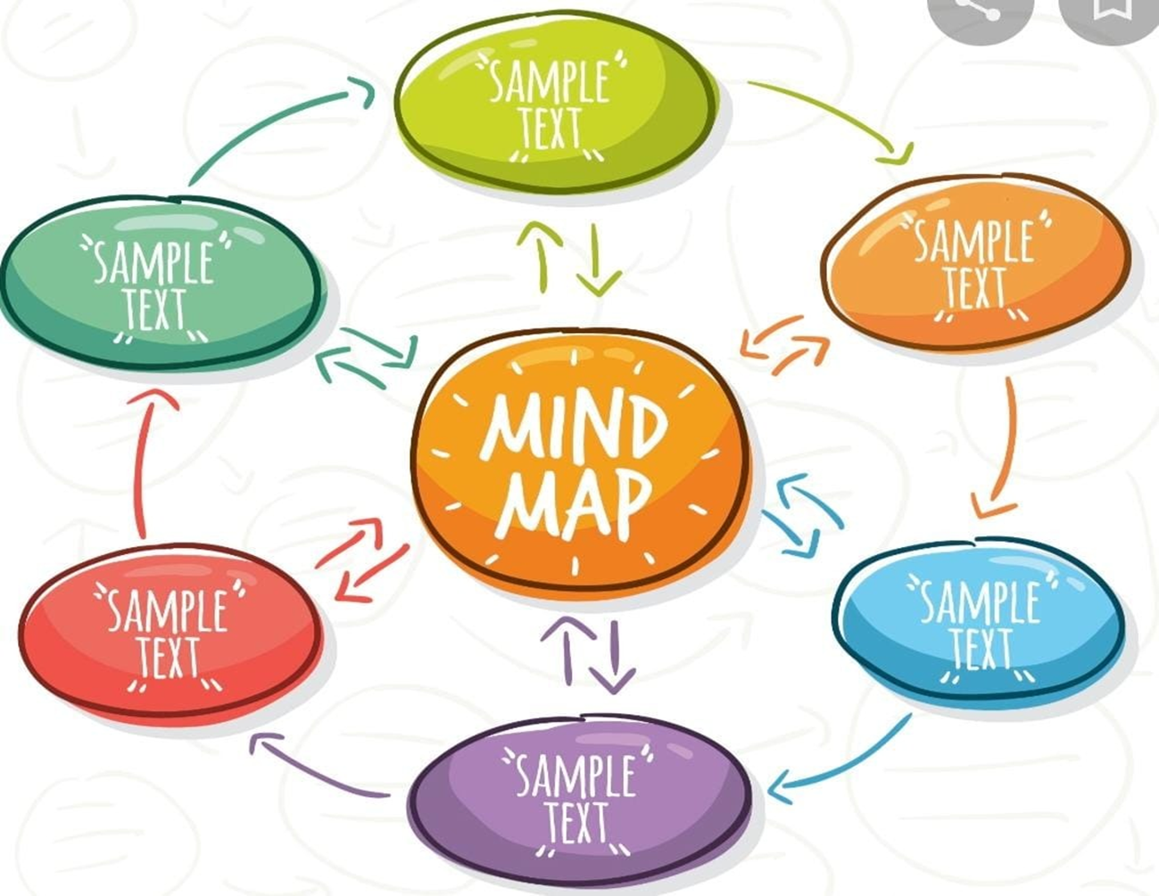  - Warm-up “Yes or No”  Teacher should ask simple question. And check that they understand. Teacher should explain that answering “Yes” means stand up and answer “No” means sit down.  Do you have brothers?  Do you like chocolate?  Do you like banana?  Have you ever been in Astana?  Have you ever seen a famous actor or actress?  Is 2+2=5?  Do you like English?  - Pre –listening  Pronunciation “Silent letters” Teacher should explain and give some example.  Silent letters are letters you can`t hear when you say a word, but exist when you write a word.  for example: guess, island, knife  - While listening  Exercise: 3  Key; a, l, l, e, r, h, t, r t, e, w, t, k  - Kahoot  Teacher should explain what is kahoot and how to play. With the help of Game “Kahoot” teacher is able to check students` knowledge from the lesson. |  |  | Sts. should guess the topic of the lesson with the help of pictures  Ss pronounce these words correctly.  Help of pictures Ss should guess the translate of the new words  Ss should watch the video carefully.  Ss should make mind map to their topic which is given. And should prepare 2 questions about their topic to the next group.  Ss should listen to teacher carefully  Ss should listen carefully and repeat after teacher.  Ss should find the silent letters in the words. Listen and check. Find words which contain silent letters in the text.  Students should play kahoot. | Formative assessment |  | Ppt  https://www.youtube.com/watch?v=8pKqvI8oQtE  poster  https://www.youtube.com/watch?v=bCb6qcnAX6c  phone
End | Home task.  Learn by heart new words.  Students express their attitude to the lesson and give self-assessment using the method: “Two stars and one wish” |  |  | Feedback  