Unit 6 Travel and holidays |  |  |  | School: 32
Date: 13.02.2025 |  |  |  | Teacher name: Zamaletdinova N.Y.
Grade: 6 V |  |  |  | Number present: |  |  | Number absent:
Theme of the lesson: |  |  | How was your weekend?
Learning objectives |  | 6.3.1.1 provide basic information about themselves and others at sentence level on an increasing range of general topics  6.4.5.1 deduce meaning from context in short texts on a limited range of familiar general and curricular topics  6.5.1.1 plan, write, edit and proofread work at text level with support on a limited range of general and curricular topics
Lesson  objectives |  | Learners will be able to:  • Listen to a conversation about a trip.  • Learn key phrases for talking about the weekend.  • Practise talking about a recent past event and camping trips.
Value links |  | Cooperation, respect each other's opinion
Plan
Planned timings | Planned activities |  |  |  | Learners’ activities | Evaluation |  | Resources
Begining  5 min | The lesson greeting.  The teacher sets the lesson objectives, letting students know what to anticipate from the lesson.  Check-up homework orally  Warm up.  the teacher asks students to watch the video then to pronounce new phrases  How was your weekend?  It was OK It was good It was great  What did you do? I listened to music. I went camping. |  |  |  | The aim: To develop pupils speaking skills and create friendly atmosphere  Efficiency: By telling the wishes they show their appreciations.  Students watch the video and practice to use the new phrases | Emoticons |  | Whiteboard, presentation, video  Whiteboard, presentation, video
Middle  30 min  5 min  5 min  10 min  5 min  5 min | Lead in  the teacher asks students to watch the video about family camping trip and answer the questions  Where are they going?  What did they take?  Pre teaching vocabulary  to revise the free time activities the teacher gives students task to match the pictures with phrases  to revise the Past Simple tense the teacher asks students to write the past form of verbs in task 1  Listening for gist  the teacher hands out the worksheet with the text Camping Last Weekend and tells students to listen and read the text after answer the question Where did they go?  Listening for specific information  the teacher tells the students to listen again and do the tasks True/False, Multiple Choice  After students have listened to the CD to check their answers, find out how many students answered correctly  Dialogues  the teacher hands out the worksheet with dialogue allow students to complete the dialogue in pairs.  after students have listened to the CD to check their answers, find out how many students answered correctly.  Speaking practice  the teacher hands out the worksheet with the model of the dialogue and asks students to complete the dialogue in pairs with their own words and phrases learned during the lesson. T asks Sts to act out their dialogues to the rest of the class |  |  |  | Students watch the video and answer the questions  Students match the pictures and phrases  Students listen and do the task  Students complete the dialogue. Then listen and check  Students complete the dialogue.  Students prepare dialogues on the given task and present it to a class | Verbal evaluation  whole class feedback  Students work individually then check in pairs  whole class feedback  Pair avaluation  whole class feedback  whole class feedback  provide whole class feedback |  | Whiteboard, presentation, video  cards  the list of irregular verbs  Worksheet with True/False, Multiple Choice  Worksheet with dialogues  Worksheet with dialogues  Worksheet with dialogues
End  5 min | Giving the home task. Learn new words, WB p.52 ex 1, 2, 3  Marks for the lesson  Reflection.  Teacher gives the assessment of the learners’ work, then ask the learners to show the pictures of their feeling about the lesson  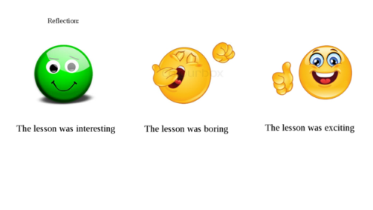 |  |  |  | Summarizing.  Sts show the pictures of their feeling about the lesson |  |  | cards

