Term 2  Unit 3"Our planet" |  |  | School: # 18
Date: 27.11. 2020 |  |  | Teacher’s name: Voronin A.
Grade 9 Э |  |  | Number present: | Number absent:
Theme of the lesson: |  |  | Solving an ecology problem.
Learning objectives(s) that this lesson is contributing to |  | 9.C9 use imagination to express thoughts, ideas, experiences and feelings  9.R2 understand specific information and detail in texts on a range of familiar general and curricular topics, including some extended texts  9.R4 read a range of extended fiction and non-fiction texts on familiar and unfamiliar general and curricular topics
Lesson objectives |  | All learners will be able to:
 |  | - Develop their reading skills in the context of recycling.
 |  | Most learners will be able to:
 |  | - Express their ideas about recycling situation in a city.
 |  | Some learners will be able to:
 |  | - Present a solution to a rubbish problem.
Assessment criteria |  | Convey fantasy ideas and experiences including emotions and senses.  Find particular facts and parts in reading passage.  Skim the extended fiction or non-fiction texts to identify the general information.
Value links |  | Respecting and protecting the environment.
Cross curricular links |  | Ecology, Social studies.
Previous learning |  | My country: Our planet.
Plan
Planned timings | Planned activities |  |  |  | Resources
Beginning the lesson | The lesson greeting.  The teacher shows a video, sets the lesson objectives, letting students know what to anticipate from the lesson.  Warm up.  Ask: What comprises the environment. Brainstorming.  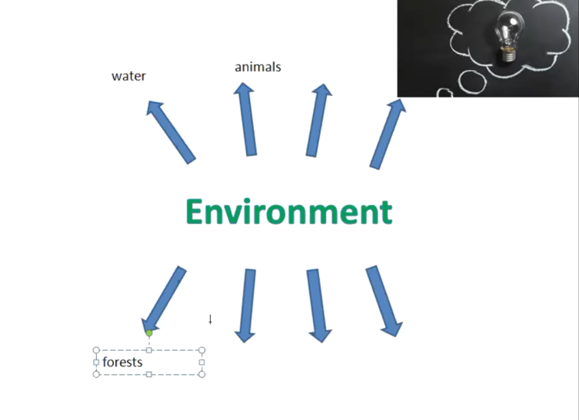
Main Activities | Vocabulary presentation: pollution, endangered species, carbon dioxide, greenhouse effect, fossil fuel, greenhouse effect, deforestation, garbage.  Studying of main ecological problems:  - Global warming  - Pollution  - Biodiversity loss  Exercise 1.  Match the definition of an ecological problem with its name:  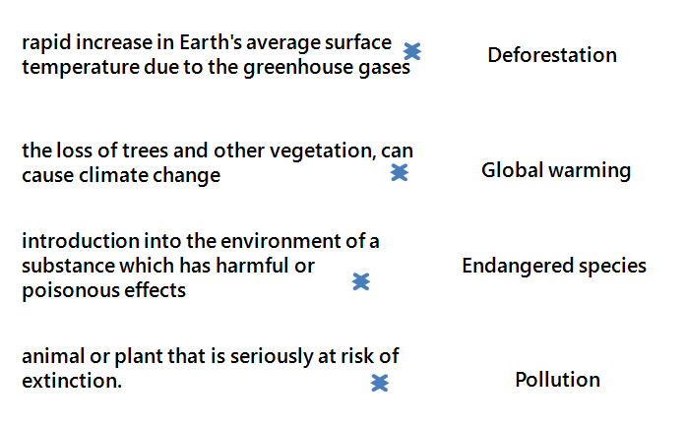  Learning the “Reduce\reuse\recycle” policy.  Exercise 2.  Sorting exercise. Decide whether the following items can be reduced, reused, or recycled. Place them in the correct box.  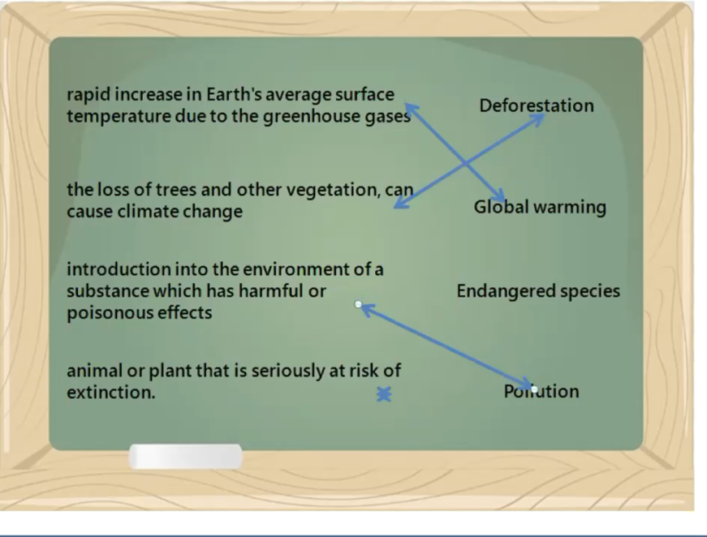  Exercise 3.  Define ecology problem, its cause and effect on environment, suggest solutions  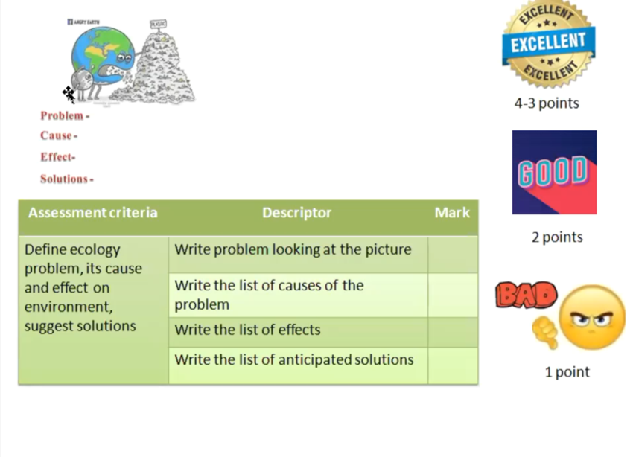
Ending the lesson | Conclusion  Reflection  At the end of a lesson learners share:  - Today I have learnt…  Now I know how to…  It was interesting to me…  What I liked most during the lesson…
End  1min | Feedback: Teacher asks students what task was difficult to them and which pair worked well.

