LESSON 22  Unit 3 My school |  |  | School №3 named after D.Kunaev
Date: 16.11.2021 |  |  | Teacher name: Terekhovich I.Y.
Grade: 2 |  |  | Number present: |  |  | Number absent:
Theme of the lesson: |  | Around school
Learning objectives |  | 2.L4 recognise with support short basic questions relating to features such as colour and number  2.L5 identify missing phonemes in incomplete words  2.UE14 use basic prepositions of location and position e.g. in, at, next to, near, on, to describe where people and things are use basic prepositions of time: on, in to talk about days and time use with to indicate accompaniment  2.S3 ask questions in basic exchanges about people, objects and classroom routines  2.W3 write familiar words to identify people, places and objects
Lesson objectives |  | Learners will be able to:  recognize, match and write words and pictures  recognise basic prepositions of location and position
Plan
Planned timings | Planned activities |  |  | Learners’ activities | Evaluation |  | Resources
Begining  5 min | ORGANIZATIONAL MOMENT  Teacher: Hello, boys and girls!  How are you?  WARMING UP  -How many (boards, windows, doors, desks, chairs) are there in the classroom? |  |  | Learners answer the question How are you?, looking at the picture.  Learners answer the question: How many (boards, windows, doors, desks, chairs) are in the classroom? | Verbal evaluation
Middle  30 min | Step 1 Around the School: Match. Listen and check.  Pupils’ books closed. Put up the Around School poster on the board.  Present the items, one at a time, and say the corresponding words/sentences.  Point to each item in random order. Ask individual pupils to name them. Ask the rest of the class for verification.  Step 2 Colour objects  Colour objects according to Teacher’s instructions  1. Colour the book red  2. Colour the pen blue  3. Colour the bag yellow  4. Colour the ruler orange  5. Colour the pencil purple  6. Colour the rubber green  7. Colour the pencil case black  MUTUAL CHECK  WARMING UP  Step 3. Read the words  Read the words, the teacher and then pupils.  Point to each word in random order. Ask individual pupils to read them. Ask the rest of the class for verification. |  |  | The pupils repeat chorally and/or individually.  Pupils colour  Pupils check up tasks of each other  Pupils listen to the song and review words, letters and sounds  Pupils read the words | Mutual avaluation  Verbal evaluation  Verbal evaluation |  | Song “What's This?”  Worksheets  Song “ABC school”
Lesson summary  5 min | There is a video on the screen with the lesson summary |  |  | Pupils look, listen and repeat words and phrases | Verbal evaluation |  | Video Smiles 2, Module 3, My school
End  5 min | FEEDBACK  There is a target on the board. T. suggests put stickers on it.  Well what did we do in our lesson?  Home task: Read the words  Saying goodbye  Results  Marks |  |  | Ss will put stickers on the target.  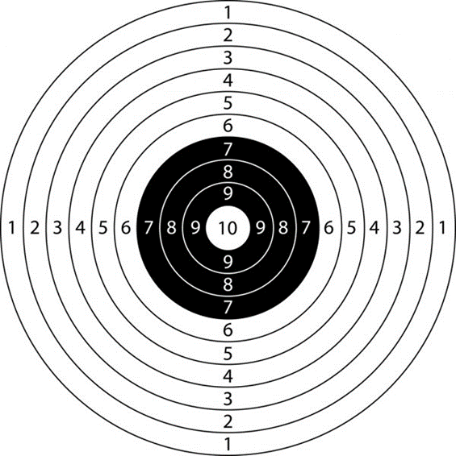 | Self-assessment

- Оргмомент
– Hello…
- How are you?

- Цели и задачи: повторим слова по темам: Цифры, Цвета, Школа
вспомним правила чтения английских гласных
английские глаголы действия
а также немного пораскрашиваем

- По слайду назвать слова, спросить фронтально, индивидуально
Песенка “What’s this?”

- Повторить цвета,
Раскраска
1. Colour the book red
2. Colour the pen blue
3. Colour the bag yellow
4. Colour the ruler orange
5. Colour the pencil purple
6. Colour the rubber green
7. Colour the pencil case black
Взаимопроверка (ответы на слайде)

- Физминутка

- Песенка «ABC»
Чтение

- Extra video

- Итоги урока, оценки

- Рефлексия

