Unit: |  | Values
Teacher name: |  | Gulnaz Turarova
Date: |  | November, 21
Grade: 5 |  | Number present: ___ |  | Absent: ___
Theme of the lesson |  | Comparative & superlative adjectives
Learning objectives(s) that this lesson is contributing to |  | 5.L1 understand an increasing range of  classroom instructions;  5.L9 recognise words that are spelt out from a limited range of general and curriculum topics;  5.S1 make basic statements which provide information on an increasing range of general and some curricular topics;  5.R1 recognise, identify and sound with support a  growing range of language at text level;  5.W7 spell most familiar high frequency  words accurately when writing independently;  5.UE3 use adjectives, including possessive  adjectives, on a growing range of general and some  curricular topics to describe things use simple one syllable and some two-syllable adjectives  [comparative and superlative] to make comparisons
Lesson objectives |  | Learner should be able to:  - recognize the cases of using comparative and superlative adjectives;  - understand short simple questions and answer them using the correct forms of adjectives;  - compare several persons and make up the sentences using comparative and superlative adjectives.
Plan
Stages / Time | Teachers actions |  | Students actions |  | Assessment | Resources
START  (2 min)  (4 min)  (2 min) | Greeting  The teacher greets the students. Then, Teacher shows the lesson and learning objectives. Ask ST some simple questions:  - How are you today?  - What day is it today?  - What is the date today?  - How is the weather today?  Warming-up  The teacher suggests doing the following task in order to revise some adjectives. The teacher explains the task:  - I'll mark exactly three minutes on the stopwatch. During this time, each group must put the letters in the correct order to get some adjectives. The team that writes the largest number of words correctly will win.  1. igb  2. cyurl  3. teingentlli  4. yttpre  5. nolg  6. yunnf  Setting the theme and the objectives of the lesson:  The teacher talks to the learners that:  - the theme of the lesson is “Comparative and superlative adjectives”;  - the main objective is to learn how to compare several objects. |  | Students greet the teacher and each other and answer the teacher’s simple questions.  The learners do the task in groups. They have to put the letters into the correct order and then pronounce these ones.  1. big  2. curly  3. intelligent  4. pretty  5. long  6. funny
MIDDLE  (5 min) | Correction work  The teacher reminds the learners that they did the task of formative assessment at the last lesson and suggests that we do this one all together:  1. It is the (cold) day of the year.  2. She is (tall) than her sister.  3. This book is the (interesting) of all.  4. Spanish is (easy) than German.  5. He is the (good) pupil in our class.  6. Dogs are (intelligent) than cats.  Practice in grammar // practice in vocabulary  I Reading  The teacher asks the learners to read and translate the following words.  Curly  Tall  Thin  Fat  Short  Straight  II Listening // Speaking  The teacher shows a picture and asks to the learners the following questions:  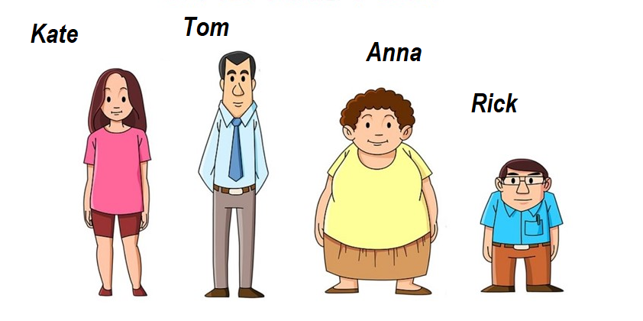  - Who is the tallest of them?  - Who is the shortest of them?  - Who has got the curliest hair?  - Who has the straightest hair?  - Who is fatter than others?  - Who is thinner than other?  IV Physical activity  The teacher suggests the learners do the physical activity.  III Writing  The teacher explains the task, during doing the task the teacher supports learners by hints and leading questions:  Translate the sentences:  1. Рик ниже, чем Анна.  2. Том самый высокий из них.  3. У Кейт самые длинные волосы.  Formative assessment  The teacher asks the learners to make up more 2 sentences to the picture. |  | The learners do the task together with the teacher and then they check their previous work.  The learners read and translate the words.  The learners answer the teacher’s questions.  The learners watch the video and repeat the movements.  The learners translate the given sentences.  The learners make up their own sentences to compare the given people. |  | The learners can recognize the cases of using comparative and superlative adjectives.  The learners can understand short simple questions and answer them using the correct forms of adjectives.  .  The learners can compare several persons and make up the sentences using comparative and superlative adjectives. | Worksheet 1  https://www.youtube.com/watch?v=JoF_d5sgGgc
END  (5 min) | Home task:  To revise the rule and the words.  Reflexion:  The teacher asks the learners to assess their knowledge of the theme by themselves.  - Я знаю правила образования сравнительной и превосходной степени односложных и двусложных прилагательных –  - Я могу составлять предложения, сравнивая несколько предметов/людей –  - Я могу распознать когда требуется прилагательное в сравнительной степени, а когда в превосходной - |  | The learners write down the home task in their vocabulary.  The learners assess their knowledge.  1-5

