Short-term plan unit: 3 (1-lesson) |  |  |  |  | School: Prestige
Date: 06.12.18 |  |  |  |  | Teacher name: Abdulakhatova Mukadas
Theme of the lesson: This is my nose |  |  |  |  | My body
CLASS: 1 |  |  |  |  | Number present: |  |  | absent:
Learning objectives(s) that this lesson is contributing to |  |  | 3.L1 recognize short basic instructions for a limited range of classroom routines spoken slowly and distinctly  3.L6 understand some specific information in short, slow, carefully articulated talk on routine and familiar topics  3.UE13 to use through the structure of abilities this is/ these are
Lesson objectives |  |  | All learners will be able to:
 |  |  | use some specific information in short, slow, carefully articulated talk on a song “ten fingers on my hands”; to guess parts of body ability using this is/ these are
Most learners will be able to:

Show

 |  |  | Recognise instructions and understand some specific information in short, slow, carefully articulated talk on a song “ten fingers on my hands”; to describe parts of body ability using this is/ these are
 |  |  | Some learners will be able to:
 |  |  | Make up the sentences with same own structure
Assessment criteria
Value links
Cross curricular links |  |  | - Knowledge of the world
ICT skills |  |  | - Smart board
Previous learning
Plan
Planned times | Planned activities (replace the notes below with your planned activities) |  |  |  |  |  | Resources
Start | ORGANIZATIONAL MOMENT  Greeting  Song “ Make a circle”  Make a circle, big big big.  Small small small.  Big big big.  Make a circle, small small small. Hello hello hello.  Make a circle, round and round.  Round and round.  Round and round.  Make a circle, round and round.  Hello hello hello.  Make a circle, up up up.  Down down down.  Up up up.  Make a circle, down down down. Now sit down. |  |  |  |  |  | Super Simple Songs  https://www.youtube.com/watch?v=ALcL3MuU4xQ
Phonetic drill  Middle  10 min | T S  Look at the board! - Какая эта буква? (Пишу на доске буквы T и H) - Волшебное звучание двух букв, который дает 1 звук. [ ð ] - Такое волшебное звучание только в английском языке, когда 2 буквы дает 1 звук. - Поставьте язычок между зубами и попробуйте произнести этот волшебный звук [ ð ] .Чувствуйте вибрацию? - Например (только учитель говорит) Смешно да? - А теперь давайте произнесем слова с этим волшебным звуком. Th th th th th Brother Mother - Знания пригодятся не только в произношениях слов, но и в нашей грамматической структуре this is/ these are Повторите this is/ these are Example: This is a pen/ these are pens - Что такое this is/ these are T and H Th Th Th Да Да Repeat Th th th th th Brother Mother this is/ these are This-это These-эти  Children make up sentences with grammar structure these are and this is and use parts of body This is a pen These are pen This is nose These are arms This is face These are legs This is a pen These are pen This is nose These are arms This is face These are legs  Warmer  Say the chant from class book page 20  1.INTRODUCING NEW MATERIAL  - A ) Pre teaching of new words :  Use flashcards 47-51 to introduce the new words. Hold up the flashcards one at time and say the words for children to repeat.  - T: Open your class books p 22 Ex 1  Let’s learn parts of our body  Class book p-22 Ex-1  Listen, point and repeat  - Ask children to look at the different parts of the body. Play the first part of the recording for children to listen and point to the pictures.  - Play the second part for children to repeat.  - play the recording all the way thought again for children to listen and point and then repeat the words  Class book p-20 Ex-2  Listen and sing!  Ask children to look at the pictures.  Focus on the song and ask question  T S  - What can you see? - What do they show/ point? Boys and girls Eyes, nose, fingers  - Play the song for children to point to the pictures when they hear the five new words. Then play it again as they follow the words.  - Recite the words of the song with the class, without the recording. Say each line and ask children repeat.  - Play the song again for children to sing.  Class book p-22 Ex-3  Listen and do!  - Ask to children to look at the pictures to see what the actions are for this song.  - Practice the actions with the class  - Play the song for children to sing and do the actions  Ten fingers on my hands,  On my hands.  Ten fingers on my hands,  On my hands.  Two eyes, one nose,  All on my face.  Ten fingers on my hands,  On my hands.  Ten fingers on my hands,  On my hands.  Ten fingers on my hands,  On my hands.  Two eyes, one nose,  All on my face.  Ten fingers on my hands,  On my hands.  Work book ex 1. P-22 |  |  |  |  |  | Flashcards  Audio CD31  CD 33  Transcript  Fingers, hands, eyes, eyebrows, shoulders  Hands, shoulders, eyebrows, finger, eyes  CD 34  Transcript  Ten fingers on my hands,  On my hands.  Ten fingers on my hands,  On my hands.  Two eyes, one nose,  All on my face.  Ten fingers on my hands,  On my hands.  Ten fingers on my hands,  On my hands.  Ten fingers on my hands,  On my hands.  Two eyes, one nose,  All on my face.  Ten fingers on my hands,  On my hands.
End  Home work | FEEDBACK  Self-assessment rubric ( Smiles)  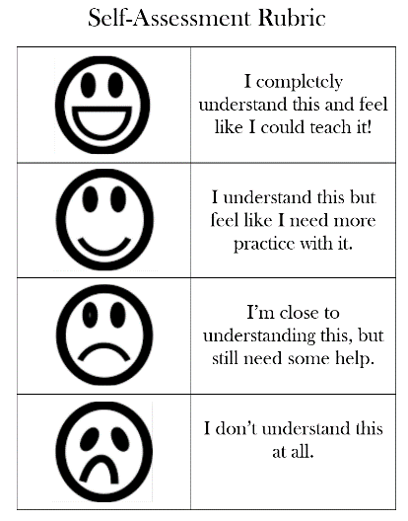
Additional information
Differentiation – how do you plan to give more support? How do you plan to challenge the more able learners? |  |  |  | Assessment – how are you planning to check learners’ learning? |  | Health and safety check  ICT links
• More support will be given to weaker learners by giving them a modified worksheets in some tasks with greater support |  |  |  | - through questioning and the redirecting of questioning in feedback activities  - through observation of playing  - through formative task |  | - White board is used no more than 10 minutes  - Use water based pens  - Health promoting techniques  - Breaks and physical activities used.  - Points from Safety rules used at this lesson.  - Use video 10 minutes
Reflection  Were the lesson objectives/learning objectives realistic?  What did the learners learn today?  What was the learning atmosphere like?  Did my planned differentiation work well?  Did I stick to timings? What changes did I make from my plan and why? |  | Use the space below to reflect on your lesson. Answer the most relevant questions from the box on the left about your lesson.
Summary evaluation
What two things went really well (consider both teaching and learning)?
1:
2:
What two things would have improved the lesson (consider both teaching and learning)?
1:
2:
What have I learned from this lesson about the class or individuals that will inform my next lesson?

