LESSON 30  Unit 4: Buildings |  |  | School: 8
Date: |  |  | Teacher name: Kuanysheva M.K.
Grade: 3 |  |  | Number present: |  | Number absent:
Theme of the lesson: |  | Around the house
Learning objectives |  | 3.1.4.1- understand a limited range of short supported questions on general and some curricular;  3.2.2.1- ask questions to find out about present experiences on a limited range of general and some curricular topics;  3.3.3.1- begin to read with rereading and usual support very short simple fiction and non-fiction texts on a limited range of general and curricular topics;  3.4.1.1- plan, write and check short sentences with considerable support on a limited range of personal, general and some curricular topics;  3.5.4.1- use determiners a, an, the, some, any, this, these, that, those to refer to things on a limited range general and some curricular topics
Lesson objectives |  | Write a story of 10-12 grammatically correct sentences, describing their dream house
Plan
Planned timings | Planned activities |  |  | Learners’ activities |  | Evaluation | Resources
Begining  5 min | Greeting & Objectives  Warm Up:  Greet students and let them take their places. Ask some lesson-opening questions.  i.e. What date is it today? What day is it today? What is the topic of the lesson? Etc.  Write the objective(s) on the board. Draw students’ attention to the lesson objective(s), make sure they all understand them (ask simple comprehension checking questions if necessary) |  |  | Learners  answer the questions |  | Verbal evaluation
Middle  35 min | My dream house poster  - tell students to go through their ‘RAFTs’ before drawing and writing, to refresh their minds on what they planned yesterday  - pass out story templates and explain to students they should only fill it in when they finish drawing/coloring/designing their houses 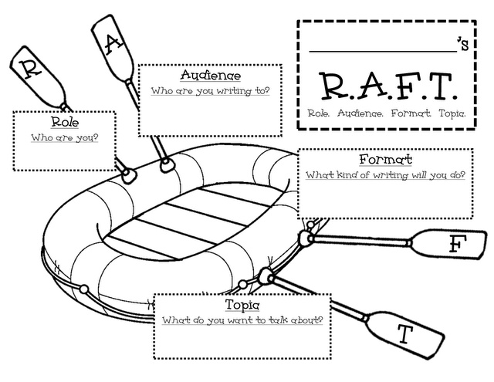  (NOTE: in case some students strongly wish to start with the story, let them do so, but inform that their poster should (at the end) 100% correspond to the story)  - inform students they’ll have 30 min to make their posters and write stories describing them  - remind (or write on the board) students that the their story volume is 10-12 sentences (2 per each room in the house)  - pass out A3 sheets with house outlines and any necessary stationery items some students may not have (markers, pencils, rubbers, etc.)  - set a timer and let students start their work  - circulate the room to make sure all learners are engaged and on task; assist if necessary |  |  | Learners  make posters and write stories describing them |  | Individual avaluation
End  5 min | Reflection: ask students to hand in their posters but leave their stories to themselves  Home task: to prepare their stories for presentation for the next lesson  Saying good-bye |  |  | Learners reflect   |  | Self-assessment | 