**UDC 372.881.111.1**

**Zh. Talgatkyzy1*, Tusupova A.K. 2**

**12***Kazakh National Women’s Teacher Training University,*

*Almaty, Kazakhstan*

**\***e-mail: [talgatkyzy_zhansaya@mail.ru](mailto:talgatkyzy_zhansaya@mail.ru)

**THE FORMATION OF SOCIOCULTURAL COMPETENCE OF PRIMARY SCHOOL STUDENTS IN ENGLISH LESSONS BASED ON FAIRY TALES**

**Abstract:**The article discusses how English teachers can use fairy tales to develop socio-cultural competence in primary school students. Socio-cultural competence refers to the ability to interact with people from diverse cultural backgrounds. Fairy tales provide insights into different cultures' values and beliefs. Through surveys, the study found that while many teachers rarely use fairy tales, some integrate them by holding discussions, debates and role-plays. Fairy tales expose students to different cultures and help appreciate diversity. They also teach values like perseverance and accepting differences. This develops empathy as students learn lessons from tales. Fairy tales improve language skills when used for reading, discussions and storytelling in English classes. They also develop critical thinking as students analyze tales' morals. However, teacher must carefully select age-appropriate and culturally sensitive fairy tales. Objectives must align with competence development, not just entertainment. While fairy tales make learning engaging, different student backgrounds require management. Professional development can help teachers address these challenges and maximize benefits like cooperative learning skills. Overall, fairy tales provide a valuable way to promote socio-cultural competence if integrated properly in English classes.

**Keywords:** socio-cultural competence, fairy tales, critical thinking, foreign language teaching, primary school, secondary school, language skills, intercultural communicative competence.

**ЕРТЕГІЛЕР НЕГІЗІНДЕ АҒЫЛШЫН ТІЛІ САБАҒЫНДА БАСТАУЫШ СЫНЫП ОҚУШЫЛАРЫНЫҢ ӘЛЕУМЕТТІК -МӘДЕНИ ҚҰЗІРЕТТІЛІГІН ҚАЛЫПТАСТЫРУ**

**Аннотация:** Мақалада бастауыш сынып оқушыларының әлеуметтік-мәдени құзыреттілігін дамыту үшін ағылшын тілі мұғалімдері ертегілерді қалай пайдалана алатыны қарастырылады. Әлеуметтік-мәдени құзыреттілік әртүрлі мәдени ортадағы адамдармен қарым-қатынас жасау қабілетін білдіреді. Ертегілер әртүрлі мәдениеттердің құндылықтары мен нанымдары туралы түсінік береді. Сауалнамалар арқылы зерттеу көрсеткендей, көптеген мұғалімдер ертегілерді сирек қолданады. кейбіреулері оларды пікірталас, пікірталас және рөлдік ойындар өткізу арқылы біріктіреді. Ертегілер оқушыларды әртүрлі мәдениеттермен таныстырады және әртүрлілікті бағалауға көмектеседі. Олар сондай-ақ табандылық және айырмашылықтарды қабылдау сияқты құндылықтарды үйретеді. Бұл оқушылар ертегілерден сабақ алған кезде эмпатияны дамытады. Ағылшын тілі сабақтарында оқу, талқылау және әңгімелеу үшін пайдаланылған ертегілер тіл дағдыларын жақсартады. Оқушылар ертегілердің өнегелілігін талдай отырып, олар сыни тұрғыдан ойлауын дамытады. Дегенмен, мұғалім жас ерекшеліктеріне сай және мәдениетті ертегілерді мұқият таңдауы керек. Мақсаттар тек ойын-сауықпен ғана емес, құзыретті дамытумен сәйкес келуі керек. Ертегілер оқуды қызықты ететінімен, әр түрлі студенттік орта басқаруды қажет етеді. Кәсіби даму мұғалімдерге осы қиындықтарды шешуге және бірлескен оқу дағдылары сияқты артықшылықтарды арттыруға көмектеседі. Тұтастай алғанда, ертегілер ағылшын тілі сабақтарында дұрыс кіріктірілген болса, әлеуметтік-мәдени құзыреттілікті дамытудың құнды әдісін ұсынады.

**Түйіндеме сөздер:** әлеуметтік-мәдени құзыреттілік, ертегілер, сыни тұрғыдан ойлау, шет тілін оқыту, бастауыш мектеп, орта мектеп, тіл байлығы, мәдениетаралық коммуникативті құзыреттілік.

**ФОРМИРОВАНИЕ СОЦИОКУЛЬТУРНОЙ КОМПЕТЕНЦИИ УЧАЩИХСЯ НАЧАЛЬНЫХ КЛАССОВ НА УРОКАХ АНГЛИЙСКОГО ЯЗЫКА НА ОСНОВЕ СКАЗОК**

**Аннотация:** В статье рассматривается, как учителя английского языка могут использовать сказки для развития социокультурной компетентности у учащихся начальных классов. Социокультурная компетентность означает способность взаимодействовать с людьми разного культурного происхождения. Сказки дают представление о ценностях и верованиях разных культур. Благодаря опросам исследование показало, что многие учителя редко используют сказки. некоторые интегрируют их, проводя дискуссии, дебаты и ролевые игры. Сказки знакомят учащихся с разными культурами и помогают ценить разнообразие. Они также учат таким ценностям, как настойчивость и принятие различий. Это развивает сочувствие, поскольку учащиеся извлекают уроки из сказок. Сказки улучшают языковые навыки, если их использовать для чтения, дискуссий и рассказывания историй на уроках английского языка. Они также развивают критическое мышление, анализируя мораль сказок. Однако учитель должен тщательно выбирать сказки, соответствующие возрасту и культурным особенностям. Цели должны соответствовать развитию компетентности, а не просто развлечению. Хотя сказки делают обучение увлекательным, ученики разного происхождения требуют управления. Профессиональное развитие может помочь учителям решить эти проблемы и максимизировать преимущества, такие как навыки совместного обучения. В целом, сказки представляют собой ценный способ развития социокультурной компетентности, если их правильно интегрировать в уроки английского языка.

**Ключевые слова:** социокультурная компетентность, сказки, критическое мышление, обучение иностранному языку, начальная школа, средняя школа, языковые навыки, межкультурная коммуникативная компетентность.

In today’s world, the ability to communicate effectively in English is becoming increasingly important. For primary school students, learning English can be challenging, but it is also an excellent opportunity to gain valuable socio-cultural competence. English lessons based on fairy tales can be an effective way to develop such competence. In this article, we will explore the formation of socio-cultural competence of primary school students in English lessons based on fairy tales. Sociocultural competence refers to the ability of individuals to understand and navigate different cultural norms, values, and behaviors in social situations. In today's globalized world, sociocultural competence is a vital skill for individuals to possess, especially for children who are just starting to learn about different cultures. English language learning is one way to develop sociocultural competence, and fairy tales can be a useful tool to achieve this goal. How can teachers effectively use fairy tales to promote the formation of sociocultural competence among primary school students in English lessons?

Socio-cultural competence refers to the ability to interact with people from different cultural backgrounds. It involves understanding and appreciating different cultures, including their values, beliefs, customs, and traditions. It also involves the ability to communicate effectively with people from different cultural backgrounds. Developing socio-cultural competence is critical for primary school students, as it prepares them for the diverse world they will encounter as they grow older. Using Fairy Tales to Develop Socio-Cultural Competence Fairy tales are stories that are rich in cultural heritage and traditions. They provide valuable insights into the beliefs, customs, and values of different cultures. Fairy tales are also an excellent way to introduce primary school students to English language and culture. By using fairy tales in English lessons, teachers can help students develop socio-cultural competence in the following ways. Fairy tales come from different cultures and provide students with an opportunity to learn about different cultures. For example, the story of Cinderella, which originated in Europe, can help students learn about European culture. The story of Aladdin, which originated in the Middle East, can help students learn about Middle Eastern culture. By exposing students to different cultures through fairy tales, teachers can help students develop an appreciation for diversity. Fairy tales are also an excellent way to teach students about different values and beliefs. For example, the story of the Tortoise and the Hare teaches students about the importance of perseverance. The story of the Ugly Duckling teaches students about the importance of accepting differences. By using fairy tales in English lessons, teachers can help students understand different values and beliefs. Fairy tales are stories that are rich in emotions, and they can help students to develop empathy. For example, the story of the Little Match Girl teaches students about the importance of compassion. By using fairy tales in English lessons, teachers can help students develop empathy towards others. Fairy tales are also an excellent way to enhance language skills. By reading and discussing fairy tales in English, students can improve their vocabulary, grammar, and reading comprehension skills. They can also improve their speaking and listening skills by discussing the stories with their peers. Fairy tales are stories that often have a moral or a lesson. By using fairy tales in English lessons, teachers can help students develop critical thinking skills. For example, teachers can ask students to analyze the moral of a story or compare and contrast different versions of the same story

**Materials and methods.** This study offershow can teachers effectively use fairy tales to promote the formation of sociocultural competence among primary school students in English lessons. The goal is to determine the theoretical and applied aspects of the formation of socio-cultural competence of primary school students in English lessons based on fairy tales. The following theoretical research methods were used in the work: critical analysis of literary sources on the problem under study; synthesis of the best practices of teachers. The study used observational surveys among teachers. In the questionnaire I raised the following questions:

* How often do you use fairy tales from different cultures in your English lessons for primary school students?
* What criteria do you use to select appropriate fairy tales for your primary school students in English lessons?
* How do you integrate the study of fairy tales into your English lessons to promote the formation of sociocultural competence?
* What teaching methods and materials do you use to facilitate the learning of fairy tales in English lessons?
* How do you assess the development of sociocultural competence among primary school students through the study of fairy tales in English lessons?
* What challenges have you faced in using fairy tales to promote sociocultural competence in your English lessons, and how have you addressed these challenges?
* What professional development opportunities have you participated in to enhance your knowledge and skills in using fairy tales to promote sociocultural competence in English lessons?
* In your opinion, what are the most important benefits of using fairy tales to promote sociocultural competence in English lessons, and how can these benefits be maximized?

As a final note, many teachers rarely use fairy tales in English lessons.

**Results and Discussion**

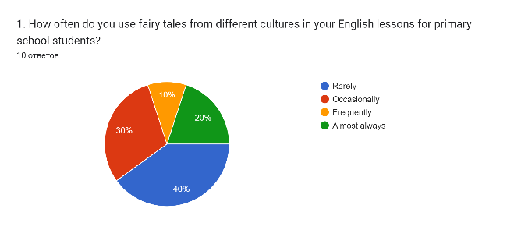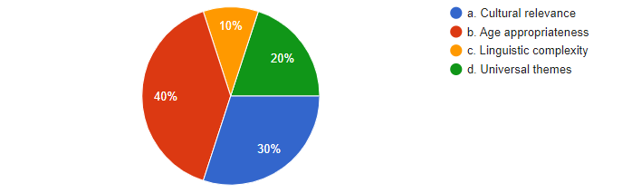

The pie charts above display how often teachers use fairy tales and what criteria do they use to select appropriate fairy tales for primary school students in their English lessons.

Overall, fairy tales are rarely used among teachers and most of them choose a fairy tales according to the age appropriateness.

Turning to the first chart, we can observe that 40% of teachers make use of fairy tales rarely, but 10% and 20% of teachers use frequently and almost always respectively. Taking a closer look at the second chart, we can see that about 30% of teachers select appropriate fairy tales for primary school students in their lessons according to cultural relevance. 20% of teachers select according to the linguistic complexity and others choose universal themes.

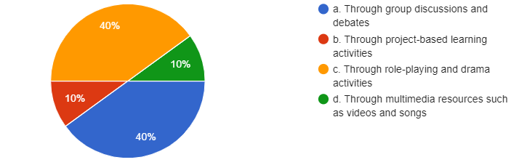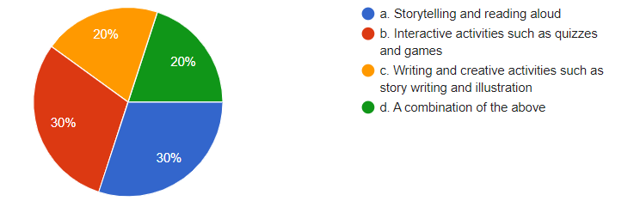

The pie charts above represent how do teachers integrate the study of fairy tales into their English lessons to promote the formation of sociocultural competence and what teaching methods and materials do they use to facilitate the learning of fairy tales in English lessons.

Overall, teachers used to teach fairy tales through group discussion, debates, role playing and drama activities. They use storytelling and reading aloud to facilitate the learning of fairy tales in English lessons.

The use of fairy tales in English lessons is a valuable teaching approach that can promote the formation of sociocultural competence among primary school students. By incorporating fairy tales from different cultures, teachers can expose students to diverse cultural perspectives, help them appreciate cultural diversity, and develop cross-cultural communication skills.

Additionally, studying fairy tales can improve students' language skills, social skills, critical thinking skills, and motivation and engagement in the learning process. One of the key advantages of using fairy tales in English lessons is that they can make the learning experience more engaging and interactive. Fairy tales often have vivid characters, memorable storylines, and universal themes that can capture students' imaginations and interest. Furthermore, the use of multimedia resources such as videos, songs, and games can enhance the learning experience and make it more fun and enjoyable for students.

Another advantage of using fairy tales in English lessons is that they can be used to promote project-based learning and cooperative learning strategies. By participating in activities such as role-playing, group work, and project-based learning, students can develop their social and interpersonal skills, such as cooperation, empathy, and communication.

However, there are also some potential challenges to using fairy tales in English lessons. One challenge is selecting fairy tales that are appropriate for the age and cultural background of the students. Teachers need to carefully choose fairy tales that are age-appropriate and culturally sensitive to avoid stereotyping or offending students from different cultural backgrounds.

Another challenge is ensuring that the learning objectives are aligned with the use of fairy tales. Teachers need to ensure that the fairy tales are used as a tool to promote the formation of sociocultural competence and to develop language skills, rather than as a mere form of entertainment or distraction.

**Conclusion.** In conclusion, the use of fairy tales in English lessons for primary school students provides a valuable opportunity to promote the formation of sociocultural competence. By selecting appropriate fairy tales and integrating them into English lessons using a range of engaging and interactive methods, teachers can help students to develop cross-cultural communication skills, empathy, and understanding. However, there are also a number of challenges associated with using fairy tales in this way, including selecting appropriate stories, managing diverse student needs and backgrounds, engaging students in the learning process, and addressing potential cultural misunderstandings. To overcome these challenges, teachers can draw on a range of strategies and resources, such as professional development opportunities, cultural sensitivity guidelines, and interactive and collaborative learning activities. Ultimately, by effectively using fairy tales in English lessons, teachers can help to cultivate a more inclusive and culturally aware learning environment that promotes the development of important life skills for their students.

**References**

1. An, S. The Use of Fairy Tales in the EFL Classroom. English Language Teaching, 10(3). - 2017. - 44-51. https://doi.org/10.5539/elt.v10n3p44
2. Belen, F. Introducing English Language Learners to Cultural Awareness through Folktales. Multicultural Education Review. - 2017. - 9(1). - 31-46. <https://doi.org/10.1080/2005615X.2017.1275739>
3. Chen, X. Using fairy tales to promote intercultural competence in EFL classes. Education Research International. - 2018. - 1-7. <https://doi.org/10.1155/2018/2475135>
4. Dai, Y. Fairy Tales in Teaching English to Young Learners. English Language Teaching. - 2015. - 8(1). - 37-42. <https://doi.org/10.5539/elt.v8n1p37>
5. Kedzierski, M. A., & Jaeger, A. J. Sociocultural competence: A key factor in foreign language education. Foreign Language Annals. - 2015. - 48(1). - 9-27. <https://doi.org/10.1111/flan.12107>
6. Lee, H. J. Using fairy tales to promote cultural awareness and critical thinking among young learners. The Journal of Asia. - 2018. – TEFL. - 15(4). - 1217-1228. <https://doi.org/10.18823/asiatefl.2018.15.4.11.1217>
7. Nikolovska, L. The role of fairy tales in teaching culture and values to young learners. Journal of Foreign Language Teaching and Applied Linguistics. - 2019. - 6(2). - 1-13. <https://doi.org/10.14744/FLTAL.2019.55750>
8. Zivkovic, S., & Dragicevic, V. Fairy tales in teaching English to young learners: An action research study. Teaching English with Technology. - 2016. -16(4). - 48-63. http://www.tewtjournal.org/VOL%2016/ISSUE%204/5%20Fairy%20Tales%20in%20Teaching%20English%20to%20Young%20Learners%20An%20Action%20Research%20Study.pdf

Talgatkyzy Zhansaya - master student of the program «"7М01705" - Foreign language: two foreign languages», Kazakh National Women’s Teacher Training University, Almaty, Kazakhstan, Gogolya Str. 114 k1, 87475550080

e-mail: [talgatkyzy_zhansaya@mail.ru](mailto:talgatkyzy_zhansaya@mail.ru)

Tusupova Alma Kokbayevna – PhD, Associate Professor of the Department of Professional Training of Foreign Languages Kazakh National Women’s Teacher Training University, Almaty, Kazakhstan, Gogolya Str. 114 k1, 87022136332