КГУ Школа-гимназия №22 им.М.Ауэзова
г. Кентау Туркестанская область
Краткосрочный план урока английского языка на тему “A Famous story” 5класс

Unit of a long term plan: Unit 9 Reading for pleasure.
Teacher name: |  | Atakhanova D
Date: |  | 14.02.2024
Grade: 5 |  | Number present: | absent:
Lesson title | A Famous story
Learning objectives | 5.4.3.1 understand the detail of an argument on a limited range of familiar general and curricular topics;  5.3.3.1 Give an opinion at sentence level on a limited range of general and curricular topics.  5.6.1.1 Use Past Simple to tell a story.
Lesson objectives | Learners will be able to:  • Learn and practise verbs to talk about the past.  • Understand stories written in the past tense.
Value links | Kindness – If you value kindness, you’ll likely always be respectful of people around you, be gentle with criticism, and always willing to welcome people with open arms.
Plan

Stages / Time | Teachers’ actions | Students’ actions | Assessment criteria | Resources
Beginning of the lesson  5 min | Organization moment  1.Greeting.  Ask about the weather.  Warm-up  • Books closed. Ask the class what they know about the Kozy-Korpesh and Bayan-Sulu story. Ask students why the story is so famous.  Lead – In    The ancient legend tells that two childhood friends, Syrybay and Karabay, decided to marry their children, who had been engaged even before they were born. Unfortunately, Syrybai died while hunting before his son was born. Growing up, Kozy and Bayan met and fell in love with each other, which made their families very happy. Having grown up, Kozy and Bayan-Sulu do end up falling in love with each other | The aim: To develop Ss speaking skills and create friendly atmosphere  Efficiency: By telling the wishes they show their appreciations .  Students say about different questions | At the organization moment T tries to award active Ss. «The praise» method is used to evaluate Ss with phrases like:  “Good job!  Well done!”  Formative Assessment    Good job! | Pictures  Student’s book
Middle of the lesson  Presentation part.  35 min | Ex: 1 P: 106  • Do the exercise with the whole class. Make sure students understand warrior (a person who fights in battle).  Differentiation:  «Verbal support» method is used to help Students use new words in the text.  Ex: 2 P:106  • Explain the task. Make sure students understand these words before they start reading: steppe, rescue, revenge, stab.  • Give students plenty of time to read the story and find the answers.  • Go through the answers. In a stronger class, ask students to read the part of the story that answers the question, e.g. for question 1 ‘Karabay had a daughter called Bayan.’ If any sentences are false, ask students to make a true sentence.  • In a weaker class, read the story to the class and stop at the sentence which helps answer the question.  Ex: 3 P:106  • Tell students to look quickly at the story again and find the five words.  • In a weaker class, stand up in front of the class and point to your hair, waist, neck. Ask the class to say each time what you are pointing at. Mime combing, tidying, wearing (round the neck and waist), and cutting (hair with a knife).  • Go through the answers. | Students identify who are characters in the story. Match the names with the roles.  ANSWERS:  1 daughter  2 lover  3 father  4 warrior  Students read the text and write true or false.  ANSWERS:  1 true  2 false  3 false  4 true  5 true  6 false  7 false  8 true  Students find these words in the text. Match the words with definitions.  ANSWERS:  1 c  2 e  3 a  4 d  5 b | Assessment criteria  - Learn and practise verbs to talk about the past.  Descriptor:  - identify who are characters in the story. Match the names with the roles.  Assessment criteria:  - Understand stories written in the past tense..  Descriptor:  - find these words in the text. Match the words with definitions.  Make CCQ questions  Yes / No |   Cards  Worksheets
End of the lesson  5 min | Home task:  Ex: 2 P: 60 WB | 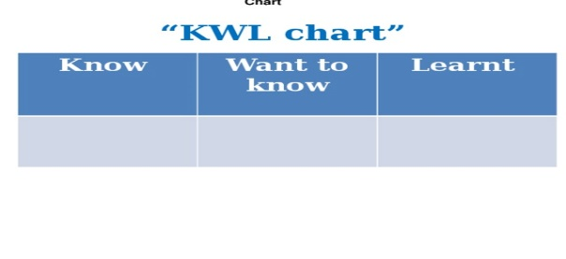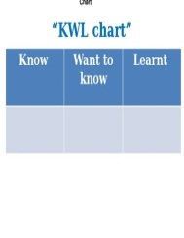 | Students use their stickers to show their knowledge according to the lesson. | Poster  KWL chart  

