The power of body language

**Preparation for the lesson ( discussing questions )**

In your country, how do you use your body to say :

Yes Stop Go away

Hi Bye I don’t know

**1.READING& VOCABULARY**

1. **Read the following passage.**

**A .Body language** makes up the largest part of our non-verbal communication - eye contact, gestures, and facial expressions can convey powerful messages. As William Shakespeare said in Troilus and Cressida - ‘There’s language in her eye, her cheek, her lip’.

However, there are substantial Whether in a culturally diverse company or visiting emerging markets, understanding what people mean through their body language can be a challenge.

cultural differences in how people use body language to communicate. Sometimes it is very obvious, many times very subtle.

**B. Facial expressions**

Many facial expressions appear to be universal and recognised all over the globe.

Research carried out by the [Paul Ekman Group](http://www.paulekman.com/universal-facial-expressions/), an American Psychologist, showed that over 90% of common facial expressions were identified by people in very different cultures. Over 10,000 facial expressions were created for the study and shown to different western cultures and isolated, pre-literate African groups.

|  |
| --- |
| Use the dictionary to find out the meaning of the next words or phrases:  Eye contact  Facial expressions  taboo |

In general, there are seven different facial expressions which correspond to distinct universal facial emotions: happiness, sadness, surprise, fear, disgust and anger.

**C. Touch**

Northern Europe and the Far East as classed as non-contact cultures. There is very little physical contact beyond a handshake with people we don’t know well. Even accidentally brushing someone’s arm on the street warrants an apology.

An innocent hug made headlines around the world in 2009 when America's first lady, Michelle Obama, broke royal protocol on a visit to Britain by hugging the Queen.

By comparison, in the high-contact cultures of the Middle East, Latin America, and southern Europe, physical touch is a big part of socialising.

In much of the Arab world, men hold hands and kiss each other in greeting, but would never do the same with a woman.

In Thailand and Laos, it is taboo to touch anyone’s head, even children. In South Korea, elders can touch younger people with force when trying to get through a crowd, but younger people can’t do the same.

**b. Match the words with their description**

**1)Happiness**  a)Brows arched and pulled together, eyes wide open, mouth slightly open.

**2)Sadness**  b)lowering of mouth corners and raising inner portion of brows.

**3)Surprise**  c) Brows lowered, eyes bulging, lips pressed firmly.

**4)Fear**  d) Arching of eyebrows, eyelids pulled up and sclera exposed, mouth open.

**5)Disgust**  e)Raising and lowering of mouth corners, cheeks raised, and muscles around the eyes are tightened.

**6)Anger**  f)lowered, upper lip Eyebrows raised, nose wrinkled, cheeks raised

**c. Put the body action verbs below into the correct categories. Choose four of the verbs above and write a sentence for each one. Compare with the rest of the class.**

**a.** **burp chew cough hiccup rumble shake shiver snore swallow sweat tremble yawn**

**The mouth and breathing:______________________**

**Eating and digestion:__________________________**

**The whole body:_____________________________**

**2.SPEAKING**

**a. Read the text which is given to you ( A,B or C). Try to find out cultural misunderstanding in the text, than mingle and exchange the information with students that have another text.**

**Don’t touch the head!**  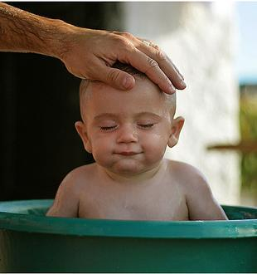

**Student A**. Thai people are very friendly, after all it is known as the “Land of Smiles”, but like any other country there are local customs visitors should follow to avoid offending someone unknowingly.

The the head of a person or statue in Thailand are regarded as the most important part of the body. It is considered rude to touch a stranger’s head, as it would be in most countries around the world. It is also disrespectful to touch the head of a statue, especially a statue of the Buddha.

Of course, close friends and family members often touch each other’s heads or hair. This is not considered rude.

Know where your feet are

**Student B**. Visitors should try to avoid pointing their feet directly at another person or Buddha statue. It is also inappropriate to step over a person or a Buddha statue. In general, your feet should always be lower than another person’s head to avoid offending someone.

Respect the local religion

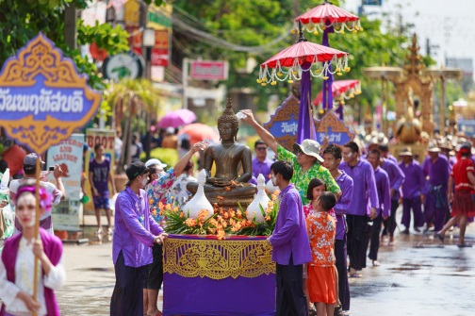

**Student C.** Buddhism plays an enormous role in the country’s culture. Most Thai people will become a monk or nun during their lifetime for a short period of time. Therefore tourists need to show extreme respect towards the religion.

Buddha statues or images should never be photographed, or interacted with in a disrespectful way. Buddhist monks may never touch (or be touched by) a unrelated women. When visiting a temple, tourists need to remove their shoes and dress conservatively. Women should avoid wearing sleeveless shirts or dresses

1. **Core Activity Classroom Exercise: Body Language over lunch role play**

In groups of 4, two people act out the role play in the manner given on the ‘emotions’ card. The other two should

observe what emotions they are conveying. Then swap over.

A: What's that you've got, can I have some?

B: You want some of my lunch? Why don't you get your own?

A: I haven't got any lunch money.

B: What's happened to it?

A: It’s got nicked.

B: That’s unlucky.

A: Yeah and they took my bag too so now I've got nothing to eat and I've got PE later and I haven't got any kit.

B: You'll have to borrow some of the lost property stuff. Mmm, I'm sure that'll look attractive.

A: Or maybe someone could lend me some?

**Discuss in pairs**

1.What emotions do you think person A was demonstrating?

What was it about their body language and tone of voice that made you think this?

2. What emotions do you think person B was demonstrating?

What was it about their body language and tone of voice that made you think this?__

Teacher shows OHT picture of an English country house sitting room and sets the scene:

1. Role play Sitting room at Mrs. Arbuthnot’s. Large open French window at back, looking onto garden. Gerald Arbuthnot is writing at the table. Lady Hunstanton and Mrs. Allonby enter the room. Threy are worried about Mrs. Arbuthnot.

Students work in groups of three and are given a short extract from a play, complete with stage directions including nonverbal cues. Students work on the three-part dialogue and act it out using body language to add dramatic effect.

Extract:

LADY HUNSTANTON (Smiling). Good morning, Gerald.

GERALD (Rising). Good morning, Lady Hunstanton. Good morning,

Mrs. Allonby.

LADY HUNSTANTON (Sitting down) (Politely). We came to inquire for your dear mother, Gerald. I hope she is better?

GERALD (Apologetically). My mother has not come down yet, Lady Hunstanton.

LADY HUNSTANTON. Ah, I am afraid the heat was too much for her last night. I think there must have been thunder in the air. Or perhaps it was the music. Music makes one feel so romantic - at least it always gets on one's nerves.

MRS. ALLONBY (Sarcastically). It's the same thing, nowadays.

LADY HUNSTANTON. I am so glad I don't know what you mean, dear. I am afraid you mean something wrong. Ah, I see you're examining

Mrs. Arbuthnot's pretty room. Isn't it nice and old-fashioned?

MRS. ALLONBY (Looking through her glasses). It looks quite the happy English home.

LADY HUNSTANTON. That's just the word, dear; that just describes it. (Turning to Gerald). One feels your mother's good influence in everything she has about her, Gerald

**3.GRAMMAR BANK**

**1 Past Simple for completed actions in the past**

Use the Past Simple (VERB+ed or irregular verbs) to express the idea that an action started and finished at a specific time in the past. It is not necessary to mention the specific time but it is implied in the verb form.

*I saw a great film yesterday.  
I travelled to Milan last month.  
Didn't you travel to Thailand a month ago?***2 Several completed actions**

We use the Past Simple to speak about a series of actions in the past that happened chronologically.

*I finished work at five, went to my favourite café and spent an hour just watching the world go by.*

**3. Past – Duration**

The Past Simple can be used to speak about a duration which starts and stops in the past.

*I lived in Spain for two years.  
I studied Italian when I was at school.*

**4. Habits in the past**

The Simple Past can also be used to describe a habit which stopped in the past. It can have the same meaning as "used to". To make it clear that we are talking about a habit, we often add expressions such as: always, often, usually, never, when I was a child, when I was younger, etc.

*I did Judo when I was a child.  
He didn’t play the guitar, he played the piano.*

Complete the following using the correct form:

1. . What did you do when the car _ fire?
2. was catching
3. caught
4. catch
5. I _ the wallet lying in the street.
6. find
7. found
8. did found
9. Did you _ your holiday in America?
10. enjoy
11. enjoyed
12. was enjoying
13. I _ about taking up yoga but I don’t think it’s my thing.
14. thought
15. was thinking
16. think
17. Whenever I went to Danny’s all I ever saw him do was _ television.
18. watching
19. watch
20. was watching
21. Thakfully Sarah didn’t hear me speaking to Peter because she _ to music with her headphones.
22. was listening
23. listened
24. were listening
25. Peter _ in Tokyo when there was the earthquake. You should get him to tell you what happened.
26. worked
27. was working
28. work
29. What _ about the new gaming console?

a) are you thinking

b) do you think

c) was you thinking

b. Study the sentences below. Match the underlined phrases with the messages below.

1. She patted me on the back when I told her that I had passed my driving test.

2. She nudged me on the arm during the boring lecture

3. "Hey you!" he said, and beckoned me over with his finger.

4. For a second I thought she was being serious, but then she winked at me.

5. I asked if she wanted to go to the cinema, and she nodded her head in agreement.

**PRONUNCIATION**

advised deserved inspired

denied kissed played

hated acted stopped

**Look at the words above and put each word in the appropriate column.**

|  |  |  |
| --- | --- | --- |
| **/d/ /** | **/t/ /** | **Id** |
|  |  |  |
|  |  |  |

6. When his team lost the match, he just sat there shaking his head.

a. Come here.

b. I'm only joking.

c. This is bad.

d. Wake up!

e. Well done!

f. Yes

**LISTENING**

**You will hear someone talking about body language. (3 minute speech)**

Fill in the gaps. Write the linkers:

1._________________________________________________, take a look at how we are sitting right now.

2. Some people, for instance, don't like to stand too close to the person they are talking to_____________________________________________________________________________________________ it makes them feel very uncomfortable.

**WRITING**

**a. Look over the photos provided and write down the answers to the questions that follow.**

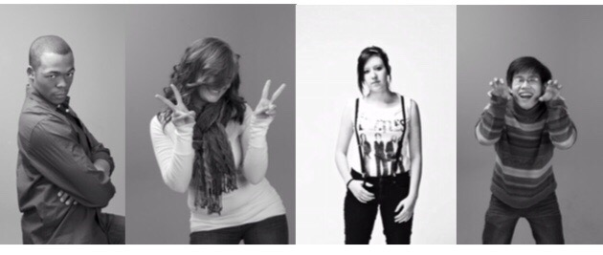

1. What message does each person’s body language send?

2. Does the racial/ethnic identity or gender of the people in the pictures affect the interpretation of their body language?

3. In some countries, __________________________________________________________________________

, it is necessary to look into the eyes of the person you are talking to in order to show interest in what he or she is saying, while in other countries, it is rude or insulting to look into someone's eyes.

?

3. Does age or social status make a difference in the way their body language is

perceived?

4. How would you react to the body language shown in each of the photographs?

5. What situations have you experienced in which your body language was

misinterpreted?

6. Have you ever made judgments about others based on their body language?

**Ex. b .Write a short story that includes a body language in the context of different culture.**