Unit : Our World |  |  | School: 8
Date: |  |  | Teacher name: Abilova F.A
Grade: 7 |  |  | Number present: | Number absent:
Theme of the lesson: |  | Natural disasters
Learning objectives  Inclusive objectives |  | 7.4.4.1 – R4 read a growing range of extended fiction and non-fiction texts on familiar and some unfamiliar general and curricular topics  7.2.3.1 – L3 understand with little or no support most of the detail of an argument in extended talk on a wide range of general and curricular topics  7.3.7.1- use appropriate subject-specific vocabulary and syntax to talk about a range of general topics, and some curricular topics  7.3.7.1- use appropriate subject-specific vocabulary and syntax to talk about a range of general topics, and some curricular topics
Lesson objectives |  | All learners will be able to:  Learn natural disasters, listen and read for gist and special information.  Most learners will be able to:  Learn natural disasters, listen and read for gist and special information, listen for specific information  Some learners will be able to:  Learn natural disasters, listen and read for gist and special information, listen for specific information, talk about natural disaster making dialogue
Criteria |  | Learners have met the learning objective if they can: speak about natural disasters and write an email
Previous learning |  | Natural phenomena
Plan
Planned timings | Planned activities |  |  |  | Learners’ activities | Evaluation | Resources
Begining  5 min | Org. moment: GREETING LEARNERS  To present natural disasters  Learners watch the short video and try to guess the theme of the lesson  Ask Ss to look at the pictures. Play the recording. Elicit the L1 equivalent for each word. |  |  |  | Learners try to guess  Ss listen and repeat chorally and/or individually. |  | Presentation
Middle  30 min | Read for gist  Ask Ss to look at the picture and read the title of the text. Elicit Ss’ guesses as to what the text is about. Ss read the text and find out.  To read for specific information  Ask Ss to read the questions and answer choices 1-3. Give Ss time to read the text and complete the table. Check Ss’ answers around the class. Refer Ss to the Word List to look up the words in the box. Learner exchange the information with partners.  Text 1  Drought in Kazakhstan  The heatwave that began in June 2021 in the Southern and Western regions of  Kazakhstan led to record temperatures up to 46.5℃.  The influx of hot and dry air masses from the region of Iran preserves abnormally hot  weather on the territory of most of the Republic of Kazakhstan. This has seriously affected  the main livestock farms in Kyzylorda, Mangystau and Turkestan regions.  The months-long drought has turned into catastrophe in Western Kazakhstan. Without  grass or fodder, thousands of cows and horses are starving to death. According to official  data, 1,161 heads of cattle, including 49 cattle, 503 sheep, 543 horses and 66 camels, died  from the drought in the Mangistau region.  Vocabulary:  heatwave (n) – жара  lead to (v) – приводить к  record temperatures (n) – рекордные температуры  the influx of hot and dry air masses –приток горячих и сухих воздушных масс  affect (v) – оказывать воздействие, влиять  livestock farms – животноводческие фермы  turn into catastrophe – превратиться в катастрофу  fodder (n) – корм  starve to death – умереть с голоду  According to official data – По официальным данным  Text 2  Forest fires in Yakutia  Fierce forest and wildfires erupted in Russia’s Yakutia, mainly in eastern Siberia. There are  196 forest fires affecting an area of 288,460 hectares – larger than the size of Luxembourg.  Across Russia, the Forest Conservation Agency listed 264 forest fires and an affected area of  325,526 hectares. The smoke from the Yakutia fires was so extensive that researchers recorded  smoke reaching as far as the North Pole. More than 4,700 people, hundreds of vehicles, 25 planes  and helicopters were deployed to put out the fires.  There are some methods to try and stop them or to try and control the damage. Sometimes  planes fly overhead and drop large volumes of water. Another way is to create a ‘buffer zone’, this  is where the firemen clear an area of vegetation so that the fire cannot continue on its path. And of  course there is huge numbers of firemen trying to put out the fires.  Vocabulary:  fierce (adj) – свирепые, яростные, сильные  Luxembourg – Люксембург  affected area – пораженная зона  smoke reaching as far as the North Pole – дым достигает Северного полюса  the Forest Conservation Agency – Агентство по охране лесов  were deployed to put out the fires – были развернуты для тушения пожаров  damage (n) – ущерб, урон  large volumes of water – большие объемы воды  ‘buffer zone’ – «буферная зона», нейтральная территория  vegetation – растительность  To consolidate information in a text  Ask Ss to work in pairs and ask and answer questions following the example referring to the text as necessary. Monitor the activity around the class.  Fill in the table with the information from your text.  Forest fires Drought  Description  (What they are)  Location  What weather  conditions and other  occurrences do they  cause?  How do they affect  people/animals?  To make dialogue  Explain the task. Tell Ss to make notes on each point and then use their notes to help them make dialogue with the partner  Formative Assessment  1 task  Listen 6 speakers talking about natural disasters. Match speakers with sentences.  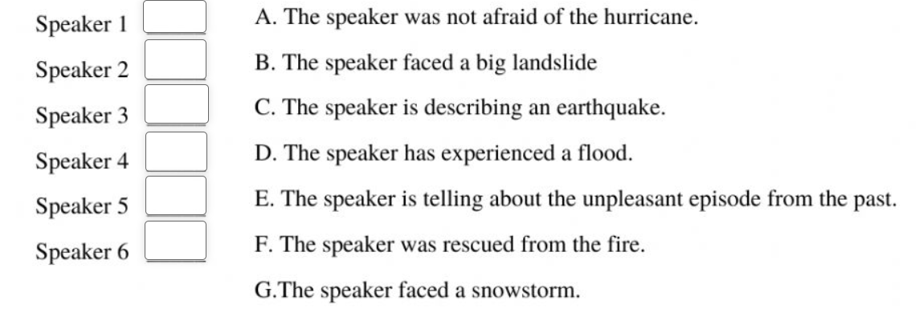  2 task  Read sentences and write names of natural disasters  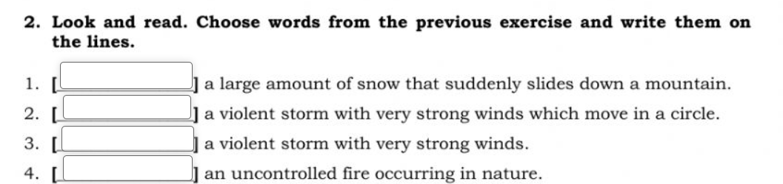  Criteria.assessment  D  E  A  F  B  G  Avalanche  tornado  hurricane  Forest fire  Points  Descriptor A learner  1 task  Learners should match speakers with sentences according to the information.  2 task  Read sentences and write names of natural disasters |  |  |  | Learners read the text individually and do the task  Learners read and complete the blanks  Learners exchange the information with the partner | Verbal evaluation  Individual avaluation  Individual  evaluation | Presentation  Cards  http://mythatsenglish.blogspot.com/2016/02/listening-test-natural-disasters.html  Cards
End  5 min | REFLECTION  Ask various Ss around the class to read questions and answer tnem by Plickers app.  Home Task  Write short news about natural disasters in our country  Saying goodbye |  |  |  | Learners answer the questions by the cards |  | Cards  Phone

