**Grade 8 - lesson 39**

|  |  |  |  |
| --- | --- | --- | --- |
| **Unit 4: Sport, Health and Exercise** | | | |
| **Teacher’s name:** | | Podlassova L.I. | |
| **Date: 02.12.21** | | | |
| **Grade: 8** | **Number Present: 6** | | **Number absent: 0** |
| **Theme of the lesson:** | Sport. Word formation | | |
| **Learning objectives that this lesson is contributing to:** | 8.2.4.1- understand with little or no support most of the implied meaning in extended talk on a range of general and curricular topics;  8.3.7.1 - use appropriate subject-specific vocabulary and syntax to talk about  a range of general topics, and some curricular topics  8.2.1.1 - understand with little or no support the main points in extended talk  on a wide range of general and curricular topics  8.2.4.1 - understand with little or no support most of the implied meaning in  extended talk on a range of general and curricular topics;  8.4.2.1 - understand specific information and detail in texts on a growing  range of familiar general and curricular topics, including some extended texts;  8.4.3.1 - understand the detail of an argument on a growing range of familiar  general and curricular topics;  8.3.5.1 - interact with peers to negotiate, agree and organise priorities and  plans for completing classroom tasks; | | |
| **Lesson objectives:** | * practice new vocabulary * use some target vocabulary successfully in response to prompts and identify most specific information in reading task * talk about word formation | | |

**Plan**

|  |  |  |  |  |
| --- | --- | --- | --- | --- |
| **Planned things. Time** | **Teacher’s activities** | **Learner’s activities** | **Assess**  **ment** | **Resources** |
| ***Beginning the lesson***  5 min | *Greeting*  Introduce the aim of the lesson  **Warm up- practice vocabulary for**  **hobbies and leisure activities**  Ask Ss to say the topic words one by one  *“Pilates – Pilates, aikido – Pilates, aikido, Zumba….”*  Ask to consolidate the vocabulary  A game “Who likes?”  Check the homework – **WB Ex.2 p.28** | Greeting  Ss say words one by one (adding a new word)  Ss play a game.  They ask questions: “Who likes Zumba? Who likes yoga? And make a step to the left or to the right  Ss check homework | Pair ass-t | Students’ book |
| ***Middle***  ***Presentation and practice***  35 min | **To introduce the topic**  Ask Ss to complete the table – “Group and individual sports” (task 1)  Ask Ss to draw a diagram  *Sport – sportsperson- activity - place*  Ask Ss to write the verbs connected with the sport (task 2)  Present new vocabulary- **SB Ex.7 p.43**  Ask to complete the sentences  **WB Ex.3 p.29**  Give Ss time to look at the pictures and label the pictures with the verbs  Ask to complete the sentences  Check Ss’ answers.  **Word formation p.43**  Ask to look at the table and guess  **SB Ex.8 p.43a**  Ask Ss to form nouns and complete the table (task 3)  **WB Ex.4 p.29**  Direct Ss to the definitions, give them time to fill in the gaps.  Check Ss’ answers.  **To introduce places of the sport**  **SW Ex.8 p.43 b WB Ex.6 p.29**  Ask Ss to read the pairs of words “Sport and places) and write “True / False”(task 4) | Ss stick the words in 2 columns  Ss write kinds of sport and information about it  Ss write down new words in their vocabulary book  Ss complete the sentences  Ss label the sketches with the verb below  Ss use the verbs to complete the sentences  Ss complete the table  Ss form compound nouns  Ss read definitions and fill in the gaps.  Ss complete the sentences  Ss read the words and write “True / False” | Pair ass  Self ass  Pair ass  Self ass  Pair ass | Students’ book  worksheet  Blackboard  Workbook  worksheet |
| ***Ending the lesson***  5 min | Home task: **SB Ex.10 p.43**  Explain the task  **Feedback**  Ask to show a smile   * What can you say about your lesson? * How are you at the lesson?   **Saying good-bye** | Write down the hometask  Ss give their opinion about the lesson.  Show their smiles |  | Workbook  worksheet |

**Task 1**

**Group activities Individual activities**

Weightlifting Zumba squash rugby boxing swimming

Aerial yoga pilates aikido football volleyball hockey

**Task 2**

**Name, a ball, a sportsperson, verbs related to sports**

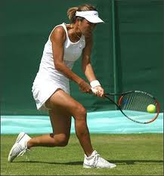 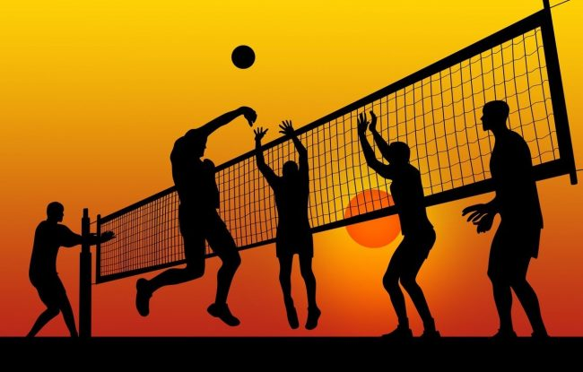 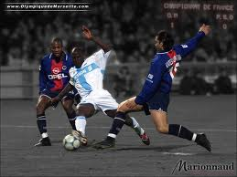 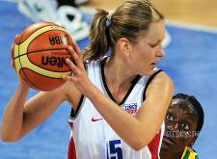

Kick kick kick kick kick kick kick kick Pass pass pass pass pass pass pass pass hit hit hit hit hit hit hit hit score score score score score score score score beat beat beat beat beat beat beat beat catch catch catch catch catch catch catch catch run run run run run run run run hop hop hop hop hop hop hop hop jump jump jump jump jump jump jump jump

**Task 3**

|  |  |
| --- | --- |
| **SPORT** | **PLACE** |
| **Football** |  |
| **Swimming** |  |
| **Ice-skating** |  |
| **Boxing** |  |
| **Basketball** |  |
| **Golf** |  |

**rink course court ring pitch pool**

**Task 4**

|  |  |  |
| --- | --- | --- |
| **SPORT** | **PLACE** | **TRUE / FASLE** |
| Football | Course |  |
| Swimming | Pool |  |
| Ice-skating | Ring |  |
| Boxing | Rink |  |
| Basketball | Court |  |
| Golf | Pitch |  |