Topic: Long-run effects of portfolio capital flow booms for developing countries

*Abstract*

This article reviews the literature on the factors that encourage portfolio capital flows to emerging economies which emphasizes that the determinants can be classified into those that are external to the emerging economies that receive the flow and internal factors to those economies. External forces or push factors are associated with the risk perception among foreign investors and the relative return of portfolios in said economies. And the internal economic attributes or pull factors, such as growth and macroeconomic stability, derived from a prudent management of economic policies, are related to the increase in demand for bonds and shares issued by emerging economies. In addition, recent developments regarding the inclusion of analysis are considered.

*Research question*

Do temporary portfolio capital booms have any impact on economies’ structural composition and, therefore, on the long-run development trajectory?

There is a prevailing consensus among economists, regardless of their theoretical approach, that financial liberalization (capital account liberalization) could result in rise of temporary surges in capital flows towards developing economies and that those charges could be destabilizing for the receiving economies and could create considerable problems in terms of macroeconomic stabilities and in terms of the dynamics of some leading variables like leading macro prices of receiving economies (Reinhart 2008). Authors also believe that sectorial composition of productive structure of developing countries can be affected thus affecting long-run development of these emerging countries.

So, there’s a belief that unrestricted capital flows can do more harm than good. As a solution, introducing some restrictions in order to hinder these flows to take place after measures of financial liberalization are implemented. Economic literature, however, mainly sees such negative effect (from capital influence booms and for full investments (not FDI)) as related to macroeconomic instability in the short run.

In this paper, I would like to investigate whether surges in capital influence could have long-lasting or even permanent effect on development process of receiving countries as they affect sectorial composition of these economies. I am interested in analyzing whether structural implications of temporary portfolio capital booms affect the productive structure of economy?

Literature should be about connection financial liberalization, capital inflows and changes in the productive structure of receiving economies. Usually this connection is implicit, meaning that it is not formalized in analytical models (are taken into account implicitly but not formally modeled). Some papers that comment on this implicit connection are Gallagher and Prates (2014) and Botta (2017).

*Model*

Endogenous determination of capital inflows, international interest rate and country-factor risk premium on international financial markets:

Essential assumptions to consider for this model:

1. For my simply model, I have decided to take an imaginary country with open economy which has only 2 sectors: real estate/stock market/natural resources and manufacturing. I have chosen specifically these 2 because I wanted one sector to be a target of speculative booms while another one should be one of the prospective structural sectors which is the driver of the economic growth. The latter opinion is based on Kaldorian first law which state that ‘Manufacturing is the engine of growth’ (McCausland, Theodossiou 2012).
2. Another important parameter of this economy is a flexible nominal exchange rate which is not regulated by Local Monetary Institutions. Their main goal is ‘Inflation Targeting’ which means ‘steering current inflation towards the target annual inflation rate’.
3. Regarding the financial sources, this economy has 2 of them:

* Foreign financial resources (capital inflows from international financial markets). We will see how the amount and the interest paid on these international capitals are determined endogenously in this model
* Domestic resources controlled by the Central Domestic Bank which pursues a given interest rate in order to get the target inflation rate.

1. Foreign financial inflows take the form of short-term foreign currency-denominated debt which must be rolled over every period of the model. This assumption reflects upon the fact that short-term horizon of particular portfolio investments represent the most volatile part of capital flows entering developing economies. There’s also past evidence to it like foreign lenders wanting to take risk in domestic currency.

The amount of capital entering the system:

This figure shows the supply of offering capitals (LSF) and demand for foreign capital by domestic financial institution (LDF). In this model, the amount of foreign capitals and the interest rate paid by domestic borrowers is determined endogenously by the intersection between the Supply of Foreign Funds and the Demand of Domestic Funds.

I(f) - the interest rate established by foreign monetary institutions (e.g. the US Fed on international financial markets).

I(t) - the equilibrium interest rate paid by domestic financial institution to get indebted on international financial market.

Σ – country factor risk (the additional is the wedge in terms of uh on top of the foreign interest rate the domestic financial institution have to pay to international lenders in order to be allowed getting indebted on international financial markets).

Supply curve is kinked because it explains the idea that perception of international investors is fundamental to determine the amount of rent capital available to developing economies. It also depicts the cost of these fundings (flat part meaning that in times of financial prosperity, foreign capital could be available at the cheap interest rate compared to interest rate prevailing in foreign financial markets. At this time, there can be a lot of foreign capital entering and given to domestic borrowers/domestic financial institutions. However, if there’s change in perception of foreign lenders, interest rate may increase but not capitals. Same capital would be available at much higher interest rate (straight vertical part). A capital reversal is also possible (the backward bending part of the supply curve). In this case, capitals available to developing economies at much higher interest rate is reduced.

Equations:

The supply of foreign capitals which is a negative function of the interest rate targeted by foreign monetary institutions(i(f)) and it is a positive function of the interest rate of the interest rate on international financial markets domestic borrowers have to pay to foreign lenders(i(int)).

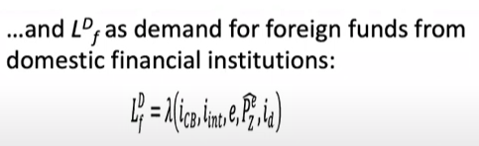

is a function of several elements:

* i(CB): is positively affected by the interest rate targeted by domestic monitoring institution.
* i(int): is negatively influenced by the interest rate that the domestic financial institution have to pay to international lenders on international financial markets.
* e: is negatively influenced by the nominal exchange rate (e - the quantity of domestic currency that we can purchase with a unit of foreign currency). The higher is the nominal exchange rate, the more depreciated/devaluated is domestic currency with respect to foreign currency. It also implies that the domestic exchange rate is more differentiated. The cost is the more appreciated(higher) is the exchange rate, the easier and cheaper becomes getting indebted in foreign currency.
* P(e z): is positively affected by the expected increase in the price of domestic speculative assets. Z - the domestic speculative asset. and P(e z) - the expected increase in the price of the domestic speculative asset. In a way this represents the usage of expected capital gains obtained by domestic financial institutions to speculate on the domestic speculative assets.
* i(d): is positively influenced by i(d) which represents the interest rate obtained by domestic financial institution when collecting money from international financial markets and then using this money to lend to domestic companies in the manufacturing sector.

The best way to combine above with the domestic financial market is to analyse the Balance Sheet of domestic financial institutions which are expected to intermediate between the international financial markets and the domestic economic system.

Domestic allocation of collected funds:

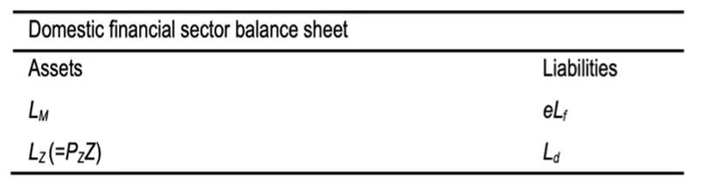

In terms of the liabilities, there are two types of liabilities:

1. Foreign liabilities denominated in the domestic currency. L(f), the amount of funds collected on international financial markets. The value of those liabilities in the domestic currency is obtained by multiplying that amount by the nominal exchange rate, e with L(f).
2. L(d), funds mobilised domestically which are supervised by the domestic monitoring institution.

These two funds collected by domestic financial institution are invested in two different ways:

1. can lent to non-financial firms in the manufacturing sector and therefore positively affects loans, L(m) representing the investments in the manufacturing sector with the purpose of accumulating productive capital.
2. can be used to speculate in the domestic speculative sector.

Z - the stock of the domestic speculative asset.

P(z) - its price.

L(z) - the quantity of resources invested in the domestic speculative in the domestic speculative sector like real estate.

For the simplicity of model, Horizontalist Theory of Money Supply is taken into account which states that there is not any form of ‘credit rationing’ and financial institutions are willing to supply the resources on demand of companies. Companies can also use any amount of funds in speculative sectors. There is a fully accommodationist approach taken by the domestic monitoring institution like Domestic Central Bank. It charges an interest rate a high on funds available domestically and the financial institution then collects those resources as they want and use them to speculate or to lend money to manufacturing companies.

If they lend money to manufacturing companies, they charge an interest rate (i(d)) which is given by applying a markup to the interest rate targeted by the domestic monetary institution. Even though there is not any credit restriction in terms of domestic funds available, in times of financial bonanza, it is more profitable for domestic companies to look for funds on international markets as those funds are available at cheaper cost (lower interest rate) rather than funds available domestically (offered at higher interest rate). There is an evidence in many developing economies that domestic monetary institution tried to charge quite high interest rates in order to strike inflation and keep it under control in a pure regime of inflation targeting (this is the example of Brazil).

2 sectors composing our economy:

1. Capital accumulation and price behaviour in the domestic manufacturing:

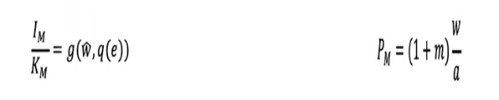

We simply assume that companies in the manufacturing sector ask for funds in order to accumulate productive capital and the demand for investments. Therefore demand for loans from the domestic banking system is purely exogenous meaning that it depends on following two components:

* The growth rate of nominal wages
* The real exchange rate (q) as influenced by the nominal exchange rate (e). In this case, capital accumulation is fully autonomous for the sake of simplicity. We do not assume capital accumulation to be influenced by capacity utilisation but rather we assume it to be influenced by the prospected future sales.

l(M)/K(M) – prospected future sales:

* The growth rate of domestic monetary (nominal) wages (‘w hat’): as an indicator of the possible expansion of domestic demand // is captured by the growth rate in nominal wages
* The evolution of international competitiveness according to the RER q(e)

P(M) – price of manufactured goods is calculated simply using the Cost-Push Inflation theory. It is given by the level of nominal wages (w) divided by the productivity of workers in the manufacturing sector (a). So, w/a simply represents Unit Labour Cost in manufacturing. Moreover, companies in this sector charge a markup given by (1 + m).

1. The behaviour of the speculative sector

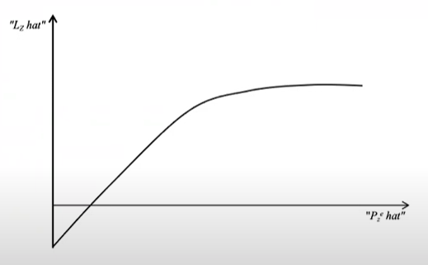

The idea of the increase in the resources pledged by domestic financial institution in the domestic speculative sector:

* L(z)hat stands for the increase in the growth rate of funds invested in the domestic speculative sector. It is a function of the expected increase in the price of the domestic speculative asset (P(z)hat). First of all, this is a price adjusting sector in the sense that we assume that the stock of the speculative asset is given in the short run.

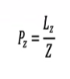

Increase in the stock of capital invested in this sector (L(z)hat) positive concave function of expected returns and hence, the expected capital gains P(e z)hat:

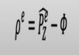

p e z hat stands for the expected increase in the price of the speculative asset.

row e is the expected profitability which is given by the expected capital gains

minus the cost of financing fee (weighted average of the interest rate that domestic financial institutions have to pay on the one side on capitals collected on international financial markets and on the other side on capitals obtained domestically).

The higher is p e z (the higher is expected profitability of investing in the domestic speculative sector), the higher is the quantity of resources. Therefore, the price of that asset is given by the quantity as z of resources invested by domestic financial institutions in that speculative sector.

The distinction between a medium run analysis and the long run analysis:

The medium-run analysis is still about the potential instability characterizing this economic system when there is a surge in foreign capitals available to this economy. The long-run analysis tries to make the matching between the effect of temporary increases in in capital inflows and the long-run development trajectory of this economy itself.

*The medium-run dynamics*

Given the purpose of the model, we focus on the modeling of capital booms and nominal exchange rate dynamics ‘e’ in medium run:

Nominal exchange rate dynamics given by notional imbalances in the balance of payments:

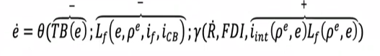

The balance of payment must always be in equilibrium (always equal to zero). There are just notional imbalances if you want temporary fictitious imbalances in so far as an agreement between the counterparts of a trade/financial deal is concluded.

Imbalances give rise to changes to the dynamics of the exchange rate.

e dot is the nominal exchange rate variation through time. Positive e dot means that the exchange rate is depreciating while the negative e dot implies the opposite.

So, there is a negative connection between the trade balance and e dot in the sense that the higher is the trade balance (if there is a surplus in the trade balance perhaps prompted by a depreciated exchange rate), exchange rate is easily appreciated (e dot is negative). This is very traditional self-stabilising effect that the depreciated exchange rate could bring about further depreciation of the exchange rate.

In the same way if lots of international funds are easily available, this could also lead to appreciation of the exchange rate (domestic currency being appreciated).

There are a lot of other components influencing the dynamics of the exchange

rate:

* one is R dot which is the variation in foreign reserves.
* Foreign direct investment (FDI) which is role played by payments on foreign capitals and foreign debt which is the product of the international interest rate and the quantity of funds of portfolio investments, short-term capitals collected by domestic borrowers on international financial markets. However, the connection is positive meaning that the higher is the interest commitments of domestic borrowers versus foreign lenders, the higher is the quantity of resources that domestic borrowers have to move towards the quantity of dollars that domestic borrowers have to give to foreign lenders to pay interest or repay part of the capital they borrowed. This obviously could cause a depreciation of the exchange rate. So, the higher is the amount of interest payments that domestic borrowers have to deal with, the nominal exchange rate is more likely to further appreciate.

2nd equation of the medium-run analysis describes the dynamics of expected returns on the speculative asset driven by adaptive expectations:



Rho e dot tells how the expectation about profits in the domestic speculative sector evolved through time and these are given by simple adaptive expectation by comparison between the realized observed profitability and expected one. If the realised profitability desired (?) an unexpected one, expectation will be revised upward. The realised profitability depends on the increase in the amount of capital effectively invested in the domestic speculative sector + the dynamics in the amount of the speculative asset like houses available in the market.

What is relevant is that under a certain parametric condition we could have multiple equilibria characterising these medium dynamics and in particular kind of instability affecting this economy. It’s due to the fact that under certain parametric condition, we may have two equilibria influencing the characterising model: equilibrium A which is a subtle path unstable or alternatively equilibrium B which is characterised by circular dynamics in its neighbourhood.

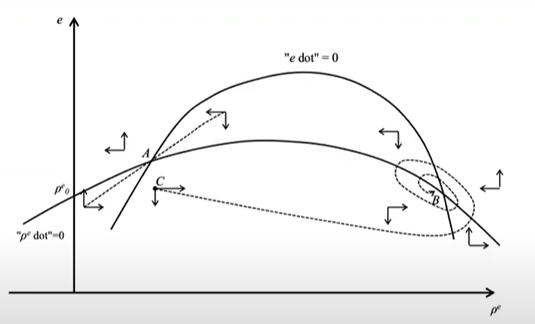

*Conclusion and policy implications*

In conclusion, capital controls involve imposing restrictions on the amount of capital, particularly short-term portfolio capital, that can enter the economy. These measures aim to manage capital inflows, ensuring stability and aligning with economic priorities. Capital controls serve as a tool to protect economic interests, enhance resilience, and facilitate strategic integration of global capital flows.

Regarding the fair distribution of the fruits of labour productivity growth, it is observed that the increase in labour productivity is not entirely passed on to foreign consumers, considering the sensitivity of net exports to relative prices. Instead, there is a closer relationship between domestic nominal wages and the dynamics of labour productivity. This linkage contributes to a more equitable distribution of the benefits derived from increased productivity.

References

Botta, A., Godin, A., Missaglia, M. (2016). "Finance, foreign (direct) investment, and the Dutch disease. the case of Colombia". *Economia Politica*, vol.33 (2), pp. 265-289.

Botta, A. (2017). "Dutch disease-cum-financialization booms and external balance cycles in developing countries". *Brazilian Journal of Political Economy*, vol.37 (3), pp. 459-477.

Botta, A. (2018). "The long-run effects of portfolio capital inflow booms in developing countries: Permanent development hangovers after short-term financial euphoria". ECLAC Production Development WP series no.221.

Gallagher, K.P., and Prates, D. (2014). "Financialization and the resource curse: The challenge of exchange rate management in Brazil". Gegi Working Paper no.8.

Koller, K. (2019). "Exchange rate dynamics, balance sheet effects, and capital flows. A Minskyan model of emerging markets boom-bust cycles". *Structural Change and Economic Dynamics* vol. 51 (4), pp. 270-283.

McCAUSLAND, W. D., & THEODOSSIOU, I. (2012). Is manufacturing still the engine of growth? *Journal of Post Keynesian Economics*, *35*(1), 79–92. <http://www.jstor.org/stable/23470003>

Reinhart, C. M., & Reinhart, V. R. (2008). Capital Flow Bonanzas: An Encompassing View of the Past and Present. NBER International Seminar on Macroeconomics, 5(1), 9–62. <https://doi.org/10.1086/595995>

Taylor, L. (1998). "Lax public sector, destabilizing private sector: Origins of capital market crises", CEPA Working Paper Series III no.6.

Yilmaz, S.D., and Godin, A., (2020). "Modelling small open developing economies in a financialized world: A stock-flow consistent approach", AFD Research Paper no.125.