**Development of the Educational-Cognitive Competence of Basic School Students in the English Lessons Through Smart Technologies**

**Author: Ryskhanova Nazgul Ermekkyzy**

Nazgul.ryskhanova@mail.ru

JSC “Kazakh Ablai Khan University Of International Relations and World Languages”

Education programme: 6В01701 – Teacher of Two Foreign Languages

Scientific Supervisor:Candidate Of Pedagogical Sciences, Professor Kalieva K.M.

Almaty, Kazakhstan

**Abstract**

This article investigates the integration of SMART technologies in English language lessons at the basic school level (grades 5–9) as a means to develop students' educational-cognitive competencies. The study examines theoretical foundations, pedagogical frameworks, and practical applications in a Kazakhstani school setting. Using a combination of experimental methods and observational data, the research highlights positive impacts on student motivation, critical thinking, independent learning, and digital literacy. The article concludes with recommendations for English teachers aiming to enhance learning outcomes through technologically enriched instruction.

**Keywords:** SMART Technologies, Educational-Cognitive Competence, Competency-Based Education, English as a Foreign Language (EFL), Interactive Learning.

**Introduction**

In the era of globalization and rapid technological progress, education systems worldwide are undergoing profound transformations aimed at preparing students for the demands of the 21st century. Among the many dimensions of this transformation, the development of educational-cognitive competence has become a key priority. This concept encompasses not only the ability to acquire and apply knowledge but also includes critical thinking, problem-solving, creativity, autonomy in learning, and the ability to evaluate and reflect on one’s own learning process. These competencies are particularly vital in language education, where students are expected not only to master linguistic forms but also to use language as a tool for cognitive and cultural interaction.

In the context of basic school education—covering students typically aged 10 to 15 in grades 5 through 9—the English language curriculum provides an excellent platform for cultivating educational-cognitive competence. English, as a global lingua franca, is not merely a subject of study but a means of accessing information, building cross-cultural communication, and developing digital literacy. However, traditional methods of English instruction, which rely heavily on textbook-driven rote learning and teacher-centered activities, often fail to engage students in higher-order thinking tasks or promote independent inquiry.

To address these challenges, SMART technologies offer promising opportunities. The term SMART stands for Self-Monitoring, Analysis, and Reporting Technology and broadly refers to digital tools and platforms designed to enhance teaching and learning through automation, interaction, and personalization. In the school context, SMART technologies include interactive whiteboards, student response systems, learning management systems (such as Moodle or Google Classroom), educational applications (like Kahoot, Quizlet, Wordwall), AI-based language learning platforms, and collaborative digital tools (such as Padlet, Jamboard, and Google Docs).

The pedagogical use of these technologies can transform the classroom into a dynamic and interactive environment. They facilitate differentiated instruction, allowing teachers to tailor tasks to individual student needs and learning styles. They provide real-time feedback, enabling students to monitor their own learning progress. They also support constructivist approaches, where students actively construct knowledge through exploration, discussion, and problem-solving rather than passively receive information.

Furthermore, Kazakhstan has recently undertaken significant educational reforms aimed at modernizing curriculum standards, aligning them with international benchmarks such as the OECD Learning Compass and UNESCO’s Education 2030 Agenda. The Ministry of Education and Science of the Republic of Kazakhstan has introduced updated curricula emphasizing key competencies, including functional literacy, creative thinking, and digital competence. In this context, integrating SMART technologies into English language education is not only desirable but necessary for achieving these national educational goals.

Despite the evident potential of SMART technologies, their integration into English language lessons at the basic school level remains inconsistent. Many schools face challenges such as lack of equipment, insufficient teacher training, and limited access to digital resources. At the same time, there is a lack of empirical research examining the direct impact of SMART technology integration on students’ cognitive development within English lessons.

Therefore, the purpose of this study is to explore how the integration of SMART technologies in English language teaching can support and enhance the educational-cognitive competence of basic school students in Kazakhstan. Specifically, the study investigates the types of digital tools most effective in promoting cognitive skills such as analysis, synthesis, reasoning, and self-regulation. It also examines changes in student motivation, engagement, and performance as a result of technology-enhanced instruction.

This research contributes to the growing body of literature on technology-enhanced language learning (TELL) and provides practical recommendations for educators seeking to modernize their teaching practices. It also supports the broader national agenda of equipping young learners with the skills and competencies necessary for success in a knowledge-based and technology-driven world.

**Methods**

2.1 Research Design

The study followed a mixed-methods approach, combining quantitative and qualitative data collection to gain a comprehensive understanding of the effects of SMART technologies on student learning. The research design included a pedagogical experiment conducted over 12 weeks, as well as surveys and interviews with students and teachers.

2.2 Participants

Participants included 80 students from two 7th-grade classes at №90 Specialized School-Lyceum in Almaty. One group served as the experimental group (n = 40), where SMART technologies were integrated into English lessons. The control group (n = 40) followed traditional instruction without technology-enhanced tools. Four English teachers participated in the implementation process, and two served as observers.

2.3 Intervention: SMART Integration

The experimental group was exposed to the following tools and practices:

*Interactive SMART Board:* Used for visualizing grammar structures, vocabulary, and pronunciation models.

*Kahoot, Quizizz, and Wordwall:* Platforms for gamified formative assessments.

*Google Classroom and Padlet:* Tools for organizing homework, collaborative writing, and feedback.

*Listening Labs and Virtual Speaking Partners:* Audio and video materials integrated for developing speaking and listening skills.

Lessons were designed using Bloom’s taxonomy and included problem-solving tasks, reflective questions, and differentiated levels of difficulty.

2.4 Data Collection Instruments

Pre- and post-tests to assess the growth of cognitive competence (reading comprehension, vocabulary acquisition, reasoning skills).

Student questionnaires evaluating motivation, perceived usefulness of SMART tools, and attitudes toward English.

Classroom observation checklists used by researchers to record student engagement and cognitive strategies.

Teacher interviews to understand implementation challenges and pedagogical reflections.

2.5 Data Analysis

Quantitative data were analyzed using SPSS to measure mean score differences between the pre- and post-tests. Qualitative data from open-ended survey responses and interviews were analyzed thematically to identify recurring patterns and insights.

**Results**

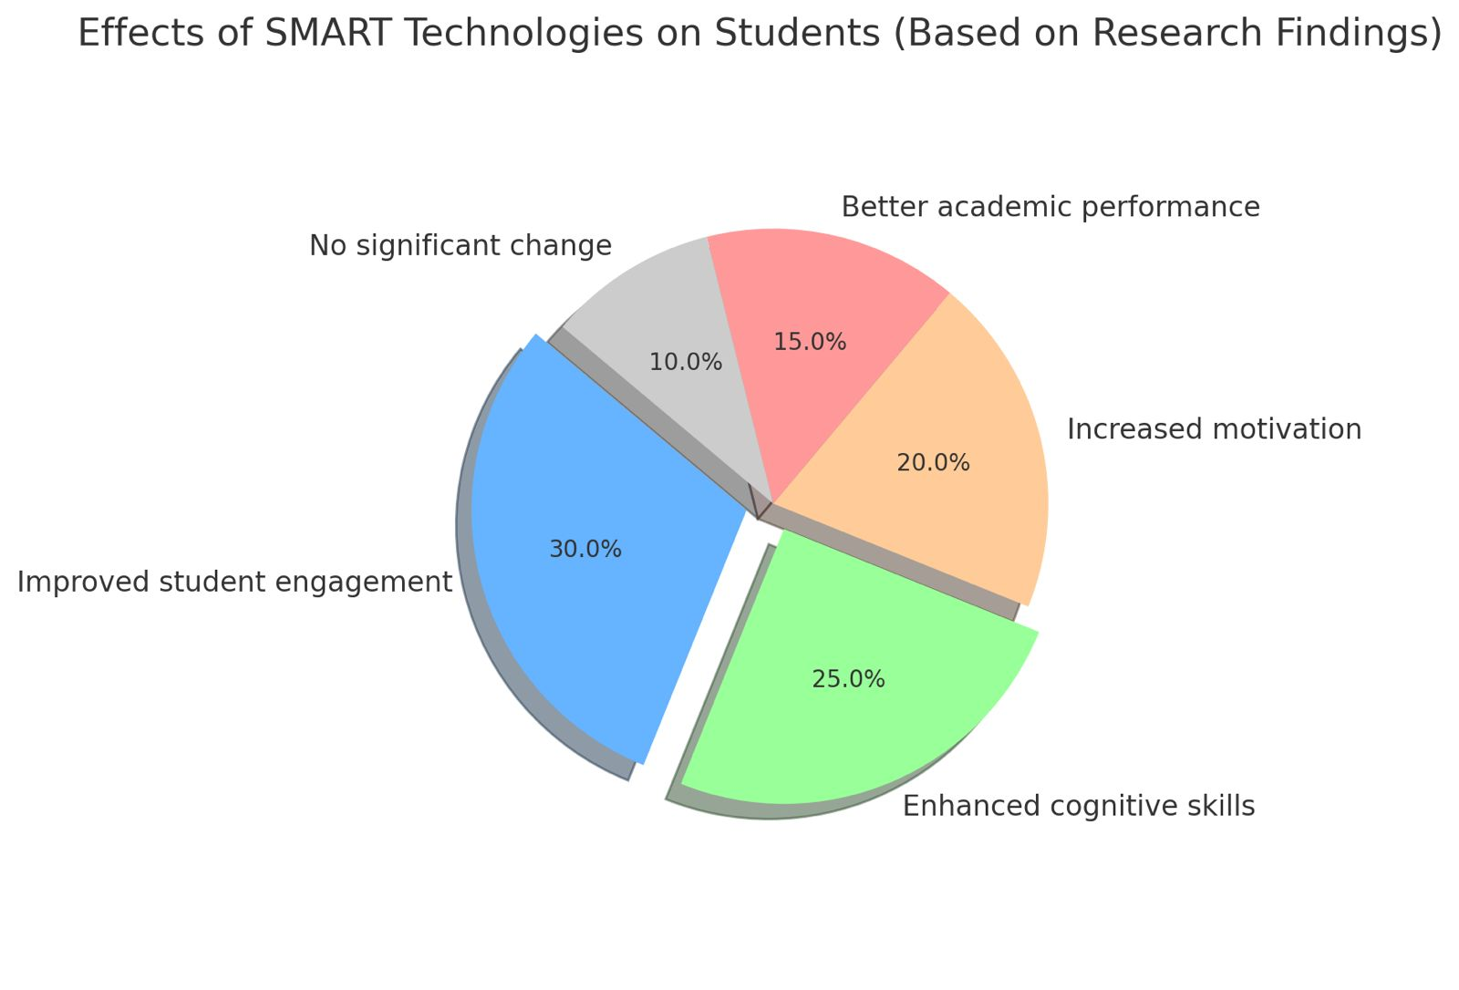

3.1 Test Score Improvement

Pre- and post-test comparisons showed significant improvement in the experimental group. The mean score increased from 61.3 to 84.7 (out of 100), while the control group’s score increased from 60.8 to 70.2. The experimental group demonstrated better performance in tasks requiring interpretation, inference, and synthesis of information.

3.2 Motivaion and Engagement

More than 85% of students in the experimental group reported that SMART tools made learning more interesting and engaging. Students especially appreciated the immediate feedback from online quizzes and the interactive features of SMART Boards.

3.3 Development of Cognitive Skills

Observational data indicated higher levels of student participation in class discussions, more frequent use of English in oral responses, and increased initiative in completing tasks. SMART tools facilitated the use of visual and auditory channels, which helped students better understand complex structures and retain new vocabulary.

3.4 Teacher Perspectives

Teachers reported increased student independence, faster lesson pacing, and more effective classroom management. However, they also mentioned challenges related to technical problems, time-consuming lesson planning, and the need for continuous professional development.

**Discussion**

The findings of this study support the growing body of evidence that SMART technologies contribute positively to the educational-cognitive development of students. In the context of English language learning, these tools support a student-centered approach by offering personalized learning paths, real-time feedback, and multimodal content delivery.

4.1 Cognitive Competence in Language Learning

Cognitive competence in the language classroom involves the ability to analyze language structures, draw connections between ideas, and apply knowledge in new contexts. SMART technologies promote these abilities through scaffolding, guided discovery, and interactive exploration. For example, digital storytelling platforms like StoryJumper allowed students to build narratives using learned vocabulary while applying grammatical rules, thus reinforcing their cognitive processing.

4.2 Integration Challenges

Despite the positive results, the study also revealed the need for systemic support. This includes better infrastructure, ongoing technical support, and teacher training. Furthermore, curriculum designers should ensure that digital tools align with learning objectives and assessment standards.

4.3 Implications for Practice

English teachers can leverage SMART technologies not just as supplementary tools, but as integral components of instruction. To optimize their use, lesson plans should:

Include specific cognitive learning goals.

Integrate formative assessment through digital quizzes.

Offer collaborative tasks using platforms like Padlet or Google Docs.

Encourage metacognitive reflection through digital journals or blogs.

**Conclusion**

The use of SMART technologies in English lessons for basic school students significantly enhances their educational-cognitive competence. By fostering engagement, independent learning, and critical thinking, these technologies offer a pathway to deeper and more effective language acquisition. However, for sustainable implementation, there is a need for policy support, professional development, and investment in infrastructure. This study demonstrates that the thoughtful integration of digital tools can transform English language education and contribute to the broader goals of 21st-century learning.

**References**

Anderson, L. W., & Krathwohl, D. R. (2001). A Taxonomy for Learning, Teaching, and Assessing: A Revision of Bloom’s Taxonomy of Educational Objectives. Longman.

Kozma, R. B. (2003). Technology and Classroom Practices: An International Study. Journal of Research on Technology in Education, 36(1), 1–14.

Ministry of Education and Science of the Republic of Kazakhstan (2021). Updated Educational Curriculum Guidelines for Basic Schools.

Prensky, M. (2010). Teaching Digital Natives: Partnering for Real Learning. Corwin Press.

Warschauer, M. (2006). Laptops and Literacy: Learning in the Wireless Classroom. Teachers College Press.