Module 6  Entertainment and media |  |  | School: специализированная гимназия № 8 с обучением на трех языках имени М.Х. Дулати
Date: |  |  | Teacher’sname: Фомичева Марина Владимировна
Grade 7 |  |  | Number present:
Theme of the lesson: |  |  | Entertainment. Speaking.
Learning objectives(s) that this lesson is contributing to |  | 7.C1 use speaking and listening skills to solve problems creatively and cooperatively in groups.  7.S3 give an opinion at discourse level on a growing range of general and curricular topics.  7.L2 understand with little support most specific information in extended talk on a limited range of general and curricular topics.
Lesson objectives |  | All learners will be able to:
- understand with limited support the main points of extended talk on Reality TV shows;
- give an opinion at sentence level on the topic of TV programs with peers or teacher’s support;
- do the matching activities (types of programs and new words) with peers or teacher’s support;
 |  | Most learners will be able to:
- understand with some support the main points and some of the details of extended talk on Reality TV shows;
- give an opinion at sentence level on the topic of TV programs with little or no teacher’s support;
- do the matching activities (types of programs and new words) with little or no teacher’s support;
 |  | Some learners will be able to:
- understand the main points and all the details of extended talk on Reality TV shows;
- give an opinion at sentence level on the topic of TV programs with no teacher’s support;
- do the matching activities (types of programs and new words) correctly independently ;
Planned timings | Planned activities |  |  | Actions |  | Resources
5 min. | - Topic introduction  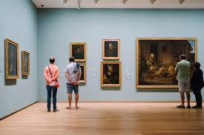  - Vocabulary |  |  | a) – watch the pictures  - guess what pictures they are  - comment on them  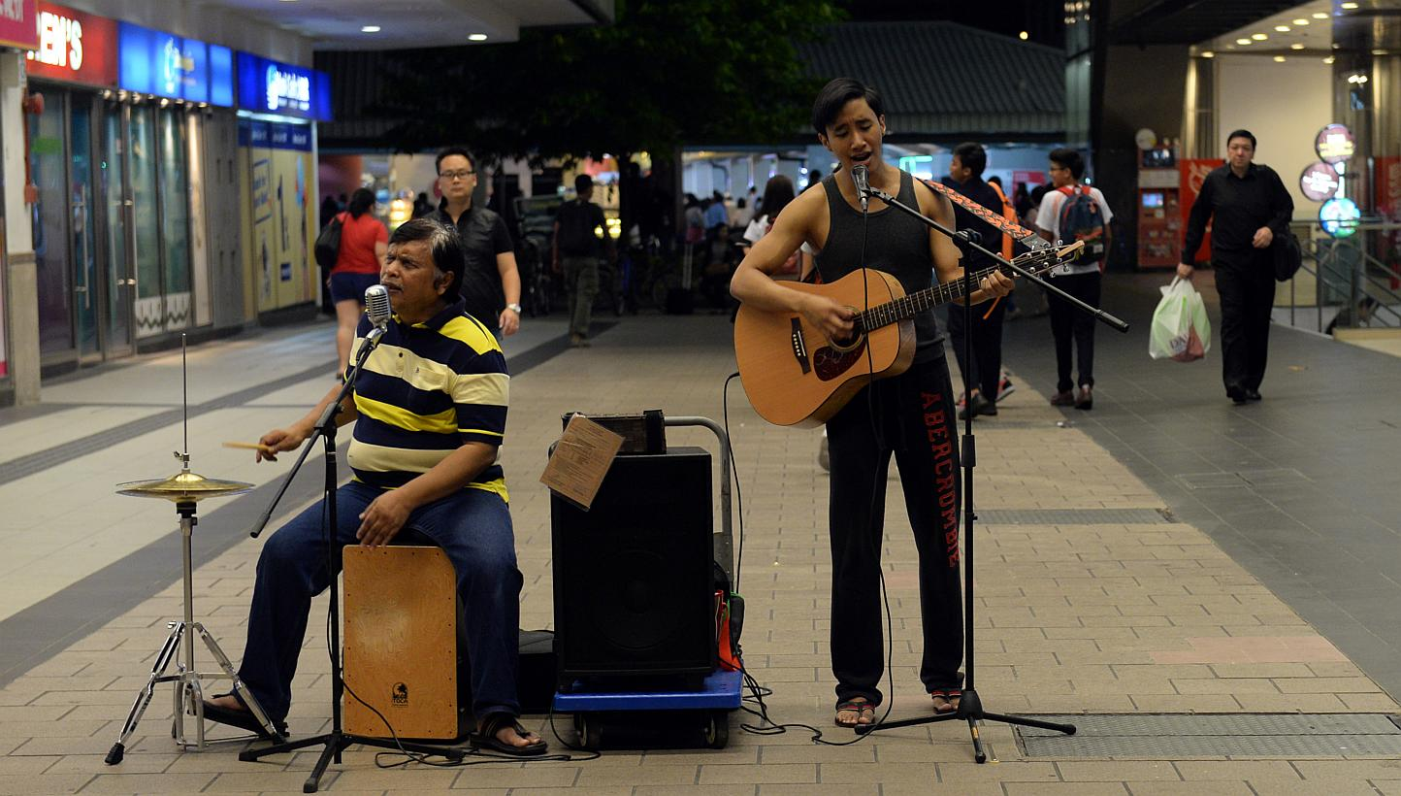  - guess the topic “Entertainment”  b) Word formation  - provide different parts of speech  c) – give the synonyms of the word “Like”  d) – What are you passionate about?  Criteria:  - use the actual vocabulary  Assessment:  - for every correct idea the student is given a point |  | PPpresentation  Smart board
Main part  27 min  7 min | The main part of the lesson  - Vocabulary. Speaking  - Words  - Cluster (groups)  - Fishbone  2. Assessment  3. Reflexion |  |  | - –complete the sentences with the words from two boxes  Match the words in box A with the words in box B. Then complete the sentences.  post good passionate take work make  - I love painting, but I am not very _______ it – some of my pictures are terrible!  - You have to ____ to be a good artist.  - Is it ok to ____ these photos of you____?  - My sister loves to ____of unusual buildings.  - It’s very difficult to ____ from painting pictures.  - My sister’s really ____making sculptures.  Assessment:  - for every correct idea the student is given a point  b) - the groups are provided with the pictures “Places of entertainment”  - comment on the pictures  - use actual vocabulary  Criteria:  - Use actual vocabulary  - Use linking words  - Team cooperation  Assessment:  - Get a point for every given idea  c)  - make up a fishbone  - present FOR and AGAINST and a conclusion  - present the information  Criteria:  - Use actual vocabulary  - Use linking words  - Team cooperation  Assessment:  - Get a point for every given idea  2. - Count the number of points  - Refer them to the assessment  “A” –  “B” –  “C” -  3. Complete the sentence.  Go on the idea... Today I have known.... |  | papers  PP presentation (pictures)

