Formative assessment task
Subject: English Grade: 1
Unit 3: My family and friends: In my house

Subject Programme  reference | Learning  Objective | Assessment Task
Reading  1.R3 | recognise some very high frequency words from local environment | Color and cut out each character from the story and glue them on top of the bed in sequential order as the occurred in the story.  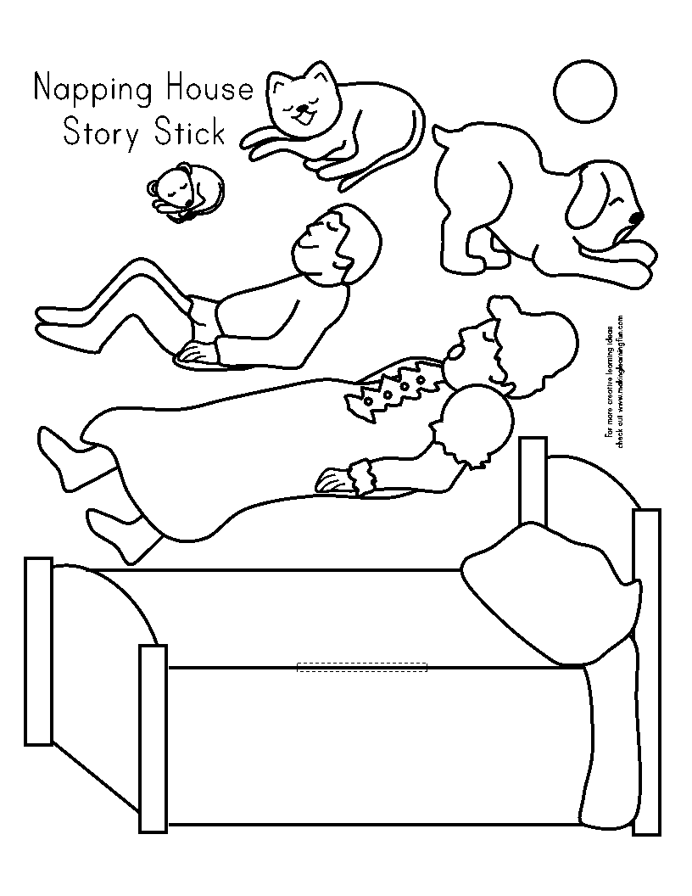
Success Criteria
Learners achieve this Learning Objective, if they |  |  | Learners are working towards this Learning Objective, if they
recognise 4-7 words |  |  | recognise 1-3 words

