Unit of a long term plan: Health
Teacher name: Satybaldieva Gulnaz
Date: 28.02.2025
Grade: 3 A |  | Number present: |  | absent:
Lesson title |  | My favourite food
Learning objectives |  | 3.3.5.1 Understand the main points of short simple texts on a limited range of familiar general and some curricular topics by using contextual clues  3.4.5.1 Link with support words or phrases using basic coordinating connectors
Lesson objectives |  | Learners will be able to:  Identify the main points of short texts using contextual clues on familiar topics  Use linking words to connect words and phrases with support
Stages / Time | Teachers actions | Students actions | Assessment | Resources
Start of the lesson  7 min  Middle of the lesson  3 min  3 min  5 min  6 min  3 min  6 min | Organization moment  Greetings the learners and forming psychological atmosphere in the classroom.  Divide into groups by method Value cards  1st group, 2nd group, 3rd group and 4th group  Checking up home task  Revise words previous lesson  Brainstorming  Teacher creates from first letter of the last words the theme of the lesson  New words Listen, point and repeat  Sandwich - сэндвич / grapes – жүзімдер / ice cream – балмұздақ / cherries – шие  New grammar theme.  Teacher explains how use linking words but or and in the sentences.  Task 1 [GW] Read the text and complete. Use method QR code.  1.I like grapes ____ cherries. My favourite food is rice. I don’t like hot choclate, ____ I like milk.  2.My favourite food is ice cream. I like sandwich _____ meat, ____ I don’t like fish.  3.I don’t like carrots, _____ I like juice. My favourite food is yogurt. I like milk ____ tea.  4. I like fish ______ meat. I don’t like yogurt _____ milk, _____ my favourite food is ice cream.  Task 2 [PW] Read and answer the question. Make a dialogue.  What is your favourite food? _________________________  Do you like grapes?  ________________________  Refreshment moment  Teacher shows a video to repeat activities  Task 3 [GW] Complete the crossword puzzle  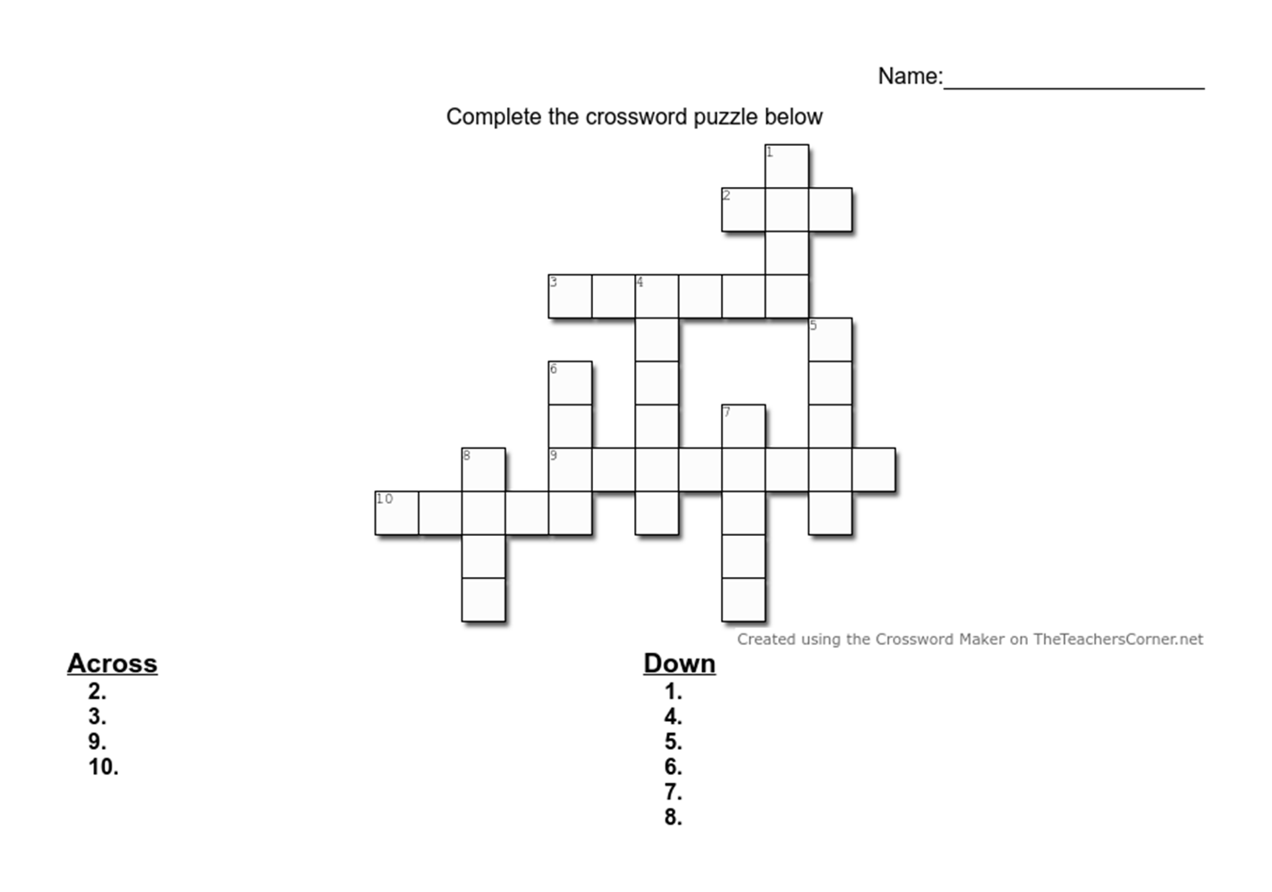  Task 4 [IW] In my fridge. Write the words in your fridge.  Task 5. Conclusion. Write about your favourite food and tell the class. | Learners respond to greeting and take their places.  Learners choose cards and divide group  Learners revise the last words  Learners name the pictures and read the theme of the lesson.  Learners listen and repeat new words. Then writes to copybook.  Learners study the new grammar theme  Learner read and complete the sentences work in a group.  - and / but  - and / but  - but / and  Learners answer the questions work with a partner  Learners repeat activities  Learners complete the puzzle  Across: 2.tea 3.yogurt 9.cherries 10. Juice  Down: 1.meat 4.grapes 5.water 6.rice 7.bread 8.fish  Learners write the names of food and drinks  Learners answer the question | Descriptor  A learner  Names the pictures correctly 1p  Descriptor  A learner  Completes correctly 1p  Works with a group 1p  Descriptor  A learner  Makes a dialogue 1p  Descriptor  A learner  Completes the puzzle  1-5 words 1p  6-8 words 2p  9-10 words 3p  Descriptor  A learner  Writes the food and drinks  1-3 words 1p  4-6 words 2p  Descriptor  A learner  Answers the question 1p |   PB  Pictures  PB  Pictures  PPT  PB  PB  PPT  Pictures  Worksheet  https://youtu.be/5H1BZtejpBo?si=dsfEBddzgL4SZF6S  worksheet
5 min  5 min |  |  |  | Worksheet  Card
End of the lesson  Reflection 5 min | Feedback  “What I learnt” strategy was used as a reflections by “Bucket”  Homework: New words  Good bye | Learners choose one of variant | Self assessment | cards

