**Multimedia-based teaching methods and the online platform as a mean of pronunciation skills forming at 8th grade**

**Introduction**. Nowadays knowledge of a foreign language is one of the most relevant qualities of a person who is planning to gain professional and personal success. The system of foreign language teaching needs to meet those conditions that are going to correspond to modern human lifestyle. To create a successful teaching process, the teacher needs to use such technologies and methods which are going to lead students not only to get knowledge and necessary information but also to become motivated in studying language. Such teaching methods are used that help to develop communicative skills and also creative ones. Multimedia technologies and different online resources belong to the list of such technologies that are oriented to the student’s personality mostly.

Education today undergoes a modernization process in which a human personality stays in the first position. In this context, personal development becomes the main value and the most relevant objective of education.

Multimedia technologies include a number of various resources: computer programs, and technical means that are used in the learning process to influence a student in the most efficient way (Nikiforova, 2021). Multimedia technologies are a sufficient part of electronic teaching resources that include digital photos, videos, different kinds of models, virtual reality, interactive modeling, sound recordings, graphics, electronic documents, and other electronic materials that can be used in the educational process. It is relevant to note that the possibilities of using such resources in teaching are almost endless because it is possible to solve all necessary tasks with the help of multimedia and online resources.

The theoretical basis of the study includes works of Russian and foreign scientists devoted to the issues of teaching the pronunciation aspect of speech (N.I. Gez, I.Yu. Pavlovskaya, G.V. Rogova, A.A. Khomutova, L.V. Shcherba, Celce-Murcia , J. Cross, R, M Dauer, J.H. Esling, P.Messum, J.D O'Connor, R.Young), the use of multimedia technologies in teaching (M.A. Bovtenko, A.D. Gartsov, S.I. Elnikova , D.A. Kocharov, O.N. Glotova, P.V. Sysoev).

The research problem is based on the fact that the use of multimedia technologies to develop students’ pronunciation skills will contribute to the effective elimination of ingrained errors.

The aim of the research is to identify the role of multimedia technologies in the process of teaching pronunciation to 8th grade students.

**Research description.** Today, most researchers, such as P.V. Sysoev, M.A. Bovtenko, A.V. Zubov et al. believe that multimedia and digital technologies have enormous didactic and methodological potential. Thus, the main aim of studying a foreign language is the development of communicative competence and its components in a foreign language, in particular, information and communication competence. To achieve this aim, it is necessary to develop foreign language skills, such as: grammatical, lexical, phonetic, as well as reading, writing, speaking and listening (Krishnasamy, 2017).

Digital and multimedia resources that are used today in linguodidactics usually include: electronic dictionaries, for example, explanatory, reference translated, terminological, etc.; authentic materials in a foreign language in various formats (graphic, text, etc.); specialized educational resources for teaching a foreign language, for example, electronic textbooks, interactive teaching materials; application programs such as Microsoft Word, Microsoft PowerPoint, etc.; means of electronic synchronous communication such as chats, instant messengers, video conferences; and asynchronous in the form of email, study groups on social networks, forums; educational Internet resources including hotlist, treasure hunt, multimedia scrapbook, web quest, etc. (Talipova, 2020).

These technologies are used in various forms of organizing the educational activities of students, such as classroom work, extracurricular work, as well as distance learning and mixed or combined learning.

Most multimedia programs that can be used in teaching the sound-pronunciation aspect of speech can be divided into: universal (used to teach various types of speech activities); specialized (designed to develop specific skills in a certain type of speech activity); auxiliary (represent some kind of support for students in the learning process) (Gerald, 2020).

Thus, multimedia and digital technologies have significant methodological potential. To unlock this potential, a teacher, when planning an English lesson using multimedia and digital technologies, must be aware of the specifics of using these technologies in the learning process, as well as take into account the specific requirements of the educational context.

To conduct an experimental study, we selected 8th grade students. The level of students was determined by testing. 8 people took part in the experiment. The research is based on a vertical experiment, the opposition of two groups of subjects is excluded. Thus, only one group of students took part in the experiment.

At the beginning of the experiment, introductory testing was carried out in the form of a diagnostic test, which consisted of 8 different typologies, accompanied by audio recordings: stress and intonation in sentences; short and long vowels; pronunciation of numerals; clear realization and perception of phonological contrasts between vowels and consonants; correct stress at the word and phrase level; phonetic cohesion; reduction of vowels in the flow of speech; use and understanding of phonetic transcription.

The experimental group testing methods are: multiple choice, transformation, substitution, cloze procedure, question-answer and identifying.

The method of teaching the phonetic side of speech involves familiarization with the theoretical component and the provision of seven types of exercises for the development of sound pronunciation skills.

As a result of the diagnostic test, the following most common errors among test subjects were identified: identification of vowels and consonants; vocabulary and phrase stress; phonetic cohesion; identification of weak and strong vowel forms/vowel reduction; use of phonetic transcription; contrast between tense and relaxed vowels; pronouncing numerals; sentence stress and intonation.

According to the results of the diagnostic test, the study was focused on the following phonetic skills that students need to develop and present seven types of exercises to develop the phonetic aspect of speech in English: clear implementation and perception of phonological contrasts between vowels and consonants; correct stress at the word and phrase level; phonetic cohesion; reduction of vowels in the flow of speech; using and understanding phonetic transcription; contrast between tense and relaxed vowels; pronouncing numerals.

After administering a diagnostic pronunciation test, scoring each test, and identifying the phonetic skills to be developed, an experiential learning package using multimedia technology was developed. During the training process, materials from platforms such as the British Council, Duolingo, Flash Card, Podcast.co, as well as the iSpring Suite program, which was used to compose exercises, were used.

To create the exercises, basic materials from textbooks on phonetics were selected (for example, Better English Pronunciation by J. D. O'Connor; Accurate English: A Complete Course in Pronunciation by Rebecca M. Dauer), and suggested the use of such programs for practicing phonetic skills as Sky Pronunciation, SaundZ Pronunciation Software, and also provided other additional information, which served as a training course on the development of phonetic competence in a pedagogical experiment.

The tests compiled in the iSpring Suite program have distinctive qualities: established listening skills with a native speaker; the ability to view the correct answer after completing the task; accounting for partially completed tasks; the ability to view the entire test after passing, indicating errors and correct answers for self-analysis. The following exercises were developed in the training program:

1. Identifying vowels and consonants: Choose the odd one out with the different sound.

1) car circus credit crown

2) those there that think

3) who where what why

4) choice chop chase chemistry

5) prize plus physics place

6) knight nose nine kind

2. Word and phrase stress: Decide which word in each line has a different stress pattern from the others. Listen and check.

1) culture facture mature texture

2) update ultimate create decide

3) clever beside trainer soldier

4) visit habit legit tactic

5) predict convict addict verdict

3. Connected speech/cohesion: Listen and fill the gaps, which contain various types of linking.

1) She expected such cold rain in the middle of Athens.

2) Do you know where Paul is? I’ve just seen him in a mall.

3) He’s obviously upset about what’s going on at work.

4) Can I phone after eight?

5) She’s staying with an old aunt of hers in the park.

6) I often go out in the evenings.

7) She’ll buy you an ice cream next week.

8) She’s much too old to go out alone.

4. Identifying weak and strong forms of vowels/vowel reduction: Decide if the underlined words have weak or strong form. Then listen and check.

1) He’d like a cup of tea. –W

2) What’s her jacket made of? – S

3) We’re going to study English and Literature. – W

4) Which did she order? A salad or a burger? She ordered a salad and a burger because she’s feeling hungry. – S

5) Who’s that present from? – S / From my boyfriend. – W

5. Using and understanding phonemic script: Write the words in normal script.

1) əˌkredɪˈteɪʃ(ə)n – accreditation

2) dɪˈpɑː(r)tʃə(r) – departure

3) mɪˈkænɪk(ə)l – mechanical

6. Connecting sounds with spelling & rhymes: Each line contains 3 words that rhyme and 1 word that doesn’t. Choose the odd one out.

Example: peal meal feel fail.

1) Girl Curl Pearl Carl

2) Flood Foot Put Boot

3) Main Pain Brain Dan

7. Pronouncing numbers & expressions with numbers: Listen to the recording and write the numbers.

1) one hundred and thirty-nine

2) twenty-four thousand eight hundred and eighty-two

3) ninety-nine thousand two hundred and fifty-three

4) one hundred and seventy-five thousand three hundred and fifteen

5) four hundred and eighty-eight thousand two hundred and fifty-seven

After the training, experimental testing was carried out.

**Results and discussion.** Thus, the structure of the experiment consists of: diagnostic test; experimental learning (working in the iSpring Suite program); final test.

The students involved in the experiment were offered a diagnostic test, which allowed them to form an idea of the state of knowledge in the chosen field and the formation of tasks for the upcoming training. Each student's test was graded on a 100-point system. After the test, the percentage of correct answers was calculated. The following results were obtained:

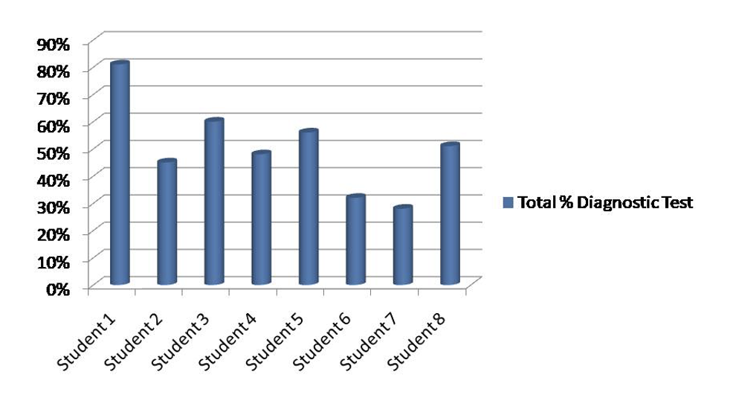

Figure 1. Overall percentage of correct answers for the diagnostic test

The training program presented above was implemented within 8 academic hours, after which experimental testing was carried out in two versions: using the program and manually.

The results of experimental testing are shown in the figure.

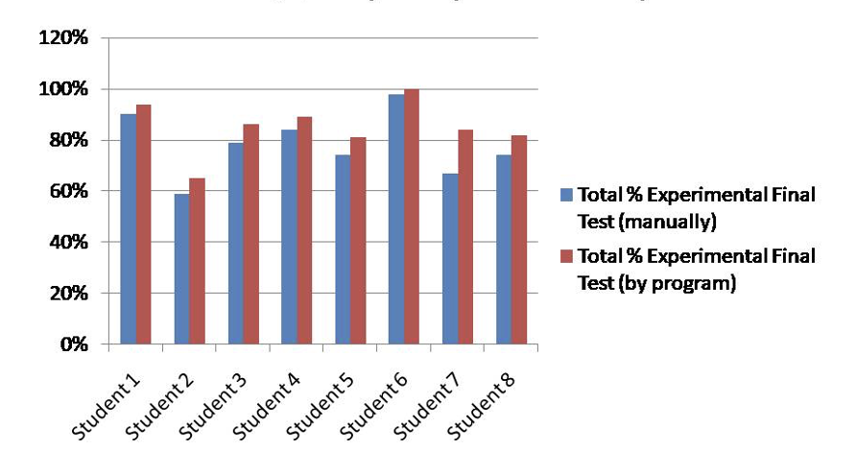

Figure 2. Results of final testing for each student (in percentage) in manual and machine calculations.

In order to better familiarize yourself with the general calculation of diagnostic and final experimental testing, pay attention to figure 3.

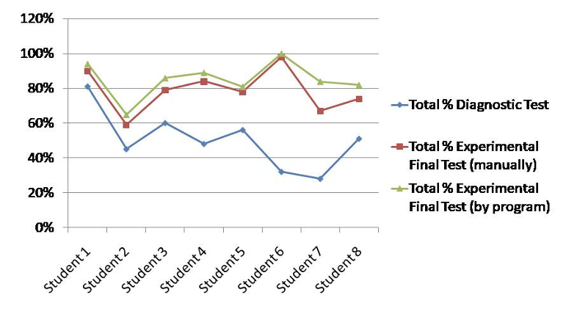

Figure 3. Results of diagnostic and final experimental tests

This figure clearly shows the percentage relationship between the two tests. It is important to observe sharp jumps and falls between the participants in the experiment. It is possible to note a significant increase in scores and, accordingly, believe that the proposed teaching system helps to the development of phonetic skills among these students, which indicates the effectiveness of the proposed methodology for developing phonetic skills using multimedia technologies.

The final experimental testing shows that mastering phonetic skills, which are based on the functioning of the mechanisms of speech perception, contributes to the successful understanding of pronunciation features, the determination of dictionary and phrasal stress, weak and strong forms of vowels, the use of phonetic transcription, as well as the recognition of complex compound numerals in English.

**Conclusion.** The results of the experimental testing indicate the effectiveness of the developed and applied methodology for teaching the phonetic side of speech to students using digital technologies, since the increase in points as a percentage for practiced phonetic skills increased by 1.7.

In the world of high technology, methods of teaching the phonetic side of speech are beginning to develop in a new direction using multimedia technologies and online platforms. Students have the opportunity to fully connect to phonics resources and materials based on their goals, but not all phonetics materials are universal, so taking into account the level, goals and objectives for the development of phonics skills in particular for students plays a significant role in drawing up a training plan is an important task. Therefore, the developed program provides an example of how to cope with the many aims and tasks that an English language teacher faces.

**References**

1. Chashina, A. F. Possibilities of using online platforms when teaching English to students of a pedagogical college: blended learning technologies / A. F. Chashina, N. M. Ucharova // From digitalization to digital transformation: Materials of the VI International Scientific and Practical Conference, Miass, January 28, 2022. – Chelyabinsk: Chelyabinsk Institute for the Development of Vocational Education, 2022. – P. 270-273.
2. Gerald, K., Harmer, J. Teaching pronunciation. How to teach pronunciation // Edinburgh Longman Educ. – 2020. – pp. 11-28.
3. Krishnasamy, R., & De Mello, G. Rethinking the teaching of pronunciation in the E S L classroom // English Teach. – 2017. – P. 14.
4. Nikiforova, I. N. Teaching English using online educational platforms / I. N. Nikiforova // Modern education: traditions and innovations. – 2021. – No. 4. – P. 151-154.
5. Rizakhodjayeva, G. A. Current perspectives on pronunciation skill development / G. A. Rizakhodjayeva, I. S. Abdulamit // Вестник Инновационного Евразийского университета. – 2021. – No. 2(82). – P. 27-34.
6. Samosudova, L. M. Educational online platforms as an effective means of teaching English / L. M. Samosudova // Bulletin of scientific conferences. – 2021. – No. 1-2(65). – pp. 120-121.
7. Talipova, N. A. The effectiveness of online platforms in teaching EFL / N. A. Talipova // Проблемы современной науки и образования. – 2020. – No. 12-1(157). – P. 47-49.