LESSON 6: Unit 3 My family and friends Дни недели  Days of the week (TH,F, S, S)  2A. Classroom objects |  |  |  | School: Astafev Secondary School
Date: |  |  |  | Teacher name: Medvedeva O.E
Grade: 1 |  |  |  | Number present: |  | absent:
Learning objectives(s) that this lesson is contributing to |  | 1.L3 recognize the spoken form of a limited range of basic and everyday classroom words  1.R1 recognize initial letters in names and places  1.S1 make basic personal statements and simple statements about objects
Lesson objectives |  | All learners will be able to:  pronounce basic words and expressions intelligibly  Most learners will be able to:  - Listen to simple songs & sing.  - Introduce their friends using he/she is.  Some learners will be able to:  - Name some days of the week
Previous learning |  | Days of the week (M, T,W)
Plan
Planned timings | Planned activities (replace the notes below with your planned activities) |  |  |  |  | Resources
Beginning  3-5 minutes | ORGANIZATION MOMENT  - Sing a song “Family song”  - Stand in a circle & answer the question: How old are you?  - Read the poem  Father, mother  Sister, brother  Hand in hand with one another.  - Repeat in chorus.  - Explain the aims of the lesson:  - Today we are going to learn the days of the week. |  |  |  |  | Nursery Rhymes My Family Songs with lyrics  http://www.youtube.com/watch?v=Y0tGsrr1yN4  Primary Colours Starter,  Hicks and Littlejohn (CUP 2002)  CD, Vocabulary cards  “Family”
Middle  25 minutes | DEMONSTRATION  - Today is Tuesday.  Demonstrate the days of the week.  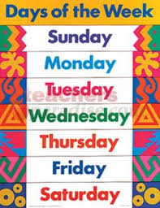  - Sing a song “Days of the week”  WRITING  Focusing on the initial letter sound of the days of the week. Learners practice overwriting capital letters M T W T F S S [upper case letters] – initial day of week letters.  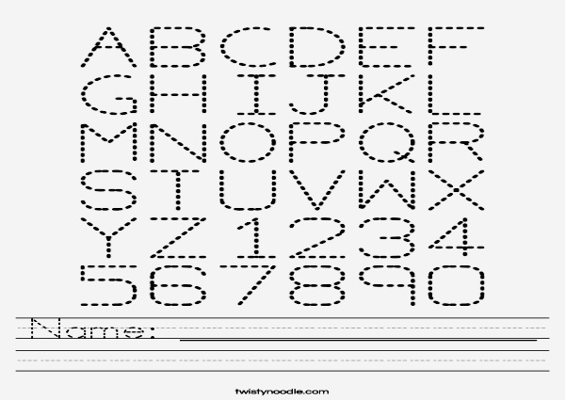  PHYSICAL MOMENT  Sing a song: Clap your hands, listen to the music, turn around, and jump up high.  ASSESSMENT  Colour the train according to the teacher’s instructions.  Train 1 Monday is yellow.  Train 2 Wednesday is green.  Train 3 Thursday is orange.  Train 4 Tuesday is white  Train 5 Saturday is pink  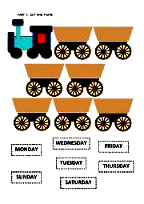 |  |  |  |  | Worksheet “Days of the week”  www.worksheetfun.com  song “Days of the week”  www.youtube.com/watch?v=941e6RnP4EQ  Worksheets  https://www.google.ru/search?newwindow=1&noj=1&biw=1887&bih=957&tbm=isch&oq=+worksheets+English+letters+to+overwrite+for+kids  Song  http://tune.pk/video/1795672/nursery-rhymes-clap-your-hands  Worksheet “Days of the week”  www.worksheetfun.com
10 minutes | FORMATIVE ASSESSMENT |  |  |  |  | A collection  of tasks for  Formative Assessment
End  5 minutes | FEEDBACK  Do you like your collage? Why?  SINGNING  Goodbye, goodbye, goodbye my friend  Goodbye, goodbye  See again.  THE LESSON IS OVER. GOOD BYE |  |  |  |  | The Goodbye Song for Children  http://www.youtube.com/watch?v=Xcws7UWWDEs
 | Additional information
 | Differentiation – how do you plan to give more support? How do you plan to challenge the more able learners? |  |  | Assessment – how are you planning to check learners’ learning? | Cross-curricular links  Health and safety check  ICT links  Values links
 | - more support can be given during elicitation, instruction and questioning phases of the lesson by nominating learners to answer items relating to more high frequency vocabulary to build confidence through participation. |  |  | - through assessment task  - through observation | - Art  - Social studies
 | Reflection  Were the lesson objectives/learning objectives realistic?  What did the learners learn today?  What was the learning atmosphere like?  Did my planned differentiation work well?  Did I stick to timings? What changes did I make from my plan and why? |  | Use the space below to reflect on your lesson. Answer the most relevant questions from the box on the left about your lesson.

