Long-term plan unit: Stress and Fear |  | School: Pokatilovka
Date: 24.01.2021 |  | Teacher name: Ikhsanova L.A
Grade: 10 |  | Number present: | absent:
Theme of the lesson: "Giving advice, Stress and Fear"
Learning objectives(s) that this lesson is contributing to | 10.3.4 - evaluate and comment on the views of others in a growing variety of talk contexts on a growing range of general and curricular topics;  10.5.1 - plan, write, edit and proofread work at text level independently on a range of general and curricular topics;  10.5.3 - write with grammatical accuracy on a range of familiar general and curricular topic;
Lesson objectives | All students will be able to:  - to disconnect from stress and beating  - ways of stress  - Expand vocabulary on the topic  Most students will be able to:  - indicates the source of the stress  - draw conclusions from the information provided  Some students may:  - Understand and evaluate information during reading and listening  - Psychologically explains stress and anxiety.
Assessment criteria | Students meet the 10.3.4 learning objective, if they can share their views on stress; 10.5.1 and 10.5.3 if they can demonstrate listening comprehension and writing during the entire lesson.
Value links | The value of staying away from stress and anxiety comes from reading and listening to "Stress consists of three stages: panic, endurance, weaken". Students learned how to stay away from these 3 challenges to avoid stress and anxiety.
Cross curricular links | Geography, Economics and Kazakh/Russian (as the mother tongue).
PLAN
Planned timings | Planned activities
5 min  10 min  15 min  5min  5 min | Teacher introduces Learning objectives to students and the ways how to succeed in them (assessment criteria).  Teacher explains to students what is expected of them at the end of the lesson.  Students revise the rules of behaviour at the lesson.  Preview: Stress vocabulary  Task 1: The teacher will read the pairs of tasks given by the students, reading the topic and presenting the contents to them. (pair work).  The teacher is involved in student assessment (pair work).  The teacher listens to the answers of the students. (class work)  Key: Task 1: Sad, disgust, fear, angry, admiration, surprise, joy. The teacher makes sure that all students understand the meaning of the new words.  Task 2: Teachers are asked students to write their sentences.  Students give examples using new vocabulary.  The teacher writes the examples of students on the board.  The teacher asks the students to repeat the new words afterwards.  Students repeat after the teacher.  Task 3: The teacher organizes the students to watch the first 5 seconds.  Learners need to identify the type of video.  Listening:  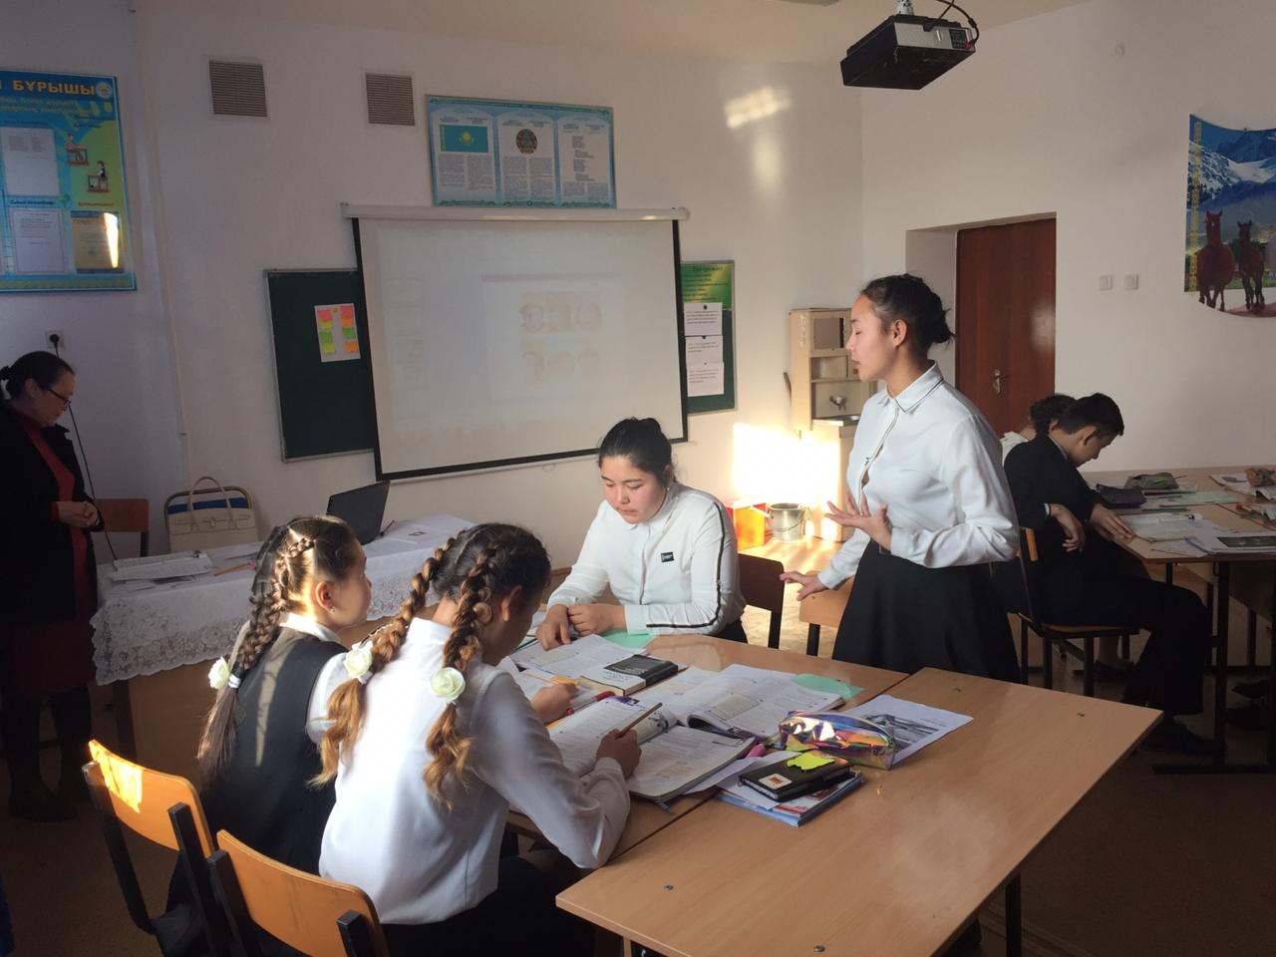  fear / үрей, қорқыныш,қауіп  [fɪə(r)]  [fɪr]  angry / ашулы,ызалы,  [ˈæŋɡri]  [ˈæŋɡri]  admiration -қуаныш  [ˌædməˈreɪʃn]  [ˌædməˈreɪʃn]  surprise / таң қалдыру  [səˈpraɪz]  [sərˈpraɪz]  joy / қуаныш,жұбаныш, рахаттану.  [dʒɔɪ]  [dʒɔɪ]  sad / sad – мұң  [sæd]  [sæd]  disgust / жиіркену  [dɪsˈɡʌst]  translation of the words in two languages.  The teacher asks the students if they need to listen again.  If needed, the teacher plays the video again.  Students evaluate themselves according to the keys.  The teacher participates in student discussions throughout the class.  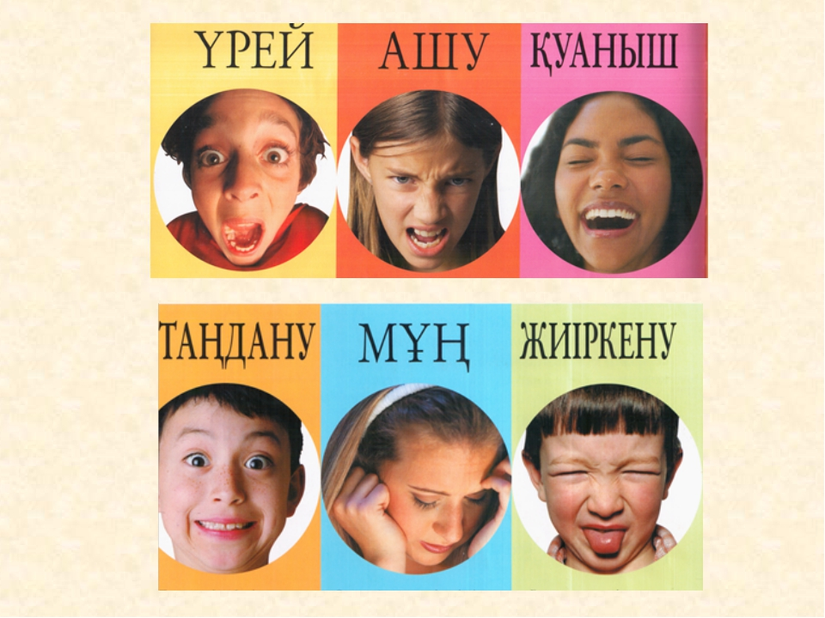  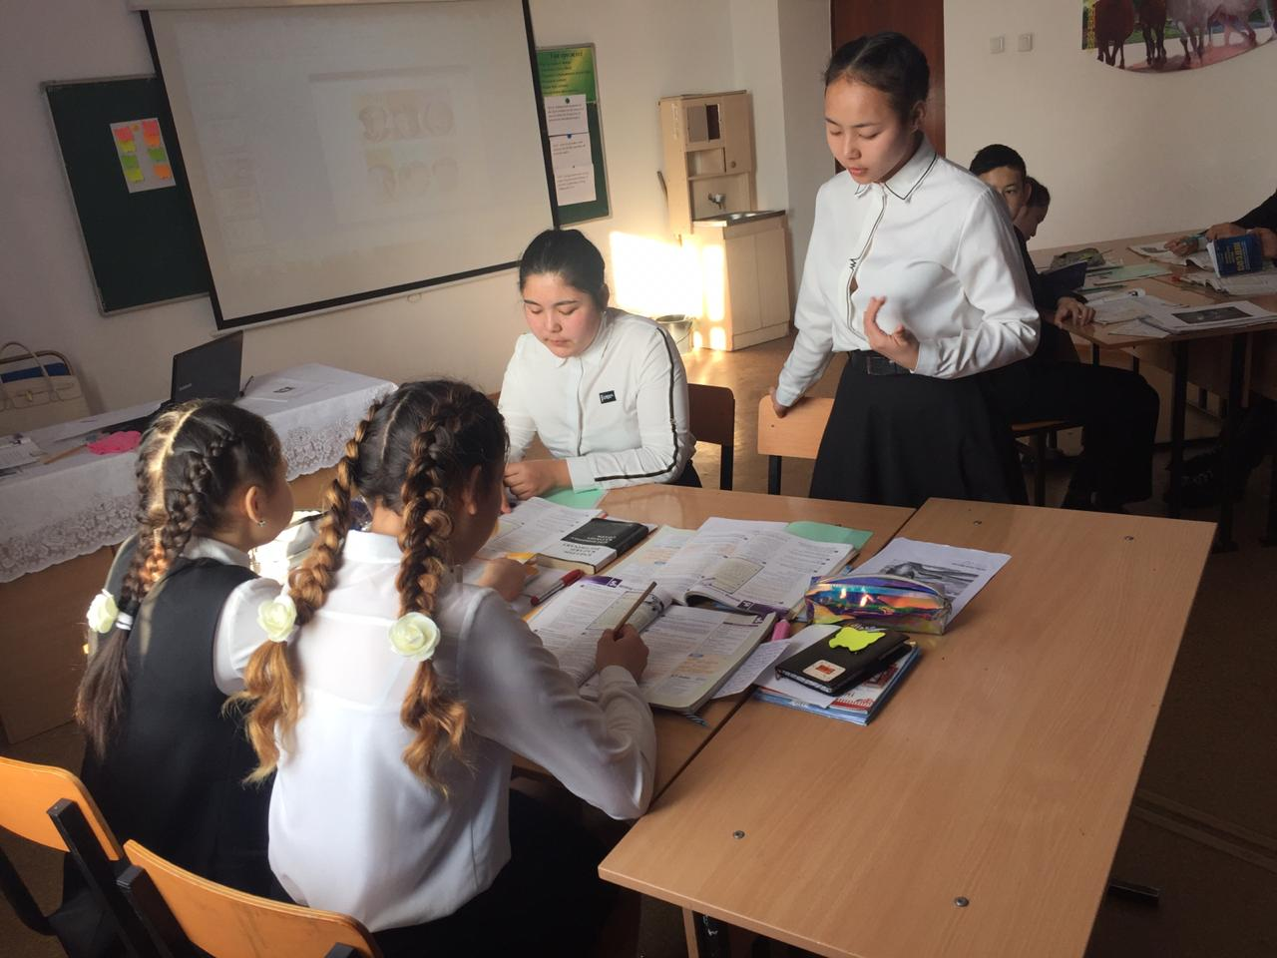  Listen to the post:  Task 5  The teacher asks students to translate the underlined sentences in the text into their own language.  Students translate the underlined sentences in the text.  The teacher will monitor and support as needed.  The teacher organizes the assessment (pair work).  Tasks 7 and 8: The teacher randomly divides the students into pairs. (pair work)  Why students need to know the meaning of "Stress consists of three stages: panic, endurance, weaken" Why?  The teacher encourages students to share their arguments with the entire class. The teacher organizes a group discussion.  General:  Students return to the lesson's expectations and goals, and discuss whether they have achieved it.
Ending the lesson | Giving the hometask.  Peer-assessment. Two stars and a wish.  - You did a really good job on ...  - I really like how you ...  - Maybe you could ...

