Проверено _________ зам.директора по УР

Краткосрочный план урока
Module:  Раздел: |  | 4. World of work.
Teacher name:  ФИО педагога |  | Mirzashukirova S.P.
Date:  Дата: |  | 15.12.2021
Class:  Класс: | 5 Ж З И К Л | Number present:  Количество присутствующих: | Number absent:  Количество отсутствующих:
Theme of the lesson:  Тема урока |  | A Job Interview p.52. All in a Day’s Work p.53
Learning objectives(s) that this lesson is contributing to:  Цели обучения в соответствии с учебной программой |  | 5.L6 identify with support the meaning from the context of a short conversation on some general and academic topics,  5.S2 ask simple questions to get information about some general topics,  5.S3 give an opinion at sentence level on a limited range of general and curricular topics;  5.S7 use specific vocabulary and syntax within some general topics,  5.R4 read some short texts of fiction and non-fiction with little support,  5.R7 determine the characteristic properties of a word, sentence, and text within some written genres;  5.R9 identify the difference between fact and opinion in short, simple texts on various general and educational topics,  5.W3 write text-level factual data describing people, places and objects,  5.W7 use with some support an appropriate text-level format of some written genres on familiar general and some academic topics,  5.UE1, use appropriate countable and uncountable nouns, including common phrases describing time and place, on some familiar common and academic topics.
Lesson objectives :  Цели урока |  | All learners will be able to:  Use and spell some target language correctly in asking and answering questions about others and themselves with some correct intonation;  Most learners will be able to:  Use and spell most target language correctly in asking and answering questions about others and themselves with some correct intonation in question activity;  Some learners will be able to:  Use and spell a range of target language correctly in asking and answering questions about others and themselves with mostly correct intonation in question activity.
Assessment criteria: |  | Recognize detailed information in a short conversation with some support;  Make up basic interrogative sentences and get information about the topic.
Language objective: |  | Ability to use subject / object pronouns.  Ability to use question words.
Value links |  | To bring up students to respect professionals and specialists of different fields;  Labour and creativity,cooperation, lifelong learning (Mangilik Yel).
Education of values: |  | Values ​​of the national idea "Mangilik El". Patriotism and civic responsibility. Respect for each other.
Resources: |  | Book Excel for 5 grade; stickers.

Planned timings:  Этап урока/ Время | The teacher’s activity Действия педагога | The students’ activities  Действия ученика | Assessment  Оценивание | Resources Ресурсы
Beginning the lesson  1 minute  1 minute  1-2 minutes  1-2 minutes  5-6 minutes | Org. moment.  - Good morning children! How are you today?  - Who is on duty today? Who is absent today?  Setting a favorable classroom climate.  Reception "Friends by the hour".  Game "I wish you today ..."  - Pupils, today is such a good day. Give each other smiles and compliments, we will share a good mood with each other.  (The teacher wishes the students new discoveries).  Phonetic charging.  - Today, during the speech warm-up, we will pronounce the sound [W].  Why do you cry, Willy?  Why do you cry?  Why, Willy? Why, Willy?  Why, Willy? Why?  Whenever we meet,  You always cry,  Why do you cry, Willy?  Why do you cry?  Grading system.  - Today the grading system will be as follows: for each correct answer you will receive a pink sticker, and for an answer with errors - a yellow sticker. At the end of the lesson, you will count your stickers and get your final grade.  Homework check.  - Now, let's check up your home task.  Your hometask was: SB Ex 5, 9 page 51. (The teacher checks, corrects and grades.). | Students greet the teacher and each other. Answer questions.  Students exchange compliments.  Students repeat after teacher.  Ex 5, 9 page 51.  Children check their homework and get stickers. | FG  Stickers  FG  Stickers | SB Excel  SB Excel
Middle  15-16 minutes  1-2 minutes | Introduction to a new topic.  Look at the job adverts, what are the jobs?  (The teacher writes sentences with new words on the board, highlighting the words.)  - What did you notice in these sentences?)  (Using these sentences as an example, explains the rules).  - Open the book on page 52. The topic of our lesson “A Job Interview”.  - Open notebooks, write down the date, class work, lesson topic, rewrite sentences from the board.  - Study task №2. Read the dialogue through and check.  - To consolidate the theme, read the dialogue and fill in the gaps with: how, what, where, when.  Introduction to a new topic №2.  Speaking.  Read the title and look at the pictures. Speak of many part-time jobs you know. Read the text to find out.  Writing.  - Study the task number 3 (A) on page 51. Mark sentences True, False.  (The teacher helps, corrects and evaluates).  - In order to consolidate a new topic, complete task number 4, p. 53.  (After completing the task, the teacher announces the correct answers).  The Game - "Ask me".  The teacher draws a little man on the blackboard, and write words around him. At the bottom of the picture is the student's name. ​Words are answers to questions that the teacher has prepared in advance. A child comes up to the board. The rest of the students ask him questions about the written words.  For example:  What is your name?  How old are you?  Where are you from?  What pet do you have?  What is your favorite food?  What is your favorite drink?  What grade are you study in?  (The teacher conducts the game. Assesses the activity).  Physical minute.  - You did a good job and you are tired. You need to rest and take a break.  "I can".  Who says: «I can hop»?  «I can hop», - says the hare.  Who says: «I can walk»?  «I can walk», - says the bear.  Who says: «I can run»?  «I can run», - says the dog.  Who says: «I can swim»?  «I can swim», - says the frog.  (The teacher conducts a warm-up). | Pupils answer the question.  Page 52;  Page 52  Listen and check.  Students complete the task.  Students read the text and answer questions, page 53; №2. Students complete the task.  Page 48; №3 (B);  Students complete the task.  (Students check, correct mistakes, evaluate their completed tasks).  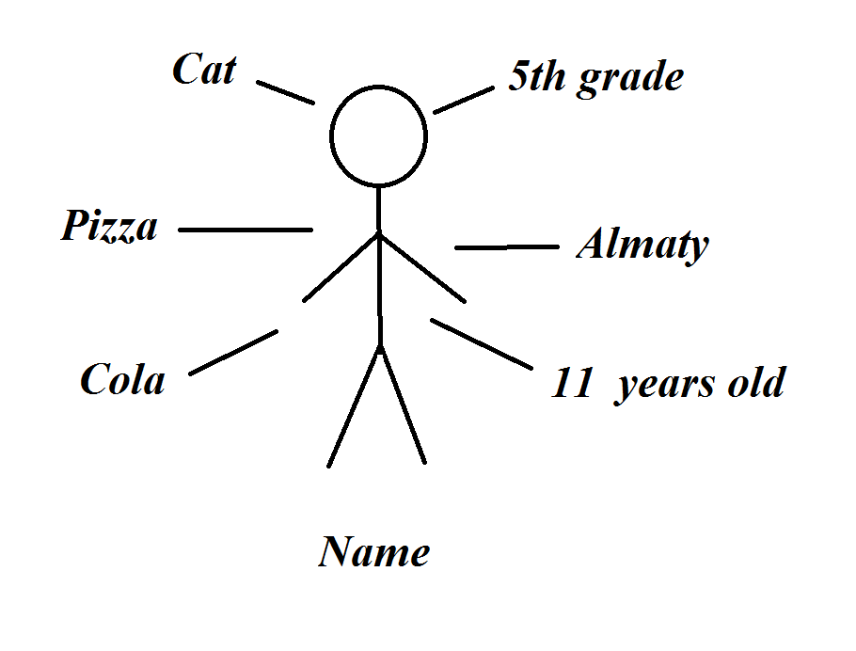  (Students participate in the game, receive grades).  (Pupils repeat after teacher). | FG  Stickers  FG  Stickers  FG  Stickers  FG  Self-esteem.  FG  Stickers | The board  SB Excel  SB Excel  SB Excel  SB Excel  The board
Ending  10-12 minutes | - I hope that after physical exercises you have rested and are ready to continue studying.  Speaking.  Work in pairs.  - Complete task №5 (A) and (B) on page 53.  (The teacher helps, corrects and evaluates).  Setting final grades. | Page 53; №5.  Students complete the task.  Students are counting stickers. | FG  Stickers  Stickers | SB Excel
Homework  1 minute | - Your task will be: page 52 tasks number 5 and 6.
Ending  1-2 minutes | Reflection:  - Answer the questions:  1. It was interesting ...  2. It was difficult ...  3. Now I can ...  4. I learned ...  5. I was surprised ... | Children answer questions.
Аddіtіоnаl іnfоrmаtіоn
Differentiation – how do you plan to give more support?  How do you plan to challenge the more able learners?  1. Determination of the criteria according to which groups of students are created for work.  2. Distribution of students into groups, taking into account the results of diagnostics.  3. Definition of assignments for selected groups of students. | Assessment – how are you planning to check learners’ learning?  Through teacher feedback: the teacher praises the students. Formative assessment. Self-esteem. Stickers. Reflection. |  | Cross-curricular links Health and safety check ICT links  Physical minute.
Reflection  Were the lesson objectives/learning objectives realistic?  What did the learners learn today?What was the learning  atmosphere like? |  | Use the space below to reflect on your lesson. Answer the most relevant questions from the box on the left about your lesson.

