Short term plan

Unit of a long term plan Unit 3, Human brain |  | School: BILIM-INNOVATION high school
Date: 29.09.2024 |  | Teacher name: Zhanar Kulmagambetova
Grade: 11 |  | Number present: | absent:
Lesson title | How memories are formed?
Learning objectives | 11.4.2 - understand specific information and detail in extended texts on a wide range of familiar and unfamiliar general and curricular topics  11.3.2 - ask and respond with appropriate syntax and vocabulary to open-ended higher-order thinking questions on a range of general and curricular topics, including some unfamiliar topics  11.1.10 - use talk or writing as a means of reflecting on and exploring a range of perspectives on the world
Lesson objectives | - Identify facts about human brain and detail information in the text  - Ask 5 formal questions about human brain  - Use dialogue to reflect opponent’s questions

Stages / Time | Teachers actions | Students actions | Assessment | Resources
Organizational moment  1 min  Warm-up  2 min | Teacher greets students  T: Look at a picture and guess what it is  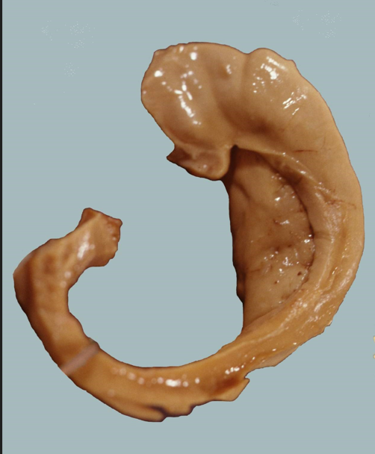  T suggests to discuss the topic and the aims of the lesson. | Ss greet the teacher  Ss look at the picture and give their variants,  guess the topic of the lesson |  | Slide 1  A picture from https://yandex.kz/images/search?from=tabbar&img_url=https%3A%2F%2Fupload.wikimedia.org%2Fwikipedia%2Fcommons%2Fb%2Fb1%2FHippocampus_and_seahorse.JPG&lr=190&pos=0&rpt=simage&text=hippocampus
Pre-reading  stage  Reading stage  Post-reading  Speaking | Test-Teach-Test  Task 1.  T: Work in pairs. Look at the sentences and decide which of them are true about hippocampus. You have 2 minutes.  Task 2.  T: Read a mixed text about hippocampus and check your answers. You have 10 minutes.  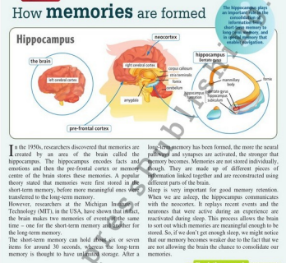  CCQs:  - Is hippocampus a part of human brain or a body?  - Is it responsible for communication or memory and emotions?  - Which memory is thought to have unlimited storage?  - Is sleeping or going for sports important for good memory retention?  Task 3.  T: Complete the phrases according to the text. You have 3 minutes  Check the task in pairs.  2 minutes  Task 4.  T: Work in groups of 4. Choose a speaker, an assistant, an assessor, a time-manager. Read the text again and make up 5 formal questions according to the text. You have 7 minutes.  Task 5.  “Hot Seat”  T asks a speaker of one of the groups to sit on a chair and answer the questions of another group.  Task 6.  T: Work in pairs. Tell your partner three things you have learned from the text. | Ss read the sentences and mark them true or false.  1 The hippocampus resembles a seahorse.  2 The hippocampus is an organ nestled deep within the human brain.  3 This organ has dentate gyrus.  4 It doesn’t play any role in our cognitive processes.  5 The hippocampus is responsible for regulating emotions, memory, and behaviours.  6 It’s a myth that sleeping influences on our memory.  Ss individually read the text and in pairs check their answers  Ss answer the questions according the text  More motivated Ss complete the phrases without support:  1 pre-frontal …  2 short/long term …  3 memory …  4 encode …  5 … are activated  6 consolidate …  Less motivated Ss  complete the phrases with given words cortex, facts, memories, synapses, retention, memory:  1 pre-frontal …  2 short/long term …  3 memory …  4 encode …  5 … are activated  6 consolidate …  Ss work in groups, read the text and make up 5 formal questions.  An assistant writes the questions of the group.  A time manager looks after the time.  A speaker gives the answers of the group.  An assessor gives an assessment to another group.  A speaker of one of the groups answers the questions of another group, an assessor of that group assesses him. | Self-assessment  Descriptor:  Ss identify true sentences correctly:  1 T  2 T  3 F  4 F  5 T  6 F  Peer assessment  Descriptor:  Ss complete the phrases correctly  1 pre-frontal cortex  2 short/long term memory  3 memory retention  4 encode facts  5 synapses are activated  6 consolidate memories  Peer assessment  Descriptor:  S answers the questions correctly. | Slide 2  Textbook “Action” p.45  Handout 1  Cards

