School 7 named after K.Ushinskii
Lesson Plan
Theme of the lesson: Treasure maps 1.
Unit:3 | Treasure and Heritage.
Teacher’s name: | Gakeseeva A.T.
Date: | 08/11/2022
Grade: 4 B | Number present: absent:
Theme of the lesson: | Treasure maps 1.
Learning objectives(s) that this lesson is contributing to: | 4.1.3.1 understand the main points of short supported talk on an increasing range of general and some curricular topics;  4.3.5.1 understand the main points of short simple texts on a growing range general and some curricular topics by using contextual clues;
Lesson objectives: | All learners will be able to:  -understand the conversation from video and do multiple choice activity;  -read the text and complete it with suitable words;

Plan:

Period | Teacher’s activity | Leaner’s activity | Assessment | Recourses
Beginning  5 min  5 min  5 min  5 min  5 min  5 min  5 min  10 min | Organizational moment  -Greeting students  Teacher asks pupils to find object under their desks. Pupils have to find bottle with map in it. Then pupils are asked to predict the topic of the lesson.  The theme of the lesson is “Treasure maps”.  Teacher introduces class with Los.  Teacher tells class that they have to find treasures by doing exercises during the lesson.  Main Part.  Teacher introduces class with new vocabulary using PPT and hands out pupils with vocabulary sheets.  Treasure-сокровище  Treasure map- карта сокровища  Bottle- бутылка  Gold – золото  Jewels- золотые изделия  Turn right –повернуть направо  Go straight on –идти прямо  Cross –пересечь  Turn left –повернуть налево  Go through- проходить чере з  Go along- идти по  Pirate [pairet]ship-пиратский корабль  Teacher tells pupils to complete the task in order to be sure that pupils learn new words  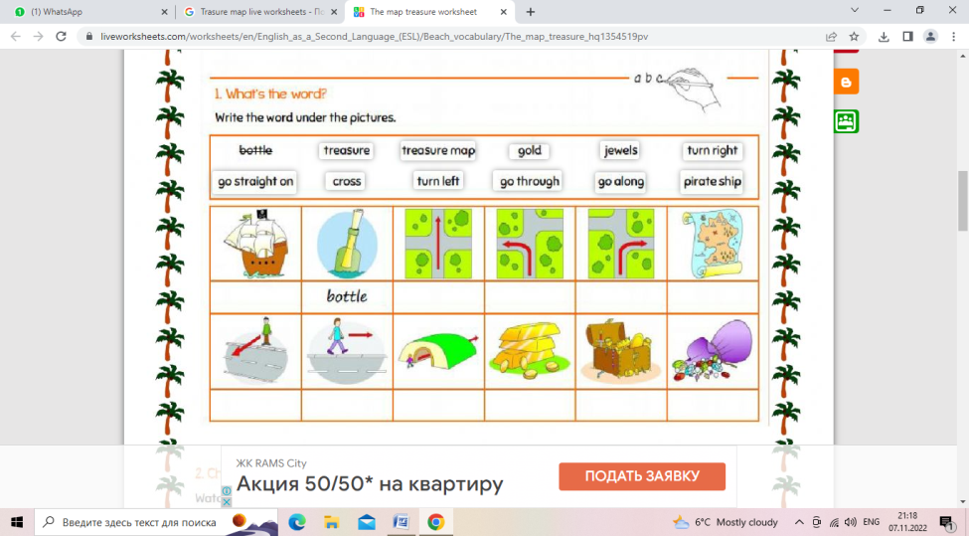  Listening.  Teacher switches on the video twice and asks pupil to watch it.  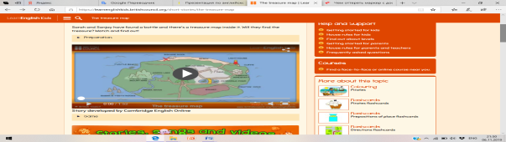  After watching video teacher tells pupils to solve the Word wall quiz. Teacher explains pupils that they have to read sentences and to choose correct answer according the video  PISA  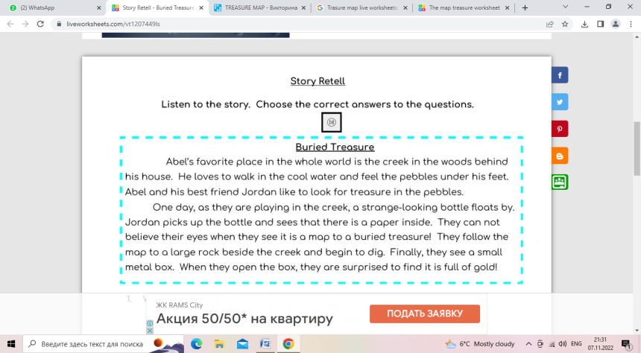  Teacher reads the story and asks pupils to do test after it. Pupils are asked to come to the board and choose correct answer.  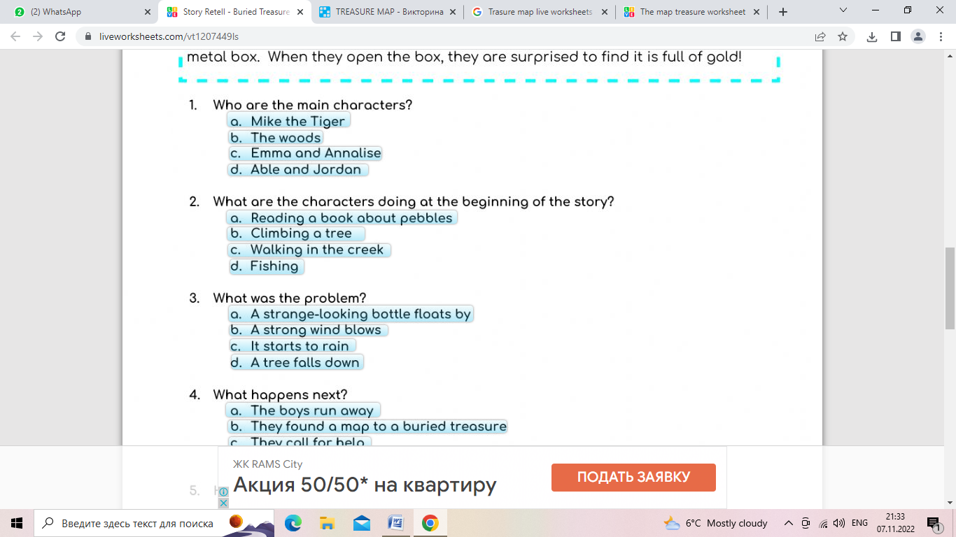  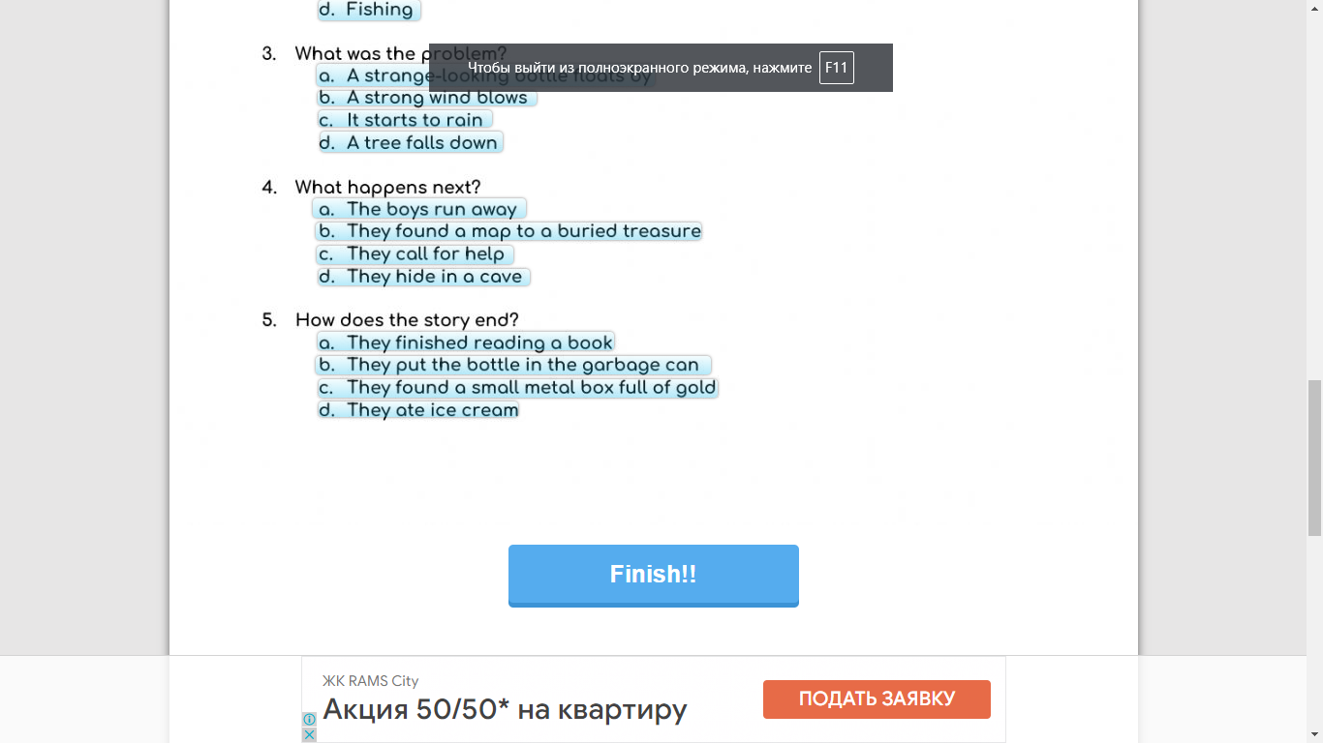  Group work.  Teacher divides class into three groups by random split.  Teacher suggest groups to solve puzzle  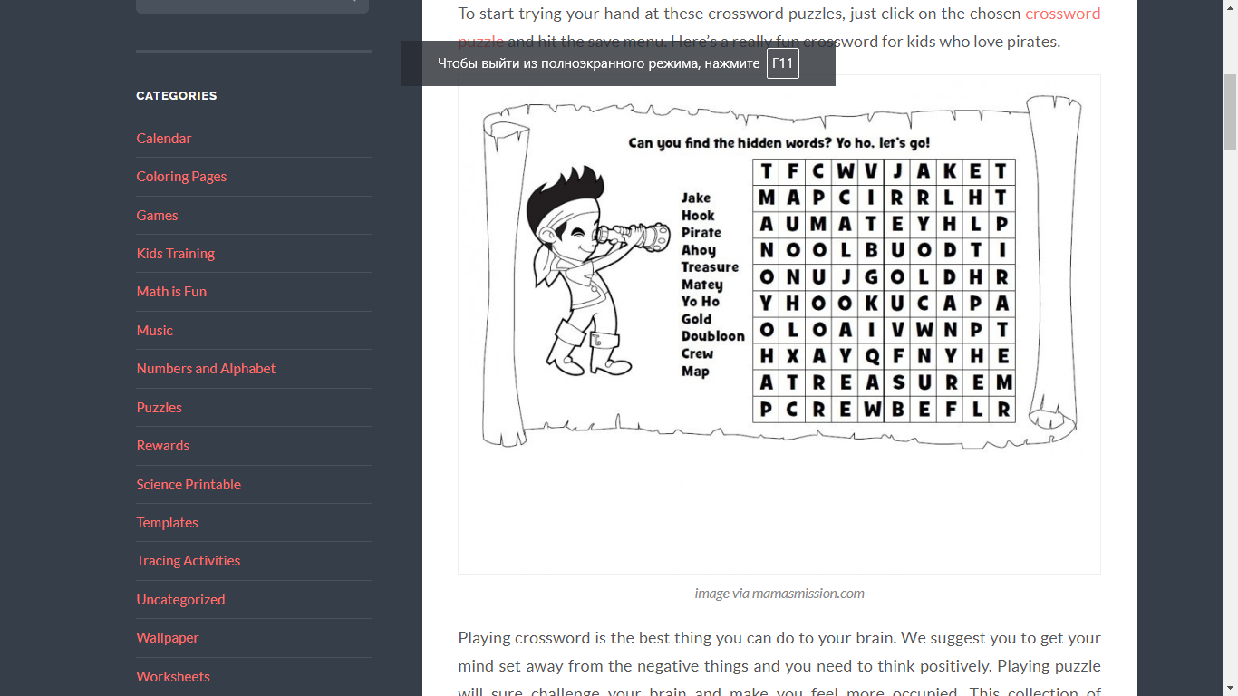  Reading.  Teacher tells pupils to read the text in groups and fill the gaps with the words above.  (parrot, hasn’t got, pirates, big, shark. Have got, hook, has got)  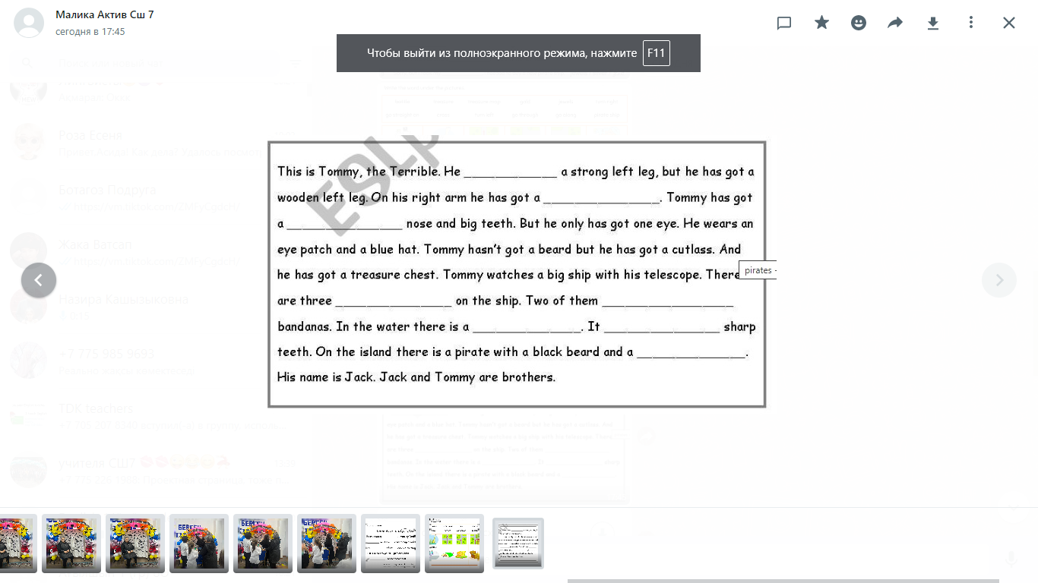  Extra activity  Matching task  Teacher asks pupils to come to the board and match picture with correct word. | Students respond to greeting  Pupils must find bottle with map in it and predict the topic of the lesson.  Pupils learn new words. Ss listen to the teacher and repeat after her.  Pupils write words under the pictures.  Pupils watch the video  Pupils read sentences and choose correct answer according the video in the Word wall quiz  Pupils listen to the story and do the test.  Answers  1-a  2-c  3-a  4-b  5-c  Each group solves the puzzle.  Pupils read the text in groups and fill the gaps with the words above.  Answers  1-hasn’t got  2-parrot  3-big  4-pirates  5-have got  6-shark  7-has got  8-hook  Pupils come to the board and match picture with correct word. | By praising  1 point  Descriptor  Pupil can:  -understand the story of the video.  -choose correct answers.  -do the task correctly.  - write the word under the picture  3 points  1 point  1 point  4 points  By praising | Bottle and map  PPT  Handout  Worksheet 1  Video  https://learnenglishkids.britishcouncil.org/short-stories/the-treasure-map  https://wordwall.net/ru/resource/5803059/treasure-map  PPT  https://www.liveworksheets.com/vt1207449ls  https://randomus.ru/split  worksheet  worksheet  https://wordwall.net/ru/resource/3282789/pirates/treasure-island
Ending the lesson  5 min | Reflection.  Teacher tells class to show the pirates as giving feedback of the lesson  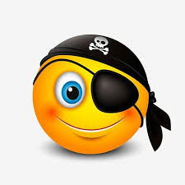  If they achieve Los they show:  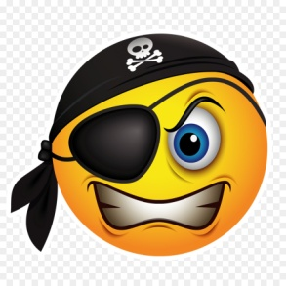  If they don’t achieve Los they show:  Teacher tells pupils that they have found the treasure. It’s knowledge that they have got in the lesson.  Home task: learn new words | Pupils evaluate themselves according the pirates smiles. | Feedback | Pirate smiles

Checked___________

