Short-term plan
Unit: | Natural disasters
Teacher’s name | Abdykashova Saule Mustafaevna
Date: | 17.11.2021
Grade: 10 | Number of present: | Absent:
Lesson title | Focus on Kazakhstan: reporting on the causes and consequences of natural disasters. The Gerund.
Learning objectives | 10.3.7 - use appropriate subject-specific vocabulary and syntax to talk about a range of general and curricular topics  10.4.3 - skim a range of lengthy texts with speed to identify content meriting closer reading on a range of general and curricular topics
Assessment criteria | -use specific vocabulary  -answer the questions about natural disasters
Lesson objectives | Learners will be able to learn:  To learn new vocabulary  To read the text and learn about types of natural disasters  Use the information from the text for discussion
Value links | Solutions to global issues, natural disasters and global citizenships
Cross curricular links | Geography, History, Biology
ICT skills | Using computer and flashcards
Previous learning | Natural disasters
Lesson procedure
Lesson stages | Teacher activity | Resources
Beginning  5 m  (IPW) | Greeting students Hello everybody! I’m glad to see you/  Guessing the theme of the lesson.  Warm-up “Define and predict”  Teacher tells learners that they are going to guess  the topic of the lesson.  Have these words written on individual slips of paper: Flood, landslide, earthquake, drought, gale, bizzard. Ss work in three groups and each group has two words which they have to think of definitions for. Ss should have an English monolingual dictionary to help them if possible. When ready, so that one student from each group reads their definitions without the term and the other group guesses the term. When finished, Ss work together in their groups of three to try to guess what the lesson will be about and what each of the words will refer to, e.g. We think it will be about the natural disasters.  When they have suggested some answers teacher  asks them to name the topic of the lesson.  - Identifying lesson objectives/Определение целей урока  - Today's topic is closely related to which subjects?  Suggested answers:  Geography  History  Biology  Сегодняшняя тема тесно свзяана с какими предматами?  Предполагаемы ответы:  География  История  Биологией | Presentation Natural disasters definition of the term
 | WITH THE HELP OF THE APPLICATION, STUDENTS DIVIDED INTO GROUPS PERFORM THE TASK "FIND A COUPLE".  VOCABULARY:  ROOT - топырақ  SOUTHERN - Оңтүстік  RAINFALL- жауын-шашын  SALTY - тұзды  IRRIGATE - СУАРУ  DAMAGE - зақымдану  DESTROYED – бұзылған  SELF-ASSESSMENT:criteria  1. SPEED  2. CORRECTNESS  САМОЦЕНИВАНИЕ:КРИТЕРИИ  - БЫСТРОТА  - ПРАВИЛЬНОСТЬ | LearningApps.org - создание мультимедийных интерактивных упражнений  https://learningapps.org/myapps.php  https://learningapps.org/watch?v=pz66vabta21
10 min | Groups receive a task:  Each of group is given a text:  1st Landslide  2nd Earthquake  3rd Aral Sea  They read the text and translate by using phone(translator), then answer on the question (highlightmain points of the text) that is given and make a poster with picture that describe the information of the text.  Question for the text:  1. Give a name the text  2. What about the text? What happened?  3. Where? When natural disaster is happened?  4. What caused the natural disaster? Reasons  5. Consequences  6. Other points of interest  1. A landslide struck southern Kazakhstan in the early hours of Sunday morning, burying some 30 people, the Kazakh emergency ministry reported on Monday. "The incident happened in the early morning when everyone was asleep. Twenty-eight bodies have been dug out so far," ministry spokesman Kairzhan Turezhanov told IRIN from the Talgar district, adding that the number of the dead could rise.  It is reported that the landslide buried two buildings in the settlement of Taldybulak in the southern Talgar district, some 20 km east of the Kazakh commercial capital of Almaty, at 1:32 am local time on Sunday.  Kairzhanov blamed heavy rains and waterlogged soil as the root causes of the incident. "Too much water was absorbed by the soil and this mud mass slipped from the mountains," he explained. Although there had been rains in the region, the incident was unexpected, he maintained.  "Last year we had more rains but there were no such incidents," the emergency official noted.  Meanwhile, rescue efforts involving some 200 emergency workers were now under way. "We are continuing to clean up the area and dig out the bodies. We will do that until we reach ground level and are sure that no bodies remain," Turezhanov said.  No casualties from landslides were reported last in year in Kazakhstan, according to the ministry. However, the mountainous parts of Central Asia, home to some 60 million, are exposed to various natural disasters, including landslides. Some 40 people were killed by a landslide in southern Kyrgyzstan in April 2003, while earlier in March another landslide destroyed a village in the southern Tajik province of Khatlon.  Meanwhile, scientists say that the recent increase in landslides and floods in the region is related to increased deforestation and higher rainfall due to global climate changes.  Question for the text:  1. Give a name the text  2. What about the text? What happened?  3. Where? When natural disaster is happened?  4. What caused the natural disaster?Reasons  5. Consequences  6. Other points of interest  2. At one time, the Aral Sea in Central Asia was the fourth largest lake in the world. It had an area of 67,300 square kilometres. Two of the biggest rivers in Central Asia, the Amu Darya and the Syr Darya, went into the Aral Sea. But the water almost disappeared.  The Aral Sea was a busy place The Aral Sea began to dry up in the 60s, when the water from the requestia flowing into it began to irrigate fields.In 1989, the Aral Sea split into two advantages of the reservoir - the Small Aral Sea on the territory of Kazakhstan and the Big Aral Sea  Then, in 2005, the Kazakh government and the World Bank built a dam. The dam separated the north and south parts of the sea. Then the north part of the Aral Sea started to fill with water again.  Philip Micklin is a scientist. He studies the Aral Sea. In 2010 he said ‘Nature can come back.’ But in 2014, he saw satellite pictures of the east part of the Aral Sea. It was completely dry.  In June 2015 a scientist from Uzbekistan, Yusup Kamalov, and a National Geographic reporter visited the Aral Sea. They found a huge desert. They stood on the sand. Once it was the edge of the water. Now the water is 80 kilometres away. They drove to the water. On the way, they passed oil and natural gas rigs. Kamalov said that every year there are more oil rigs. They arrived at the edge of the Aral Sea. The water was very salty. There were no fish. Kamalov said, ‘This is what the end of the world looks like’.  Question for the text:  1. Give a name the text  2. What about the text? What happened?  3. Where? When natural disaster is happened?  4. What caused the natural disaster?Reasons  5. Consequences  6. Other points of interest  3. Almaty city in Kazakhstan has been destroyed or damaged by devastating earthquakes three times in the last 125 years. Catastrophic earthquakes in Almaty took place in 1770, 1807, 1865, 1887, 1889 and 1911. In each of these earthquakes the city was heavily destroyed but was rebuilt every time. The 1911 Kebin earthquake happened on 3 January in Kazakhstan. Registering at a 7.7 magnitude, it killed 452 people, nearly 1,100 houses and 4,545 yurts were destroyed by the earthquake and the resulting landslides. About 85% of the world's fatal earthquakes have occurred within Eurasia and the severity of this threat is increasing rapidly as millions of people every year migrate into megacities. A fundamental problem is that devastating earthquakes such as those in Bam, Iran in 2003 (30,000 deaths), Muzzafarabad, Pakistan in 2005 (75,000 deaths) and Wenchuan, China in 2008 (70,000 deaths), were either previously unknown, or their threat had not been recognized.  SELF-ASSESSMENT: criteria  1. SPEECH  2. POSTER  3.TIMING  TIME FOR THE PERFORMANCE IS 2-3 MINUTES  САМОЦЕНИВАНИЕ: КРИТЕРИИ  1. РЕЧЬ  2. ПОСТЕР  3. ВРЕМЯ  ВРЕМЯ ДЛЯ ВЫСТУПЛЕНИЯ 2-3 МИНУТЫ | Word doc “Doc1”
10 min | WITH THE HELP OF THE APPLICATION, STUDENTS DIVIDED INTO GROUPS PERFORM A TEXT-BASED QUEST.  С ПОМОЩЬЮ ПРИЛОЖЕНИЯ СТУДЕНТЫ, РАЗДЕЛЕННЫЕ НА ГРУППЫ, ВЫПОЛНЯЮТ КВЕСТ ПО ТЕКСТАМ.  SELF-ASSESSMENT: CRITERIA  1. SPEED  2. CORRECTNESS  С1АМОЦЕНИВАНИЕ: КРИТЕРИИ  - БЫСТРОТА  - ПРАВИЛЬНОСТЬ  ОТВЕТ: 6032003RAIN1911 | Learnis – квест «Пора прибраться»  https://www.learnis.ru/549388/
End of the lesson | Identifying lesson objectives and learning outcomes  by the end of the lesson together with students  Teacher concludes the lesson and asks students to reflect their own activity at the lesson.  GRINDER BAG BUCKET  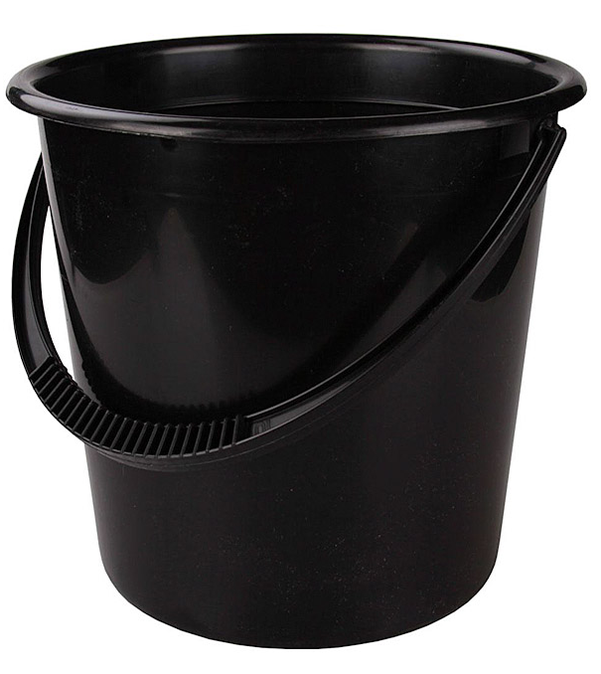

Оценивание с помощью карточек:
Красный 20 б
Зеленый 15 б
Желтый 10 б

Assessment using flashcards:
Red 20 b
Green 15 b
Yellow 10b

