Unit 7: Healthy Habits |  |  | School: School 5 named after A.Zhubanov with pre school
Date:13.04.22 |  |  | Teacher name: Dzhangurbaeva D.S.
Grade: 7 “G” |  |  | Number present: |  |  | Number absent:
Theme of the lesson: |  | Making plans and arrangements
Learning objectives |  | 7.1.1.1 use speaking and listening skills to solve problems creatively and cooperatively in groups;  7.3.6.1 begin to link comments with some flexibility to what others say at sentence and discourse level in pair, group and whole class exchanges;  7.5.6.1 link with little or no support, sentences into coherent paragraphs using a variety of basic connectors on a range of familiar general topics and some curricular topics;
Lesson objectives |  | All learners will be able to:  Identify the meaning of the theme  Complete the dialogue with the key phrases  Most learners will be able to:  Speak and listen skills to solve problems creatively and cooperatively  Make up sentences using indefinite pronouns  Some learners will be able to  Discuss and give their opinions by own words  Write a short dialogue about to start keeping a diet
Assessment criteria |  | - apply speaking and listening skills to solve problems creatively and cooperatively in groups.  - use specific vocabulary words in making a dialogue
Previous learning |  | Present Continuous for future
Plan
Planned timings | Planned activities |  |  | Learners’ activities | Evaluation |  | Resources
Begining  5 min | ORGANIZATION MOMENT  Greeting  Warm - up.  It’s time to think!  It’s time to speak!  It’s time to show!  It’s time to ready study go!  “Brain storm” activities  Quotation: “a healthy mind in a healthy body”  Thales of Miletus.  What did Miletus Thales mean by this proverb? |  |  | Greeting  Students repeat and actions | Verbal evaluation  Verbal evaluation |  | PPT slides  1-12
Middle  30 min  End  5 min | Group Division: Students are divided into two subgroups using colored sweets.  1 group – Happiness  2 group - Smiles  Teacher asks go through the indefinite pronouns on the slide, and point out that the ending changes depending on the purpose of the pronoun. In a weaker class, explain that -thing relates to an object, -where relates to a place, and -one relates to a person. In a stronger class, elicit this information.  We use indefinite pronouns to refer to people or things without saying exactly who or what they are. We use pronouns ending in -body or -one for people, and pronouns ending in -thing for things. And pronouns ending in – where for places.  Task 1. Test  Teacher asks them to imagine that they want to meet some friends and go to a football match. Asks: What things do you need to talk about with your friends?  Teacher asks the students to practice speaking like this in English.  Task 2. Ex.1 Teacher asks students to listen for where and when Callum and Gemma are meeting.  Task 3. Ex. 2 Teacher asks students to complete the dialogue with the key phrases and check.  1 b Are you doing anything this evening?  2 d No, nothing special.  3 a What are you up to?  4 c if you’re interested.  5 f It’s on at  6 e Shall I meet you outside … ?  Task 4. Ask and answer the questions using “some”.  Do you see anything in the fridge?  What is healthy food?  What is unhealthy food?  Task 5. Speaking. . Situations and Role plays  Teacher hands out situation tasks to two groups. They have to solve the problem and act out the dialogue  Students will discuss in their group about health habits and make up a dialogue. (Role play )  Feedback with a smile.  Pupils will take the stickers and put on the suitable smile. 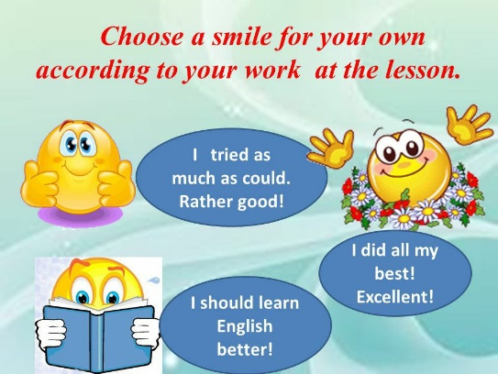  Home task: s.b. page 98 ex 5  Saying goodbye. |  |  | Students do the test  Students own answers  Students listen and answer  Students own answers  Students own answers  Students makes up a dialogue and act. | Verbal evaluation  Individual avaluation  Individual avaluation  Individual avaluation  Individual avaluation  Individual avaluation  Self-assessment |  | PPT slides  1-12  PPT slides  1-12  CD  Students book p.98  Students book  PPT slides  1-12  PPT slides  1-12

