THE MINISTRY OF EDUCATION AND SCIENCE OF THE REPUBLIC OF KAZAKHSTAN
ABAI KAZAKH NATIONAL PEDAGOGICAL UNIVERSITY

«Approved by »
_________________________
The Chair of Foreign Languages

FINAL PROJECT
Theme: «Formation of reading skills at the middle stage of education using information technology»
6B01703 - « Foreign language: two foreign languages»

Performed by:
Popova D.D.
Koltunova A.I.
Auelbek N.O.

Academic supervisor:
Balmukhanova S.N.

Almaty 2022
Fulfillment Schedule

№ | Types of work | Date | Completion mark
1 | Preparation of a research program | October | Done
2 | Preparation of an analytical review of the topic | October | Done
3 | Collection of raw empirical data | November | Done
4 | Processing and analysis of the information received | November | Done
5 | Development of methodological tasks and exercises | December | Done
6 | Preparation and design of the text part of the diploma project | January | Done
7 | Preparation and design of visual (graphic) material | February | Done
8 | Preparation of presentation for pre-defense | March | Done
9 | Defense of the diploma project | June | Done
The task was given “_____” __________2021
Scientific supervisor: Balmukhanova S.N. ____________
Student: Popova D.D.________________
Student:Koltunova A.I. ________________
Student:Auelbek N.O. ________________
CONTENT

- INTRODUCTION……………………………………………..………………….......4
- PRACTICAL PART……………………………………………..................................7
- CONCLUSION………………………………………………………………….......26
- LIST OF USED LITERATURE……………………………………………………..27
- APPENDIX 1………………………………………………………………………..28
- APPENDIX 2………………………………………………………………………..29
- APPENDIX 3………………………………………………………………………..33
- APPENDIX 4………………………………………………………………………..36

INTRODUCTION
Relevance of the project and its novelty. Reading in a foreign language is one of the most essential tools for effective foreign language proficiency. Through reading, the experience accumulated by humanity in various areas of life, the development of the intellect, and the education of a socially valuable person are transmitted. [1, p. 192].
Reading is one of the four types of speech activity, which is a necessary and important component in teaching English. "Reading is a written reproductive type of speech activity, as a result of which we receive the necessary information, emotions or learn the author's position" [2, p. 331].
Reading as a type of speech activity in a foreign language is the most essential for most people. Few people have the opportunity to communicate with native speakers, but almost everyone has the opportunity to read in a foreign language. That is why teaching to read is very important in teaching a foreign language. [3, p. 331].
In this connection, it is necessary to consider the available definitions of the term "reading", given by various researchers in the field of foreign language teaching. The well-known psychologist D.B. Elkonin wrote: "Reading is, first of all, the process of reconstructing the sound form of words according to their graphic (letter) model" [4, p. 37]. V.G. Goretsky and V.A. Kiryushkin mean that reading is such a type of speech activity, which consists in the identification, active processing and awareness of semantic information [5, p. 254].
According to A. N. Leontiev, reading in a non-native language is a special case of the perception process [6, p.9].The famous psychologist L.S. Vygotsky understood reading as a technology of intellectual development, a way of acquiring culture, a mediator in communication, a means for solving life problems [7, p. 158].
According to S.K. Folomkina, reading is defined as "a process aimed at extracting information contained in a written speech work-text" [8, p.268]. Z.I.Klychnikova analyzes reading in detail as a type of speech activity and identifies essential features that distinguish it from other types of verbal communication [9, p.17].
Historically, reading "appeared later than oral speech and on its basis" [10, p.139], and became one of the important means of communication and cognition.
Reading belongs to receptive speech activities, the purpose of which is visual recognition of graphic signs and understanding of written language. [11, p.239]. Reading enters the sphere of communicative and social activity of people and provides a written form of communication in it [12, p.256]. As E.I. Passov notes, reading is focused on "semantic perception" [13, p. 27].
Nowadays there is a rapid development of information and communication technologies and their pervasion in all spheres of social life, including the educational sphere. That is why the problem of the most effective application of information technology in teaching reading in a foreign language becomes very relevant. The specific nature of teaching a foreign language lies in the fact that students learn the language in an artificial language environment due to the lack or of a natural one. This situation involves the widespread use of computer technology and various technical means of teaching, which can contribute to the successful formation of reading skills in English at the middle stage of teaching. [14, р.13].
According to N.D. Galskova and N.I. Gez, correction and improvement of reading is carried out at the middle stage of teaching [15, p. 231]. In this way, the use of information technology in secondary school opens up new opportunities for developing reading skills in English.
Consequently, all of the above arguments specify the relevance of the final project.
The noveltyof the final project consists in formation of reading skills based on using information technology in teaching the English language in secondary school.
The aim of the final project is to create methodological recommendations focused on formation of reading skills through the application of information technology including reading texts, and interactive tasks and exercises to be used in practical English lessons in 7th grade.
Research objectives:
1) to study scientific and methodological literature related to the concept of reading as a receptive type of speech activity in teaching a foreign language.
2) to review and select Internet resources and approaches that would be methodologically effective for the purposes of the final project based on information technology.
3) develop a system of tasks and exercises based on the text for reading, taking into account the formation of applicable Internet resources for the development of reading skills based on the textbook "Excel" grade 7.
Expected results of the project: methodological recommendations aimed at formation of reading skills by the way of application of information technology in English lessons in secondary school in 7th grade.
Stages of the final project implementation:
1) Study of relevant literature on the topic of the final project.
2) Selection of information technology resourcessuitable to the aims of the final project and appropriate methods of teaching reading.
3) Application of IT resources in English language teaching.
Prospects of final project:
Тhe theme of the final project is perspective, since nowadays in conditions of modernization of education at all the levels the introduction of innovative computer technologies is an urgent must and want. The evident rapid development of IT results in new digital technological approaches which would require their research and practical application.
Project content:
The final project consists of Introduction, Practical part, Conclusion,List of used literature and Appendices.
Introduction provides a brief description of the theoretical aspects of the final work; clarifies the relevance, goal and objectives and formulates the expected results of the project.
Practical part contains methodological teaching materials used on formation of reading skills with the help of information technology in English language teaching practice.
In Conclusion, the results of the work done during preparation of the final projectare summarized and conclusions are made.
The List of literatureincludes the list of works used for writing the diploma project.
The Appendices include lesson plans, tables, visualizations of the interactive activities, and diagrams with assignments and exercises used in practical English lessons.
Description of the project team and each participant's area of responsibility for specific parts of the project:
The projectteam participants are Popova D.D., Koltunova A.I and Auelbek N.O. Each participant has her own area of responsibility for specific parts of the project.
1. Popova D.D. is responsible for analysis and choice of appropriate IT resources and methods of their application in practical English lessons.
2. Koltunova A.I. responsible for methodological literature analysis and creating reading textbased exercises with view to IT resources, as well as for designing and editing the final project.
3. Auelbek N.O. responsible for analysis of theoretical literature to justify the relevance of the project topic and developing reading text related tasks and exercises.

PRACTICAL PART
«Formation of reading skills at the middle stage of education using information technology»
Nowadays there is a rapid development of information and communication technologies and theirimplementation in the teaching process. That is why the problem of the most effective application of computer technologies in teaching reading in a foreign language becomes very topical.
Reading in English class is very important. It helps to:
- increase the vocabulary.
- understand the meaning of the text.
- to practice grammar structures.
Information technologies are being used increasingly insecondary schools to develop reading skills at the middle stage. It is impossible to imagine a modern school without new information technologies, because the next level of the educational process involves the use of computer technology in school. The use of information technologies in the classroom is one of the modern means of implementing a personality-oriented approach in teaching English at school. The modern lesson assumes a new level of knowledge acquisition, development of cognitive interests, intellectual and creative abilities.
Among the most frequently used IT in the educational process, necessary to name: interactive whiteboards, electronic textbooks and manuals demonstrated using a computer and a multimedia projector, testing programs and simulators, electronic reference books and encyclopedias, educational resources on the Internet, paintings and illustrations on CD and DVD media.
In order to find out the effectiveness of the use of information technology in the formation of reading skills at the middle stage, a lesson was conducted using information technology.
Experimental teaching was conducted in Municipal State Institution Secondary School #9, located in the Almaty region, Grade 7. There are total 25 students in Grade 7.

During the English lessons we used these Internet resources:

Table 1.1 –Internetresources (APPENDIX 1)
The main tasks of teaching:
1) Development of an English lesson based on a model of teaching reading using Internet resources.
2) Formationof reading skills based on Internet resources in grade 7.
Text #1
Excel for Kazakhstan (Grade 7) Student`s book (authors: Virginia Evans, Jenny Dooley).
DAVID COPPERFIELD
By Charles Dickens
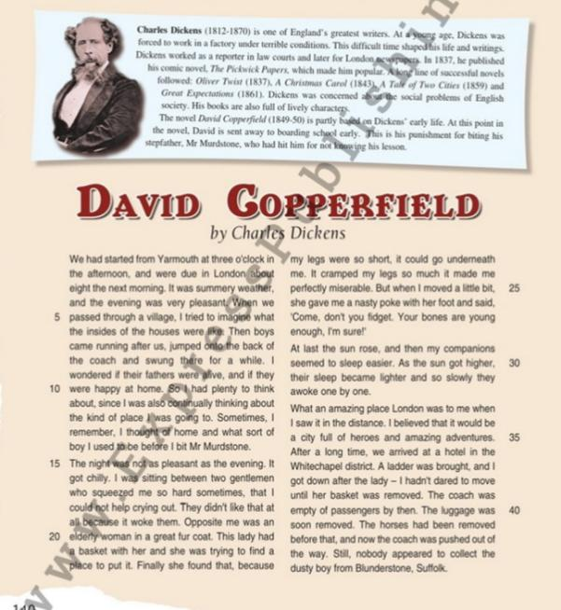
Table 2.1– Reading text. Excel for Kazakhstan (Grade 7) Student`s book (APPENDIX 2)
Pre-reading stage
Task1. Answer the questions
Students answer the questions using the Padlet interactive board after looking atthe text.
In this activity, students use the Padlet educational platform, they answer the questions.
- What is the title of the text?
- What is the author’s name?
- Do you know any other works by this author?
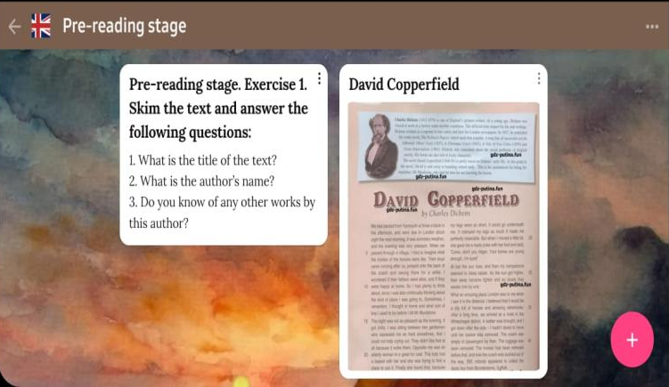
Table 2.2 -Pre-reading stage. Task 1(APPENDIX 2)

Task 2. Vocabulary
Match the words with definitions:
1. Jump  2.Distance  3. Coach | a. to push yourself suddenly off the ground and into the air using your legs  b.the amount of space between two places  c. someone whose job is to teach people to improve at a sport, skill, or school subject
Table 2.3 -Pre-reading stage. Task 2 (APPENDIX 2)

Task 4. Brainstorming
Brainstormingallows student to expand students vocabulary for better students understanding new information from the text.
In this activity students recall words related to the topic of the text. Students are given only categories, and they must recall the words and enter them into the mind map on their own.
A mind map is a tree-like diagram: in the center is the key topic (idea, problem), and around it are the constituent parts (tasks, resources). It illustrates both the objects themselves and the connections between them.
We made mental map using the Mind Meister app. Students used it to create 3 kinds of mind maps and use them in different ways.
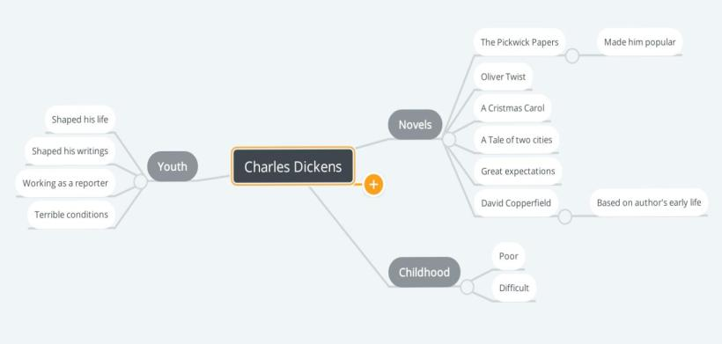
Table 2.4 - Pre -reading stage. Task 3 (APPENDIX 2)

While-reading stage
Task 1. Reading.
Read the first paragraph and identify the text'smeaning.
The exercise was performed in the Book Widgets service. Studentsare invited to make an approximate conclusion on the title and the first paragraph, what can be discussed in the text.
We had started from Yarmouth at three o’clock in the afternoon, and we were due in London about eight next morning. It was summer weather, and the evening was very pleasant.When we passed through a village I tried to imagine what the insides of the houses were like. Then boys came running after us ,jumped onto the back of the coach and swung there for a while.
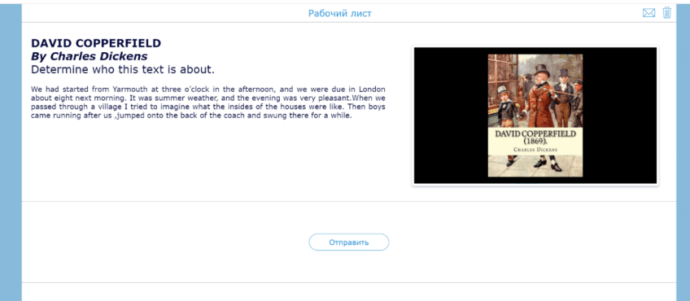
Table 2.5–While-reading stage. Task 1(APPENDIX 2)
Task 2. Find the missing words.
Students read the text "DAVID COPPERFIELD" and insert the missing words according to the text.
This assignment is done by using the Wizerservice.The task involves finding the correct information.
1. We had started from Yarmouth at three o’clock in the _______, and we were due in London about eight next morning.
a)afternoonb)day c)evening d)light
2. It was summer weather, and the _______ was very pleasant.
a) afternoon b)circulating c) evening d) gases
3. When we passed through a village I _______ to imagine what the insides of the houses werelike.
a) slow down b)stay c) tried d)break apart
4. Then boys came running after us,_______ onto the back of the coach andswung there for a while.
a) conductionb) jumped c) swung d) evaporation
5. The night was not so _______ as the evening.
a) pleasant b) convection c)radiation d) combustion
6. At last the sun _______, and then my companions seemed to _______ easier.
a) pleasant b) convection c) radiation d) combustion
7. As the sun got _______, their sleep became lighter, and so slowly they awoke one by one awoke.
a)higher b) awoke c) radiation d) combustion
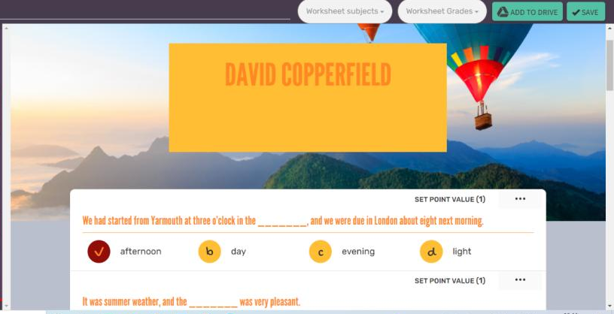
Table 2.6 - While -reading stage. Task 2(APPENDIX 2)
Task 3. Match true or false.
In this assignment, students must find the correct or incorrect statement from the text. We used the Kahoot platform for this exercise, students can see the answer right after all questions. At the end of the test, a table of winners is provided.
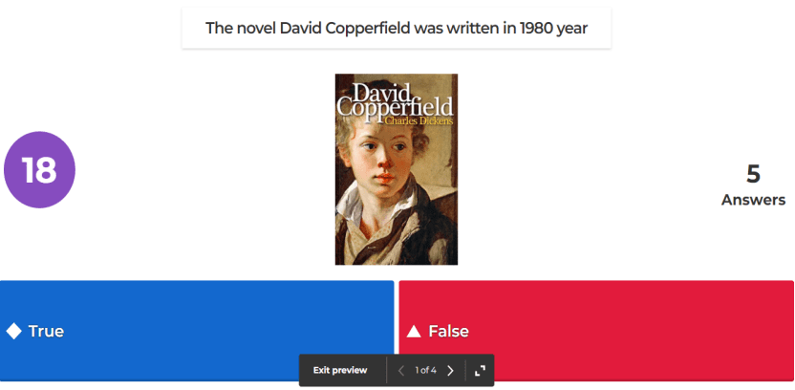
Table 2.7 - While -reading stage. Task 3 (APPENDIX 2)

Post-reading stage
Task 1. Making a plan.
Students make a plan of the text, highlighting its main thoughts.
The exercise was performed in the Book Widgets service in the "Lesson Questions" section. Students need to answer how much the lesson material was understood and prepare an answer to the question.
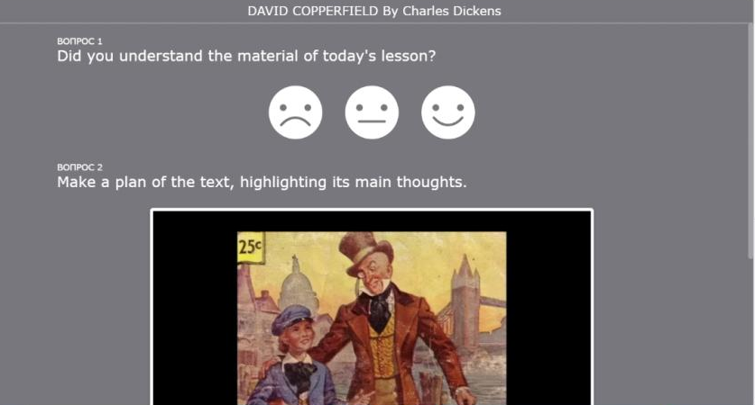
Table 2.8 - Post -reading stage. Task 1(APPENDIX 2)
Task 2. Logical order.
In this assignment, students put sentences in the correct logical order according to the text.
Here they must move the sentences up and down, after the task is completed the student sees the correct and incorrect answers immediately.This task is done using the Learning App platform.
Table 2.9 - Post -reading stage. Task 2 (APPENDIX 2)
Table 2.10 - Post -reading stage. Task 2 (APPENDIX 2)

Text #2
Enjoy English for 7th grade(authors: M.Z. Biboletova, N.N. Trubaneva).
Music in the Streets
As you go home after a hard day’s work, and you get off the metro train, you sometimes have to walk a long way to the exit or to change trains. Suddenly in the noise, some music is heard. Those are street musicians. You take out a coin from your pocket and throw it into their hat or instrument case. These musicians bring color and life to the city streets. Street musicians are aged between 17 and 30 years. Some of them are men, some women. They play classical music, pop or folk music, old and new songs. Many musicians are former university students or professional musicians.
Andrew Hain, for example, was once a music student, but he gave up music and became a painter. Now he plays in the underground because he doesn’t want to forget how to play. His girlfriend is a painter, too. She helps him to collect the money. Another street musician, David MacNell, tells new players:
“Learn new songs all the time, or else you’ll have fewer and fewer listeners. Wear bright clothes to attract attention. Make sure that the places where you choose to play are warm. The best places are bridges and certainly the underground.”
On Sundays, Hyde Park is the best place, as the speakers here address the people. The street musicians are doing their business with the many tourists who visit the park. The weather is one of the worst problems. It is not so easy to play the violin or the guitar on a rainy November day in London and try to smile.
A much worse problem is the police. From time to time, they come, and the musicians are moved to a different place. True, they are not often fined. One musician told me:
“The policeman asked me what I was doing. I said I was just practising. Some money just fell out of my pocket into the guitar case, and I was told to leave my place. I think it’s not fair. People love street music. It makes the city more attractive.”

Pre-reading stage
Task 1.
Brainstorming allows student to expand your vocabulary and prepare students to receive new information from the text.
This activity asks students to recall words related to the topic of the text. Students are given only categories, and they must recall the words and enter them into the mind map on their own.
A mind map is a tree-like diagram: in the center is the key topic (idea, problem), and around it are the constituent parts (tasks, resources). It illustrates both the objects themselves and the connections between them.
We made this mental map using the Mind Meister app. Students used it to create 3 kinds of mind maps and use them in different ways.
Task 2. Vocabulary:
In this task, the student is required to find the appropriate definition for the word and attach it to it using the computer mouse. After attaching all the definitions to the desired words, finish the task and look at the result of the work done.
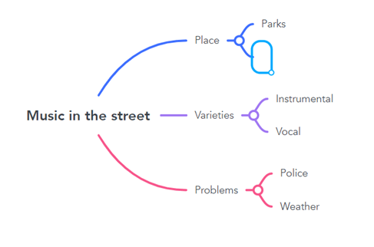
Table 3.1 - Pre-reading stage. Task 1(APPENDIX 3)

While-reading stage
Task 1. Reading:
Read the text «Music in the Streets» again and complete the sentences according to the text. Here the student need to read the text and fill in the blanks with the suggested words. After finding all the words the student can check the correctness of the task.
Here the student need to read the text and fill in the blanks with the suggested words. After finding all the words the student can check the correctness of the task.
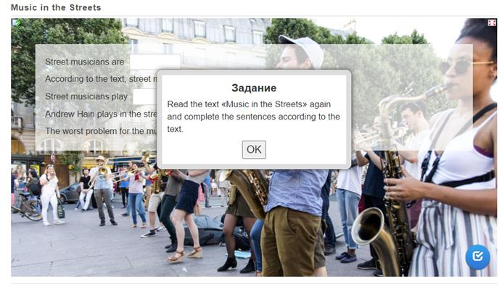
Table 3.2 - While -reading stage. Task 1(APPENDIX 3)

Post-reading stage
Task 1. Answer the questions:
Students answers open-ended questions after reading the text.
- Why should street musicians wear bright clothes?
- What are the best places for street musicians?
- Which is worse for street musicians – the weather or the police?
- Why do street musicians need to learn new songs all the time?
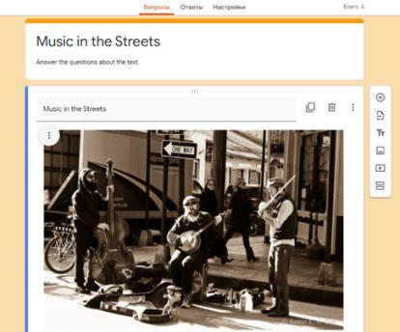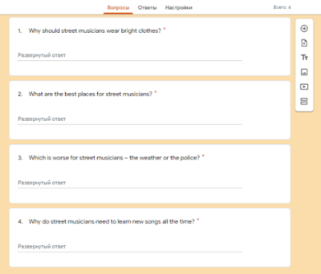

Table 3.3 - Post -reading stage. Task 2(APPENDIX 3)
Task 2. Logical order.
In this assignment, students must put sentences in the correct logical order according to the text.
Here they must move the sentences up and down, after the task is completed the student sees the correct and incorrect answers immediately.
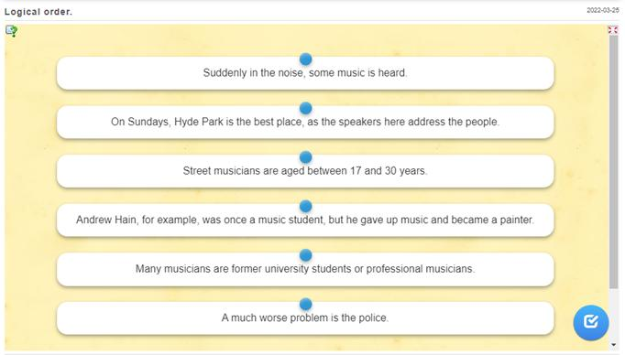
Table 3.4 - Post -reading stage. Task 2(APPENDIX 3)

Text #3
Enjoy English for 7th grade (authors: M.Z. Biboletova, N.N. Trubaneva).
My New School Is Fantastic
Rita Nelson is fourteen, and she has changed her school because her parents moved to another town this summer.
“Let me tell you about my new school. I’m having a great time. All pupils are very friendly, but it’s very different from my old school. I can tell you! First of all school starts at 8.00 here, a whole hour before it did in that school. This morning I forgot about it and got to school ten minutes late, so the teacher put a note into my record-book. I was really angry!
There are a lot of other differences in this school, of course. We have seven lessons here almost every day. What else? The school day is different, too. In my former school we finished school at 3.00, and then most pupils went home. Here we finish lessons at 3.30, and then most pupils go to sports practice. Well, they love sports here.
I joined gymnastics and football clubs here. A lot of girls play football in this school. I had my first practice yesterday, and I feel tired today.
Another important thing here is learning to do practical things. Their metal and wood shops are like small factories, and we are taught to drive as well. It’s fantastic. I had my first lesson in driving a tractor yesterday.”

The Pre-reading stage
Task 1. Vocabulary:
This is an exercise on Pre-reading we created it in two ways. The first method is a matching task. In the second method, we created a multiplechoice quiz.
Match the words with definitions:
1. town  2. late  3. record-book  4. difference  5. factory | a. (happening or being) near the end of a period of time  b. a place where people live and work, containing many houses, shops  c. the way in which two or more things which you are comparing are not the same  d. a building or set of buildings where large amounts of goods are made using machines  e. a book containing records of the best or most outstanding achievements in a particular activity

- Match
Drag each keyword to its definition.
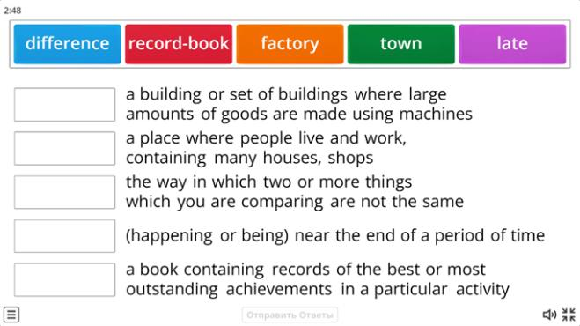
Table 3.5.Pre-reading stage. Task 1(APPENDIX 3)
2. Quiz
A series of multiple choice questions. Click the correct answer to continue.
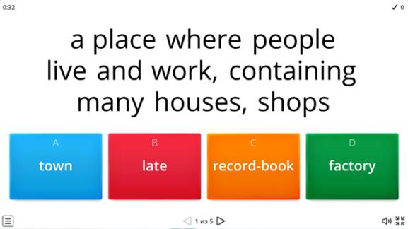
Table 3.6.Pre-reading stage. Task 1(APPENDIX 3)

While-reading stage
Task 1. Reading:
Read the text « My New School Is Fantastic» again and complete the sentences according to the text.
This exercise was created in the Word wall service in the form of a quiz "Game Show". A quiz with multiple choice and limited time. This exercise is great for the goal, which involves finding out from children how carefully they read the text.
1. Rita Nelson is _______
a) 13 b) 14 c) 15
2. Lessons in Rita’s previous school started at
a) 7 o’clock b) 8 o’clock c) 9 o’clock
3. Rita has _______ lessons every day.
a) 5 b) 6 c) 7
4. Rita’s lessons are over at
a) 3. 00 b) 3.30 c) 4.00
5. After lessons most pupils go
a) to sports practice b) home c) for a walk
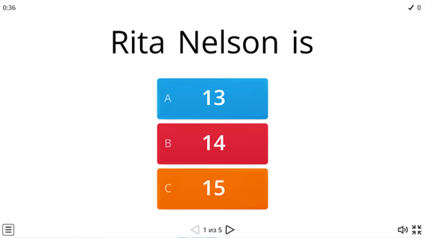
Table 3.7. While -reading stage. Task 1(APPENDIX 3)

Post -reading stage
Task 1. Drawing a plot.
Draw a plot you like from the text and describe it.
With the help of an interactive whiteboard in the Book Widgets service, students are invited to draw a plot from the text and describe the resulting drawing.
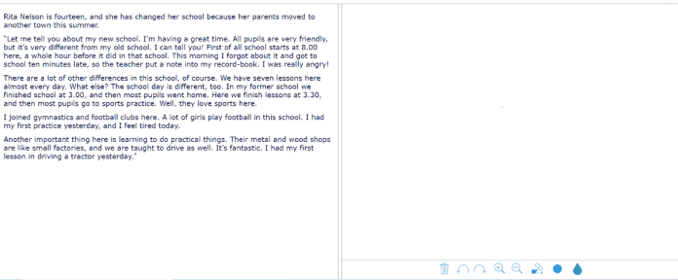
Table 3.8. Post -reading stage. Task 1(APPENDIX 3)
To check the effectiveness of the use of information technology in English lessons for teaching reading, such methods of research as observing and experiments were used. The participants of the experimental activity were the students of the 7th grade.
In order to get feedback on our reading instruction, we made a questionnaire for the 7th grade students. We needed to find out their attitudes and opinions about using a variety of Internet resources to teach reading in English lessons and to find out the efficiency of using information technology in teaching reading speech activities.
After the lesson, students were asked to fill out a questionnaire to get a reflection on working with the interactive whiteboard and using information technology in English lessons in order to determine the impact on motivation and on the formation of students' reading skills.
Analysis of the results of teaching process.
This survey was conducted remotely using Google Forms. Thanks to this site, it was convenient to see the results of the survey and conduct a visualization using diagrams.
Questionnaire
Mark only one answer
1. Was it interesting to complete the tasks using ICT technology?
а) Yes
b) No
c) Don't know
2. Did you like using interactive whiteboard at the lessons of English language?
а) Yes No Don't know
b) No
c) Don't know
3. Which Internet resource did you like best?
- Kahoot
- Book Widgets
- Quillion
- Wizard service
- Word wall
- Mind meister
- Learning App
- Wizer
- Padlet
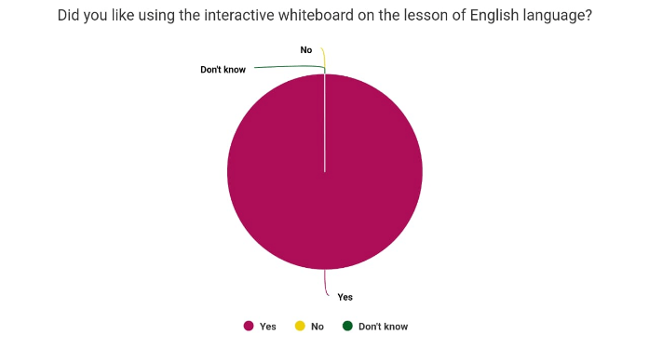

Table 4.1 - Survey results(APPENDIX 4)

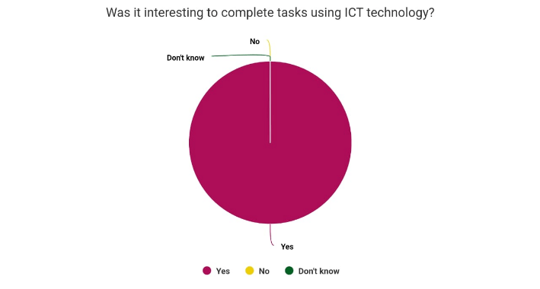
Table 4.2 - Survey results(APPENDIX 4)

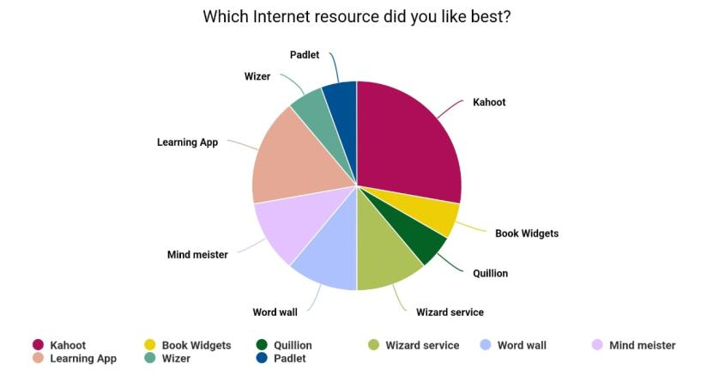
Table 4.3 - Survey results(APPENDIX 4)
As a result of the survey conducted with the 7th grade of the CSI secondary school #9, the effectiveness of the use of information technology English lessons in the formation of reading skills was proved.
Teaching reading in foreign language lessons usingInternet resources contributed to increasing the level of cognitiveinterest of students.
Each task was carried out with the initiative of the students, and there was a sense of interest in achieving a good result of the work. The choice of the sequence of tasks was justified and methodically correct, since it was a logical continuation of the work in the lesson.
Based on the general observation of students, during classes with the use of information technology, it can be concluded that interest in studying the material increased, work in the classroom began to "boil" and studentswere actively involved in the lesson process. Thus, an experimental study shows that information technologies can be included in the process of forming reading skills in English and this increases motivation, increases cognitive interest and thereby brings good results.

CONCLUSION
The purpose of practical part was to substantiate the effectiveness of diverse information technology resources in the formation of reading skills in English lessons.
We have selected Internet resources to create methodological recommendations focused on the formation of reading skills through the application of information technology in teaching reading, including relevant texts for reading, tasks and exercises to be used in practical lessons in the 7th grade. After completing the teaching activities, we asked students to fill out the questionnaire to determine the effectiveness of information technology. According to the results of the survey based on the responses of students, it can be concluded that the use of information technology in English lessons for the purposes of final project was effective.
Thus, during the work on the final project the concept “reading” was considered from a theoretical aspect; the criteria for selecting the necessary educational Internet resources were determined; the stages of working with a reading text were identified; the types of tasks and exercises for the formation of reading skills using information technology were developed, and the collected material was put into teaching practice with follow-up analysis.
The aim of the final project has been achieved, namely, the effectiveness of application of information technology in the process of formation of reading skills in English at the middle stage of education was proved and presented in methodological recommendations.
Application of IT in English lessons turned out to be beneficial for students. With the help of information technology acomfortable foreign-language atmospherewas created, a wide variety of diverse computer based taskswas visually introducedand completed, increasing the interest and engagement of students in Englishteaching activities. The most important outcome was the visible improvement of reading skills of students, along with tangible progress in vocabulary and grammar structures.

LIST OF SOURCES AND USED LITERATURE
1.Galskova N. D. Modern methods of teaching foreign languages. Manual for teachers.– M.: ARKTI, 2004.–р192.
2. Lyakhovitsky M. V. Methods of teaching foreign languages Methodical manual.- M.: Bustard, 2006.- 369 p.
3. Zimnaya I. A. Psychological aspects of teaching speaking in a foreign language. – M., 1985.- p. 331.
4. Elkonin D.B. How to teach children to read.-M., 1991.- p. 37.
5. Goretsky V.G. et al. Lessons of teaching literacy.-M., 1988.- p. 254.
6. Leontiev A. N. Psychology of teaching reading // Elementary school: plus minus. 1999. No. 10. p - 9.
7. Vygotsky, L.S. Psychology of child development/L.S. Vygotsky. -MaskvaExmpo, 2004.- p. 158.
8. Folomkina S.K. Methodology of teaching reading in English at secondary school. Avtoreferatdokt. diss. М., 1974.- p.268.
9. Klychnikova Z.I. "Psychological features of learning to read in a foreign language",1994. - p.17.
10. Methods of teaching foreign languages in high school. - Moscow: Prosveshcheniye, 1991. - p.139.
11. Bim I.L. Methods of teaching foreign languages as a science and problems of a school textbook. - M., 1994.- p.239.
12. Vaisburd M.L. Requirements for texts for independent (synthetic) reading in English in the seventh grade. - M. – 1955.-р.256.
13. Passov E. I. Learning to read: A textbook. – Voronezh: Interlingua,2002.- р.27.
14. Zakharova I.G. Information technologies in education / I.G. Zakharova //- Moscow: Akademiya, 2007.р.13.
15. "Methods of teaching foreign languages in secondary school. N.I. Gez, M.V. Lyakhovitsky, A.A. Mirolyubov, S.K. Folomkina, S.F. Shatilov. М., 1982. – рр 231-245.

APPENDIX 1

Table 1.1 - Internet resources

APPENDIX 2

Text #1
Excel for Kazakhstan (Grade 7) Student`s book (authors: Virginia Evans, Jenny Dooley).
DAVID COPPERFIELD
By Charles Dickens
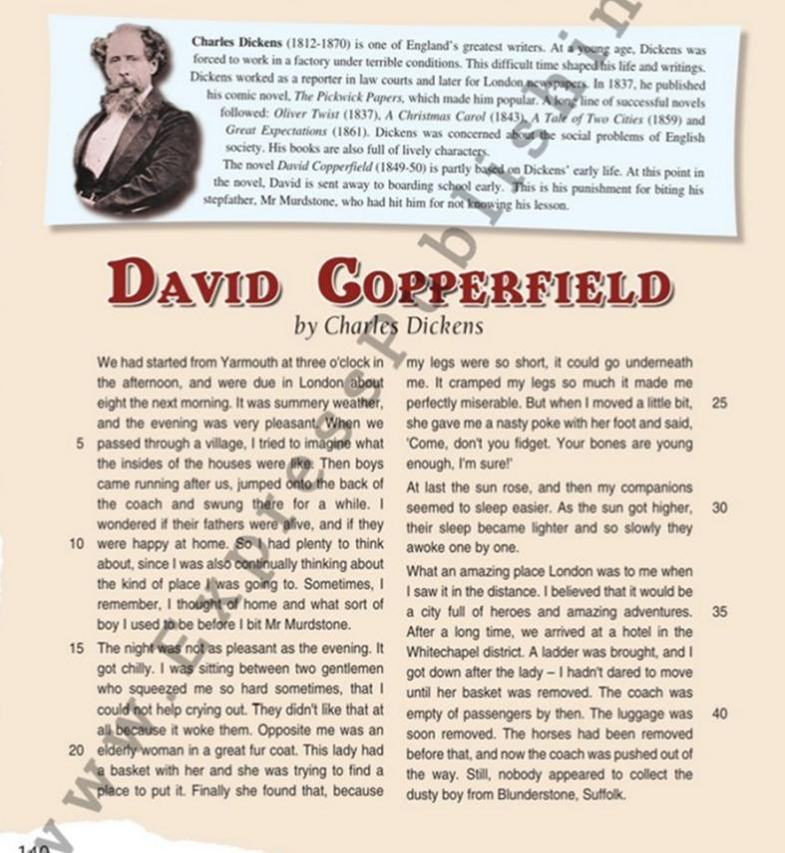
Table 2.1 - Text #1. Excel for Kazakhstan (Grade 7) Student`s book
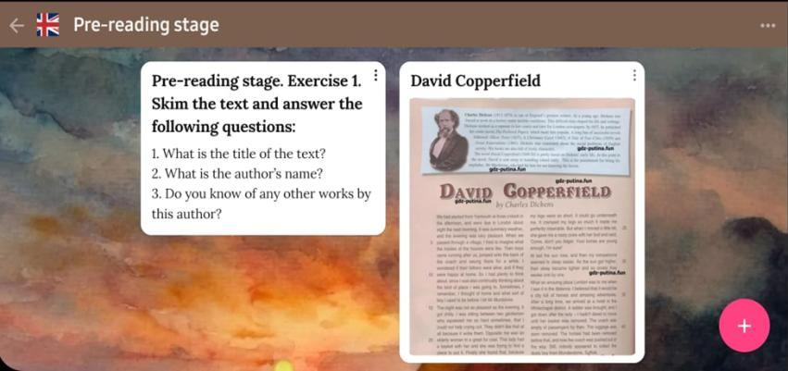
Table 2.2- Pre-reading stage. Task 1
Table 2.3-Pre-reading stage. Task 2
Table 2.4 - Pre-reading stage Task 3
Table 2.5 - While-reading stage. Task 1
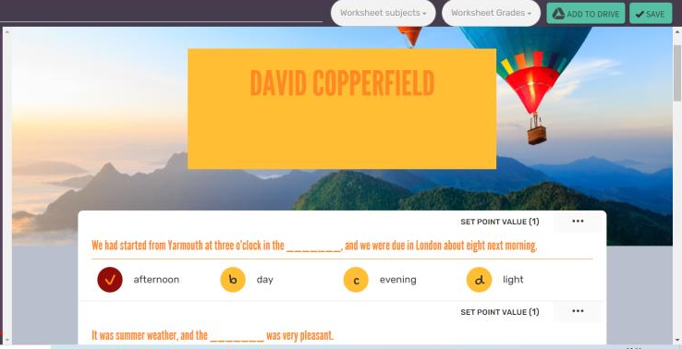
Table 2.6 -While -reading stage. Task 2
Table 2.7 - While -reading stage. Task 3

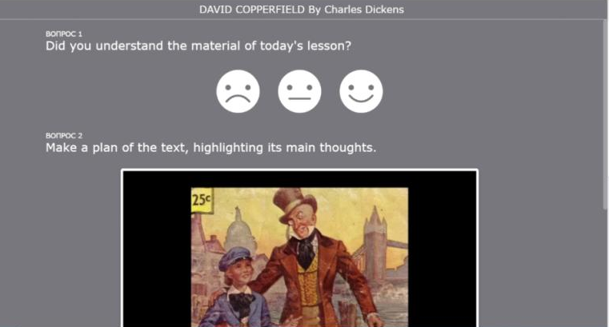
Table 2.8 - Post -reading stage. Task 1
Table 2.9 - Post -reading stage. Task 2

APPENDIX 3

Table 3.1 - Pre-reading stage. Task 1

Table 3.3 - While -reading stage. Task 1
Table 3.3 - Post -reading stage. Task 1
Table 3.4 - Post -reading stage. Task 1
Table 3.5.Pre-reading stage. Task 1
Table 3.6.Pre-reading stage. Task 1
Table 3.7. While -reading stage. Task 1
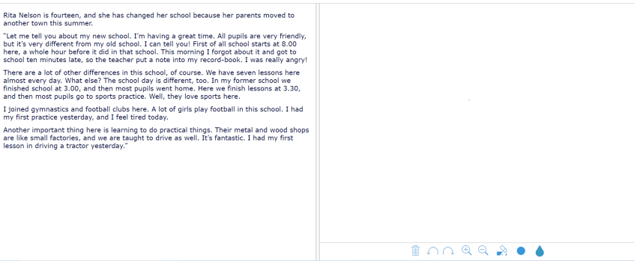
Table 3.8. Post -reading stage. Task 1

APPENDIX 4
Questionnaire

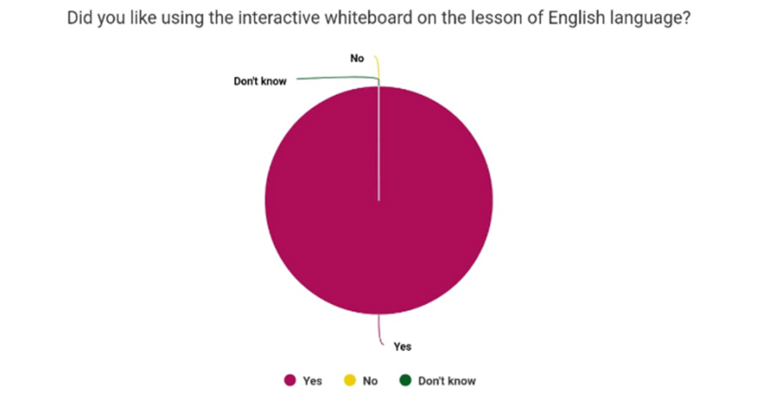

Table 4.1 - Survey results

Table 4.2 - Survey results

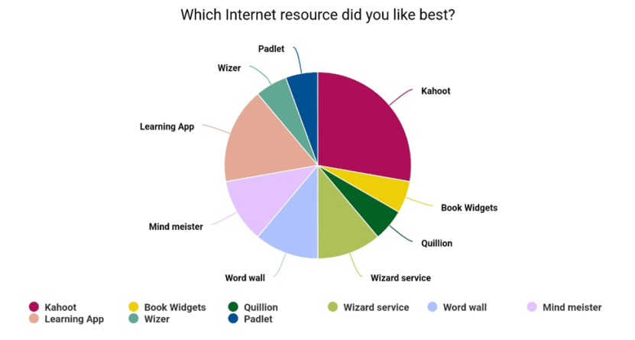
Table 4.3 - Survey results

