**Mariya Tkachenko,**

**School-Gymnasium № 44**

**My vision of effective education and upbringing**

The choice to become a teacher was made consciously by me. Openness, desire for knowledge and the desire to share it have always been my key characteristics. I got my first experience working in a private children's development center teaching foreign languages to students from 5 to 60 years old. It was a diligent period in which I gained a vast experience. Since September 2022 I’ve been working as an English teacher at School- Gymnasium № 44, taking into account previous experience and striving to develop in various directions.

In the process of teaching and educating students, I use the following approaches: humanistic and individual approaches. These approaches seem to me the most important, since I consider one of the main tasks of a teacher to understand and accept students as they are, to show them their uniqueness. It is crucial that the opinions and desires of students are taken into account by adults, hereby we show our respect and create optimal conditions for teaching and educating. A harmonious environment for students that perceives them as individuals is the basis for the education and upbringing of a harmonious personality.

Considering the rapidly developing technologies and the world around us, the following concepts have become part of my work: gamification and growth mindset. Gamification techniques are used to control the discipline during lessons and also in the learning process, various tasks with elements of the game are created. The figure below shows examples of gamification for discipline control. 1, 2, and 3 drawings add elements for activity and diligence to achieve the goal, for example, saving a person from a desert island. Drawing 4 is on the contrary, here the task is not to let the skydivers get into the water. This technique unites students and make them concentrated.

**Figure 1.** *Gamification to maintain discipline*

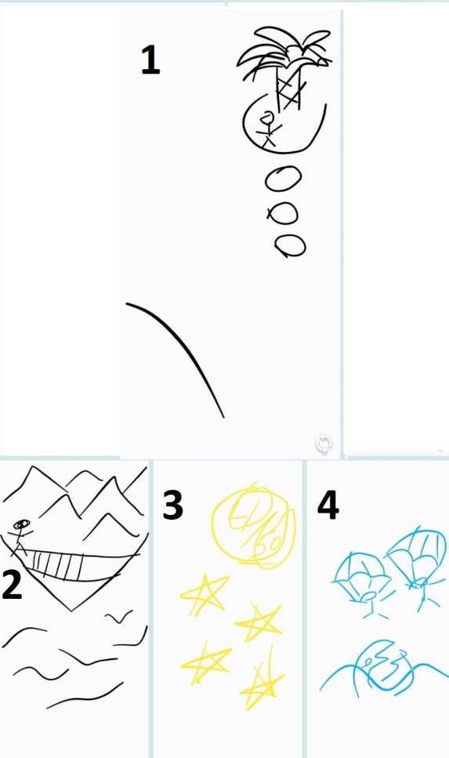

A growth mindset is more about the educational part, however, I believe that it is important to use different phrases and have conversations with students in the learning process, encouraging and letting them know that everything is possible and that in any situation, you can always find an unusual way out.

As a contribution to learning, I consider the growth of academic performance in my classes and the desire of students to learn English. Students participate in school and various competitions, are interested in culture, and try to deepen their knowledge using diverse electronic resources. The mission of the teacher is to motivate students through their example for continuous learning.