Writing Map of Development as an Effective Tool to Improve Students’ Writing Accuracy
Ayazhan Abdulmanova
Aigul Askarova
Gulnara Galimzhanova
Saya Rakhimbekova
Aliya Tashenova
English Teachers, NIS Kokshetau

Abstract

The present article is based on the results of Lesson Study conducted in Grade 5,6 and 9. The teachers focused on the effectiveness of Writing Map of Development, a strategy that aims at the refinement of writing skills. The chosen strategy showed its effectiveness and viability.

Настоящая статья основана на результатах Исследования Урока, проведенного в 5-х, 6-х и 9-х классах. Участники группы анализировали эффективность стратегии Writing Map of Development, направленной на совершенствование навыков письма. Выбранная стратегия показала свою эффективность.

Бұл мақала 5,6 және 9 сыныптарда өткізілген Lesson Study нәтижелеріне негізделген. Топ мүшелері оқушылардың жазу дағдыларын жетілдіруге бағытталған Writing Map of Development жазу стратегиясының тиімділігіне талдау жасады. Таңдалған стратегия тиімді болды.

This article is based on the analysis of students’ written papers obtained after Lesson Study.
Writing in a foreign language has always been one of the most difficult skills for students to acquire. The analysis of students’ writing papers after a year of distance learning has revealed even a greater number of obstacles that students face on the way to error-free writing. The COVID-19 pandemic has introduced both positive and negative consequences on the educational process. Cheating, worsening of handwriting are just a few of them. Having analyzed students’ papers at the beginning of 2021-2022 academic year, it was decided that what students needed most then was the improvement of their grammar accuracy. To fulfill this goal English language teachers use many effective strategies and tools in the classroom such as correction codes, writing organizers, peer-assessment, and regular teacher’s feedback. For this year such instructional techniques as scaffolding, criteria based assessment and self-assessment have been chosen to organize the process of teaching. (Western Australian Minister for Education, 2013)
Writing Map of Development allows teachers to apply all these strategies and enhance students’ writing skills which ensures meeting the needs of every student in the classroom. (Western Australian Minister for Education, 2013). Teachers started implementing the map by first having adapted it according to the level of students in each researched group. As it was mentioned above grammar accuracy was the main focus of the research conducted within the Lesson Study project, therefore all the changes in the map were related to grammar only. (See picture 1) The adapted version of the Writing Map of Development was used at English language lessons with Grade 5,6 and 9 students to examine its effectiveness in achieving grammar accuracy in the process of writing. According to the tool, the students are to cover all areas in the given level in order to be able to move from the inferior to a higher level. The main goal was to eliminate certain elementary grammar mistakes which learners still make. (See picture 2) The effectiveness of the strategy was checked by Lesson Study approach. To analyze the effectiveness of the map, three ‘case students’ of different levels in each group have been chosen (A student- a student who represents a group of students with high academic performance, B student – a student with a sufficient level of English grammar who experiences difficulties in grammar, C student – a student who needs much support from the teachers).
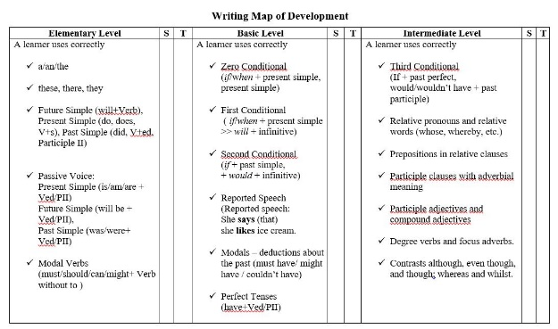 Picture 1. | 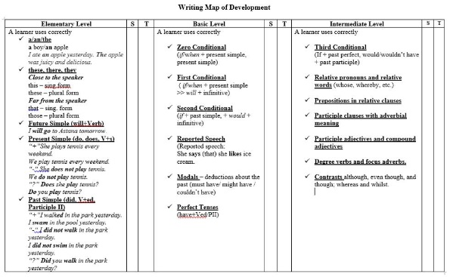  Picture 2.
Our research started with co-planning and leveling the grammar material of Writing Map of Development in both grades. Working in different grades caused certain difficulties connected to lesson observation. Thus, it was decided to use video recording during the researched lessons in order to upload them into MS Teams corporate platform so that each teacher in a group could observe the lesson and provide feedback on the effectiveness of the researched strategy. Lesson observation and feedback from colleagues allowed to see to what extent the map is helpful for students and what changes should be introduced to make it more effective.
After each researched lesson, teachers analyzed all common problems and mistakes of individual students in order to help them succeed in the future writing tasks. All participants of the current project were able to sharpen their skills both as reflective teachers and as researchers by working in a group, getting and receiving careful feedback and evaluation of colleagues, analyzing the mistakes.

Case 1
Grade 9 students have been studying at NIS Kokshetau for almost 3 years and their expected level of proficiency is intermediate. Unfortunately, the unexpected transition to online learning due to the pandemic prevented them from achieving the necessary result. We began to use the WMD by analyzing the results of students’ writing performance in the first term and constructing the map of development based on the common mistakes and students’ needs. The map was introduced to all the students, all the details and unclear moments were clarified and discussed with the students. Each student identified their level in the map according to the mistakes that they made in their works. The work with the map is not a one-day activity. This is the process, which lasts throughout the academic year at English language lessons. Students used WMD while writing all their formative written assignments to ensure avoidance of making elementary mistakes. It was also used as a way of peer and self-assessment in the classroom. The observation during the focused lessons showed that WMD allowed students A and B in all groups of Grade 9 to control their writing and avoid frequently made mistakes which they usually make. Students C also used this map effectively but they needed more support from their teachers. Lesson observations and feedback from learners showed that WMD is a successful strategy to employ at language lessons and enhances their academic writing skills.
Case 2
For 5 and 6 Grade students the developing of writing skills is extremely essential as during the whole academic year they have been preparing for External examination. The WMD was edited accurately and adapted for 5 and 6 graders according to appropriate grammar level. Based on teachers’ analysis one of the major problems was students’ difficulties in identifying their own errors. They could hardly be focused on details of their writings and mostly relied on teacher’s assistance. Whereas intermediate level students peer check and give feedback confidently, elementary level students need much more time for whole-class discussion to be able to proofread with teacher’s support.
Based on the analysis of the current Lesson Study, it is concluded that Writing Map of Development has positively influenced the quality of writing performance of ‘case learners’. Together with WMD, students were actively engaged in peer- and self-assessment which also has had a significant impact on students’ performance. The observation of students’ formative and summative writing assignments revealed that students A and B considerably improved their writing skills and grammar while students C demonstrated less mistakes in using simple sentences and tend to include more complex structure as, for example, First Conditional in their essays. Overall, it might be suggested that WMD is an effective tool to use at English language lessons as it allows learners to control their grammar and teachers to monitor the progress of each student in the classroom.
References
Dylan, W. (2011). Embedded Formative Assessment. Publisher: Hawker-Brownlow Education.
Gibbons, P. (2015). Scaffolding Language Scaffolding Learning. Teaching English Language Learners in the Mainstream Classroom. Heinemann Portsmouth, NH.
Western Australian Minister for Education. (2013). First Steps in Literacy: Writing Map of Development. Publisher: Pearson Canada Inc.

