School: | Secondary school №26
Unit: | Time
Teacher name: | Unaibekova G.K
Date:
Grade: 3 | Number present: | Number absent:
Theme of the lesson: | I get up at eight o’clock
Learning objectives(s) that this lesson is contributing to | 3.4.1.1 plan, write and check short sentences with considerable support on a limited range of personal, general and some curricular topics; 3.3.6.1 understand with considerable support, some specific information and detail in short, simple texts on a limited range of general and some curricular topics;
Lesson objectives | Learners will be able to:  • To make up a dialogue and answer the questions

Planned timings | Teacher's actions | Learners` actions | Assessment | Resources
2  minutes | ORGANISATION MOMENT:  • Greet students.  • I ask daily questions  What date is it today? What’s the weather like today? How are you? | Students answer. | -
35  minutes | MAIN PART  Warm-up Is it rainy today? Is it sunny today? Is it cold today? Is it snowy today?  Checking home task.  Practice  Pre-listening task. Leaners are suggested to look at flashcards. Let’s revise the new words.  - Slowly slowly. I cover the flashcard and slowly reveal the picture. You must identify what’s on the flashcard as soon as you recognise it.  - What is missing? I stick the flashcards on the board. Close your eyes and cover your eyes with your hands. I remove one flashcard. Open your eyes and say what’s missing.  Watch the video listen the story.  Post-listening task.  Task 1. Ex 10 p/39  Read the story and complete.  Assessment criteria Descriptor  Complete the sentences - eight - shower - teeth - breakfast - school  Energizer “Happy song”  Task 2. Active method “Magic box”  Everybody stand a circle put on a box take turns. When music stopped they must answer the question.  1. What time is Liam gets up? It is eight o’clock  2. What does he do at first? He has a shower  3. Where does he go? He goes to school  Task 3. Ex -13. p.39  Listen and read. Make a new dialogue with your friends.  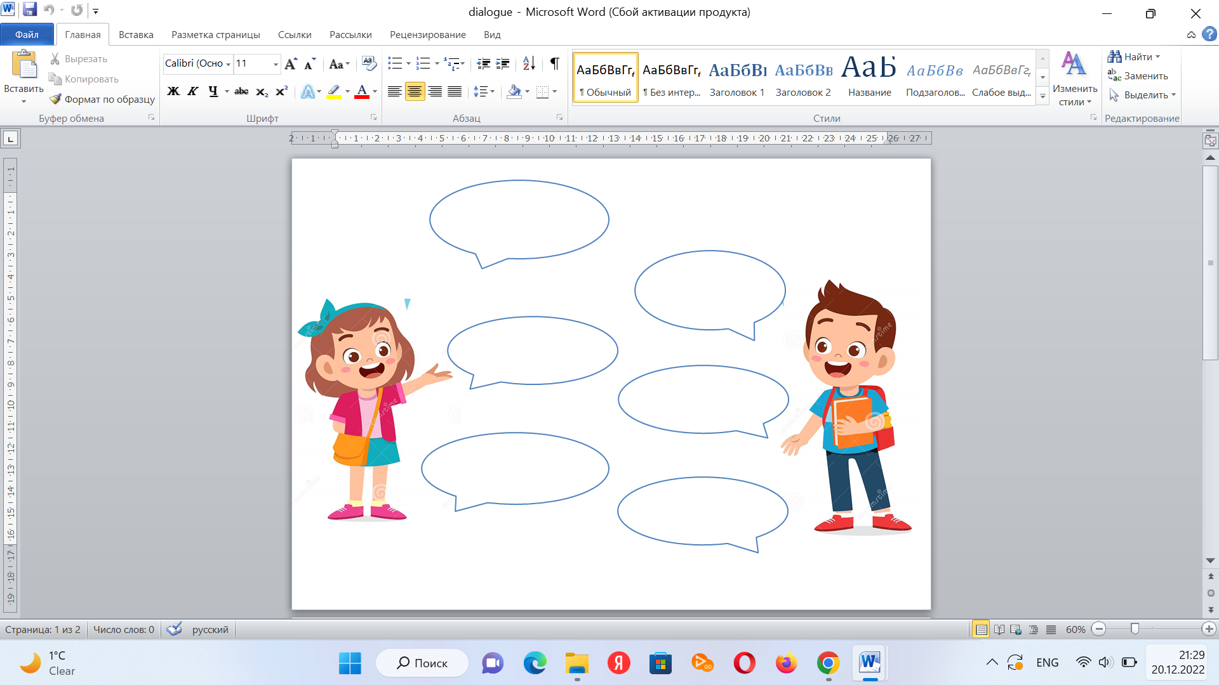 | Listen to teacher  Look at flashcards and answer the questions  Watch the video and do the task  Sing a song  Learners do the tasks | Formative assessment  Assessment with tickets | PPP  Box  Worksheets
3  minutes | Reflection and feedback:  Teacher asks learners to do feedback for the lesson.  Home task: to learn words | Pupils do feedback | Feedback | 