Unit:8 |  | Healthy habits
Teacher’s name: |  | Kulybekov Aidar  Date:
Grade: 7 |  | Number present: |  | absent:
Theme: |  | Bullies
Learning objectives(s) that this lesson is contributing to |  | 7.4.2.1 understand specific information and detail in texts on a range of familiar general and curricular topic.  7.2.5.1 recognize the opinion of the speaker(s) in supported extended talk on a range of general and curricular topics.  7.5.3.1 write with moderate grammatical accuracy on a limited range of familiar general and curricular topics.
Lesson objectives |  | Listen and read for general understanding
 |  | Introduce the topic
 |  | Practice giving advice using should/ shouldn’t
Planned timings | Teacher’s activities |  | Pupil’s activities |  | Mark | Resources
Warm up | Good day, Dear boys and girls.  How are you today?  What date/ day is today?  What is he showing with his gesture?  The theme of our lesson is Bullies!!! |  | Explanation |  | Emoticon | Picture  Student’s book
Beginning of the lesson | 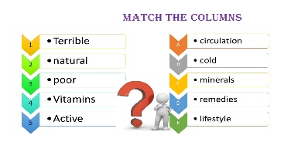  Let’s check previous lesson! |  | 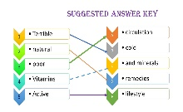  Match the columns |  | Emoticon  Mark | Excel 7  Workbook  p62 ex 2
 | Read the dictionary entry.  Bully /’bʌli/ (V) to use power to hurt or frighten sb  call sb names,  make fun of sb’s appearance,  write nasty things about sb,  steal sb’s money,  tell lies about people,  borrow things from people and keep them forever,  force people to do things they don’t want to,  hit people. |  | Make sentences. |  | Emoticon, marks | 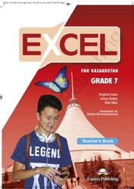  Student’s book
Middle | - What is bullying?  - Which of the following could be kinds of bullying?  Answer key:  Bullying is being unkind to someone.  They are all kinds of bullying. |  | Oral responses |  |  | Excel 7 Student’s book
 | 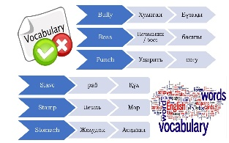  New words for the lesson |  | Students write the new words to the dictionary.
 | 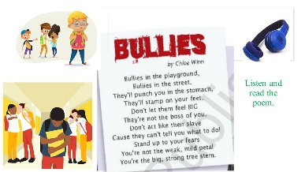  How does Chloe feel about bullies?  Suggested answer key.  Chloe thinks that bullies act as though they are better than other people. In her opinion, they’re not and so we shouldn’t listen to them. Chloe isn’t scared of bullies, she stands up to them. |  | Listen and Read the poem.  Students share with their opinion. |  | 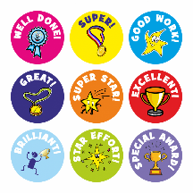 | Excel 7  Student’s book  p 96
 | 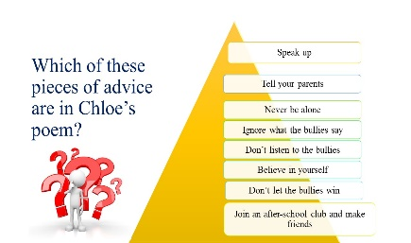  Use ideas from the poem and give advice about how to stop bullying.  Use should or shouldn’t.  f. ex: you should speak up.  Suggested answers key.  Should  You should stand up for yourself  You should ignore what they say  You should tell a parent or a teacher.  You should believe in yourself  Souldn’t  You shouldn’t give them any of your money or possessions.  You shouldn’t do what they say  You shouldn’t let the bullies win  Let’s watch a video!  https://youtu.be/yKCY0mxSBPc?t=56  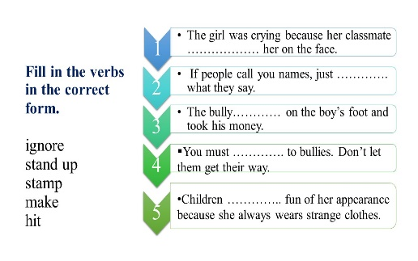  COMPREHENSION ACTIVITIES. |  | 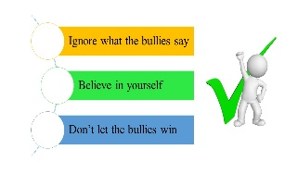  The students give definite answer.  The students give their answer orally.  Watching.  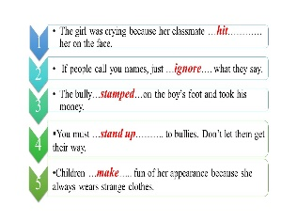  Students do the exercise. |  | 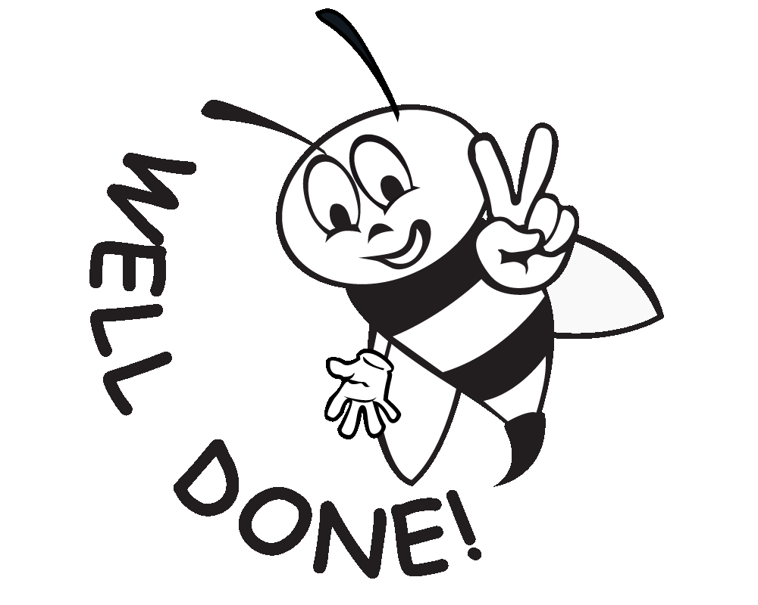 | YouTube.  Excel 7  Workbook  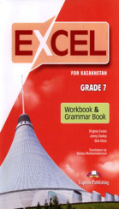  p 62 ex 3
 | Collect and comment information about bullying under the headings.  - What is bullying?  - Who are bullies?  - Why do they bully?  - Where does it happen?  - What can you do?  Suggested answer key:  - Bullying is when a person is piked on by a person or group with more power.  - Bullies pick on people they think don’t fit in, because how they look, their race or religion.  - The bullies think their target is simply weak  - Bullying can happen anywhere, but mostly it happens at school  - The best thing to do is tell an adult. It can be school counsellor, teacher, parent or friend. They will give you support you need. |  | Students share with their opinion and show point of view. |  |  | Excel 7  Student’s book  p 96
Ending the lesson | 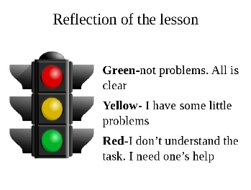  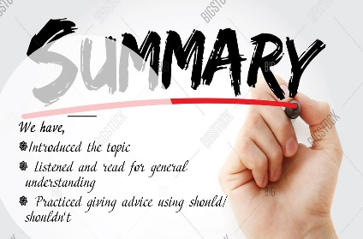 |  | Listen |  | Emoticon | Book

