Short term plan
Unit 9 Holidays |  | School-gymnasium №34 named after A.Taimanov
Teacher name: |  | Ibrasheva A.Zh
Date: |  | 16.05.2024
Grade: 5G |  | Number present: | absent:
Lesson title | Amazing adventures
Learning objectives | 5.2.3.1 understand an increasing range of unsupported basic questions on general and curricular topics;  5.3.6.1 communicate meaning clearly at sentence level during, pair, group and whole class exchanges;  5.4.1.1 Understand the main points in a limited range of short simple texts on general and curricular topics
Lesson objectives | Learners will be able to:  - listen to a video about adventures of Kazakhs  - learn words for clothes.  - talk about adventures in their country
Plan
Stages / Time | Teacher’s actions | Students’ actions |  | Assessment criteria | Resources
Beginning of the lesson  10 min  (Warming-up    3 min.  Pre-learning  «Brainstorming» method  7 min) | Organization moment :  1.Greeting.  Ask about the weather.  Warming up    I. Lead – In Activity.  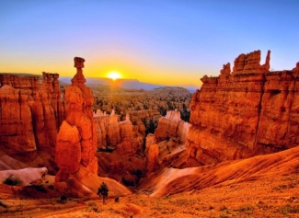  II. A video about great adventures of Kazakhs.  - What do you think of the video?  - Do you like adventures?  - Where would you like to go?  - Did you go to adventure holidays?  Teacher introduces the theme and objectives of the lesson | The aim: To develop pupils speaking skills and create friendly atmosphere  Efficiency: By wishing each other they feel better and feel the support of others  Students of the class are listed.  Students' attention is drawn to the lesson.  Students say different words from the picture  Having watched a video, students try to discuss the topic, answering teacher’s questions. |  | The teacher to assess learners for their ability.  “Good job!  Well done!”  Formative Assessment    Good job!  Assessment criteria  make basic statements related to personal information, people and objects | Warming up words on the board  Picture  Most beautiful places in Kazakhstan #travel #adventure #explore #nature - YouTube
Middle of the lesson  Presentation part.  30 min | III. NEW WORDS  YURT - КИІЗ ҮЙ  RABBIT - ҚОЯН  MOUNTAIN - ТАУ  STEPPES - ЖАЗЫҚ ДАЛАЛАР  DUNE - ТӨБЕ,ШОҚЫ  EAGLE - ҚЫРАН БҮРКІТ  HUNT- АҢ АУЛАУ  GRASSLAND - ШАБЫНДЫҚ,ЖАСЫЛ АЛҚАПТЫ ДАЛА  SAND - ҚҰМ  DESERT - ШӨЛ ДАЛА  IV. «BRAINWRIGHT» team work    V. Ex:1 P:105 (matching)  • While reading ask pupils answer the questions.  Read the text, then answer these questions.  Where are the 'singing dunes'?  Where did Emma stay on the steppe?  What animals did she see?  What did Emma think about her rafting trip?  Did Emma cycle to North Inylchek Base Camp?  How did she feel after her trip to the canyons?  What was the best part of her holiday  VI. TRUE or FALSE  (individual work)  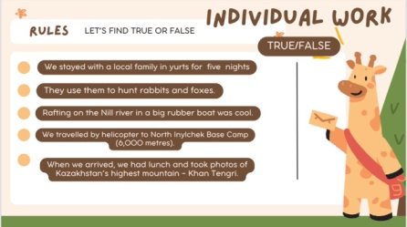 | • Learners read and repeat the words after the teacher, give their Kazakh equivalents  • Learners do team work, then find puzzle  ANSWERS  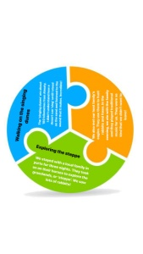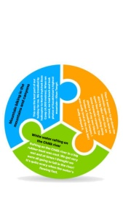  • Learners read the text, then answer these questions  ANSWERS  1. about 180 km from Almaty  2. in yurts for three nights  3. rabbits, eagles, foxes,  4. It's quite scary  5. No  6. She enjoyed this trip.  7. Mountain biking in the mountains and canyons.  • Learners read the text, then answer these questions  • True or False  ANSWERS |  | Descriptors: learners  -read the words  -translate the words  Self-assessment  Descriptors:  learners  - find the puzzles.  - match correct photos  Total: 2 point  Descriptors:  - read the text  - match the questions with the answers  Total: 2 point  Descriptor:  learners  - define if the sentence true or false;  -correctfalse sentences.  Total: 10 points |   Card  Worksheet  Sheets of puzzles  Students book
End of the lesson  5 min | FEEDBACK  Learners provide feedback on what they have learned and got from the lesson.  Giving hometask. | Teacher motivates students.  Gives home task: Ex.5 |   Ss evaluates each other’s knowledge. |  | Poster Success  

