Module 7 Water, water everywhere

Lesson plan

LESSON: Module 7  Theme: Weather and clothes |  | School: КГУ «Гимназия» №79
Date: 11.03.2024 |  | Teacher name: Tkachenko N.L.
CLASS: 3В |  | Number present: |  | absent:
Learning objectives(s) that this lesson is contributing to | 3.2.5.1- pronounce familiar words and short phrases intelligibly when reading aloud;  3.3.1.1- recognise, identify and sound with support a limited range of familiar words in simple sentences;  3.3.2.1- read and follow with limited support familiar instructions for classroom activities
Lesson objectives | All learners will be able to:  recognise and use some target language correctly and show comprehension of some written and spoken familiar words in simple sentences
Most learners will be able to:
recognise and use most target language correctly and show comprehension of most written and spoken familiar words in simple sentences
Some learners will be able to:
recognise and use target language correctly with clear pronunciation and good comprehension of written and spoken familiar words in simple sentences
Previous learning
Plan
Planned timings | Planned activities |  | Smiles  Resources |  | Teacher  Notes
Beginning the  lesson | Good afternoon boys and girls! How are you?...  I am glad to see you again. Sit down, please. What day is it today? What is the season now? Let’s start our lesson.  For each correct answer you will get coin smile. At the end of our lesson we will find out who will be the champion.   - ? |  | Cards

Presentation  and practice  3.2.5.1  3.2.3.1 | Step 1 On the board the new words and pictures  Repeat these words after me. Children repeat these words some times chorally and individually, checking for correct pronunciation.  Dress Shorts  Socks Raincoat Umbrella  T – shirt Coat  Boots Hat  Train the memory  Let’s play the game ‘’What’s missing? Ask children close your eyes. Remove a card. Ask children to open their eyes and ask What’s missing? |  | Target vocabulary
3.3.1.1 3.3.2.1  3.5.9.1  3.5.15.1 | Step 2 Train the listening memory  On the board – flashcards. Teacher says these words and children have to listen and point to the appropriate picture.  Step 3 On the board flashcards (pictures and words) Student open two cards and find the suitable pictures and words.  Step 4 Work in the pairs  I ‘ll give you envelops. In the envelope there are many pictures and words. You have to match the picture with the word. |  |  | flashcards
Step 5
Divide these nouns in 2 groups.
On the board cards Rainy weather/sunny weather

Children go to the board and put pictures in correct place.
Which do you need when it’s sunny/rainy? Students say.
I don’t need shorts when it’s rainy. I need an umbrella.

Ending the lesson 3.2.1.1 | Grammar practice.  Children have individual cards. And write down the sentences in the cards.  Which do you need when it’s rainy?  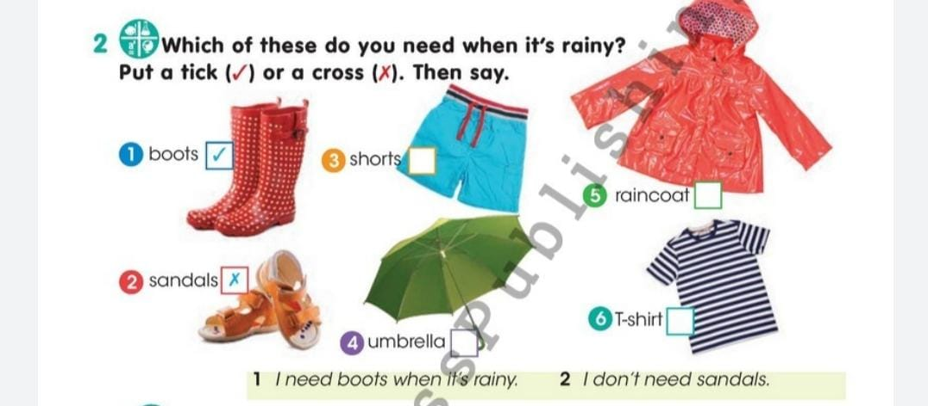  Answer key  Items to be ticked: umbrella, raincoat Items to be crossed: shorts, T-shirt  I don’t need shorts when it’s rainy. I need an umbrella.  Summing up of the lesson  What did you like at the lesson?  Was it interesting for you?  If it was interesting put the tick in correct place on the board.  
Additional information
Differentiation – how do you plan to give more support? How do you plan to challenge the more able learners? |  | Assessment – how are you planning to check learners’ learning? | Cross-curricular links  Health and safety check  ICT links  Values links
work with weaker groups in read and tick task providing support e.g. by prompting them to sound out initial letters  challenge stronger learners to answer questions in Step 1 with full short answers |  | monitoring learner responses in questioning task and drilling answers where learners need  support with pronunciation | cross-curricular links:

