Раздел: | Reading for Pleasure
ФИО педагога | Tatyana Vladimirovna Arendarenko
Дата: | 2023
Класс: | Количество присутствующих: | Количество отсутствующих:
Тема урока: | The legend of Alpamys
Learning objectives/  Цели обучения в соответствии  с учебной программой | 8.1.9.1 use imagination to express thoughts, ideas, experiences and feelings;  8.4.1.1 understand the main points in texts on a growing range of unfamiliar general and curricular topics, including some extended texts;  8.4.2.1 understand specific information and detail in texts on a growing range of familiar general and curricular topics, including some extended texts;  8.4.5.1 deduce meaning from context in short texts and some extended texts on a growing range of familiar general and curricular topics;  8.2.2.1 understand with little or no support most specific information in extended talk on a wide range of general and curricular topics;
Lesson objectives/ Цели урока  Learning outcomes | -Understand a legend about a Kazakh hero.  -Use reading and listening skills for identifying specific information.  -Apply analytical skills while reading and describing pictures.  SS will be able to  -identify 2-4 main characters from Kazakh legends;  -match 5-8 expressions with their definitions;  -analyse and fill in the 8-10 gaps in the text while listening;  - put 6-9 sentences in the correct order to make up a story;  (Students can get 27 and more points)
Ход урока
Этап урока/ Время | Действия педагога | Действия ученика | Оценивание | Ресурсы
Warm up -3 min | Provides SS with visual support. | SS try to read one of the riddles and guess the word.  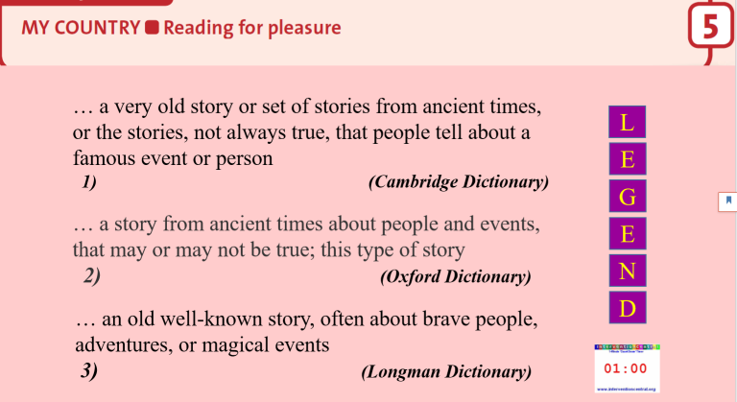 | Formative assessment | PPP: Slide 1-2
Lead-in -4 min | Presents the topic asking SS to look at the pictures and express their guess.  Elicits what Kazakh legends SS know from their Kazakh lessons.  Provides SS with quiet Kazakh music of dombyra.  Controls SS’ answers | SS try to guess who is who in the pictures.  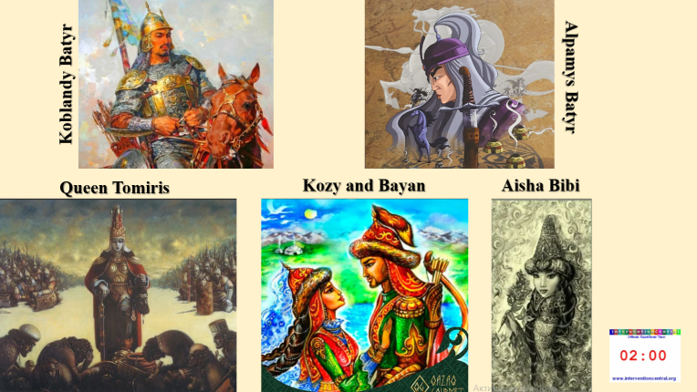 | Formative assessment | PPP: Slide 3
Pre-Reading: The Legend of Alpamys  5 min | Presents vocabulary connected with the topic.  Provides SS with a sheet of paper (a matching task)  Offers SS to do the task.  Controls SS’ answers, | SS do the task individually and compare their results in pairs.  SS look at the words p. 64 and look up the unknown words in dictionaries.  1.once upon a time a) to get on a horse  2.a noble man b) dishonestly  3.wealthy c) to speak to a God in order to ask for sth  4.a herd of cattle d) a long time ago  5.to pray e) rich  6. a feast f) a member of the highest social rank in a society  7. to mount a horse g) a large meal for many people  8.unfairly h) a large group of cows and bulls | Formative assessment: 1 point for each correct answer (8 points)  Peer assessment | PPP: Slide 4  Additional paper resource  Student’s Book “English Plus 8”
Reading  - 15 min | 1)Encourages learners to look at the picture and do the tasks. | - SS look at the picture and describe Baibory and his problem.  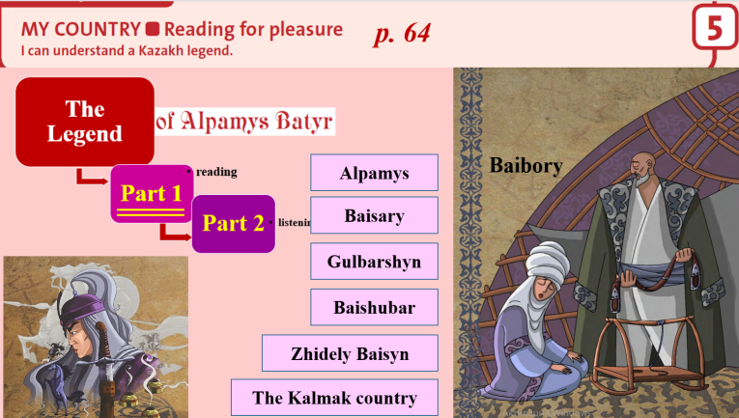  - SS read other names and say who’s who.  - SS work in pairs asking and answering the questions on Part 1.  Differentiation: more able SS ask Why-questions, less able SS answer When/ How many How old/ Where –questions. | Formative assessment: | PPP: Slide 5  Student’s Book “English Plus 8”
Listening, Part 1  -5 min | Provides SS with the audio file.  Offers an opportunity to listen to some names of the main characters.  Provides SS with a sheet of paper with tasks.  Assessor  Monitors SS’s work around the class. | SS try to repeat some names after the announcer.  The part with Gulbarshyn’s message.  Then they get 2 different tasks for listening.  Differentiation: more able SS fill the gaps without scaffolding, less able SS fill the gaps choosing a correct variant from 3 ones.  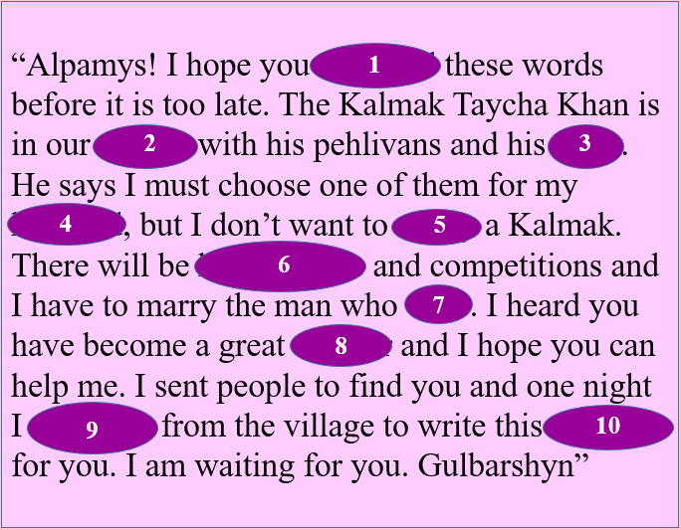  “Alpamys! I hope you 1) … these words before it is too late. The Kalmak Taycha Khan is in our 2) … with his pehlivans and his army. He says I must 3) … one of them for my husband, but I don’t want to marry a Kalmak. There will be 4) … games and competitions and I have to marry the man who 5) …. I heard you 6) … a great warrior and I hope you can help me. I sent 7) … to find you and one night I 8) … from the village to write this message for you. I am waiting for you. Gulbarshyn”  1) a) read b) will read c) reads  2) a) village b) town c) city  3) a) chose b) chosen c) choose  4) a) horse b) military c) sports  5) a) win b) won c) wins  6) a) became b) have become c) has become  7) a) people b) a message c) a letter  8) a) got away b) ran away c) threw away | Formative assessment 1 point for each correct answer (10/ 8 points) | PPP: Slide 6-7  Additional paper resource: cards
https://www.youtube.com/watch?v=DIHWx2PaAo0&t=246s
(1:52 min -4:29 min)
Listening, Part 2  8 min | Before listening offers SS to watch the video summarizing  Provides SS with the audio file.  Monitors the process | SS watch the video and try to predict what will happen after this.  SS work in groups putting 9 sentences in the correct order according to listening task 2. | Formative assessment 1 point for each correct answer (9 points) | PPP: Slide 8-9  Audio file  Video file  Additional paper resource: cards
Homework  2 min | Provides SS with explanations on their homework, assessment criteria, etc. | 1) Prepare retelling /a short summary of the legend of Alpamys Batyr  2) Learn new words and get ready for a dictation. | Formative assessment | Student’s Book “English Plus 8”  Internet resources
Reflection- 2 min | Provides SS with the forms to fill in.  Teacher gives individual feedback to SS’ work | SS count and write down points they gained at the lesson.

Assessment Form
Your name and surname:

1) Matching task  Individual task | 2) Listening 1  Ind./ Group | 3) Listening 2  Group work | 4) Speaking | Total: … points
8 points | 8-10 points | 9 points | points
1)I can name 1 -2 of the main characters of the legend and describe them.
2) I can name 3-4 of the main characters of the legend and describe them.
3) I can ask/ answer …. questions on Part 1.
4)I can retell the legend abou Alpamys Batyr in 5-6 sentences.
5) I can retell the legend abou Alpamys Batyr in 8-10 sentences.
6) I can retell the legend abou Alpamys Batyr in 12-15 sentences.

