LESSON 1: Unit3  My family and friends  Family and friends |  |  |  |  | Secondary school named after B.Akhmetov
Date: |  |  |  |  | Teacher name: Kabdolda G.K.
Grade: 1 |  |  |  |  | Number present: | absent:
Learning objectives(s) that this lesson is contributing to |  |  | 1.UE7 use personal subject pronouns to identify things  1.S 5 produce words in response to prompts  1.S 1 make basic personal statements and simple statements about objects
Lesson objectives |  |  | All learners will be able to:
- write new letters with support
- pronounce basic words and expressions intelligibly
- name some members of family with teacher’s support
 |  |  | Most learners will be able to:
- write new letters with limited support
- name some members of the family without teacher’s support
 |  |  | Some learners will be able to:
- write new letters
- name all members of their family
Previous learning |  |  | Students learned colors, the words for 10 classroom objects and alphabet letters from A to M, numbers 1-10.
Value links |  |  | Respect, Cooperation
Language objective |  |  | Learn new letters (N;O), learn new words (father, mother, brother, sister, grandfather, grandmother, family)
Cross-Curricular Link |  |  | Self-study, Art
Use of ICT |  |  | PPT, video
Intercultural awareness |  |  | The role of family in modern world
Kazakh culture |  |  | The role of family in Kazakhstani society
Pastoral Care |  |  | Assure you met all learners’ emotional, mental and physical needs
Plan
Planned timings | Planned activities (replace the notes below with your planned activities) |  |  |  |  |  |  | Resources
Beginning  10 min  (IW) | Greeting, Warm Up and Letters  Greet the students.  - “Hello!”/”Good morning!”/”Good afternoon!” “How are you?”- I am fine, good, ok, super.  Warm-up  Letter Writing Practice  Review old letters by calling them out and having students write them on the paddles.  - Introduce new letters “N;O” and show how to write them. Practice writing them with boards.  - Give students a stamp or a sticker for successful completion. Assign new letters for homework.  - Sing a song “English Alphabet”  - Teacher draws learners’ attention to the board |  |  |  |  |  |  | Overwriting  Worksheet #1  http://www.youtube.com/watch?v=75p-N9YKqNo
Middle  25 min  (IPW) | Introduction of the topic “My family and friends”  - Students are suggested a video to watch and guess the topic of the lesson.  - Teacher draws students’ attention to the board (PPT) and drills the vocabulary in chorus.  Focus on: I’m… You are… She is.... He is… and  Yes that’s right / No....  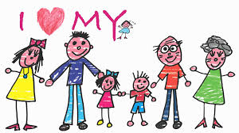  - Practice: trace the letters in each row to write the names of family members. Then draw a line to match each family member name to its picture. |  |  |  |  |  |  | Video “My family and me”  PPT  Overwriting  Worksheet #2
 | - Students do the coloring task, and then present it to the class naming the members of the family.  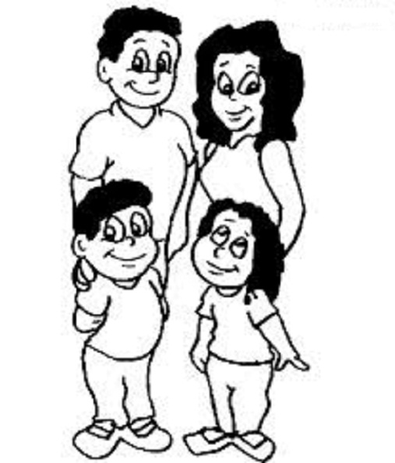 |  |  |  |  |  |  | Coloring worksheet #3
End  5 min  (W) | Closing Reflection/Self-Assessment & Goodbye  Using the same thumbs up motions, ask students:  1) Did you like the lesson?  Students stand up and sing the goodbye song. |  |  |  |  |  |  | Goodbye Song Video  https://www.youtube.com/watch?v=Xcws7UWWDEs
Additional information
Differentiation – how do you plan to give more support? How do you plan to challenge the more able learners? |  |  |  | Assessment – how are you planning to check learners’ learning? |  |  | Cross-curricular links  Health and safety check  ICT links  Values links
- more support can be given during elicitation, instruction and questioning phases of the lesson by nominating learners to answer items relating to more high frequency vocabulary to build confidence through participation. |  |  |  | - through questioning and the redirecting of questioning in feedback activities  - through observation |  |  | - World around us  - Art
Reflection  Were the lesson objectives/learning objectives realistic?  What did the learners learn today?  What was the learning atmosphere like?  Did my planned differentiation work well?  Did I stick to timings? What changes did I make from my plan and why? |  | Use the space below to reflect on your lesson. Answer the most relevant questions from the box on the left about your lesson.
Summary evaluation
What two things went really well (consider both teaching and learning)?
1:
2:
What two things would have improved the lesson (consider both teaching and learning)?
1:
2:
What have I learned from this lesson about the class or individuals that will inform my next lesson?

