Term: 1  Unit 1 Lesson 1. | All about me.
Teacher’s name: | Sabyrkhanova Asel Mirbolsynovna
Date: | 11.09.22
Grade: 2 | Number present: | Number absent:
Theme of the lesson: | Greetings and family words.
Learning objectives(s) that this lesson is contributing to | 2.1.2.1 recognise with considerable support an increasing range of common personal questions  2.1.9.1 recognise the spoken form of familiar words and expressions  2.2.2.1 ask questions in order to satisfy basic needs and find information on familiar topics and classroom routines  2.2.6.1 use short answers appropriately in short, basic exchanges and take turns when speaking with others in a limited range of short, basic exchanges  2.3.4.1 begin to use with support a simple picture dictionary
Lesson objectives | By the end of the lesson the students will be able to:  - use family words;  - greet people and ask questions about them.

Lesson procedure:
Stages of the lesson/ Time | Teacher’s activity | Student’s activity | Assessment | Resources/ materials
Greeting.  Organisation moment. | - As children come into the class, say Hello. Encourage them to say Hello to you. Say It's a new year. Welcome back!  Begin the lesson with some greetings. Ask and answer How are you? and What's your name? with individual children. | The students greet the teacher and answer the questions.
Warm up: | Warm up.  - Tell children that this year they will meet a new Kazakh boy and girl, Saken and Marzhan. Tell them to open their Pupil's Books to page 4, and to look at the photos of Saken and Marzhan at the top of the page. How old do they think they are? | Pupils try to guess the age of Saken and Marzhan.
Main activities: | Ex.1 p.4.  - Ask a confident boy and girl to come to the front. Help them to read the dialogue as the class listens.  - Say the dialogue again, pausing after each line for the class to repeat. Encourage children to make the words flow together, avoiding any unnecessary pauses.  - Ask children to work in pairs and say the dialogue with their partner, this time using their own names and ages. Monitor and help as necessary.  - Ask some of the pairs to say their dialogues for the class.  Ex.2 p.4. CD 01.  • Ask children to look at the pictures of the children in Exercise 2. Point to each one in turn to elicit their names. (If it is the first time the class have seen these characters, point in turn and say their names for children to repeat - Rosy, Billy, and Tim. Explain that they will see these characters throughout the course.)  - Explain that they are going to listen to the Welcome song and then sing it. Play the recording once for children to listen and follow the song in their books.  - Focus attention on the words. Read each line for children to repeat after you.  - Play the recording again for children to sing along. | A pair of pupils read the dialogue in front of the class. Then the rest of the class repeat phrases after each line. Further pupils role-play the conversation.  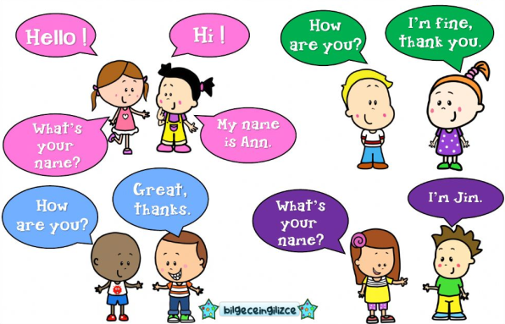  Pupils listen to and repeat the names of the course characters. Then listen to the Welcome song, repeat the lines and sing it. | Role-play | Student’s Book “Family and friends 2. Kazakhstan edition”. (Oxford University Press)  Work sheets
Physical training exercise | A break for physical activity.  Teacher plays the video with physical exercises. | Pupils watch and do physical exercises.
Main activities: | Ex.3 p.4. CD 01.  - Ask children to think of actions for the song (see suggestions below).  - Play the song again for children to sing and do their actions.  Song actions  Welcome back to all our friends - wave  Fun and learning never end! - punch the air  Welcome back, it's a happy day - wave and smile  A day for learning - mime opening a book  A day for play! -jump in the air  Ex.4 p.4. CD 02.  - Tell children they are going to hear someone describing a picture of Rosy's family. Ask children to read out the family words in the word pool. Check that they remember the meaning of all the words and revise any as necessary.  - Play the recording. Pause after the first item for children to find Rosy's mum. Point out the example 1.  - Play the recording through to the end, pausing after each item for children to write the numbers. | Pupils sing the song and do the actions.  Pupils revise the meaning of the family words. Then listen to the description of the picture to identify the family members and write the corresponding numbers.  Answers:  (clockwise from left) 8,9,1,2,6,3,7,5,4  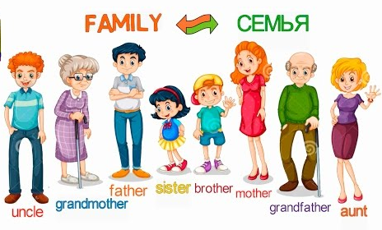 | Song-based task.  Choose the word that describes what you hear
The end of the lesson | • At the end of the lesson, wave goodbye to the class and say Bye! Goodbye! Write the words on the board and remind children of the meaning. Encourage the children to wave and say Bye! or Goodbye! to you.  Giving the homework. | SS write their homework for the next lesson. | Pupils evaluate themselves using evaluation lists.  