**Parallel and perpendicular lines**

In analytic and Euclidean geometry, **parallel lines** are coplanar lines that never meet, no matter how far they extend. In a coordinate plane, two distinct non‑vertical lines with slopes $m_{1}$ and $m_{2}$ are parallel if and only if

$$m_{1}=m_{2}.$$

Parallelism also implies that corresponding angles formed by a transversal are congruent, and alternate interior angles are congruent.

By contrast, **perpendicular lines** intersect at a right angle (90°). In slope‑form, two non‑vertical lines with slopes $m_{1}$ and $m_{2}$ are perpendicular if and only if

$$m_{1}×m_{2}=-1$$

—that is, their slopes are negative reciprocals ($m_{2}=-\frac{1}{m_{1}}$). Perpendicularity also implies that adjacent angles formed at their intersection are right angles.

Key Properties & Postulates

* **Parallel Postulate**: In a plane, through a point not on a given line there is exactly one line parallel to the given line.
* **Transversal Angle Relationships**: A line cutting two parallel lines creates
  + *Corresponding angles* that are equal,
  + *Alternate interior angles* that are equal,
  + *Consecutive interior (same‑side) angles* that sum to 180°.
* **Perpendicular Bisector**: A line perpendicular to a segment at its midpoint bisects the segment into two equal parts.
* **Slope Criteria**:
  + Parallel: $m_{1}=m_{2}$
  + Perpendicular: $m_{1}⋅m_{2}=-1$

Kazakh–English Terminology

| **Қазақша** | **Ағылшынша** | **Explanation** |
| --- | --- | --- |
| Параллель түзулер | Parallel Lines | Coplanar lines that do not intersect. |
| Перпендикуляр түзулер | Perpendicular Lines | Lines that intersect at a right angle (90°). |
| Бұрыштық коэффициент | Slope | $Δy/Δx$. |
| Қиылысу нүктесі | Point of Intersection | The common point where two lines meet. |
| Қиылысу бұрышы | Angle of Intersection | Angle formed at the intersection of two lines. |
| Сәйкес бұрыштар | Corresponding Angles | Angles in matching corners when a transversal cuts parallel lines. |
| Ішкі айқыш бұрыштар | Alternate Interior Angles | Non‑adjacent interior angles on opposite sides of a transversal. |
| Ішкі тұстас бұрыштар | Consecutive Interior Angles | Interior angles on the same side of a transversal; sum to 180°. |
| Орташа перпендикуляр | Perpendicular Bisector | A perpendicular line through a segment’s midpoint. |
| Тік бұрыш | Right Angle | Exactly 90° angle formed by perpendicular lines. |
| Координаталар жазықтығы | Coordinate Plane | The 2‑D plane with an $x$‑ and $y$‑axis. |

Key Kazakh–English Phrases

| **Қазақша сөз тіркесі** | **Ағылшынша сөз тіркесі** |
| --- | --- |
| Параллель түзулерді анықтау | Identifying parallel lines |
| Перпендикуляр түзулерді салу | Constructing perpendicular lines |
| Бұрыштық коэффициентін табу | Finding the slope |
| Бұрыштық коэффициеттерін салыстыру | Comparing slopes |
| Орташа перпендикулярды салу | Drawing a perpendicular bisector |
| Түзулердің қиылысу нүктесін табу | Finding the intersection point of two lines |
| Координаталық жазықтықта параллель және перпендикулярларды зерттеу | Exploring parallel and perpendicular lines on the coordinate plane |
| Түзулер арасындағы қашықтықты есептеу | Calculating the distance between parallel lines |
| Фигурадағы перпендикулярларды белгілеу | Marking perpendiculars in a figure |

**Терминдерді жаттауға арналған тапсырмалар:**

**Exercise 1.** Match each **term** on the left with its **definition** on the right. (Terms 1–15; Definitions A–O)

| **Term** | **Definition** |
| --- | --- |
| 1. Parallel Lines | A. Two lines that meet at a right angle |
| 2. Perpendicular Lines | B. Lines in the same plane that never intersect |
| 3. Slope | C. A line that cuts across two or more other lines |
| 4. Negative Reciprocal | D. A pair of angles on the same side of a transversal that sum to 180° |
| 5. Transversal | E. The product of the slopes of two perpendicular lines equals –1 |
| 6. Corresponding Angles | F. The ratio “rise over run” for a non‑vertical line |
| 7. Alternate Interior Angles | G. One angle in each of two “matching” corners when a transversal cut parallel |
| 8. Consecutive Interior Angles | H. Two lines that intersect at exactly 90° |
| 9. Parallel Postulate | I. Angles inside the “parallel strip” on opposite sides of a transversal |
| 10. Perpendicular Bisector | J. A line through a point not on a given line that is parallel to that line |
| 11. Point of Intersection | K. A line through the midpoint of a segment at 90° |
| 12. Coordinate Plane | L. The exact point where two lines cross |
| 13. Right Angle | M. A flat, two‑dimensional surface with x‑ and y‑axes |
| 14. Collinear | N. Two angles formed by parallel lines and a transversal that are congruent |
| 15. Parallel Slopes | O. Points that lie on the same straight line |

**Exercise 2.** Complete each sentence with the correct **term** (choose from the list below).

**Word Bank:** parallel lines, perpendicular lines, slope, negative reciprocal, transversal, corresponding angles, alternate interior angles, consecutive interior angles, parallel postulate, perpendicular bisector, right angle, point of intersection

1. Through any point not on a given line there is exactly one __________ to that line.
2. Two lines with slopes $m_{1}$ and $m_{2}$ are perpendicular if $m_{1}×m_{2}=-1$, meaning the slopes are __________.
3. A __________ is a line that crosses two or more other lines in a plane.
4. When a transversal cuts two parallel lines, __________ in matching corners are congruent.
5. Two angles on opposite sides of a transversal and inside the parallels are called __________.
6. Two angles on the same side of a transversal and inside the parallels are called __________ and sum to 180°.
7. A __________ meets another line at exactly 90°.
8. A __________ is the set of all points with two coordinates $\left(x,y\right)$.
9. A __________ goes through the midpoint of a segment at a right angle.
10. The __________ states that parallel lines never intersect.
11. The __________ of a non‑vertical line is the “rise over run.”
12. The __________ is the common point where two lines cross.

**Exercise 3.** Decide if the statements are true or false.

1. Parallel lines have slopes that are negative reciprocals.
2. Perpendicular lines intersect at $90​^{∘}$.
3. A transversal can create corresponding angles.
4. The slope of a vertical line is zero.
5. Parallel lines exist in the same plane.
6. If two lines are perpendicular, their slopes add to zero.
7. Corresponding angles are always equal.
8. A horizontal line has an undefined slope.
9. Parallel lines are always the same distance apart.
10. A right-angle measure $180​^{∘}$.

**Exercise 4.** Name the term described in each sentence.

1. Lines that never meet and have equal slopes.
2. Lines that intersect at $90​^{∘}$.
3. A line that crosses two or more lines.
4. The measure of a line’s steepness.
5. Angles in the same position relative to a transversal.
6. A grid system for plotting points.
7. The point where two lines cross.
8. An angle measuring $90​^{∘}$.
9. A flat surface extending infinitely.
10. A mathematical statement like $y=mx+b$.

**Solve practice problems:**

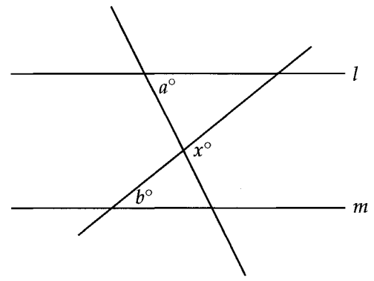

1. In the figure above, lines $l$ and $m$ are parallel. What is $x$ in terms of $a$ and ?   
A) B) C) D)

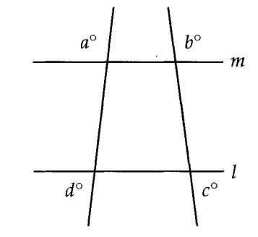

2. In the figure above, lines $l$ and $m$ are parallel. What is the value of $a+b+c+d$?  
A) 270 B) 360 C) 720 D) It cannot be determined from the information given.

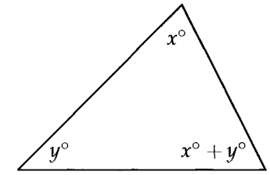

3. In the figure above, if $x=40$, what is the value of $y$?  
A) 40 B) 50 C) 80 D) 90

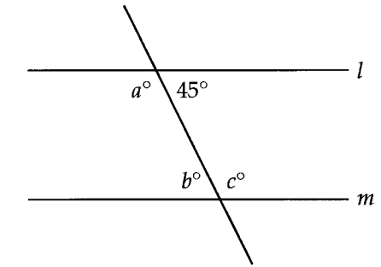

4. In the figure above, lines $l$ and $m$ are parallel. Which of the following must be true?  
I. $a=3b$; II. $a+b=b+c$; III. $b=45$.  
A) III only B) I and II only C) II and III only D) I, II, and III

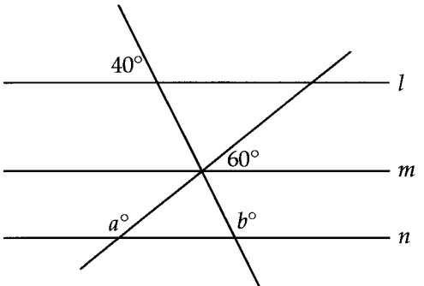

5. In the figure above, lines , , and are parallel. What is the value of ?

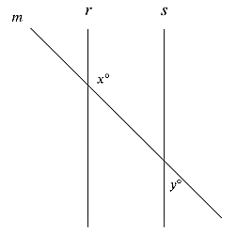

6. In the figure shown, lines $r$ and $s$ are parallel, and line $m$ intersects both lines. If $y<{65}^{∘}$, which of the following must be true?

A) B) C) D)

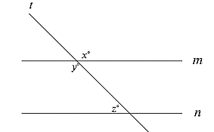

7. In the figure, lines $m$ and $n$ are parallel. If $x=6k+13$ and $y=8k-29$, what is the value of $z$?  
A) 3 B) 21 C) 41 D) 139

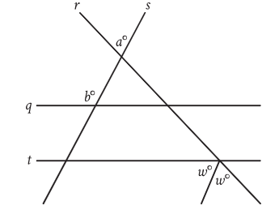

8. In the figure, parallel lines $q$ and $t$ are intersected by lines $r$ and $s$. If $a={43}^{∘}$ and $b={122}^{∘}$, what is the value of ?

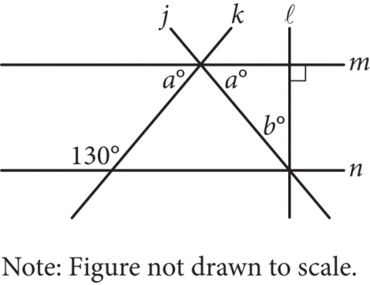

9. In the figure above, lines $m$ and $n$ are parallel. What is the value of $b$?

A) 40 B) 50 C) 65 D) 80

10. A line intersects two parallel lines, forming four acute angles and four obtuse angles. The measure of one of the acute angles is ${\left(9x-560\right)}^{∘}$. The sum of the measures of one of the acute angles and three of the obtuse angles is ${\left(-18x+w\right)}^{∘}$. What is the value of $w$?