**Abizhay Ayazhan Zhigerkyzy**

Student of 4 course of EP “Foreign language: two foreign languages”

Astana International University

Astana, Kazakhstan

e-mail: [ayazhan12262002@gmail.com](mailto:ayazhan12262002@gmail.com)

**LEARNING ENGLISH WITH THE PROGRAMM ASSISTANCE WORDWALL**

**Abstract***:*At the moment, there are a lot of applications for learning English that help teachers conduct a lesson much easier and more efficiently. In this article, we will consider how the Word Wall application will help students learn English and compare their achievements before and after the experiment. This article will tell you how this teaching technique will help you learn the language faster and easier.

*Key words:* *wordwall, application, method, interactive and printed products, English vocabulary, new words, learn effective.*

**Introduction**

Currently, there are numerous tools that make learning simpler and more effective for the learner. One of these apps is wordwall. The versatile tool Wordwall may be used to create both interactive and printed products. Wordwall is a useful tool for teachers to interact with students and verify homework.

**Aim**

The aim of the experiment is to test whether how Wordwall is effective or not in learning English

**Hypothesis**

It is predicted that students who study with this method will acquire English far more quickly and easily than those who learn the language on their own.

**Background**

In his post, he discusses word learning using the app in several classes and languages, such as Turkish-English, Arabic-English, etc. Many students who learned words using this method felt very good about themselves and expressed it, but when asked to speak, they did not do as well as they had in the application. And by observing this, you may conclude that while words are much easier to learn using the app, you still need to practice in real life [1].

In order to improve reading comprehension for FL college students, the current study suggests integrating mobile fiction Apps (MFAs) into reading education. Examples of icion can be found in Tom and Conten's works. Downloadable from the Google Play and Apple App Stores, AnDs Thal describes the benefits of utilizing MFAs, literary appreciation abilities that may be acquired with MFAs, and instructional phases with MFAs. MFAs can be used as follow-up exercises or as an addition to ESLEFL reading instruction. The students can use them wherever, whenever, and as many times as they need because they are free, simple, and quick to download, update, and delete. Downloading an app like Harry Potter, Oliver Twist, Sherlock Holmes, or any learning app is the first step in learning how to use a smart phone [2].

**Method and materials**

We decide to enroll 2 students (student M and U) in the classics program who will use the wordwall application to study English as a test of our theory. Children may quickly memorize new words or any information they learn in class using this application, then solidify their knowledge at the end.

All students can play the individual and group games on the app.

The first step is to prepare materials for the lecture on the subjects covered. During the lesson, I will disassemble various quizzes that they may play in groups as well as individually. I will use the application to check homework and get comments from the students. Each student will be given a question about a previous topic, and we will compare the answers they provide with the answers the teacher had previously provided.

Each participant will receive a score for the right response, which will be added up at the conclusion to determine the winner. As a result, pupils will more easily retain information and emotionally connect with it, which will help us apply it to real-world situations and strengthen its retention

**Pretest of students U and M**

|  |  |  |  |
| --- | --- | --- | --- |
|  | Grammar | Speaking | Vocabulary |
| U | 8/12 | 10/10 | 7/10 |
| M | 6/12 | __ | 3/5 |

**Results of the experiment of the first student U and student M**

|  |  |  |  |  |
| --- | --- | --- | --- | --- |
|  |  | Week 1 | Week 2 | Week 3 |
| U | Vocabulary | 8/8 | 13/15 | 20/22 |
| Speaking | 10/10 | 6/7 | __ |
| Reading | 7/10 | 8/10 | __ |
| M | Vocabulary | 5/5 | 8/9 | 11/13 |
| Spelling | 5/5 | 5/9 | __ |

**Post test of two students U and M**

|  |  |
| --- | --- |
| Vocabulary | |
| Student U | 20/22 |
| Student M | 11/13 |

This slide shows what results the students show during the three weeks of student M and U.

Every week, students showed different results and the biggest peak for the first student was in the first week, as well as for the second student. By the end of the week, each student showed their abilities in the knowledge of words and received the highest scores

**Account of the event in detail**

1. Student U in the first week showed good results in grammar and spelling, which took place using the app, in the second week there were also mistakes, but not significant, the main work on the text was done, in the third week student U answered questions and appreciated the lessons we took, student U was very busy throughout and actively participated in the lessons and answered questions, as well as remembered the results and answered questions well, her conversational skill improved, the student was not afraid to answer and make mistakes at all, in the survey about the lessons and the application, she answered very openly and gave her honest score for the application.

2. The student M is much higher and has grown younger than the first student, so they chose easy tasks for him, the student showed an average level at the beginning, but was very interested because of the graphics of the application and did the exercise with pleasure, in the second week it was a little difficult for the student M to find words, since a certain time was set there due to then the student started to get a little nervous and forgot the words, after the third week, the tasks and questions were much easier for him and he answered easily and simply, the student liked that the application is very colorful and good graphics

**Answers from student M**

1. иә 2)жоқ болған жоқ,барлығы оңай болды 3)иә әрине қызықты әрі пайдалы болды 4)иә өткім келеді 5)иә айтамын,себебі осы қосымша маған ағылшын тілін жақсырақ білуге көмектесті
2. Мен осы сабақта көп жаңа сөздер білдім,өз сөздік қорымды көбейттім,мәтінді дұрыс оқуға тырысамын,ойындарда өз ойымды жақсы жеткізе алатын болдым

**Answers from student U**

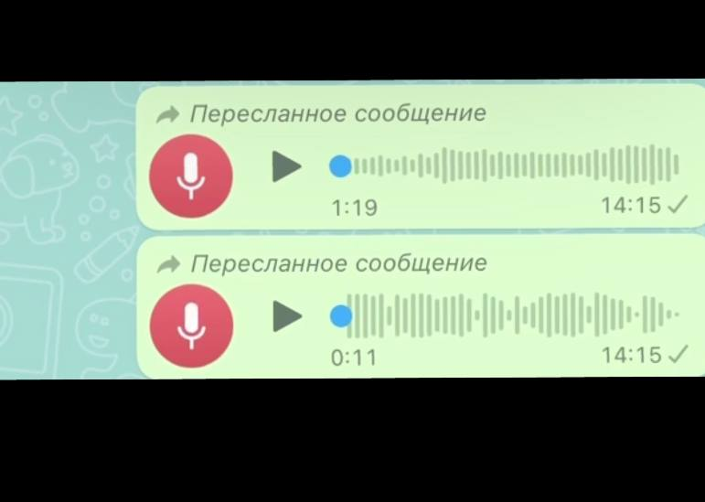

**Discussion**

The data presented here indicates that our hypothesis was confirmed and all the results were achieved, for all three weeks both students began to learn words much faster and use them to answer questions, they also learned new words and gave a higher result at the end of the experiment. According to the data, we can say that our hypothesis is confirmed and this method allows teachers to easily and quickly pass the lesson online as well as offline. Looking at our sources of information, for the most part it coincided but according to the latest results, the students were shown different results. Especially the results of the first student is a lot more surprised me, because for that period of time was not expecting a good result.

**Conclusion**

In conclusion, this useful tool improves memory and makes learning, memorization of vocabulary, and homework much more enjoyable. Nearly all of the objectives were met by the experiment's conclusion, and each student had learnt and could use their newfound knowledge. Since student M often commented on the aesthetics and the application, and because student Yu enjoyed using it, she found it simple to respond to questions, this application will be highly engaging for the lower grades as well. The experiment's findings indicate that using Wordwall is a good way to verify homework and assimilate new material.

**References:**

1. [1] Supyan Hussin, Nooreiny Maarof, JV D’cruz The Internet TESL Journal 7 (5), 1-7, 2001
2. [2]. Hung, P., Lam, J., Wong, C., & Chan, T. (2015, July). A study on using learning management system with mobile app. In *2015 international symposium on educational technology (ISET)* (pp. 168-172). IEEE.
3. Payne, H. E., Lister, C., West, J. H., & Bernhardt, J. M. (2015). Behavioral functionality of mobile apps in health interventions: a systematic review of the literature. *JMIR mHealth and uHealth*, *3*(1), e3335.
4. Gowin, M., Cheney, M., Gwin, S., & Franklin Wann, T. (2015). Health and fitness app use in college students: a qualitative study. *American Journal of Health Education*, *46*(4), 223-230.
5. Jeffrey, B., Bagala, M., Creighton, A., Leavey, T., Nicholls, S., Wood, C., ... & Pit, S. (2019). Mobile phone applications and their use in the self-management of type 2 diabetes mellitus: a qualitative study among app users and non-app users. *Diabetology & metabolic syndrome*, *11*(1), 1-17.
6. Dallinga, J. M., Mennes, M., Alpay, L., Bijwaard, H., & Baart de la Faille-Deutekom, M. (2015). App use, physical activity and healthy lifestyle: a cross sectional study. *BMC Public health*, *15*(1), 1-9.
7. Zhao, J., Freeman, B., & Li, M. (2016). Can mobile phone apps influence people’s health behavior change? An evidence review. *Journal of medical Internet research*, *18*(11), e287.