Student Activity Sheet
Subject | English
Teacher | Mukataeva Ayiza
textbook | Excel 5 grade
Theme | Pink Dolphins. Adverbs and Adjectives
Learning objectives | 5.4.1.1 understand the main points in a limited range of short simple texts on general and curricular topics;  5.6.14.1 use prepositions to talk about time and location, use prepositions like to describe things and about to denote topic, use prepositions of direction to, into, out of, from, towards on a limited range of familiar general and curricular topics;  5.6.9.1 use simple present and simple past regular and irregular forms to describe routines, habits and states on a limited range of familiar general and curricular topics;
Type of the lesson | Studying new material
Student’s name

Procedure | Ресурсы
Learn  5 min  5 min  10 min | Open your book and look at the table and complete the rule p. 88. ex. 1  always – әрқашан  usually – әдетте  often – жиі  sometimes – кейде  never – ешқашан  Do exercise  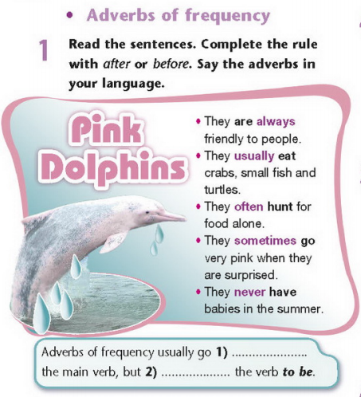  Look at the Prepositions of time  Watch the video and write down the grammar.  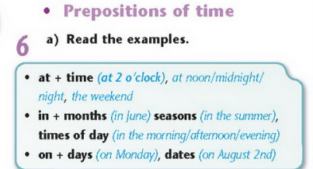
Answer  5 min  15 min  5 min | Look at the table and learn the rule of Comparitive and Syperlative adjectives  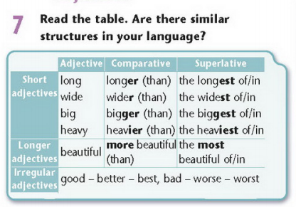  Open your workbook p. 52 ex. 1, 4, 5  Do exercise  Listen song and sing and dance  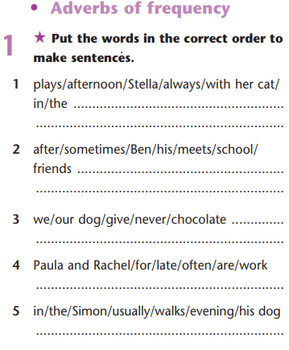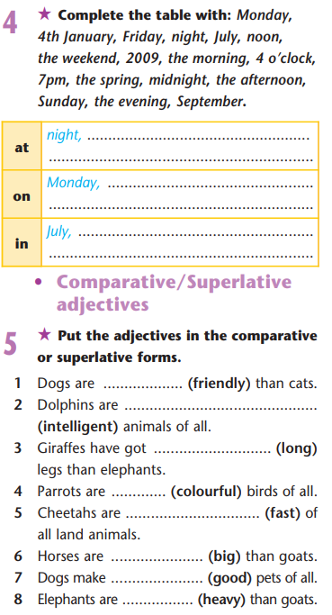
Рефлексия | I have learnt _______________________.  I have difficulty in ____________________.  It was easy

Обратная связь от учителя  (словесная оценка и/или комментарий) | Комментарии к работе ты сможешь найти в кунделик.kz

