Title: “The world belongs to those who read”
Form: contest
Participants: learners of 5th grades
Procedure:
I. Start
- Good day, teachers and pupils and welcome to our contest called “The world belongs to those who read” between the learners of the 5th grades. Our learners will work in 4 teams:
- Reading buddies
- Book lovers
- Know-alls
- Why-ages
Each contest will be assessed by supervisors of each team, who will fill in the assessment sheet for each contest:

Team`s name | 1st contest | 2nd contest | 3rd contest | 4th contest | 5th contest
Points
Total

Learners, please, come choose the card and identify your teams.

II. Contest

1st contest “Tongue twisters”

The teams are asked to read 3 tongue twisters as fast as they can:

1. Fred fed Ted bread and Ted fed Fred bread.
2. I looked right at Larry’s rally and left in a hurry.
3. I saw Susie sitting in a shoeshine shop. Where she shines, she sits, and where she sits, she shines.
Maximum number of points for this contest: 3. Fluency, reading skills and pronunciation is assessed here.

2nd contest “Read and find incorrect words”

The teams are given the text which they have to read carefully and find five incorrect words (the words that do not belong to the content of the text)

Maximum number of points for this contest: 5

3rd contest “Captains` contest”

The captains of 4 teams are asked to write as many words as they can in 2 minutes from the word “environment”

Maximum number of points for this contest: no. The teams get a point for each word spelled correctly

4th contest “Race”

The teams are suggested to run to the opposite side of the room, hitting a tennis ball with a racquet, find and write one letter from the code, then come back to their teams hitting a tennis ball with a racquet.

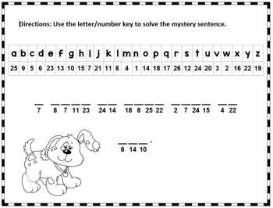
Maximum number of points for this contest: 1. If the teams write the whole sentence correctly, they get 1 point.

5th contest “The best painter”

In this contest the teams are suggested to listen to the description read by the teacher, draw and colour what they hear.

Hi, it`s me again! My name`s Alice and I go to school. My school is blue and it has got three floors. After school I go home. My house is small and grey. There is a big green tree near my house. I have a cat and a dog. The cat is white and the dog is brown.

Maximum number of points for this contest: 15. The teams get 1 point for every correct picture and colour.

It`s high time to know the results of today`s contest … The team with the highest number of points will get a Grand Prize, the others 1st, 2nd and 3rd place respectively.

Алматы облысы
Кербұлақ ауданы
«Д. Қонаев атындағы орта мектеп» КММ

«Оқушылардың оқу қажеттіліктерін анықтау»
(семинар)

Дайындаған:
Е. Галиева
ағылшын тілі пәнінің мұғалімі

Сарыозек ауылы
2021-2022 оқу жылы

