Summative assessment for the cross curricular units «Creativity & Reading for Pleasure»

Name ____________________________________ Grade 5 ____

Learning objectives | 5.4.5.1 deduce meaning from context in short texts on a limited range of familiar general and curricular topics;  5.5.4.1 write with support a sequence of extended sentences in a paragraph to give basic personal information;
Assessment criteria | - Identify true/ false sentences  - Make up sentences, which give personal information
Level of thinking skills | Knowledge and comprehension Application
Duration | 30 minutes
Reading (15 min)
Task 1. Read the story about magic paintbrush.
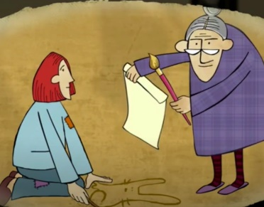
The magic paintbrush
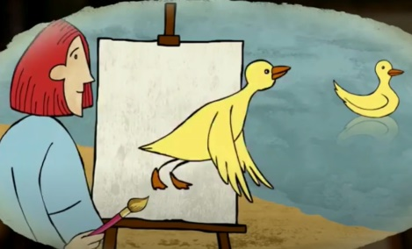
Rose loved drawing. She was very poor and didn’t have pens or pencils. She drew pictures on a sand with sticks. One day an old woman saw Rose and said, “Hello! Here is a paintbrush some paper for you!” “Thank you!”, smiled Rose. She was so happy. She looked around and saw a duck on the pond and she decided to draw a duck. Suddenly the duck flew off the paper and Rose understood that she had a magic paintbrush.
Rose was a very kind girl. She drew pictures for everyone in her village. She drew a cow for the farmer, pencils for teacher, toys for all children.
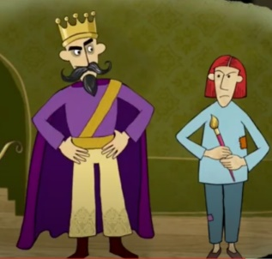
The king heard about the magic paintbrush and sent a soldier to find Rose. When soldier took Rose to the king, king asked Rose to draw a tree with a lot of money on it. But Rose helped only poor people and king was rich. Rose refused to draw a tree with money for king. The king sent her to the prison. But Rose was brave and clever, she drew a key for the door and escaped from prison. The king chased after her. So she drew a big hole, and splat! The king fell in.
Today Rose uses her magical paintbrush to help people, who really need help.

Task 2. Read the sentences and mark True/ False.
1. Rose was poor girl, so she didn’t have pens to draw. ___________
2. Old woman gave her a magic stick. ___________
3. Rose drew pictures for rich people. ___________
4. King asked Rose to draw a tree full of money. ___________
5. King sent Rose to village. ___________
6. Rose drew a key to get from prison. ___________
7. Rose uses the magic paintbrush to help people, who need real help. ___________

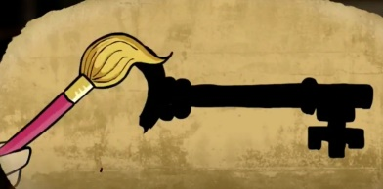
Writing
Task 1. Write a short text about your favourite book in 7-10 sentences.
You should write about it:
What is your favourite book?
Why is it your favourite book?
Example: I like reading. Especially I like fantasy stories. My favourite book is Harry Potter. It’s a story about wizard. He does some magic things. He goes to a big school of magic called Hogwarts. Harry Potter meets new friends, studies and faces the most evil magician Lord Voldemort. This book is very exciting!
- Grammatically correct sentences
- Correct spelling
- Use Present Simple
- Use active vocabulary
- Contain answer to the question Why.

.

