Grade: 7
Module: Healthy habits
Theme of the lesson: Reading The greatest player
Strand: Reading skills
Learning objectives: 7.4.1.1. understand the main points in the texts on a limited
range of unfamiliar and curricular topics.
7.4.5.1.deduce meaning from context in short texts on
a growing range of general and curricular topics
Approach: Text Based Approach
Pre-reading
Pictures / the activity is for the whole class The teacher provides pictures related to the topic of the text; students guess what the text will be about; students present their ideas. /
Look at the pictures and share your ideas, what the text will be about.
The text will be about a sportsman. He is a basketball player. He is a champion. His number is 23.
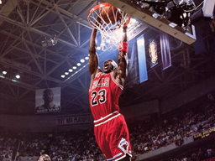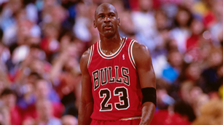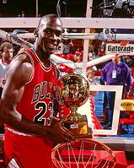
Reading for gist / students look through the text to get the general idea of what it is about/
Look through the text for 1 minute and tell the class what the text is about.

The greatest player
Michael Jordan is American professional basketball player. He is often considered the greatest player in the history of the game. He led the National Basketball Association (NBA) Chicago Bulls to five championships.
Jordan was born on the 17th of February, 1963 in Brooklyn, New York. He entered the University of North Carolina in 1981. Two times Jordan led the U.S. basketball team to Olympic gold medals in 1984 in Los Angeles and in 1992 in Barcelona, Spain.
In 1984 he was drafted by the Chicago Bulls. In the 1995-1996 season Jordan led the Bulls to a regular season record, the best in the history of the NBA Finals. At 1.98 m , Jordan was an very talented shooter, passer and defender. His nickname is “ Air Jordan” Because of his extraordinary leaping ability and the acrobatic maneuvers he used to evade defenders as he approached the basket.
Students’ expected answers:
The text is about the professional basketball player Michael Jordan.
The text is about biography of a sportsman.
While – reading /students focus on text features and comprehension/
Comprehension Questions
Yes/No questions. Read the text and answer the questions
- Is Michael Jordan American ? Yes
- Was he born in Washington? No
- Did he lead his team to Olympic gold medals? Yes
- Did he play for the Chicago Bulls? Yes
True/ false statements Read the statements and mark True or False
- Jordan was born in winter True False
- Jordan graduated the university in 1981 True False
- Jordan played for Chicago Bulls since 1985 True False
- He was the best player in the history of NBA True False

Post- reading
Retelling Retell the text using the sentences of the previous tasks

