**TEACHING IS THE GREATEST ACT OF OPTIMISM**

**MIRZAMURATOVA AKMARAL NURZHANOVNA**

**English Teacher**

**KSU "LYCEUM SCHOOL No. 210"**

**Almaty city, Alatau district**

I am working at KSU "Lyceum School No. 210" I love working with children. They are full of energy, ideas, and curiosity. Teachers play an essential role in everyone’s life. Not only do they teach us in schools but we also learn many useful things like moral values, social etiquette’s, how to treat others & be friendly with our classmates.

It is granted that technology has opened the door of new learning & has also changed the course of education. But a good teacher has the power to change our life, ignite us in the most perfect way.

Teaching is one of the noblest profession. The impact that a teacher has on a pupil’s life is profound and lasts forever. I chose teaching as my profession because I believe that it is one of the most rewarding and fulfilling careers that anyone could ever choose.

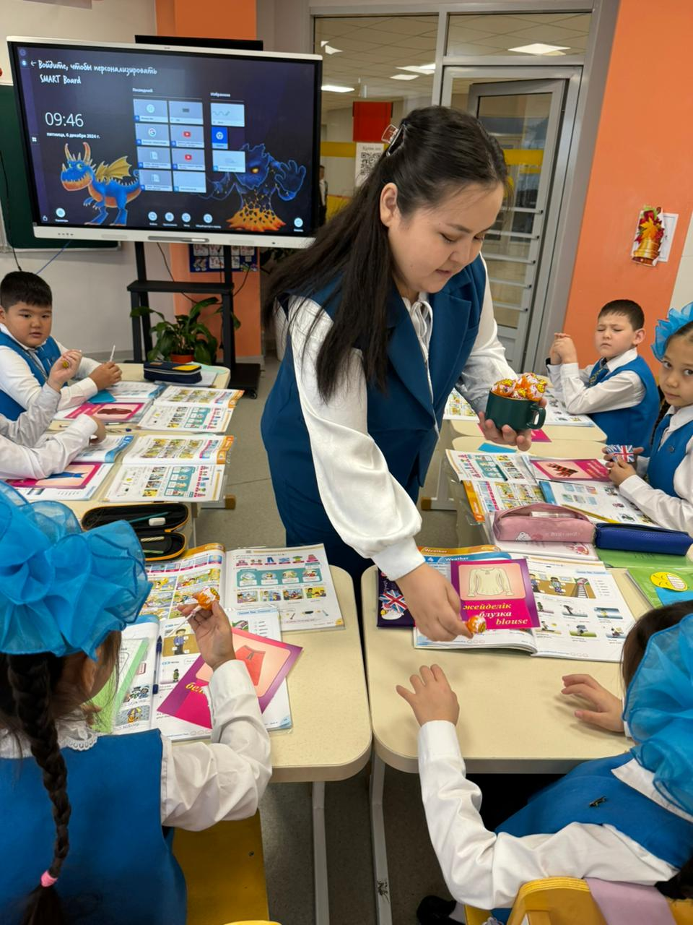 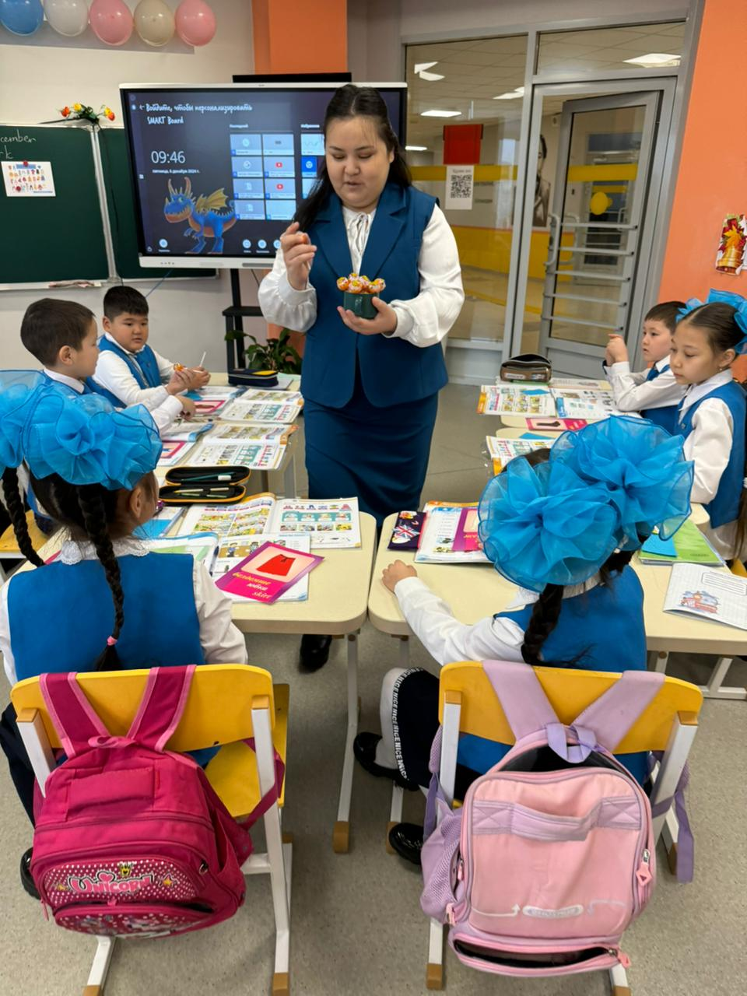

TEACHING IS THE GREATEST ACT OF OPTIMISM

My teaching experience

Being able to guide them, mentor them, and help them grow into informed, critical-thinking adults is something that I find deeply gratifying. I believe that every child has the potential to succeed, and it is up to us as educators to help them reach that potential.

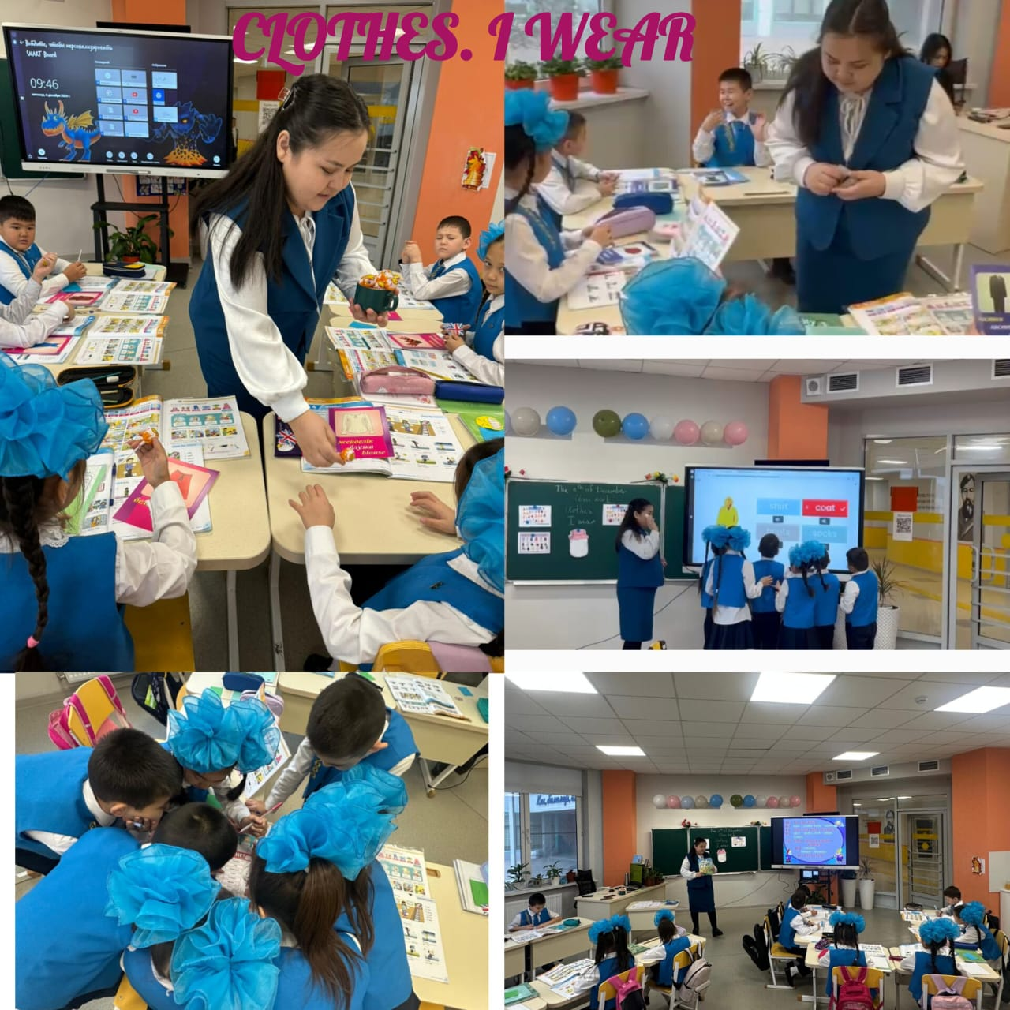

Children are full of energy, ideas, and curiosity

I believe that educators have a unique opportunity to make a positive impact on society. Through my work as a teacher, I can touch the lives of countless individuals, helping them to acquire the knowledge and skills they need to make positive contributions to their communities. Furthermore, education is an essential tool for promoting social justice and creating a more equitable society.

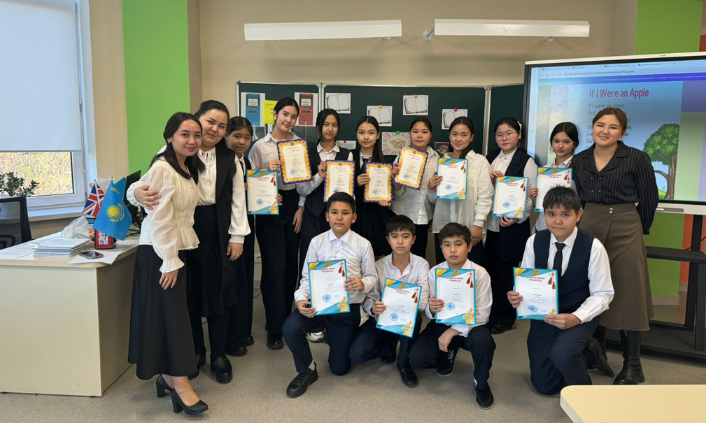

Teaching is the greatest act of optimism

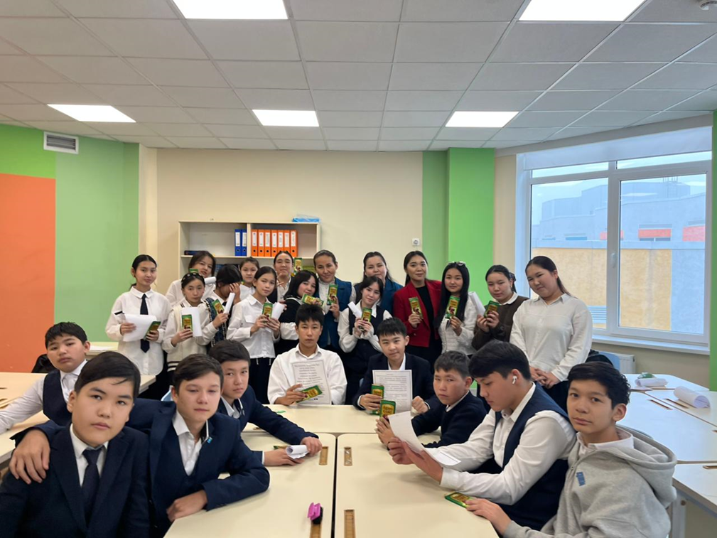

As a teacher, I can help dismantle long-standing societal inequities by giving all students equal access to a quality education.

In conclusion, I have chosen teaching as a profession because I have a passion for helping young people, I believe in the power of education to change lives, and I find the career to be deeply rewarding. By becoming a teacher, I hope to make a positive impact on the lives of countless students and help them achieve their full potential. I am excited to embark on this journey and look forward to the challenges and rewards that lie ahead.