Unit 2: Natural Disasters |  |  |  | College: Kokshetau Higher Medical College
Date: |  |  |  | Teacher name: Kussainova Gulden Kuanyshbekovna
Group: F-11/9 |  |  |  | Number present: | absent:
Lesson title |  | Natural Disasters
Learning objectives(s) that this lesson is contributing to |  | 10.1.9 Use imagination to express thoughts, ideas, experiences and feelings  10.2.1 Understand the main points in unsupported extended talk on a wide range of general and curricular topics, including talk on a limited range of unfamiliar topics  10.2.2 Understand specific information in unsupported extended talk on a wide range of general and curricular topics, including talk on a limited range of unfamiliar topics
Lesson objectives |  | Learners will be able to:  - Imagine the ideas of causes, consequences of natural disasters;  - Recognise the main points in unsupported extended talk;  - Identify specific information in unsupported extended talk
Assessment criteria |  | - Express thoughts, ideas, experiences and feelings with imagination  - Recognize the main points in extended talk on topic natural disasters  - Identify specific details in extended talk on a wide range of topic natural disasters
Value links |  | National unity, peace and harmony in our society
Cross-curriculum |  | Geography, Physics
Previous learning |  | Vocabulary relating to natural disasters
Plan
Planned timings | Planned activities |  |  |  |  | Resources
Start  0-7 minutes | CLASS ROUTINE: Teacher greets learners; learners respond to greeting and take their places.  - Good morning, pupils! I am very glad to see you. How are you?  - Nice to meet you too! We are fine, thanks, and what about you?  -Now let's turnto each other, smile and wish each other good luck!  They stand up, turned to each other, smiled and wished good luck!  Pre-learning  (P) Students will be given a set of pictures and they should think about and discuss with the person next to them what these pictures have in common (what they depict). This discussion should lead to students identifying these pictures as examples of natural disasters.  Teacher ask students to refer the disaster to one of the Earth’s spheres.  STARTER:  (W) Eliciting vocabulary  Teacher pre-teaches the words about natural disasters: earthquake, hurricane, volcanic eruption, wildfire, tornado, flood, tsunami, drought, forest fire, blizzard, landslide, avalanche, typhoon. Teacher will offers to watch the videowith vocabulary. Learners should repeat after the speaker.  Descriptor:  -practice their pronunciation on the topic natural disasters  (f) Oral assessment. Good job, well done.  INTRODUCTION  After the eliciting teacher asks learners to try to predict the topic of the lessons. After students guess the topic of the lesson teacher introduces them with the learning objectives. |  |  |  |  | List of pictures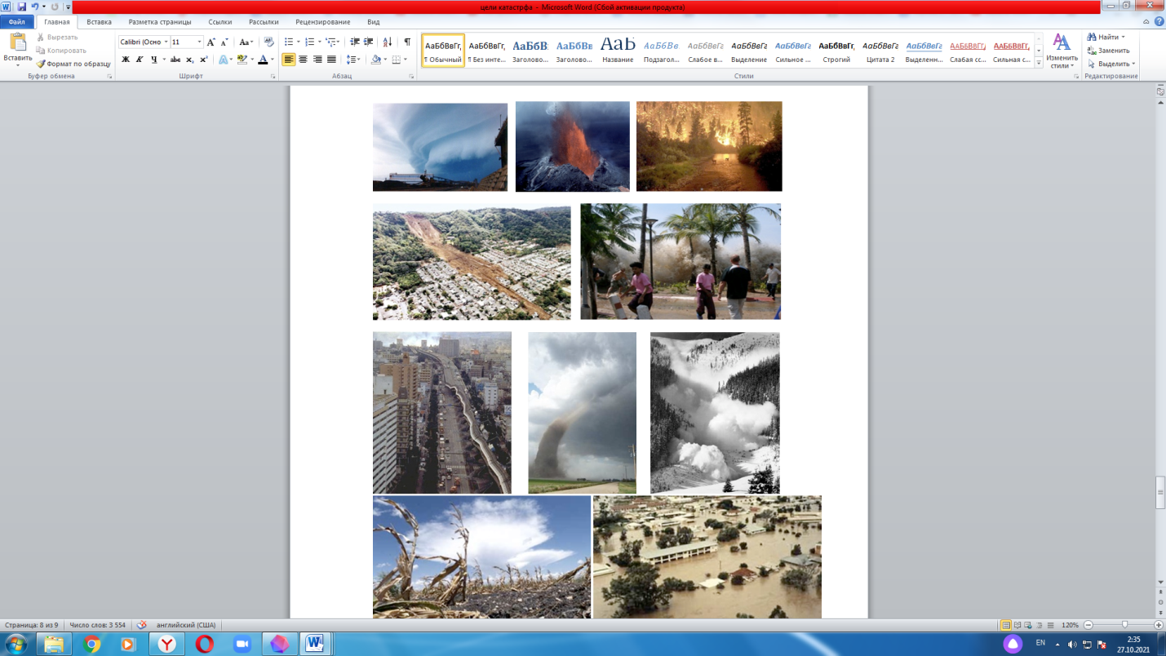  https://youtu.be/nSc_6YbQ2TI  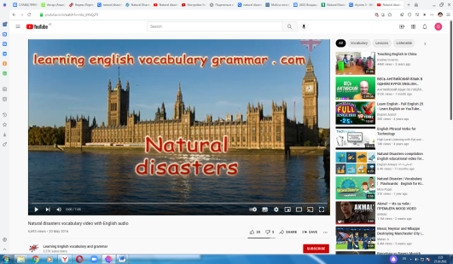
Middle  8-40 minutes | DEVELOPMENT  Activity “Forecasting”  The learners will be divided into three groups by using the "Puzzle".  (G)Imagine that you work for the emergency services. How do you help the people affected by  - a wildfire  - a flood  - an earthquake  Offering solutions, make up a story on the theme “If I were …”  Descriptor: a learner  -imagines the emergency service  - chooses the types of natural disasters  - elicits the story of the helping by natural disasters with visual images  - give their forecast  Differentiation by outcome  (setting a restriction on the number of words for more able students)  (f) Group-assessment: “Two stars and one wish”, students write on the stickers two positive points and one to improve/wish.  (D, W)The teacher invites learners to watch a video on the topic "Natural disasters".  He explains the activity and gives the instructions.  Activity “True or False”.  (I) The Game prepared by teacher on the platform learningapps.org  Descriptor: a learner  - matches the pictures with their titles  - chooses True or False  (f) Self- assessment: use traffic lights as a visual means of showing understanding. Students show in the air red, amber or green cards: red=understand, amber = does not say, green = don’t understand.  Activity “INSERT”  (I) You’ll watch the video and tick «v», «+», «-», «?»  «v» «+» «-» «?»  You should put a tick «v»if you knew this fact before (соответствует тому , что вы уже знаете) Newinformation (является для вас новым, интересным) Thoughtdifferently (противоречит тому, что вы уже знали или думали, что знаете) Don’tunderstand, havequestions (непонятно или вы хотели бы получить более подробные сведения)  Information tick  - Every year we hear of dramatic natural disasters.  - First of all a volcanic eruption where suddenly a river of lava flows down the volcano  - Tsunamis often come after an earthquake  - Earthquakes usually caused the most damage in towns and cities where buildings move and fall down.  - A lack of water causes illness and shortage of food.  Descriptor: a learner  - reads the sentences  - identifies the specific information about disasters  - tick «v», «+», «-» or «?»  Differentiation by time allowed. ( Less able learners will be given more time for their answers. More able learners support the less able learners in the group)  (f) Peer- assessment: “Hamburger”, at the first students write something positive about their work, at second an area that the student could work on, at third something positive about their work.  [W] Energizer. Double, double  Activity “CHAIN”  (G) After watching the video about natural disasters such as earthquakes, hurricanes, tornadoes, volcanic eruptions the students fill in the following table and working in groups inform each other where serious earthquakes have taken place on our planet, where people suffer from hurricanes, where tornadoes are common, where there are active volcanoes  Natural Disasters Continents Countries  Earthquakes Asia, South America, North America, Europe Japan, China, India, Turkey, Peru, KZ, Mexico, the USA, Armenia, the Russian Federation, Portugal  Hurricanes Asia, North America Japan, the Russian Federation, China, the Philippines, the USA  Tornadoes North America the USA  Volcanoes Europe, Asia, South America the Russian Federation  Descriptor: a learner  - identifies specific details  - fills in the table by answering his questions  - expresses their feeling according to the definite disaster  Differentiation by scaffolding, sentence frames. (Less able learners will be given pictures with words and will also be given sentence frames, where they will have just put the words and formulate a sentences to express their feelings and thoughts)  (f) Self-assessment: KWL table.  Create a grid with three columns – what they Know, what they Want to know, what they have Learnt.  Activity “Bank of terms and definitions”  (I) The Game prepared by teacher on the platformwordwall.net  Descriptor: a learner  - selects the keywords with their definitions  - identifies the vocabulary  Differentiation by visual aids (less able learners prepare pictures with the definition)  (f) self- assessment: sheet, evaluate it using this scale, circle the selected |  |  |  |  | 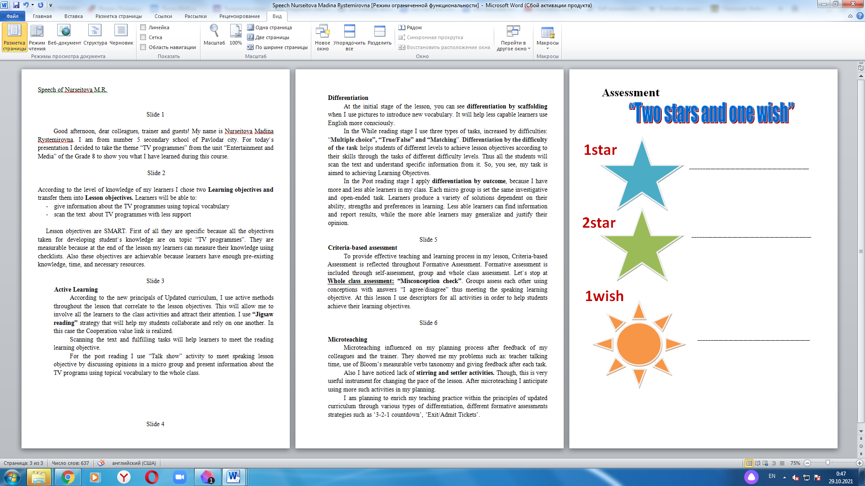  https://youtu.be/q8eIwmSJP0o  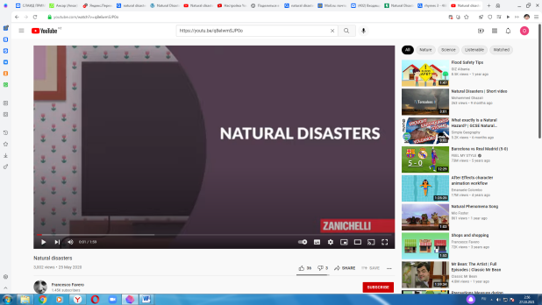  https://learningapps.org/display?v=pmyb88gqn21  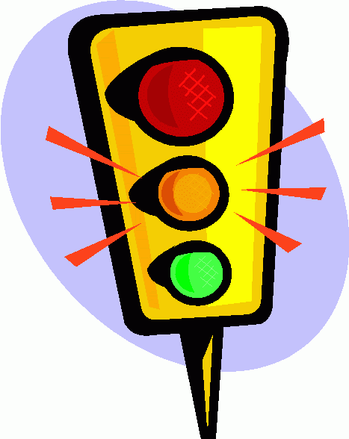  https://learningapps.org/display?v=pthtkthy321  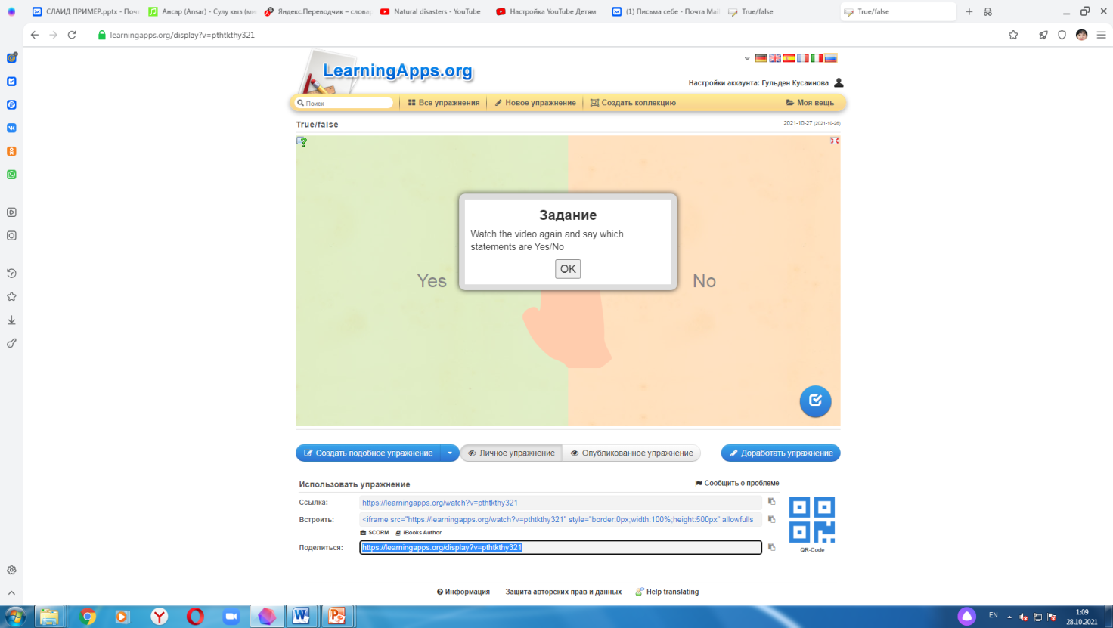  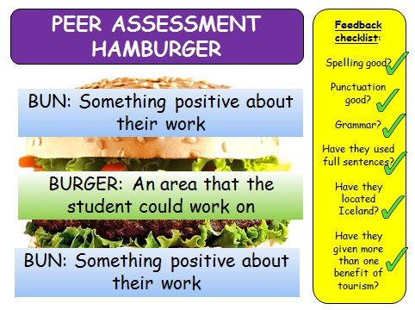  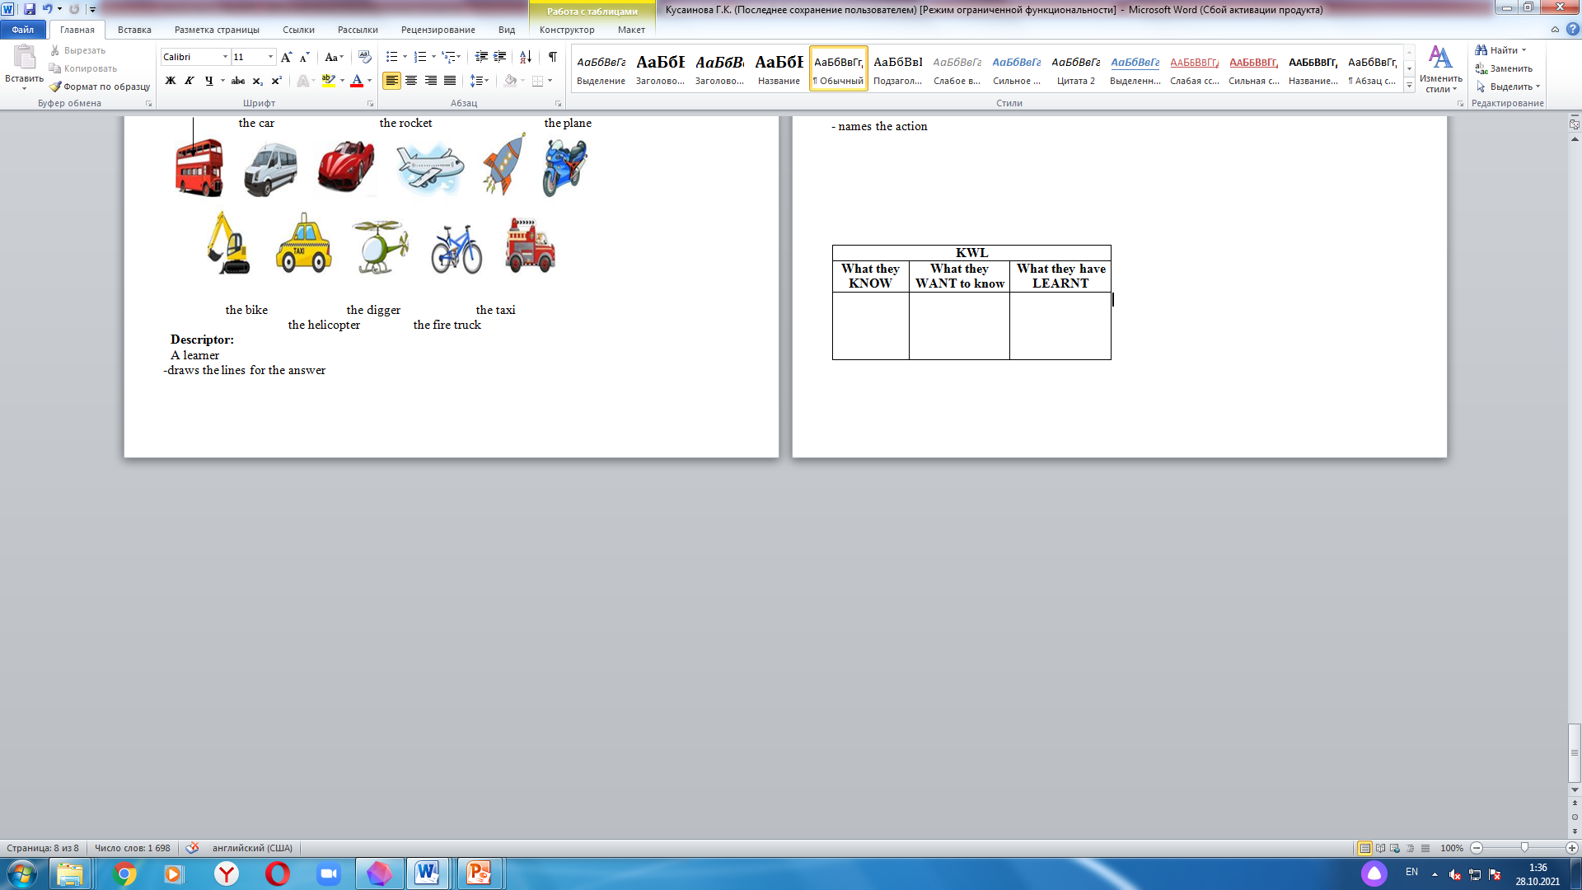  https://wordwall.net/play/24028/155/132  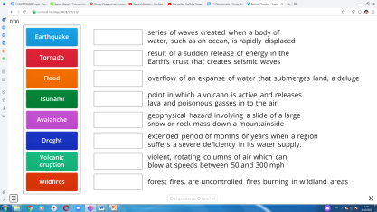  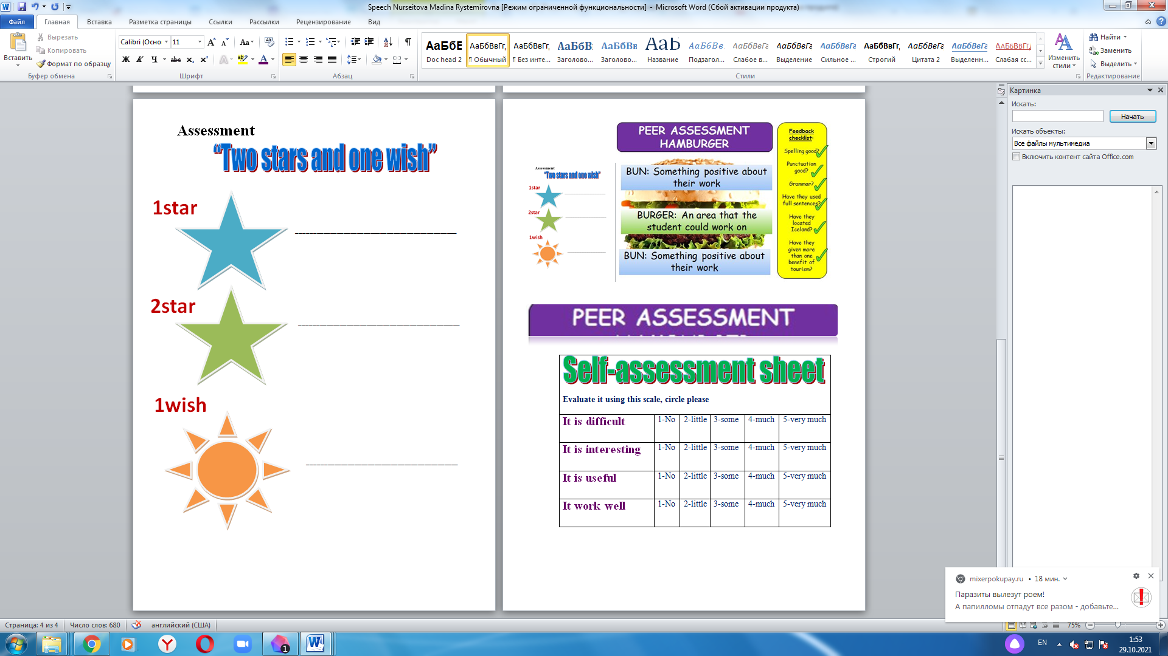
End  5 minutes | PLENARY  Reflection  Feedback.  Teacher asks guiding questions to less able students such as:  - Can you name types of natural disasters?  Teacher asks guiding questions to more able students such as:  - Can you answer the definition of the types of natural disasters?  The glade of success: PMI diagram.  Encourage pupils to identify what has worked and not worked, was interesting for their learning.  Evaluation of the lesson:One-Sentence Summary. Students write a sentence summarising their knowledge of natural disastersincluding who, what when, why, how, where etc.Students take one minute to compose a sentence.  Class routine. Teacher thanks whole class for the active participation and give the homework.  Teacher and learners say see you soon. |  |  |  |  | Prepare diagram for each pupils.
Additionalinformation
Differentiation – how do you plan to give more support? How do you plan to challenge the more able learners? |  |  | Assessment – how are you planning to check learners’ learning? |  |  | Health and safety check
Teacher organizes different types of differentiation. It is differentiation:  - by outcome;  - by time allowed  - by scaffolding, sentence frames  - by visual aids  Differentiation by outcome  (setting a restriction on the number of words for more able students)  Differentiation by time allowed. (Less able learners will be given more time for their answers. More able learners support the less able learners in the group)  Differentiation by scaffolding, sentence frames. (Less able learners will be given pictures with words and will also be given sentence frames, where they will have just put the words and formulate a sentences to express their feelings and thoughts)  Differentiation by visual aids (less able learners prepare pictures with the definition) |  |  | . Teacher holds different types of formative assessment:  - group– assessment;  - self – assessment  - peer-assessment  - oral-assessment  - KWL  All types of assessment focus learners on their progress and grade of their achievement of the learning objectives. |  |  | Use physical training during lesson through listening and dancing while watching video

